Important information from your doctor’s surgery
 | Hello, my name is K and I work at your doctor’s surgery.
I work as a care coordinator.

Care-coordinator is a healthcare worker.

My job is to make sure that you get the help from your doctors’ surgery you need.

 | I would like to get to know you.
I work on:

- Monday
- Tuesday
- Wednesday
- Thursday
- Friday.
Am Pm | I work from 8am to 4pm during the week.  Sometimes I work on a Saturday too, but this is not usual.
What can you talk to me about?

- Your Health Check
- Reasonable adjustments you need
- Your health and support needs
- Things that worry you or you need help with

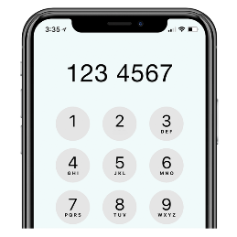 | If you want to talk to me, here are my details:  Email:  Phone number:  (This number will not cost you more than usual)
I look forward to meeting you.

Thank you.

