Clinical Safety Case Report – eHub eConsult
NHS Folkstone, Hythe & Rural PCN

Published: DATE
Document filename: eConsult
Directorate / Programme | South East Region Primary Care Transformation Programme | Project eConsult PCN eHub
Document Reference CSCR
Director: | Dr. Aravinth Balachandran | Status Issued
Owner: | Dr. Aravinth Balachandran | Version 1.2
Authors: | Andy Harrison - ETHOS Ltd. | Version issue date | 27/07/2023

Document Management
Revision History
Version | Date | Summary of Changes
0.1 | 29/05/23 | Draft Created
0.2 | 05/07/2023 | Updated from Hazard Workshop
1.0 | 13/07/2023 | Final copy from review meeting.
1.1 | 25/07/2023 | Updated from review comments.

Reviewers
This document must be reviewed by the following people:
Reviewer name | Title / Responsibility | Date | Version
Andy Harrison – Safety Engineer, ETHOS Ltd. | Author | 25/07/2023 | 1.2
Pete Davis Clinical Safety Officer, ETHOS Ltd | Reviewer | 25/07/2023 | 1.2

Approved by
This document must be approved by the following people:
Name | Title | Date | Version
Dr Aravinth Balachandran | GP Partner | Oaklands Health Centre  Clinical Director | Folkestone, Hythe & Rural PCN | 03/08/2023 | 1.2
Tim Caroe | Medical Director, Primary Care Transformation  Primary Care Transformation Programme - NHS England South East Region | 09/08/2023 | 1.2

These documents provide additional information and are specifically referenced within this document.
Ref | Title | Document or Location | Version
1 | DCB 0129 - Clinical Risk Management: its Application in the Manufacture of Health IT Systems - Specification | DCB 0129 | 3.2
2 | DCB 0160 - Clinical Risk Management: its Application in the Deployment and Use of Health IT Systems - Specification | DCB 0160 | 4.2
3 | eConsult Clinical Safety Report Copy inc Hazard Log |  | 5.7
4 | PCN Hub Operating Model – Pilot Practice Overview, Oaklands Health Centre eHub Pilot | Document available on request from Folkestone, Hythe & Rural PCN | v  1.2
5 | PCN Hub: Federated Online Consultation Triage & Minor Illness Service:  [20230527_FHR_PCN_Hub_Outline_SOP] | Document available on request from Folkestone, Hythe & Rural PCN | v2.01
6 | e-Consult Clinical Incident Reporting Form | Clinical Risk Management File eConsult | -
7 | Smart Inbox Clinical Safety Case Report | Smart Inbox Clinical Safety Case Report.pdf | v2.1
8 | Clinical Safety Case Consultation Writeback | PRJ0011190 | 5/6/2023
9 | NHSmail O365 Shared Tenant Clinical Safety Case | https://support.nhs.net/knowledge-base/o365-shared-tenant-clinical-safety-case-report/ | V5.83
10 | eHub Hazard Log | eConsult eHub Hazard Log v1.1 | v1.2

Contents tbc
Executive Report. 5
Introduction 6
Background 6
System Definition / Overview 7
High level flow upon go-live: 8
eConsult intended uses 11
Governance 11
Incident reporting 12
Clinical Risk Management System 13
Clinical Risk Analysis 13
Associates Clinical Risk Documentation 14
Clinical Risk Control 15
Hazard Log 15
Configuration Control / Management 15
Summary Safety Statement 16
Recommendations: 16

Document Control
This document is available in two forms, controlled and uncontrolled. Uncontrolled variants are all other electronic and printed copies.

Executive Report.

eConsult is an established product which complies with the DCB 0129 clinical safety standard. The manufacturers have strong governance, incident management, disaster recovery and processes in place. The product is used across many CCGs/PCNs and General Practice already.

The eHub model in which Folkstone Hythe and Rural PCN wish to utilise eConsult is a new way of working with online consultations. The project team have a project plan, governance arrangements, are completing testing, training and have developed workflow structures. All of which is included within the Standard Operating Procedure. eHub communication to patients and general practice is key so that all are fully informed.

The hazards associated with eConsult and the eHub model have been identified, reviewed and controls applied where possible. The residual risk score for all hazards are below 2:
“…Acceptable where cost of further reduction outweighs benefits gained or where further risk reduction is impractical…”

Therefore, providing the above controls and considerations are met the eConsult eHub model is safe for deployment within the PCN.

Introduction
The purpose of this clinical safety report is to comply with the clinical safety standard DCB0160 Clinical Risk Management: its Application in the Deployment and Use of Health IT Systems. This report is written in relation to the deployment of the eConsult product within Folkstone, Hythe and Rural PCN as an eHub model.

The Clinical Safety Objectives for this product and model are:
- The design, development and deployment has continued monitoring of the Hazard assessment / Hazard Log
- The system is clinically safe in the context of its intended purpose or use.
- To monitor any change to the system, assess any potential risk and mitigate these.
- Identify and assess clinical hazards/risks to ensure patient safety.
- Identify safety critical functionality of the system and evidence assurance activities in these areas to mitigate clinical risk.

The clinical safety case report aims to provide part of the argument that the product complies with NHS clinical safety standards (Ref 1 & 2) As such it is deemed clinically safe and fit for purpose to be used within the region.

Background
The procurement of eConsult was facilitated under the NHS England national Dynamic Purchasing System (DPS) framework for online consultations. The eConsult product is to be used as a centralised processing model within Folkstone Hythe and Rural PCN forming an eHub.
In the context of the Folkestone, Hythe and Rural PCN, the “eHub” is a centralised processing model for delivering online consultations at scale across multiple NHS GP practices. The model this clinical safety case report is based on is specifically for use of eConsult. For use of this document in informing safety cases for PCNs ‘eHub’ developments, they will need to consider their own particular ‘eHub’ models on an individual basis.
With the Folkestone, Hythe and Rural PCN eHub model, eConsults will be processed at a central location. Any eConsultations that cannot be dealt with by the eHub clinical team, or wider PCN clinical teams, will be triaged to the patient’s practice directly.
The eHub model enables effective healthcare to be delivered collaboratively with a small, dedicated team working on behalf of all the practices. The eHub contains a specialist team who are experts in triaging eConsultations so each practice only sees the requests they need to.
The aim is to decrease the daily workflow pressures On GP Practices and enable patients to self-manage, self-care and refer where appropriate electronically. To promote the ‘digital first’ strategy and assist in the triage of demand on the practices.

The aim of the eConsult deployment is to safely and effectively:
- process eConsult reports in a timely manner.
- determine if prescription/advice, telephone consultation or face to face encounter is required.
- utilise PCN and practice resources and staff, promoting the ‘Right Care, Right Time, Right Person’ approach.
eHub will support practices with primary care pressures by:

- Supporting the management of increasing levels of patient demand
- Ensure patient needs are met effectively as possible by clinically triaging their query using an appropriately trained healthcare professional.
- Share existing and additional workforces, resources and to flex capacity to better meet demand across the locality.
- Increase collaboration and peer support across the locality.

System Definition / Overview
eConsult is an online portal where patients can self-check their symptoms with ‘self-help’ content, obtain pharmacy advice or choose to consult with their GP using a structured questionnaire (online consultation). Self-help information is syndicated directly from NHS choices and some pharmacy advice content has been curated by eConsults own clinical team. The servers are hosted in the HSCN environment to safeguard security and no patient identifiable information or eConsult reports are stored on their servers.
The eConsult portal is typically accessed via the GP practice patient facing website or NHS App. If a patient chooses to submit an online consultation, a report is generated from the answers to the questionnaire and securely sent to the practice. The platform is available to anyone over the age of 18. There is specific paediatric content that is available for patients aged between 6 months and 18 years. Paediatric online consultations must be submitted by the parent or guardian, however children between 16-18 can complete an online consultation themselves. eConsult is not to be used for urgent medical attention, a patient disclaimer, explanation and confirmation box is presented at the start of the process to warn patients of the risk of submitting an online consultation for urgent needs. Red flag questions are also embedded within the questions sets. If these questions are triggered, the process stops and the patient is signposted to urgent or emergency services.
EMIS Web is used by all GP practices within Folkestone, Hythe & Rural PCN for management of patient records. For the eHub, the 'PCN Hub Operating model’ utilises an the EMIS Clinical Service and is linked to constituent GP practice systems via a series of technical data sharing agreements.
This allows eHub staff access and manage the following as a ‘central service’ in support of the GP practices:
- View full GP records from organisations who use the eHub.
- Conditional PCN prescribing and appointment booking.
- Access to national spine services.
- Automated updating of the patient’s GP record via EMIS ‘Consultation Write Back’ functionality.
- Communication with patient’s GP practice via cross-organisational tasking.
Clinical and administrative eConsult requests for the GP practices and eHub are configured to use eConsult’s Smart Inbox Tool and currently configured to provide ‘dual delivery’ of the online consultations in conjunction with the PCN EMIS Clinical Service MESH Inbox. The requests are restricted from a GP Practice IG perspective to view of only related to the individual practice.

Administrator queries include but are not exhaustive of:
- Fit note requests
- Test results
- Referral letters
- Prescription queries
- Appointment management

The PCN Hub team will perform two key functions:
- All online consultations will be matched to a registered patient in the clinical system and attached to the patient’s GP record with any relevant clinical codes added
- All clinical online consultations will be triaged and either managed by a PCN level healthcare service, or passed back to the registered GP practice for management.

High level flow upon go-live:
The following section describes the intended operation of the eHub from initial set-up:
- Patient submits an online consultation via their practice website, or the NHS App.
- The online consultation is delivered to two locations:
  - The eConsult Smart Inbox
  - The PCN Hub EMIS Clinical Service (Workflow)
- The PCN Hub clinical team triage the clinical online consultations that have been receive using the eConsult Smart Inbox.
- The PCN Hub administrative team ensure that the online consultations received are attached to the relevant patient record within the practice clinical system.
- The PCN Hub team will either manage a clinical online consultation through to completion, through the appropriate use of a PCN service remote, telephone, video or face to face consultation OR the online consultation will be passed back to the patient’s registered GP practice for management and closure.
- The PCN Hub team will be responsible for ensuring that the patient’s clinical record is updated with all relevant information resulting from any form of patient contact.

The high-level flow can be illustrated as described in the following diagrams, Fig 1 is an overview and the consultation process is shown in Fig 2.
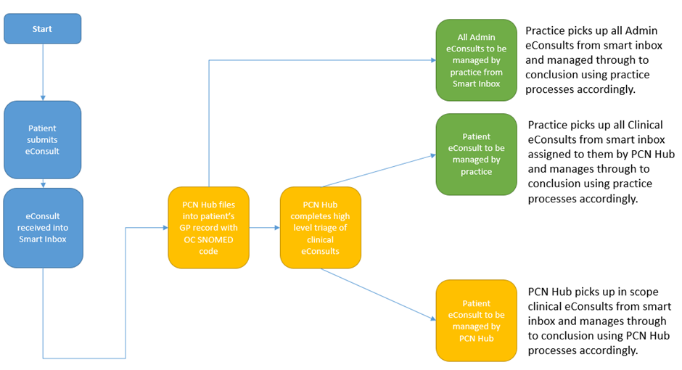
Fig 1 – High Level View of eHub processing of eConsult submissions
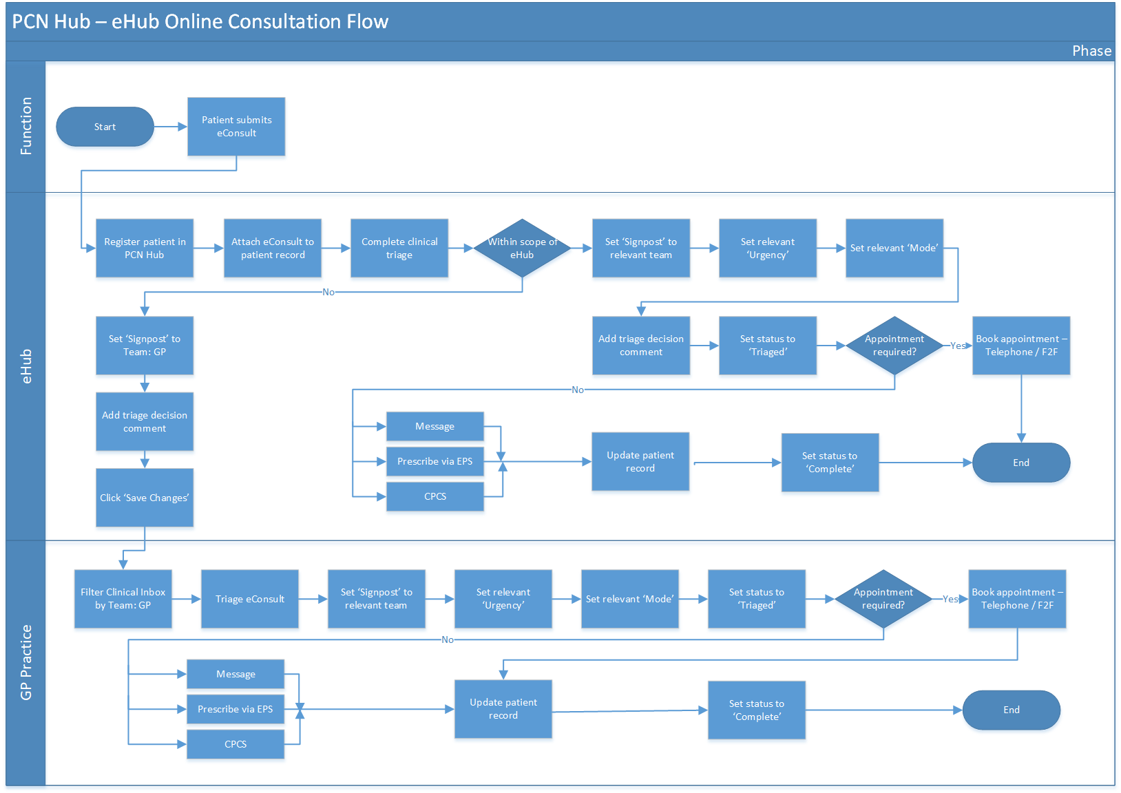

Fig 2. The above diagrams shows the eConsult consultation process.

Operating Hours:
Online Consultation Platform
Each practice within the PCN will define the times during which their online consultation service is available to patients. The implementation of the eHub element of the PCN Hub operating model does not require a practice to amend or align their online consultation availability hours.
eHub Team
The eHub team will work to a published rota which cover the Standard Network Hours which is currently:
08:00-20:00 Monday to Friday
09:00 – 17:00 Saturday

The patient will access the eConsult form via their usual GP practice website or NHS App. Once the patient completes the form, they will receive the message with agreed timescale. The form will be delivered securely to the eHub where it will be reviewed and matched to a GP practice within the PCN. The form will be triaged by a team of Advanced Nurse Practitioners. The patient will either be contacted if the eConsult has been determined unsuitable for online consultation or passed to a clinician to review and respond.
The eConsult ‘signposting’, urgency and triage decision is determined by the eHub team and the eConsult can be set to ‘Triaged’ status. Appointments can also be arranged by the eHub team through contact with the patient. Prior to ‘Completing’ the eConsultation, the patient record is updated.
The clinicians will still have full access to the patients’ medical record, and will be able to contact and hold dialogue with the patient, if necessary, before making any management decision. This is in-line with the recommendations made by the General Medical Council (GMC) and Nursing and Midwifery Council (NMC) with regards to remote consulting (Ref: GMC Prescribing and managing medicines and devices 2013 P60-66, NMC Standard of proficiency for nurse and midwife prescribers P36).

Benefits
The eHub’s main benefit is of economies of scale where a central team can efficiently manage patient eConsultations as a core function.
- Less patients attend the practices across the network saving the NHS GPs time and increasing their access.
- Practices have more time to deal with more patients with complex needs or long-term conditions.
- Clinicians and administrative staff only deal with requests that need to be seen by the practice.
- An eHub model enables different routing options for managing eConsults within hours, out of hours, or for managing fluctuations in demand.
- A centralised model allows for improved access and convenience for the patient population.
- Increased consistency across all practices within the eHub.
- Efficient utilisation of additional capacity and clinical expertise provided by PCN level teams.
- Flexibility for the patient, providing potential option to be seen same day if they are able and willing to attend a GP practice that may not be there own.
- A consistent approach to online consultation triage through the application and management of a PCN level process.

eConsult intended uses
eConsult is intended to be used by patients seeking non-urgent medical advice. Non-urgent is defined as conditions that are not immediately life-threatening emergencies such as severe chest pain, breathlessness, severe bleeding, acute confusion, loss of consciousness, uncontrolled fitting, anaphylaxis and stroke.
Patients using the system are required to be registered to an NHS GP surgery.
The intended users of the eConsult product include but not is not exhaustive of:
- Patients (non-urgent)
- Administrators
- Care navigators
- Secretary’s
- Prescription clerks
- Nurses
- GP’s
- Junior Doctors
- Pharmacists (in house)
- Pharmacy Technicians (in house)
- Additional Roles Reimbursement Scheme (ARRS) including: Physiotherapy, Mental Health Practitioner and Advanced Clinical Practitioners (NHS England ARRS)
The product will be used only as intended which is to facilitate patients through the online pathway whilst ensuring quality of care is not compromised.

Governance
eConsults clinical development team consist of 7 NHS clinicians, a mixture of GPs and senior nurses who author new content and partake in peer review of generated content via a strict clinical governance process that is audited. New content is created from latest guidelines including National Institute for Clinical Excellence (NICE), Clinical Knowledge Summaries (CKS), NHS Choices and other relevant referenced sources. The red flag questions with appropriate level of alerts are discussed amongst the development team within regular clinical review meetings before templates are finalised and signed off. eConsult also hold monthly clinical governance groups which are represented from a pool of external clinicians from various specialities including A&E, ITU, Pharmacy and Paramedics to provide critical feedback on the safety elements of our templates. eConsult is responsible for the DCB0129 Clinical Safety Standard- Clinical Risk Management: its Application in the Manufacture of Health IT Systems. They do have a Hazard log and clinical safety case report with provides some assure that their product is safe for deployment.
Governance within Folkstone Hythe and Rural PCN consists of :
PCN Senior Team including:
Dr Aravinth Balachandran (PCN Clinical Director),
Andy Gove (PCN Digital Transformation Manager),
Kim Lee (PCN Operational Manager),
Jo-Ann Lodge (PCN Lead Pharmacist),
Andrew Powell (Digital Transformation Lead).

PCN Board consisting of
Nominated GP partner from each constituent practice.

Folkstone, Hythe and Rural PCN have adopted a model for their online consultation tools which will be used in the future in relation to the eHub model.

Testing & Training
The eConsult product has undergone a series of testing, this includes infrastructure testing, technical testing, and User Acceptance Testing (UAT). This involves the project team, eConsult, Clinicians, Administrators.

UAT included the end-to-end online consultation process from patient contact through to receipt of the form and the workflow processes tested.
Consult test/deployment processes including:

- Products meet ISO27001 and the Cyber Essentials Certified Plus certification standards.
- Well established test and development methodology including customer communicated deployment planning;
- Logged and managed ‘known issues and workarounds’;
- Well established approach for initial set-up of services.
- UAT including interoperability testing for the product, e.g. EMIS integration.
- Training provided for clients including sample SoPs, procedures and access to product help.

Incident reporting
If there is any concern about the eConsult system, including, for example, where an urgent condition is not detected that created a risk of harm to the patient, then this concern must be raised as soon as possible to eConsult. This would ideally be by using eConsult’s customer facing web portal (www.econsult.net) to capture details of the incident and upload an anonymised eConsultation report or, less efficiently, by completing the Incident Form (Ref 6).

Clinical Risk Management System
The Clinical Risk Management activities include the following areas:

- Risk Analysis
- Scope Definition
- Clinical Hazard Identification
- Clinical Risk Estimation
- Control Option Analysis
- Clinical Risk Benefit Analysis
- Control Measure Implementation

The clinical safety activities for this project has been completed by a group of clinical safety experts outsourced by Folkstone, Hythe and Rural PCN. The above areas have been completed by the safety experts and is reflected within this CSCR.

Clinical Risk Analysis
This has been conducted by:
- Pete Davis Clinical Safety Officer, ETHOS Ltd.
- Andrew Harrison Principal Safety Engineer, ETHOS Ltd.
Detailed product documentation obtained from eConsult has been reviewed and utilised to support the safety assessment conducted.
Folkstone, Hythe and Rural PCN have liaised with specialist clinical safety officers and clinical safety engineers as well as users and the eConsult product team. They have helped to identify and define any clinical hazards which are potential sources of harm to patients.
The method used by the clinical safety officer is a principle, called the AFAP principle. See diagram below. The principle stands for “as far as possible” and its core is to look at the individual risk and assess how that may be controlled to reduce the likelihood of it occurring through applying mitigations. This principle aligns not only to DCB 0129 & DCB 0160 clinical safety standards, but also to the most recent publication of ISO standard for the risk management of medical devices (EN ISO 14971:2019).
Of note is the current operating statistics for eConsultations for the eHub. To the date of this report in excess of 28,000 eConsultations have been processed by the eHub and no clinical safety incidents recorded.
eConsult is defined as a medical device according to the MHRA as it provides a diagnosis based on user input. There is Class 1 Medical Device certification for the application detailed in the eConsult CSCR MHRA Reference number 8656 (Ref 3).
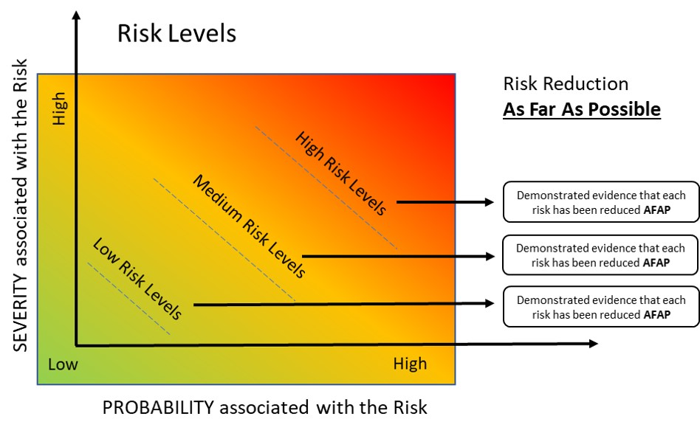
As well as the eConsult product undergoing analysis the eHub model has also been reviewed and hazards identified and reviewed.

There are a total of 10 hazards assessed for the eHub. These are scored as follows-
 | Residual Risk Rating
Hazard Log ref: | Risk Rating 1 | Risk Rating 2 | Total
eHub | 8 | 2 | 10

There are no hazards recorded with a score higher than 2 which is determined as acceptable.
The clinical risk associated with each hazard was scored based on two factors; the severity of harm (if the hazard were realised) and the likelihood of occurrence of that harm. For each of these factors the presence or otherwise of existing mitigation was considered. The criteria used for assessment is provided in appendix 1 and 2.

Associates Clinical Risk Documentation
Supporting this safety cases:
Safety Case | Reference
Smart Inbox Clinical Safety Case Report | 7
Clinical Safety Case Consultation Writeback | 8
NHSmail O365 Shared Tenant Clinical Safety Case | 9

Clinical Risk Control
There are several activities that provide the diligence in assurance, technical integration, communication, training, and clinical governance one would expect. The areas of control are as follows:
- Technical Assurance & Integration
- Training (provided to users)
- Operational Go-Live
- Business Process (Standard Operating Procedures) for users
- Live Service

Of the 10 hazards identified, all scored a classification of 2 or less and therefore acceptable, where further risk reduction may be impracticable. However, additional controls have been applied where available, and have been recorded accordingly. These can be found in the hazard log.

Hazard Log
The eHub Hazard Log (Ref 10) includes the following components:
- Hazard identification
- Description of patient safety consequences
- Explanation of hazard causes and contributory conditions
- Identification of existing mitigating controls
- Estimation of clinical risk
- Identification of participating personnel
eConsult have their own Hazard log which contains a high number of hazards which detail more defined possible cause scenarios. The hazards identified by eConsult have been reviewed and where applicable incorporated into the hazard log for the eHUB deployment.

Configuration Control / Management
Any changes to the eConsult product will be communicated with the programme team(s) where applicable. These changes will have been reviewed in the development stage and prior to release by the eConsult development team, Clinical governance team and signed off by their Clinical Safety Officer (CSO). These changes then will be reviewed in line with the DCB0160 standard. Any communications which require dissemination to the eHUB team and GP practices will be done so through the governance team and eConsult, as arranged. Where any additional risk(s) are identified by the change this will be reviewed, further regression testing will be completed to ensure accuracy and consistency of the products and intended use.

Summary Safety Statement
eConsult is an established product which complies with the DCB 0129 clinical safety standard. The manufacturers have strong governance, incident management, disaster recovery and processes in place. The product is used across many CCGs/PCNs and General Practice already. The eHUB model in which Folkstone Hythe and Rural PCN wish to utilise eConsult is a new way of working with online consultations. The project team have a project plan, governance arrangements, are completing testing, training and have developed workflow structures. All of which is included within the Standard Operating Procedure. eHub communication to patients and general practice is key so that all are fully informed. The hazards associated with eConsult and the eHub model have been identified, reviewed and controls applied where possible. The residual risk score for all hazards are below 2- Acceptable where cost of further reduction outweighs benefits gained or where further risk reduction is impractical. Therefore, providing the above controls and considerations are met the eConsult eHub model is safe for deployment within the PCN.

Recommendations:
To minimise clinical risks recommendations are listed below :
- The users within the eHub will not use the eConsult product as an alternative to any clinical or professional judgement
- Reports are processed within the recommended and agreed timescales
- There must be a clear Standard Operating Procedure that details the workflow process(s) and incident management process
- Clinicians should have access to the full medical record when processing eConsult reports and follow GMC guidance for remote consulting in the case of doctors and NMC guidance for remote consulting in the case for nurse practitioners
- Should ‘Close The Loop’ by contacting patients directly with the outcome from their online consultation. This may be frequently done by an administrator but in some instances maybe a clinician.
- In the case of pediatric consultations, these should be closed via a telephone or face to face encounter to mitigate the risk of making clinical decision based on third party information.
- Fallback Solution should be in place if the product, NHS Mail /MESH or workflow process fails.

Appendices

Appendix 1 Hazard Log

eConsult eHub HL V0.1.xlsx

Appendix 2
Hazard Consequence definitions
Consequence Classification | Interpretation | Number of Patients Affected
Catastrophic | Death | Multiple
 | Permanent life-changing incapacity and any condition for which the prognosis is death or permanent life-changing incapacity; severe injury or severe incapacity from which recovery is not expected in the short term | Multiple
Major | Death | Single
 | Permanent life-changing incapacity and any condition for which the prognosis is death or permanent life-changing incapacity; severe injury or severe incapacity from which recovery is not expected in the short term | Single
 | Severe injury or severe incapacity from which recovery is expected in the short term | Multiple
 | Severe psychological trauma | Multiple
Considerable | Severe injury or severe incapacity from which recovery is expected in the short term | Single
 | Severe psychological trauma | Single
 | Minor injury or injuries from which recovery is not expected in the short term. | Multiple
 | Significant psychological trauma. | Multiple
Significant | Minor injury or injuries from which recovery is not expected in the short term. | Single
 | Significant psychological trauma | Single
 | Minor injury from which recovery is expected in the short term | Multiple
 | Minor psychological upset; inconvenience | Multiple
Minor | Minor injury from which recovery is expected in the short term; minor psychological upset; inconvenience; any negligible severity | Single

Appendix 3
Likelihood Category | Interpretation
Very high | Certain or almost certain; highly likely to occur
High | Not certain but very possible; reasonably expected to occur in the majority of cases
Medium | Possible
Low | Could occur but in the great majority of occasions will not
Very low | Negligible or nearly negligible possibility of occurring

Appendix 4
Likelihood | Very High |  | 3 | 4 | 4 | 5 | 5
 | High |  | 2 | 3 | 3 | 4 | 5
 | Medium |  | 2 | 2 | 3 | 3 | 4
 | Low |  | 1 | 2 | 2 | 3 | 4
 | Very Low |  | 1 | 1 | 2 | 2 | 3
 |  |  | Minor | Significant | Considerable | Major | Catastrophic
 |  |  | Severity

Appendix 5

5 | Unacceptable level of risk
4 | Mandatory elimination of hazard or addition of control measure to reduce risk to an acceptable level
3 | Undesirable level of risk. Attempts should be made to eliminate the hazard or implement control measures to reduce risk to an acceptable level. Shall only be acceptable when further risk reduction is impractical
2 | Acceptable where cost of further reduction outweighs benefits gained or where further risk reduction is impractical
1 | Acceptable, no further action required

