Social media messaging

We will be running a four-week paid for campaign on TikTok and we will be sharing organic content (non paid for) via our regional @NHSsoutheast X account.

We would really value your support in sharing our TikTok asset (from Thursday 19 June only) and all other campaign branded imagery organically via your channels, using hashtag #LoveYourCervix. This is important as it will help when we come to evaluate the campaign.

We have a social media schedule with suggested content including case studies for you to use – see below.

Alternatively, please like/share social content posted from our regional X account which will be scheduled from Wednesday 18 June 2025 – a day before the launch.

Suggested content as follows: -

We are excited to be launching #LoveYourCervix tomorrow – a brand new campaign to encourage greater uptake in women, particularly aged 25-29 | 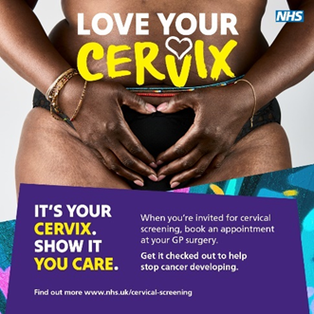
Today sees the launch of #LoveYourCervix which will be encouraging women aged 25-29 to get screened when invited. | Insert TikTok clip
Cervical screening, often known as a smear test, is a simple yet vital health check for women. #LoveYourCervix | 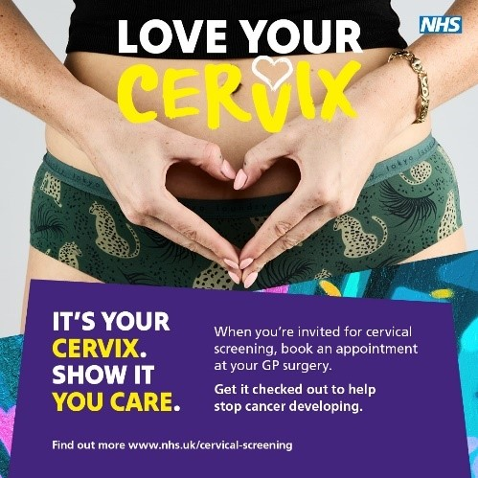
Check out our 30-sec clip about cervical screening! It's quick, easy, and could save your life. Young women, this is for you! Watch, share, and spread the word. #loveYourCervix | TikTok clip
These three inspiring young women are encouraging others to take charge of their health and #LoveYourCervix as part of a vital new cervical cancer screening campaign launched. Press releases - South East Communications - Futures | 
It’s important that all eligible women attend cervical screening. Our Deputy Medical Director Daghni Rajasingam talks about the importance of keeping up to date with your screening. #LoveYourCervix | 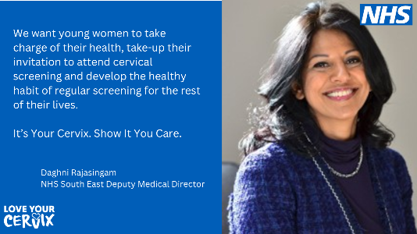
Did you know cervical screening is a free test that checks for high-risk HPV and abnormal cell changes? Early detection is key! #LoveYourCervix | 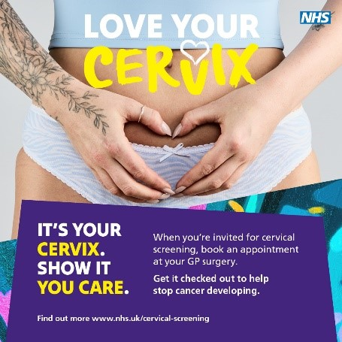 C
Megan, aged 27, from Kent talks about her experience of cervical screening and why it’s so important. #LoveYourCervix | 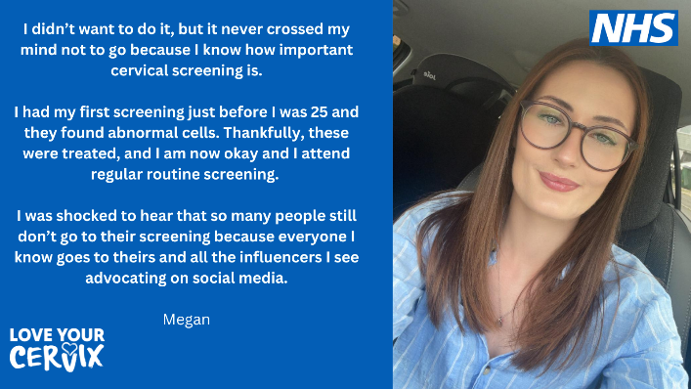
The goal of cervical screening is to identify those at higher risk of cervical cell changes or cancer for early intervention. #LoveYourCervix | 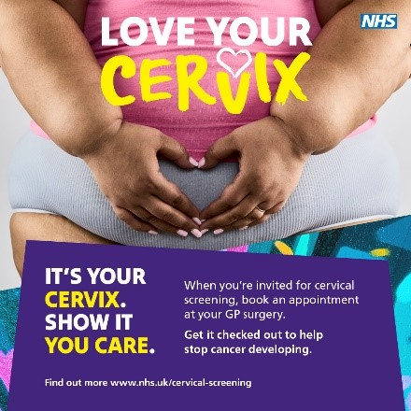
This short video explains the importance of cervical screening for women. If you’ve missed your appointment or are putting it off, contact your GP practice today. | Click here to download the video
We want women to feel informed, empowered, confident, prepared, and supported when it comes to cervical screening. This is the message from our deputy medical director. #LoveYourCervix | 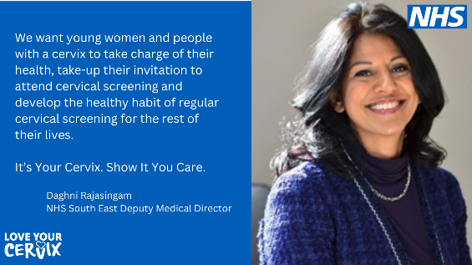  S
Shreya, 28, from Berkshire, talks about the reasons why she will never ignore cervical screening when invited. #LoveYourCervix | 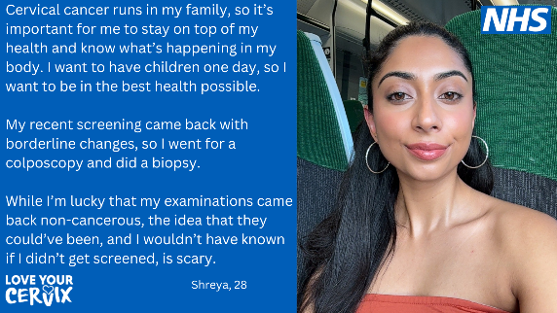
Been invited for cervical screening? Put your health at the top of your to-do list and book your appointment as soon as you can. #LoveYourCervix | 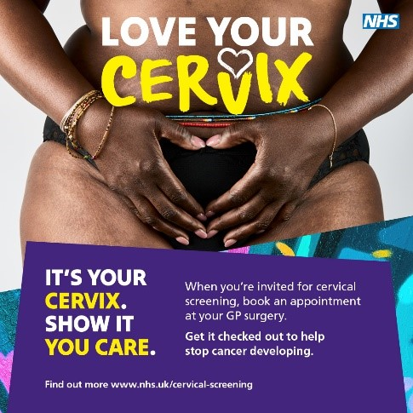
Morgan, aged 27, is encouraging others of a similar age to come forward for their cervical screening when invited as she explains how her screening was quick and easy. #LoveYourCervix. | 