# 

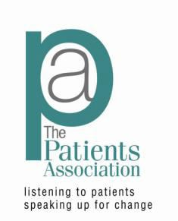

# **Why not join our Patient Participation Group?**



**Be heard in your surgery!**

**Get Involved!**

Your **NHS** needs **YOU!**

**Why not join our Patient Participation Group?**

**We work together to get the best experience for all and much more…**

**For more information contact:**