GP Name
Address Line 1
Address Line 2
Address Line 3
Address Line 4
Client Name
Address Line 1
Address Line 2
Address Line 3
Address Line 4
Address Line 5 Date

Dear Client name

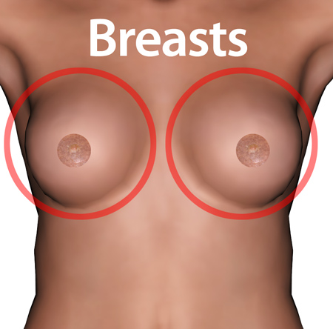 | We have been told that you did not go to your breast screening appointment.
 | 1 out of every 8 women will get breast cancer and it is more likely to happen the older you get.  It is easier to treat problems when they are found early so it is important to go for screening.
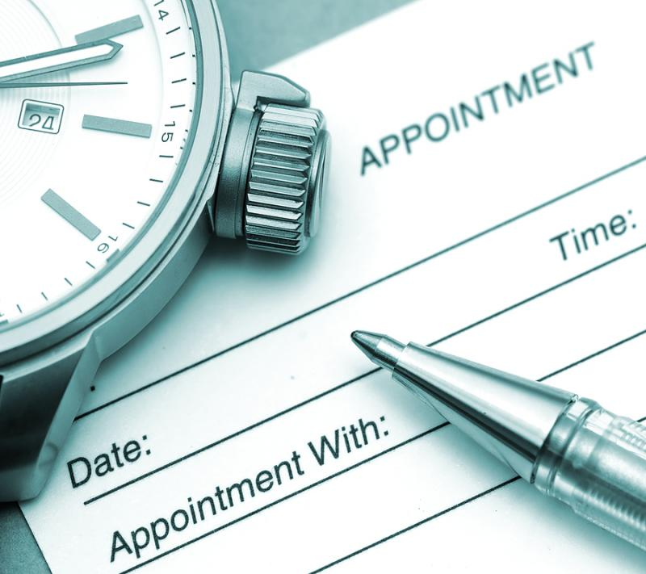 | Another appointment has been made for you. Please go to this appointment to help you stay healthy.  Your new appointment will be sent through on another letter.

Yours sincerely

GP Name

SX Number
NHS Number

