Insert NHS Organisation logo

Dear Patient

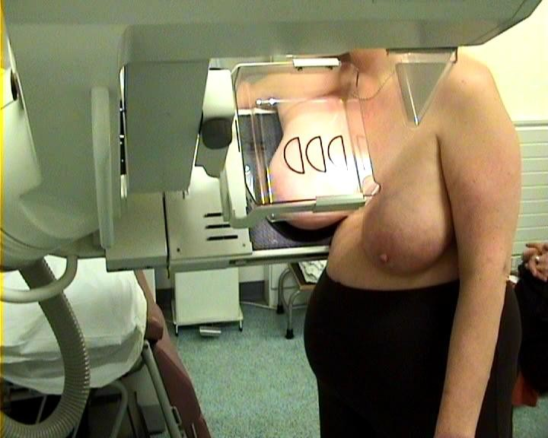 | Thank you for coming to your breast screening appointment.
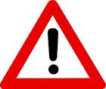 | The pictures were not clear so we have not been able to get a result.  This means that we need to take some more pictures of your breasts.
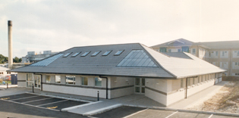 | To do this an appointment has been made for you at the add location  It is important that you go to this appointment to help you stay healthy.
 | You can bring someone with you.
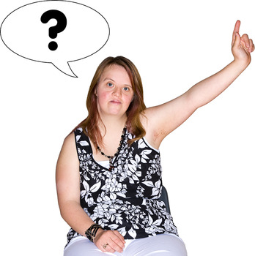 | If you have any questions about this you can talk to a Breast Care Nurse on  Add contact no.

Yours sincerely

Add Drs name

Your Ref:
NHS Number

