Insert NHS Organisation logo

Dear patient

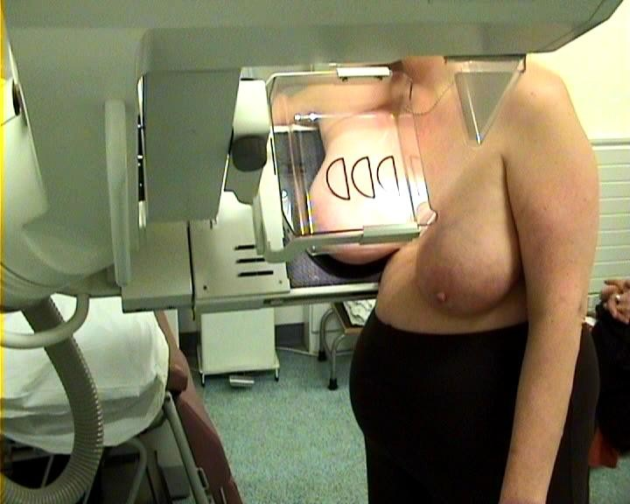 | Thank you for coming to your breast screening appointment.  We need to take some more pictures of your breasts.
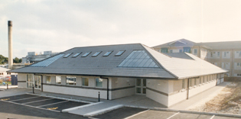 | To do this an appointment has been made for you at the insert location on  Day, Date  at Time
 | You can bring someone with you.
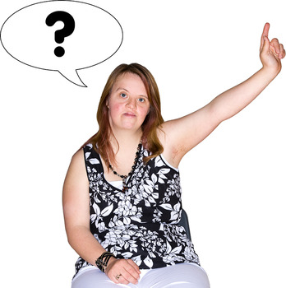 | If you have any questions about this you can talk to a Breast Care Nurse on  Add contact number

Yours sincerely

Add Drs name

Your Ref:
NHS No:

