Insert NHS Organisation logo

Dear Patient

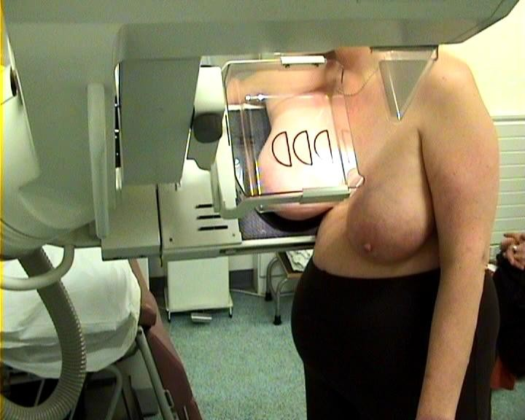 | Thank you for coming to your breast screening appointment.
 | The pictures showed that everything looked okay.
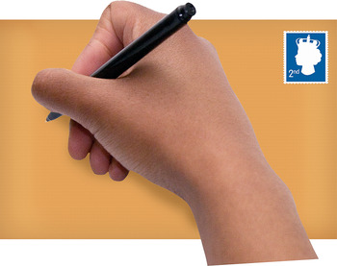 | You will get a letter asking you to have the pictures done again in 3 years time.  It is important that you go for this to make sure that you stay healthy.
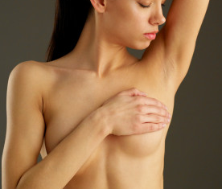 | Until then, check your breasts regularly for any changes.  Go to see your doctor if your breasts start to look different, or feel different.  You can talk to your doctor if you are worried about your breasts.
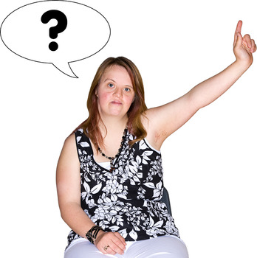 | If you have any questions you can talk to  a Breast care Nurse add contact no.

Yours sincerely

Add Drs name

Your Ref:
NHS No:

