Insert NHS Organisation Logo

Dear Patient

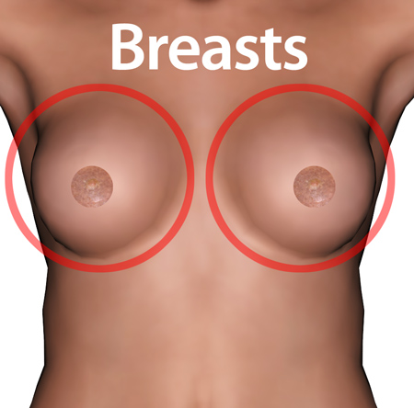 | An appointment has been made for you to go for breast screening.  This is called a mammogram.
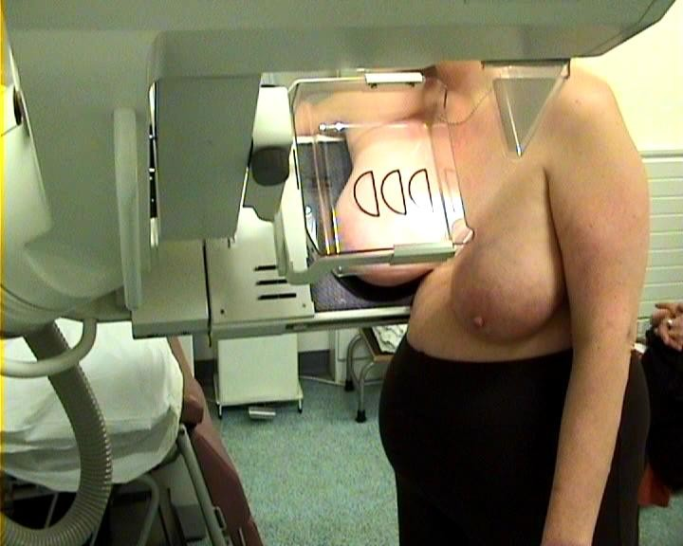 | A special picture is taken of your breasts.  It is important that you go to this appointment.  The picture will be taken by a woman.
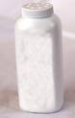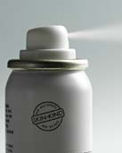 | Do not wear talcum powder or deodorant when you go for screening.
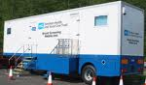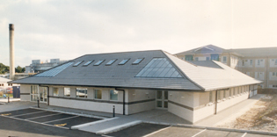 | Your appointment will be at a mobile van  or  Add details of location
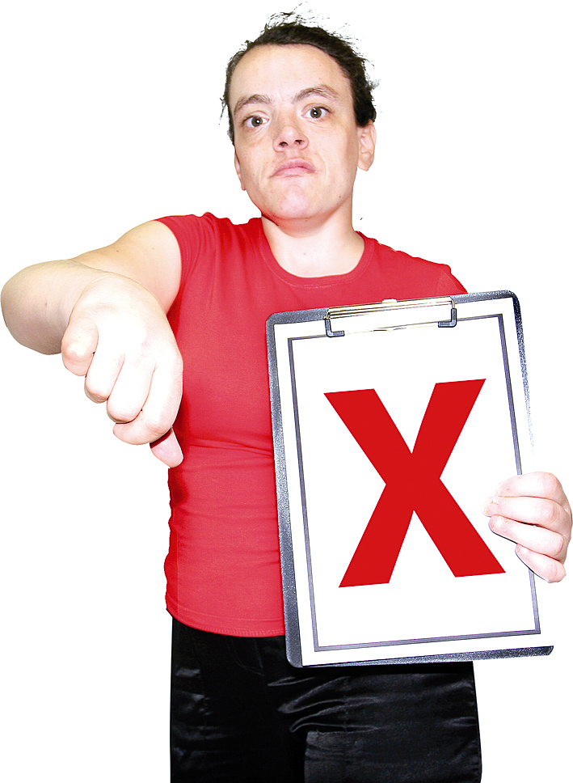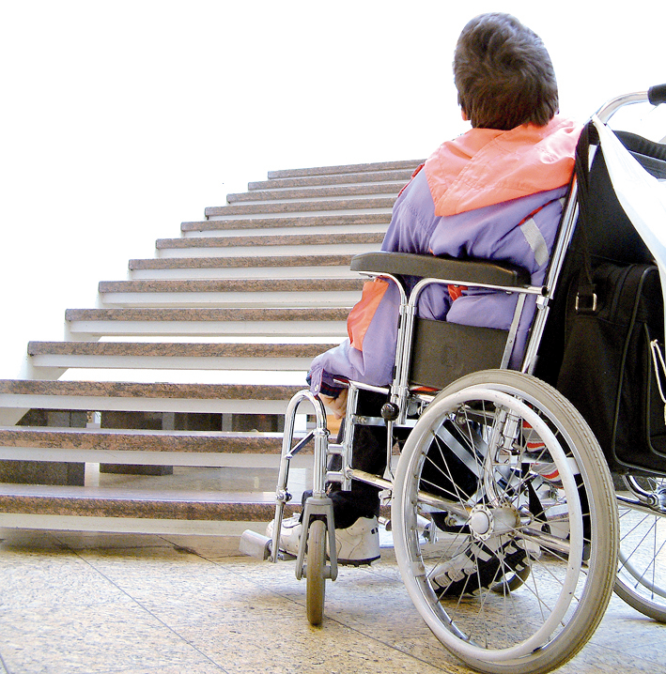 | If your appointment is at the van and you will not be able to climb the stairs please phone to change your appointment to the other location

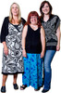 | You can bring someone with you.
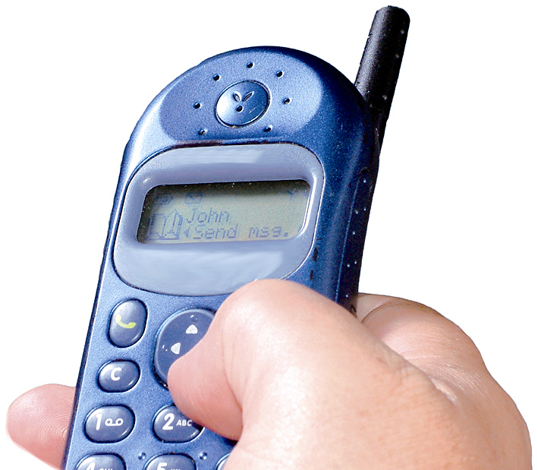 | If you do not want to go for your appointment or need to change it, phone  Add contact number
 | Add a point of contact including photo and telephone number.

Yours sincerely

Insert Drs name

Your Ref:
NHS No:

