Adult - Oral & Maxillofacial Surgery Referral Form  Form1. Adult Oral Max Form_Version September 2018  Devon, Cornwall and Isles of Scilly Local Area Team | 

Patient’s Details  Title:  First Name:  Surname:  Sex:  Date of Birth:  NHS Number (If Known):  Telephone Numbers: Home: | Address:  Postcode:  Mobile:
Date of Referral:  Date of last appointment with Dentist: | Has the reason for referral been explained to patient:
Referring Practitioner:  Name:  Address:  Tel: e mail: @nhs.net | Patient's GMP:  GMP Name:  Address:  Tel:
Does the patient have a disability? Yes: No:
If yes please specify:

1. Reason for Referral:- Please select one or more of the following reason(s) and supply additional information in the box
Conscious sedation/GA  ( GA/Sed request form attached) |  | Non third molar extraction |  | Third molar extraction
Retained Roots |  | Apicectomy |  | TMJ
Abnormal soft tissue or bony lesion |  | Oral Cancer/Oral Medicine / Salivary gland disease |  | Facial deformity

2. Details of why referral is necessary:

Relevant tooth notation

L
R
8 7 6 5 4 3 2 1 1 2 3 4 5 6 7 8

8 7 6 5 4 3 2 1 1 2 3 4 5 6 7 8

Patients Name: | Patients Date of Birth:
Suspected Malignancy: 2 Week Wait, Head and Neck Cancer referrals must be faxed/emailed to either:
Royal Devon & Exeter Hospital – rde-tr.opafasttrackteam@nhs.net North Devon District Hospital – 01271 311724
Torbay Hospital – 01803 654981 Royal Cornwall – 01872 252300 Derriford Hospital – 01752 430912
( For Torbay, Cornwall and Plymouth 2 Week Wait | please use the appropriate form)
3. Oral Lesions:- (Please give details and grid reference from the below diagram (e.g. D18))

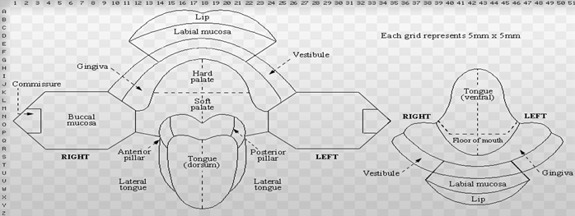

4. Reason for Referral (cont)

(Digital radiographs should be clearly printed)
Has a radiograph been attached; Yes: No:
If not; please explain why:

Please attach a full medical history with current medication completed and signed by the patient. *Please tick box to confirm:
*If the patient is taking warfarin what is their most recent INR?

Does your patient meet the criteria to be referred to a primary care based provider Yes: NO:

If your patient meets the criteria to be referred to secondary care do they have a preferred choice of provider (Please write):

Referring practitioner to sign below indicating completion of all relevant sections of referral form

Signature: Date:

Please send the completed referral proforma to:
Devon Patients | Cornwall Patients
Devon Referral Support Services (DRSS) Dental  Bridge House, Collett Way, Brunel Industrial Estate  Newton Abbot, TQ12 4PH  Tel: 01626 883897  Email: d-ccg.drss-admin@nhs.net | Kernow Health Referral Management Service  1st Floor Cudmore House, Treliske Industrial Estate  Truro, Cornwall TR1 3LP  01872 226700  Email: KCCG.RMCDentalReferrals@nhs.net

