Adult - Oral & Maxillofacial Surgery Referral Form  Devon, Cornwall and Isles of Scilly Local Area Team | 

Patient’s Details:  Title:  First Name:  Surname:  Sex:  Date of Birth:  NHS Number:  Telephone Numbers:  Home:  Mobile: | Address:  Postcode:
Date of Referral:  Date of last appointment with Dentist: | Has the reason for referral been explained to patient:
Referring Practitioner:  Name:  Address:  Tel: e mail: @nhs.net | Patient's GMP:  GMP Name:  Address:  Tel:
Does the patient have a disability? Yes: No:
If yes please specify:

1a. Reason for Referral
Relevant tooth notation

L
R
8 7 6 5 4 3 2 1 1 2 3 4 5 6 7 8

8 7 6 5 4 3 2 1 1 2 3 4 5 6 7 8

1b. Reason for Referral:- Please select one or more of the following reason(s) and supply additional information in the box
Conscious sedation/GA  (GA/Sed request form attached) |  | Non third molar extraction |  | Third molar extraction
Retained Roots |  | Apicectomy |  | TMJ
Abnormal soft tissue or bony lesion |  | Oral Medicine /Salivary gland disease |  | Facial deformity

2. Details of why referral is necessary:
(To access current referral guidelines please click on the link below)
https://www.england.nhs.uk/south/wp-content/uploads/sites/6/2019/02/mcn-oral-surgery-referral-guidelines-for-gdps-jan-2019-v1.pdf

3. Medical History: - Please attach up-to-date medical history form for all referrals – referrals will be returned if this is not included
Medical Conditions:  Current Medication:  Allergies:  Smoking / alcohol:  *If the patient is taking Warfarin what is their most recent INR? | Tick ALL relevant boxes  Warfarin*  NOACs e.g. rivaroxaban  Aspirin/Clopidogrel  Bleeding disorders  Bisphosphonates (IV)  DMARDS  Oral Steroids  Uncontrolled Diabetes  Valve replacement  Immunosuppressant’s  Chemotherapy  Patient Signature:  Date:

Patients Name: | Patients Date of Birth:
Suspected Malignancy: 2 Week Wait, Head and Neck Cancer referrals MUST be faxed/emailed to:
Royal Devon & Exeter Hospital | Email: rde-tr.opafasttrackteam@nhs.net | (No fax)
North Devon District Hospital | Email: ndht.cancerbookings@nhs.net | Fax: 01271 311724
Torbay Hospital | Email: tsdft.headandneck2ww@nhs.net | Fax: 01803 654981
Derriford Hospital | Email: plh-tr.RK9Cancer2WW@nhs.net | Fax: 01752 430912
Royal Cornwall | Email: rch-tr.suspectedcancer@nhs.net | (No fax)

(For Torbay, Cornwall and Plymouth 2 Week Wait | please use the appropriate form) | please use the appropriate form)
3. Oral Lesions:- (Please give details and grid reference from the below diagram (e.g. D18))

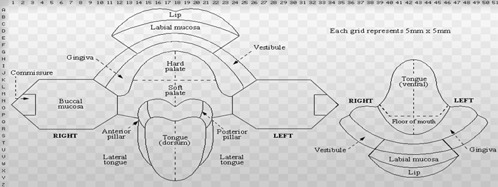

(Digital radiographs should be clearly printed)
Has a radiograph been attached; Yes: No:
If not; please explain why:

Does your patient meet the criteria to be referred to a primary care based provider Yes: NO:

If your patient meets the criteria to be referred to secondary care do they have a preferred choice of provider (Please write):

Referring practitioner to sign below indicating completion of all relevant sections of referral form

Signature: Date:

Please send the completed referral proforma to:
Devon Patients | Cornwall Patients
Devon Referral Support Services (DRSS) Dental  Bridge House, Collett Way, Brunel Industrial Estate  Newton Abbot, TQ12 4PH  Tel: 01626 883897  Email: d-ccg.drss-admin@nhs.net | Kernow Health Referral Management Service  1st Floor Cudmore House, Treliske Industrial Estate  Truro, Cornwall TR1 3LP  01872 226700  Email: mailto:KCCG.RMCDentalReferrals@nhs.net

