[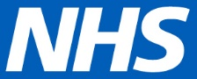](https://nhsengland.sharepoint.com/sites/thehub)

Dear ...............................................................

DOB: .............................................. NHS No: .............................................

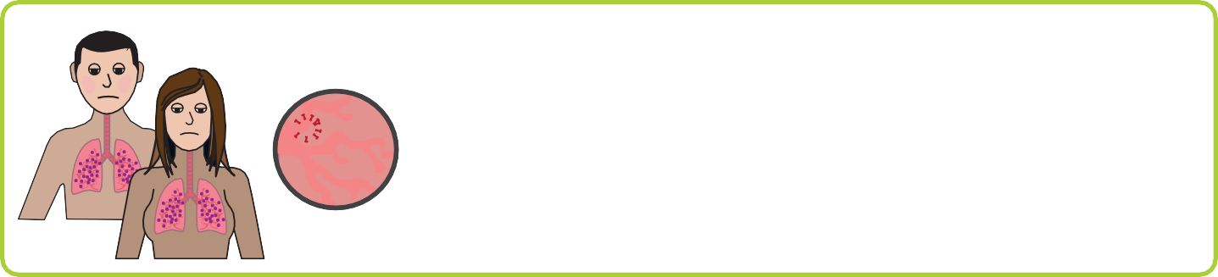

**Coronavirus** has changed the way your GP surgery works.

We want to make sure that you are fit and healthy

at this time/as it is **“business as usual”.**

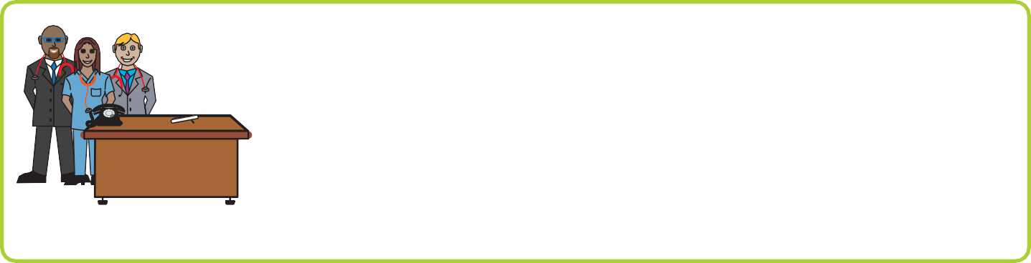

It is not good for us to invite you into the surgery for your learning disability annual health check now so we are changing the way we do your health check.

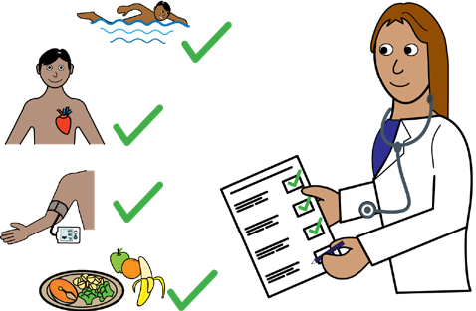

**Part 1. Fill out your “Get Checked Out Checklist”**

You can ask your family or friend to help you to fill this

out.

If you don’t have anyone to help you fill it out then please tell us.

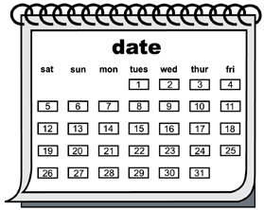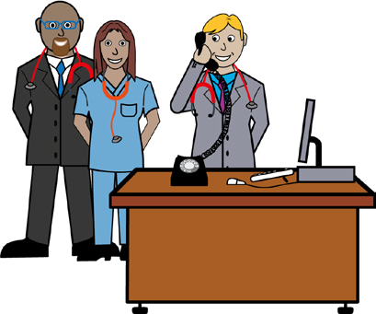

Once this is done we will give you a time that we will phone you to talk about the answers that you have put in your checklist.

You can ask a family member or friend to help you to answer the questions when the GP calls you. If you don’t have anyone to help but would like someone please tell us.



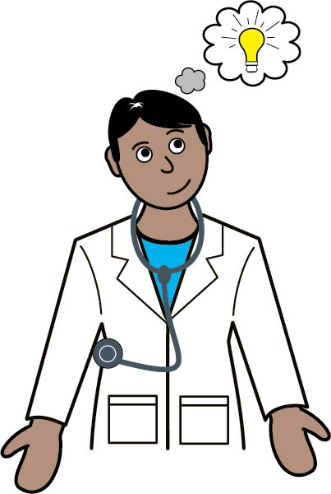

Once we have asked you all of the questions we will think about what we need to do next.

It may be that we ask you to have some more tests to make sure that you are fit and healthy at this time.

Or it may be that you can wait for the next part of your health check when the surgery opens as normal.

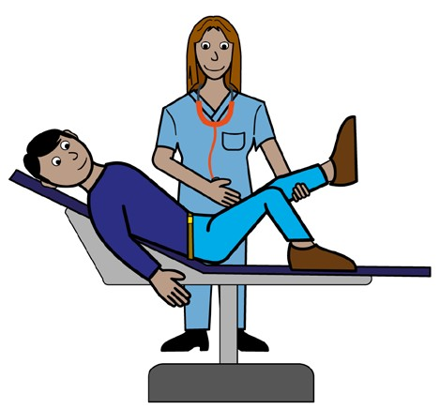

**Part 2. Once the practice is allowed to invite you to the surgery.**

We will ask you to come in for a **physical examination.**

When this is done we will give you a copy of your health

**action plan.**

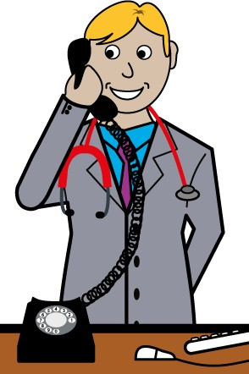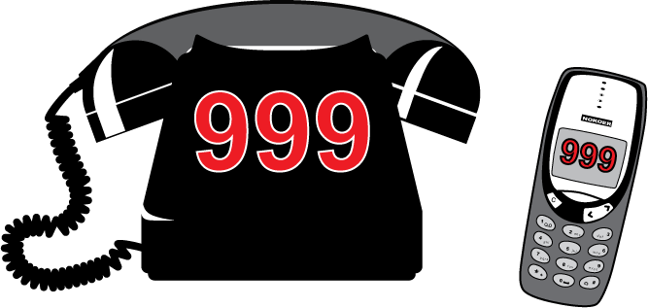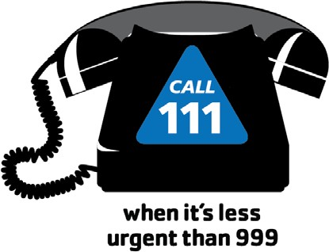

If you feel unwell you can call the practice before

this time.

If you are not able to call the surgery then you can call 111.

If it is an emergency you can call 999.

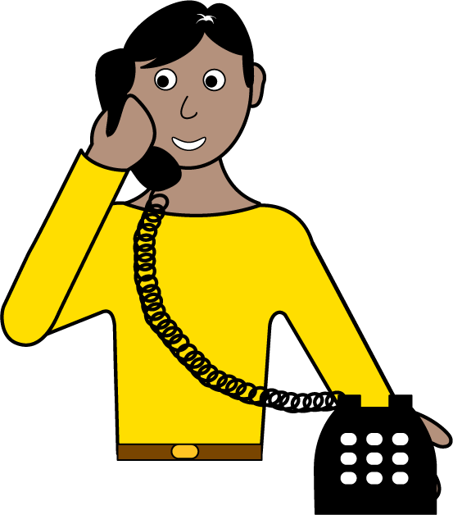

If you have any questions or you need help with any of the health check then please call the surgery on.

With thanks to