[](https://nhsengland.sharepoint.com/sites/thehub)

Today’s date: ......./......../........... Completed by: …………………………

Your GP Practice…………………..…………………………………………..

Learning Disability Liaison Nurse: …………………………………………..

**EMIS - My Health**

**Questions**

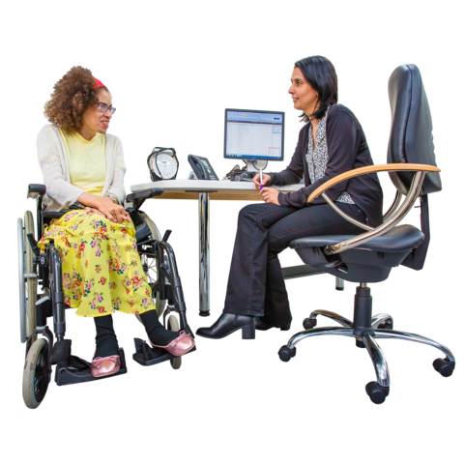

**Confidential**

Name: ………………….……………………………………………………….

Date of Birth: ……. / …..…. / ……..NHS Number: …….............................

**You can have someone help you answer these questions or you can see the nurse or doctor on your own.**

Update version 17/12/2019



**Capacity /Consent**

Are you happy to answer the questions about your health and lifestyle?

Image result for red cross

Would you like someone to help you today? Image result for red crossThe person helping me today is (Mum, Dad, name of support worker)

**Surgery Staff:** Please check the patient consents to

Electronic record sharing Y/N

Share information with summary care records with additional information Y/N

Consent to share data with specified third party Y/N

Just add tick boxes

**Surgery staff:** Please consider any specific tests relating to the persons disability. For Example: Dementia screening or thyroid testing for those with Downs Syndrome.

Have you had a health check before? Image result for red cross

If so when?

Do you have actions from my health check? Image result for red cross

Anything outstanding

Is there anything I can help with today? Image result for red cross

Are you worried about anything? Image result for red cross

**Support and Patient Information**

Do you have a carer or a support worker? Image result for red cross Name………………….

Is your carer employed? Image result for red cross

**Surgery staff:** Is a carer’s assessment required? Image result for red cross

Do you have a Social Worker? Image result for red cross

**Details:**

**Are emergency contact details up to date?**

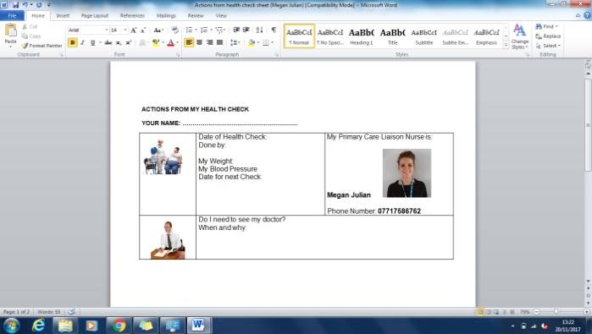**Surgery Staff:** Is there anything from recent letters or last year’s health check outstanding.

**14-17 year olds only**

Where do you go to School?

Do you have an Education, Health & Care Plan (EHC)? Image result for red cross

**Surgery Staff:** Is the patient currently under transition from Child to Adult services? Do you need to start this process? Refer to CAMHS if needed.

**All Patients**

**Immunisations**

Are you up to date with immunisations? Image result for red cross

Date of last flu jab

Tetanus Image result for red cross Not Known

Polio (if needed) Image result for red cross Not Known

HPV (if needed) Image result for red cross Not Known

MMR Image result for red cross Not Known

Pneumococcal Vaccination Image result for red cross Not Known

Hepatitis B (if needed discuss with GP) Image result for red cross Not known

**Surgery Staff:** Individuals in shared accommodation require Hepatitis B vaccine. Can any of the immunisations be given now? If not – please document on actions from my health check.

Do you have any allergies? Image result for red cross

What are they?

**Surgery Staff: Reasonable Adjustments**

Does this patient need more time for appointments?

Consider correct environment?

Extra support with communication, such as easy read?

Does the patient need an appointment at a specific time of day?

Preferred method of communication, such as makaton?

**Functional life skills**

**Mobility**

Any permanent physical disability? Image result for red cross

Any problems with your joints, moving or co-ordination? Image result for red cross

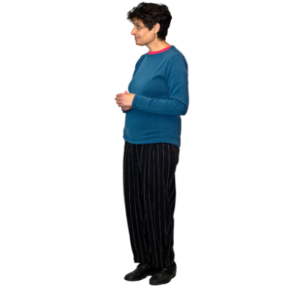**Surgery Staff:** Consider osteoarthritis, pain relief, vitamin D levels.

Any problems with posture, standing or spinal curvatures? Image result for red cross

Any tremors or shaking? Image result for red cross

Do you use any mobility or positioning aids or equipment? Image result for red cross

Does anyone help you with your personal care? Image result for red cross

**Surgery Staff:** Refer to GP, Physiotherapists, OT, Community Learning disability team or Primary Care Liaison Nurses for additional support. For patients with Profound Multiple Learning Disability (PMLD) please refer to Community Learning Disability Team for annual assessment and information sharing.

**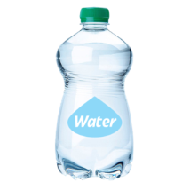**

**Daily Living Skills**

**Eating**

Do you need help to eat? Image result for red cross

(Consider if the person needs help to shop for, plan, prepare and cook a meal)

If  - Who helps you?

**Hydration**

Do you need help to drink? Image result for red cross

If  – Who helps you?

**Dressing Ability**

Image result for red crossCan you dress yourself? Image result for red cross

If – Who helps you?

Image result for red cross

**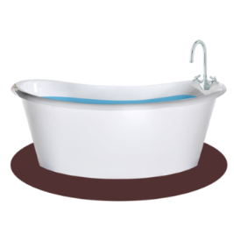**

**Bathing**

Do you bath or shower? Bath / Shower Image result for red cross

Do you need help to wash? Image result for red cross

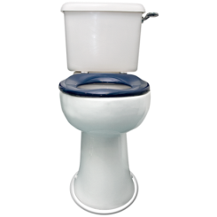If  – who helps you?

**Toilet Dependency**

Do you go to the toilet on your own? Image result for red cross

Do you need help to go to the toilet? Image result for red cross

If  – who helps you?

**Daily Living Support**

Does anyone help you at home? Image result for red cross

**Surgery Staff**: Consider a referral to adult social care 0300 1234 131

**Lifestyle and health promotion**

**Diet**

Do you need a special diet? Image result for red cross

What would you normally eat for:

Breakfast Lunch Tea Supper Snack

**Surgery Staff:** Does patient require a referral to health promotion 01209 615600

**Exercise**

What activities do you do?

**Surgery Staff:** Consider leaflet on healthy living and exercise. www.easyhealth.org.uk

**Smoking**

Do you smoke? Image result for red cross

How many cigarettes do you smoke a day?

Would you like help to stop smoking? Image result for red cross

**Surgery Staff:** Does patient require a referral to the stop smoking service?

**Alcohol and substance misuse**

Do you drink alcohol? Image result for red cross

What do you drink?

How many glasses?

How often do you drink alcohol?

Do you take any recreational drugs? Image result for red cross

Is there anything you would like to talk about? Image result for red cross

**RELATIONSHIPS:**

Do you have a partner? Image result for red cross

Have you ever had sex with anyone? Image result for red cross

Do you know about contraception? Image result for red cross

Do you know how people get pregnant? Image result for red cross

Do you know about sexual diseases? Image result for red cross

Would you like any information on these issues? Image result for red cross

Would you like to talk to someone? Image result for red cross

Do you know it is okay to say **‘NO’** if you don’t want to have sex or be touched? Image result for red cross

Do you know you must listen and stop if someone else says ‘**NO**’?

Image result for red cross

**Easy read information available at:**

[www.apictureofhealth.southwest.nhs.uk](http://www.apictureofhealth.southwest.nhs.uk)

[www.easyhealth.org.uk](http://www.easyhealth.org.uk)

**Female screening**

Have you noticed any problems or changes with your breasts or nipples? (pain, lumps, discharge, etc) Image result for red cross

Do you check your breasts every month? Image result for red cross

(47+) Have you had your breast screening? Image result for red cross

Have you ever had a smear test? Image result for red cross

(25+) Are you due a smear test? Image result for red cross

Would you like any information about this? Image result for red cross

Easy read information available at easyhealth.org.uk

Refer to Learning Disability Screening Liaison Nurse for support if needed on screeningliaison@nhs.net

**HEIGHT AND WEIGHT:**

Current height:

Current weight:

Waist measurement:

Do you think you have put on or lost any weight recently? Image result for red cross

Blood Pressure: …..….. / …..…..

Have you had any blood tests in the last year? Image result for red cross



**EYES AND VISION:**

Any problems with your eyes? Image result for red cross

Any pain or itching? Image result for red cross

Do you wear glasses? Image result for red cross

When did you last have an eye test?

(Routine tests should be done every two years)

Name of optician:

If you have Diabetes have you been for Retinal Screening in the last year (as well as an eye test) Image result for red cross

**Surgery Staff:** Patients that are diabetic and have not attended retinal screening, please refer to Learning Disability Screening Liaison Nurse at screeningliaison@nhs.net

**EARS AND HEARING:**

Do you have a hearing or ear problems? Image result for red cross

Any problems at the moment? Image result for red cross

Do you have an ear Doctor (audiologist) Image result for red cross

Date of last appointment:

**Surgery Staff PLEASE CHECK EVERYONES EARS.**

**Surgery Staff:** Does the patient have any behaviour that could suggest a hearing problem? For example turning the TV up or a balance problem.

****

**MOUTH AND TEETH:**

Name of Dentist:

When was the last time you visited the dentist?

Do you see a dentist regularly? Image result for red cross

Any problems with your mouth, teeth or gums Image result for red cross

Do you have difficulty eating or chewing? Image result for red cross

Do you think you have bad breath? Image result for red cross

Do you have any problems with dribbling? Image result for red cross

Do you ever get mouth ulcers or cold sores? Image result for red cross

**Surgery Staff:** Consider referral to Community Dental Service if patient is not able to manage mainstream dentist.Email [kccg.rmcdentalreferrals@nhs.net](mailto:kccg.rmcdentalreferrals@nhs.net)

Tel: 0333 405 0290

Consider SALT referral.

GP Section

**BREATHING**

Do you have any problems with your breathing? Image result for red cross

Do you get short of breath? Image result for red cross

Do you have a cough that is not getting better? Image result for red cross

Do you bring up mucous or phlegm? Image result for red cross

****Do you have any blood in your spit? Image result for red cross

**Gastro – Intestinal**

Do you have any problems eating or swallowing? Image result for red cross

Do you cough when you eat and drink? Image result for red cross

Do you cough after you eat and drink? Image result for red cross

After eating do you any pain? Image result for red cross

**Surgery Staff** – If yes to any of the above please consider a SALT referral.

**Having a poo**

Do you ever get tummy/stomach pains? Image result for red cross

Do you have any pain when you go to the toilet? Image result for red cross

Do you ever find it difficult to poo (constipation)? Image result for red cross

Do you ever have very loose poo (diarrhoea)? Image result for red cross

Have you seen any blood, jelly or black in your poo? Image result for red cross

OVER 60’s: Have you done your bowel screening? Image result for red cross

**Surgery Staff**: Refer to Screening liaison nurse on screeningliaison@nhs.net if bowel scope screening not complete (offered once at age 55) or bowel screening (60 -75 years, invited every 2 years).

**Having a pee**

Do you have any problems when you go for a pee? Image result for red cross

Have you had your pee tested recently? Image result for red cross

Do you ever find it hard to go? Image result for red cross

Is your pee a dark colour? Image result for red cross

Does your pee smell? Image result for red cross

Do you find that you need to go for a pee more often? Image result for red cross

Do you ever have any accidents with your pee in the day or night (wet the bed)? Image result for red cross

Do you wear pads? Image result for red cross

If where do you get them?

**Surgery Staff:** Consider a referral to the community nursing team for continence assessments.

**Women’s health**

Do you have periods? Image result for red cross

Do you have any problems with them? Image result for red cross

Have you been through ‘The Change’ (menopause)? Image result for red cross

Are you having any problems with this? Image result for red cross

**Central Nervous System**

Have you been seen in neurology? Image result for red cross

Date of appointment

Have you had any changes in your seizures? Image result for red cross

**Epilepsy**

Do you have any kind of epilepsy? Image result for red cross

Do you or someone else write down when you have a

seizure? Image result for red cross

Do you have an epilepsy nurse? Image result for red cross

****

**Cardiovascular system**

Any heart problems or chest pain? Image result for red cross

Any problems with your breathing or a cough? Image result for red cross

Do your ankles swell? Image result for red cross

Do you get blue skin for example around your lips? Image result for red cross

**Surgery Staff:** (Men aged 65) Refer to screening liaison nurse for ‘AAA’ support if required.

Diabetes - When was patients last HbA1c if not within the last 12 months consider a recheck.

**Muscoskeletal** – Is the patient at risk of Osteoporosis? Yes No – Please give posture advice.

**Feet**

Are you having any problems or pain with your feet? Image result for red cross

Do you need any special footwear? Image result for red cross

Who cuts your toenails?

Do you ever see a chiropodist or podiatrist? Image result for red cross

When?

Name of Chiropodist / Podiatrist:

**MENTAL HEALTH**

Do you sleep well at night? Image result for red cross

If not do you know why? Explain:

How are you feeling?

Is anything worrying or upsetting you? Image result for red cross

Do you have someone you can talk to about things? Image result for red cross

Any behaviour that you have, which are a problem for you or anyone else? (self-harm, aggression, rituals, etc) Image result for red cross

Do you seem more confused or forgetful? Image result for red cross

**Surgery Staff**: Consider early onset dementia particularly in Down Syndrome or referral to outlook southwest.

**Examination and measurements**

**Surgery Staff** Please complete a physical examination

Pulse rate Heart sounds

Digestive system Skin

Pressure areas Breast

Female pelvis (if needed)

**Latest results**

**Surgery Staff**

HbA1c Serum Cholesterol

Full blood count Serum HDL cholesterol levels

Thyroid function test Urea and electrolytes

Liver function test Urine dipstick

**Please repeat bloods if patient requires them.**

**Surgery Staff also remember:**

Lithium and anti-epilepsy drug levels PSA (if indicated)

Vitamin D if on anti-epileptic drugs CRP (if indicated)

FSH in prolonger amenorrhoea

Stool H pylori antigen (if indicated)

**Medication**

|  |  |  |
| --- | --- | --- |
| Name | Dosage | What do you take it for? |
|  |  |  |

Are you worried about any of your medication? Image result for red cross

Do you take any over-the-counter medicines? Image result for red cross

**Surgery Staff:** Please use STOMP (Stopping The Over Medication of People with Learning Disability) to review any patient taking more than 2 anti-psychotic medications.

**End of life care**

**Surgery Staff:** Has advanced care planning been considered? Yes / No

Is patient on the gold standard framework? Yes / No

**Surgery Staff:** Are there any safeguarding concerns?

Make referral to safeguarding team.

|  |
| --- |
| Patients Goals ( GP record of items on Actions from Health ) . |

**With thanks to Cornwall Partnership NHS Foundation Trust**

**ACTIONS FROM MY HEALTH CHECK (Copy to be given to patient)  
  
YOUR NAME: ……………………………………………..…………………**

Date of Health Check:…………………Completed by:…………………….

|  |  |  |
| --- | --- | --- |
| BPwoman2 | My height:  My Weight:  My Blood Pressure:  Date for next Check: | My Primary Care Liaison Nurse is:  Phone Number: |
| GP1 | Do I need to see my doctor?  When and why: | |
| Diabetes_nurse1 | Do I need to see anyone else?  Who and Why: | |
| Social_worker2 | Health advice given: | |
| Dont_know_man2 | Anything else I need to know? | |