THIS FORM MUST ACCOMPANY THE RELEVANT ORAL SURGERY REFERRAL FORM
PATIENT DETAILS
Surname: …………………………………….……………… First name: ……………………..……………… Date of Birth: ………………….………
REFERRAL INFORMATION
Name of Provider to Receive referral ( )
FULL PATIENT DETAILS | REFERRER DETAILS
Mr ☐ Mrs ☐ Miss ☐ Ms ☐ Dr ☐ Other ☐  Male ☐ Female ☐ NHS Number:  Surname:  First name:  Date of Birth: | Mr ☐ Mrs ☐ Miss ☐ Ms ☐ Dr ☐ Other ☐  Surname:  First name:  Job Title:  GDC/GMC Number:
ADDITIONAL INFORMATION
Justification for Sedation request. (tick all that apply)

Anxiety ☐
Lack of Co-operation ☐
Needle Phobic ☐
Pronounced Gag Reflex ☐
Other Please state ☐
DETAILS OF PREVIOUS:
DENTAL TREATMENT / ONGOING DENTAL TREATMENT /PREVIOUS SEDATION/PREVIOUS GENERAL ANAESTHETICS
Has the patient used any recreational drugs currently or in the past?

Cannabis / Skunk ☐
Benzodiazepines ☐
Intravenous drugs ☐

Give additional details:

ANXIETY SCALE: MODIFIED DENTAL ANXIETY SCALE FOR PATIENTS OVER 12 YEARS
Please ask your patients aged 12 and over to complete the MDAS patient questionnaire – see appendix.

Total Score = …………….
Patients BMI = …………
Score see appendix below.
Patients with a BMI over 40 will need to be informed that individual assessment may be required and sedation may not be available.
Is the patient pregnant? YES ☐ NO ☐
PATIENT CONSENT TO REFERRAL AND ASSOCIATED TREATMENT
Has the patient understood and consented to the referral? YES ☐ NO ☐
Patient Signature accepting the condition of referral to be considered for sedation ……………………………………
CONFIRMATION AND SIGNATURE OF REFERRING PRACTITIONER
I confirm that this patient referral meets the current referral guidelines as issued by the Southwest LDN.
(Referral guidelines are available on the LDN website).
I understand that incomplete and/or inappropriate referrals will be returned for revision and may delay patient treatment. Please note that it is now a mandatory requirement for referrers to provide their GDC or GMC Number on this form.
Please tick to confirm. ☐
Print Full Name:………………………………………………………………………………………………… Date:………………………….................

Signature: ………………………………………………………………………………
MODIFIED DENTAL ANXIETY SCORE QUESTIONNAIRE. Please score patient anxiety questionnaire as below.

Each of the five answers is scored as follows:
Not anxious = 1
Slightly anxious = 2
Fairly anxious = 3
Very anxious = 4
Extremely anxious = 5
So, the total Questionnaire Score is a sum of all five items (range 5 to 25)

Please convert the questionnaire score to a rank score as below and record this on the referral form.
MDAS 5-9(minimal anxiety)
MDAS 10-12(moderate anxiety)
MDAS 13-17(high anxiety)
MDAS 18-25(very high anxiety)

Details for where to refer in your region are found at page 21 onward in the Oral Surgery Referral Guidance Document access from the link Here
For Somerset Primary Care DwSI MOS Referrals Indicate requested provider stating “DAC Bridgwater • Frome • Taunton • or Yeovil”
If in doubt, contact your local Oral Surgery Provider.
If you feel the case is urgent but not suspected cancer, please contact your local provider in person to discuss.

For all suspected cancer cases please use the Relevant 2 Week Wait referral form which can be accessed from the link
Here

CAN YOU TELL US HOW ANXIOUS YOU GET, IF AT ALL, WITH YOUR DENTAL VISIT?

PLEASE INDICATE BY INSERTING ‘X’ IN THE APPROPRIATE BOX

- If you went to your Dentist for TREATMENT TOMORROW, how would you feel?
 | Not  Anxious ☐ | Slightly  Anxious ☐ | Fairly  Anxious ☐ | Very  Anxious ☐ | Extremely  Anxious ☐
- If you were sitting in the WAITING ROOM (waiting for treatment), how would you feel?
 | Not  Anxious ☐ | Slightly  Anxious ☐ | Fairly  Anxious ☐ | Very  Anxious ☐ | Extremely  Anxious ☐
- If you were about to have a TOOTH DRILLED, how would you feel?
 | Not  Anxious ☐ | Slightly  Anxious ☐ | Fairly  Anxious ☐ | Very  Anxious ☐ | Extremely  Anxious ☐
- If you were about to have your TEETH SCALED AND POLISHED, how would you feel?

 | Not  Anxious ☐ | Slightly  Anxious ☐ | Fairly  Anxious ☐ | Very  Anxious ☐ | Extremely  Anxious ☐

If you were about to have a LOCAL ANAESTHETIC INJECTION in your gum, above an upper back tooth, how would you feel?

 | Not  Anxious ☐ | Slightly  Anxious ☐ | Fairly  Anxious ☐ | Very  Anxious ☐ | Extremely  Anxious ☐

_________________________________________________________________

Instructions for scoring (remove this section below before copying for use with patients)
The Modified Dental Anxiety Scale. Each item scored as follows:

Not anxious = 1
Slightly anxious = 2
Fairly anxious = 3
Very anxious = 4
Extremely anxious = 5

Total score is a sum of all five items, range 5 to 25: Cut off is 19 or above which indicates a highly dentally anxious patient, possibly dentally phobic.

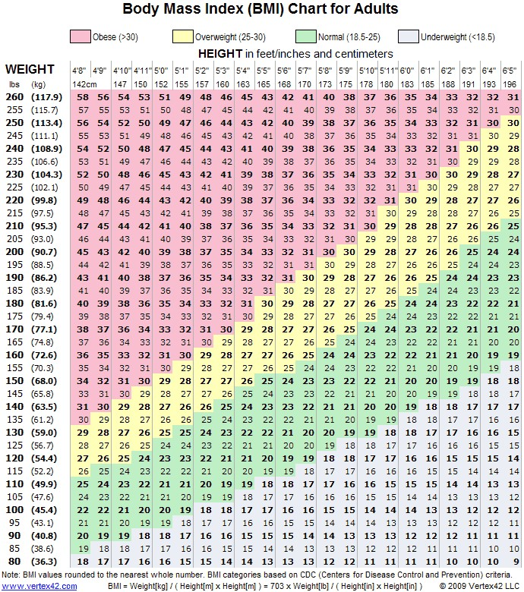

Link to NHS BMI Calculator Here

