DRAFT LETTER FOR CLINICIANS TO SEND TO IMMUNOSUPPRESSED CHILDREN AGED BETWEEN 6 MONTHS AND FOUR YEARS
Dear Parent or Carer,
The Covid-19 vaccination programme has been vaccinating children aged five and over since 2021.
Advice has now been received from the Joint Committee on Vaccination and Immunisation (JCVI) to vaccinate those children aged from six months to four years, and who are in clinical risk groups.
Your child has been identified as being in a clinical risk group, and we invite you to make an appointment for their first dose of vaccine **INSERT BOOKING ARRANGEMENTS HERE**
The JCVI has made this recommendation after reviewing Covid-19 vaccination trials in children, safety surveillance of children’s Covid vaccination and also studying how the Covid-19 illness affects children under the age of five.
Children with underlying health conditions have a much greater chance of serious illness from Covid-19 compared to children without underlying health conditions and this is why we are extending the invitation for vaccination to your child.
Those who are in clinical risk groups include children with chronic respiratory disease, chronic heart conditions, chronic conditions of the kidney, liver or digestive system, chronic neurological disease, endocrine disorders, mitochondrial disease and those who have suppressed immune systems because they are having chemotherapy, radiotherapy, have leukaemia or are transplant recipients.
Please bring your child’s personal health record (“red book”) with you to the appointment. A healthcare professional will record the vaccination in the book and check that your child is up to date with their routine vaccinations. If you have lost or need a new copy, please ask your local health visitor or health centre.
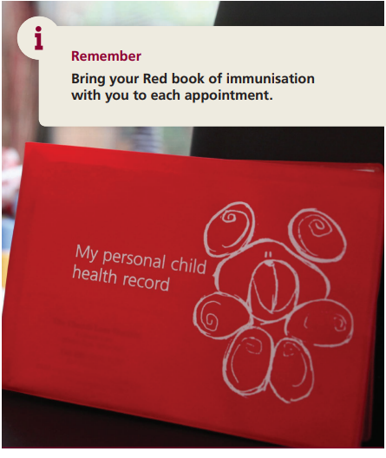
Further information about immunisations for this age group is also available through the links below or via the QR codes accessible via your smartphone:
- A guide to immunisations for babies up to 13 months of ages.
- A guide to immunisations for pre-school.
The healthcare professionals looking after your child will also be happy to answer any question you have about the vaccination.
With best wishes

