Dorset School Aged
Immunisation Pathways for the 2023/24 academic year

Introduction
This information aims to support local practices in understanding the school aged immunisations programme for the 2023/24 academic year, including any changes to the schedule. We hope you find this information useful and clear: if you have any comments, suggestions or queries please contact the Vaccination and Screening Team on England.swvast@nhs.net.

Overview of School Aged Immunisations

From September 2023, the following immunisations will be delivered by the school aged immunisation provider:

- Influenza: Reception up to Year 11 in mainstream schools (including home-schooled and other children not in mainstream education) and reception up to but not including 18 years old in special schools.
- HPV dose 1: Year 8 girls and boys
- Men ACWY: Year 9
- Td/IPV: Year 9
- Measles, Mumps and Rubella (MMR) catch up vaccinations

Please note that the flu community clinic schedule for the Dorset school aged immunisations provider is available at the end of this document.

GP Checklist

- Check that all data on immunisations delivered by the school aged
immunisation provider that has been sent to you has been uploaded onto your GP practice patient records.

- Check that all data on immunisations you have given in your practice has been
sent to the Child Health (CHIS) team. This includes any vaccination from the routine schedule given as a travel vaccination. If you are unsure, send it again or contact the Child Health (CHIS) team (provide.chisdorset@nhs.net) to discuss this with them.

- You will receive a summary report of any students with routine immunisations
outstanding who are now outside of the school programme. These children will receive a letter from CHIS asking them to make an appointment with their GP practice.

- Review how young people are invited for vaccinations at your surgery and whether this meets their needs. Points to consider:
  - Are the sessions outside of school hours?
  - Can the young people get to your surgery for the appointments?
  - Consider evening or weekend sessions for parents to be able to attend appointments too.
  - Are you sending patient information leaflets (PILs) to ensure young people are aware of what they are being invited for?
  - Are you using text messaging reminders?

- Make sure you are promoting school aged immunisations through leaflets,
posters and through links on your website.

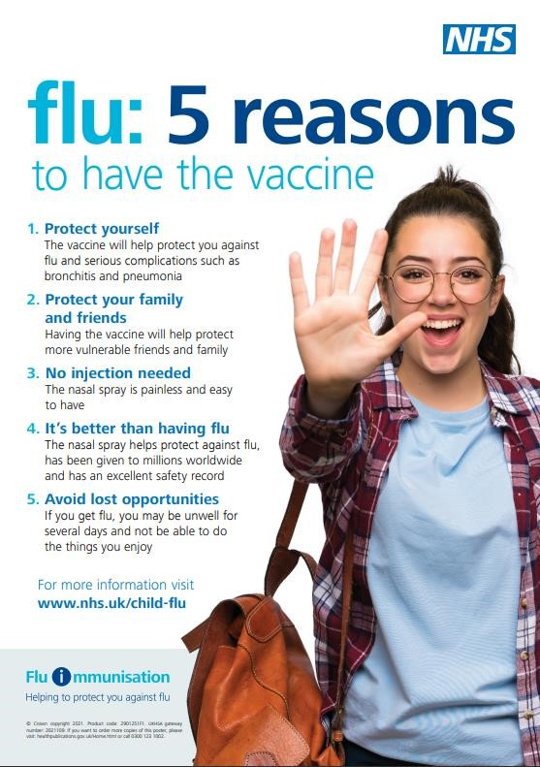

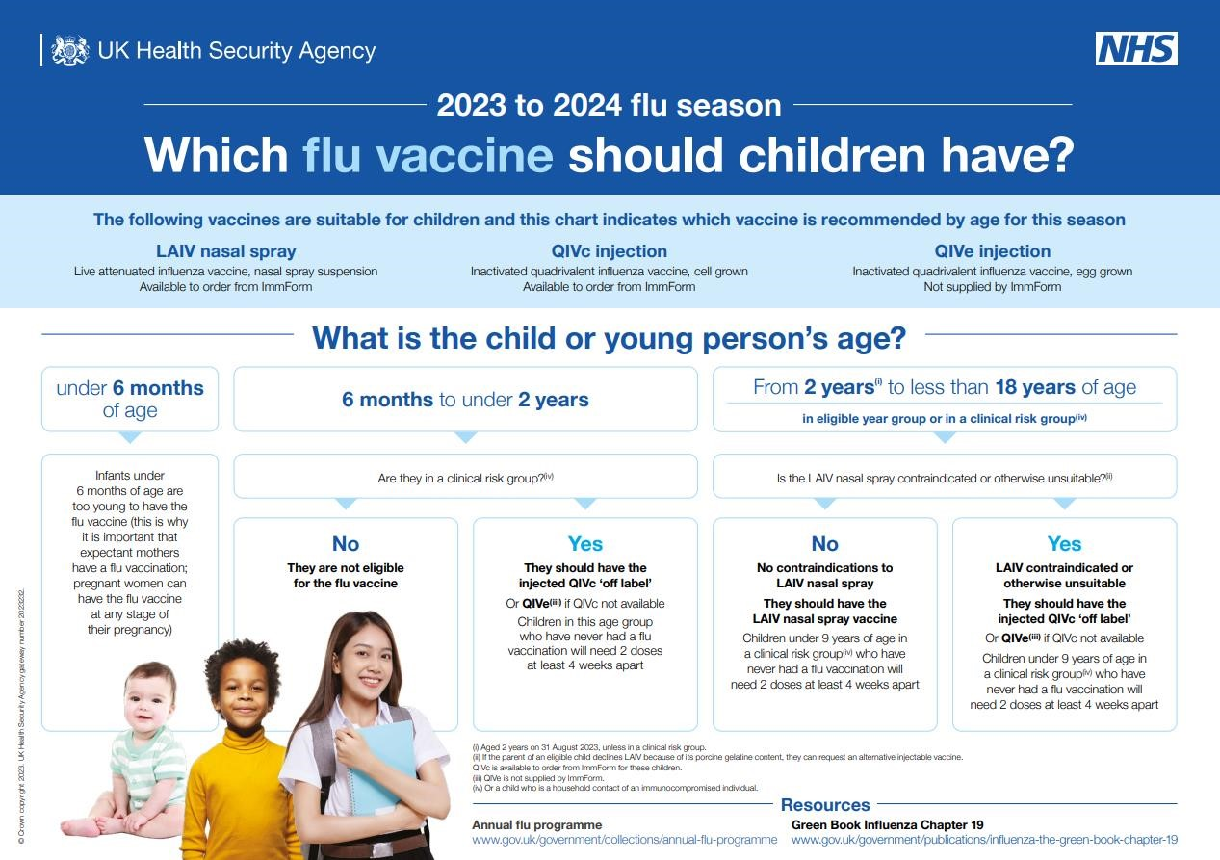

D
orset

School Aged Immunisation Pathways for the 202
3
/2
4

academic year

5

Changes to Vaccinations and Immunisations in 2023/24
These changes are to reflect forthcoming changes to the routine vaccination schedule recommended by JCVI (information on this found here: Letter: General Practice contract arrangements in 2023/24

HPV
As recommended by the JCVI, from 1st September 2023, the HPV vaccination programme will move from a 2 dose to 1 dose schedule for the routine adolescent programme including all those who remain eligible up to the age of 25. This change will not apply to those who are HIV positive or those who are immunocompromised for whom the three -dose schedule will remain.
This change will align HPV vaccine doses across age grou ps, as well as aligning school, sexual health, and general practice provision, thus minimising the risk of conflicting or missing doses.
As such, practices will deliver just one dose of the HPV vaccine in most cases from September 2023. Eligibility for girls is up to the age of 25 years. Eligibility for boys is based on age for those born on or after September 2006.
Migrant health - Vaccinating children
To support healthcare professionals, guidance on screening and immunisations for individuals who are fleeing conflict can be found here:

Further information on migrant health and immunisations can be found here: Moved to the UK: migrant immunisation - GOV.UK (www.gov.uk)
For children of refugees and asylum seekers, they may have had different vaccinations to the
UK routine immunisation schedule. Please see the links below which may be helpful when
checking vaccination status: Vaccination process for HPV
Vaccination of individuals with uncertain or incomplete immunisation status
(publishing.service.gov.uk)
International-versus-UK-vaccination-schedules-August-2022.xlsx (live.com)
For immunisation queries and support, please contact the NHS England Vaccinations and Screening Team: England.swicars@nhs.net

Vaccination Process for
HPV

Information passed to CHIS

For a
ny
child

who misses
an
HPV

dose the school aged
immunisation team

will
offer
catch
-
up clinics until the end of
Year 11 either in the school or
the community.

If the
child is in
year 10

or above
, they can
also
receive vaccination at their GP
.

Child misses
HPV

Child
attends
session and
receives
HPV

New
Year 8
childre
n,
both boys
and girls
,

will be invited to
attend a vaccination session for
their
single

HPV dose. If they
miss this session, they will be
invited to a mop
-
up session by
the school aged immunisation
provider
.

E
ligible cohorts pre 2022/23 academic year

who are

completely
unvaccinated
will

be consented as part of the HPV catch up programme on a
one dose HPV vaccination schedule from September 2023.

Only one dose of
the HPV vaccine is needed to be considered fully vaccinated
.

The school aged immunisation provider will
continue to offe
r

any outstanding HPV doses
,
regardless of the change from a 2 dose to 1 dose vaccination schedule,

up until
the end of
Year 11
and not only up to the age of 16 years
.
The GP will be responsible for delivery of missed
vaccinations
for students after the end of Year 11 (up to their 25
th

birthday)
.

GP practices can
also

provide HPV vaccinations to adolescent girls and boys who have attained the
age of 14 years but who have

not attained the age of 25 years and have missed vaccination under
the school’s programme. Please note that vaccination of boys commenced in 2019/20 without a
catch
-
up programme, therefore GPs should only vaccinate boys born on or after 1
st

September
2006
.

For
individuals who are HIV positive or those who are immunocompromised the three
-
dose schedule will remain
.
For more information please refer to the
Green Book,

.
Chapter 18a

Vaccination Process for Meningitis ACWY

Usually, children Has the vfrom age 10 are child ever not normally received a
eligible for Men dose of ACWY until they MenC reach 13-15 years conjugate ^{No} old vaccine?

Year 9 children will be Child misses invited to attend a Men ACWY
vaccination session. If
they miss this session, they will be invited to a Child attends
mo p-up session by the session and school aged receives
immunisation team Men ACWY

By the end of Has the
year 9, child Yes children received a
should have dose of Men
already been ACWY
offered Men conjugate
ACWY since the ^{No} vaccination age of 10?

Explain child
Yes will be offered
vaccination in school year 9
GP practice to vaccinate with Men ACWY.
Information
No further Men ACWY passed to vaccination is then
CHIS required in school year 9.
The school aged immunisation team will attempt to catch-up any child who misses Men ACWY
up to the end of year 11. If the child is in year 10 or above, they can also receive vaccination at their GP.
Information passed to CHIS
Child is up to date with vaccination and does not need another dose of Men
ACWY
SAIS or GP to vaccinate with Men ACWY until end
of year 11. GP can Information
vaccinate anyone from passed to age 14 up to age 25 CHIS

Older groups eligible through opportunistic vaccination

Men ACWY vaccination should be offered by GP practices to eligible young adults aged 14 or older who have missed a school aged immunisation provider offer on an opportunistic basis or who self-present at the GP practice, unless immunisation is contraindicated.
Eligible patients must be under the age of 25 years at the time of vaccination and include:

- those attending university/further education for the first time at the time of vaccination
- those aged 19 years on 31 August 2023
- those eligible from August 2015 remain eligible up to the day before their 25th birthday
- those vaccinated at any time during the period 1 April 2023 to 31 March 2024
Vaccination Process for Td/IPV (Teenage
Booster)

Vaccination Process for

MMR

Child attends
session and
receives TD/IPV

Information passed to CHIS

Children in year 8 or younger
should not be routinely
offered Td/IPV until they
have reached year 9 where
this will be offered by the
school aged immunisation
team.

Td/IPV should ideally be
given 10 year
s after the first
booster (around 13 years 4
months). However, there may
be circumstances where
young people require this
before year 9.

No

Explain child will be offered
vaccination in school year 9

Is there a reason that the
child
should receive
vaccination before the
school age offer is made in
year 9 (e.g. travel abroad)?

Yes

GP Practice to
vaccinate with TD/IPV

Pass information
to CHIS

Year 9 children will be invited
to attend a
vaccination
session. If they miss this
session, they will be invited
to a mop
-
up session by the
school aged immunisation
team.

Child misses
Td/IPV

The school aged immunisation
team will attempt to catch
-
up
any child who misses Td/IPV
up to the end of year
11
. If the
child is in year 10

or above

they
can
also
receive vaccination at
their GP.

Any older children, young people
or adults aged over 14
who have missed any dose of Td/IPV

(
from the school aged immunisation providers or otherwise
)

should be vaccinated
opportunistically in general practice.

Please refer to the
Green Boo
k

and the
incomplete vaccination schedul
e

for further information.

Vaccination Process for

MMR

Child found to have had
no doses of MMR or

1
dose of MMR to be
offered
vaccine(s)
through consent
process at same time
as offer for HPV, Td/IPV
& MenACW
Y
.

Child attends session and
receives MMR vaccine.

If
child has previously had
one dose, then course is
complete.
If child has previously had
no MMR doses, t
hen 2
nd

MMR dose offered a
minimum of 4 weeks from
the 1
st

dose.

Information passed to
CHIS

and GP.

Child misses MMR

The school aged
immunisation
team will attempt
to catch
-
up any
child who misses
MMR.
T
he GP
can also give
any
missed doses.

Childs MMR
vaccination status
checked at same
time as offer for
HPV, Td/IPV,
MenACWY.

There is no upper age limit to catch up on MMR. The school aged
immunisation team will continue to offer MMR alongside other school aged
immunisations to complete the full course where possible.

2
nd

MMR dose

missed.

Date of births and year groups for 2023/24 academic year

School Year | Date of birth | Age
Reception | 01.09.18 – 31.08.19 | 4 to 5
Year 1 | 01.09.17 – 31.08.18 | 5 to 6
Year 2 | 01.09.16 – 31.08.17 | 6 to 7
Year 3 | 01.09.15 – 31.08.16 | 7 to 8
Year 4 | 01.09.14 - 31.08.15 | 8 to 9
Year 5 | 01.09.13 - 31.08.14 | 9 to 10
Year 6 | 01.09.12 - 31.08.13 | 10 to 11
Year 7 | 01.09.11 – 31.08.12 | 11 to 12
Year 8 | 01.09.10 – 31.08.11 | 12 to 13
Year 9 | 01.09.09 – 31.08.10 | 13 to 14
Year 10 | 01.09.08 – 31.08.09 | 14 to 15
Year 11 | 01.09.07 - 31.08.08 | 15 to 16
Year 12 | 01.09.06 – 31.08.07 | 16 to 17
Year 13 | 01.09.05 - 31.08.06 | 17 to 18

Useful Contacts
South West Vaccination and Screening Team: England.swvast@nhs.net

Dorset Child Health Information Service (CHIS):

Provider | Address | Contact number | Contact email / website
Provide CIC | Provide - Child  Health  5A Widcombe  Street  Poundbury  Dorset  DT1 3BS | 0300 303 9996 | Email: provide.chisdorset@nhs.net  Website: https://www.provide.org.uk/service/childhealth-information-service/

Dorset school aged immunisation provider:

Provider | Address | Contact number | Contact email / website
Dorset HealthCare  University NHS  Foundation Trust | Acorn Building  St Leonards Hospital  Ringwood Road  St Leonards  BH24 2DW | 01425 891162 | Email:  dhc.immsenquiries@nhs.net Website:  https://www.dorsethealthcare.  nhs.uk/schoolageimms

Useful links

Training
- Men B and Men ACWY programmes: a video training guide for healthcare professionals (PHE, last updated September 2015)
- Immunisation and vaccination training update via e-learning (Skills for Health)

Resources
- Meningococcal leaflets, consent forms, information for healthcare practitioners and other Men ACWY-specific materials (UKHSA, last updated January 2023)
- Men ACWY GP invitation letter template (PHE, last updated August 2016)
- HPV and Men ACWY leaflets and posters, and the immunisations for young people leaflet (which includes information on Td/IPV) can be ordered from: https://www.healthpublications.gov.uk/Home.html
- HPV vaccination Information for healthcare practitioners (UKHSA, Last updated June 2023)
- MenACWY programme: information for healthcare professionals (PHE, Last updated June 2020)
- Complete Routine Immunisation Schedule (UKHSA, Last updated April 2023 to include links to translated versions)
- Vaccination of individuals with uncertain or incomplete immunisation status (UKHSA, Last updated May 2023)

Supporting guidance
- Immunisation against infectious disease (Green Book) (UKHSA, Last updated November 2020)
- Meningitis Research Foundation
- Meningitis Now
- Vaccine Knowledge Project

Financial information
- Letter: General Practice contract arrangements in 2023/24

Data
- Uptake data for HPV, Men ACWY and Td/IPV for the main cohorts can be found on the ImmForm website

PGDs
- PGDs can be accessed via the NHS England South (South West) website

Dorset School Flu Immunisation Clinic Schedule 2023/24
Please note that clinic schedules are subject to change.

Any parents that would like to have their child/children vaccinated must book to attend clinics by calling 01425 891162 or email dhc.immsenquiries@nhs.net.

Dorset School Aged Immunisation Pathways for the 2023/24 academic year

15

