ImmForm

ImmForm (https://portal.immform.phe.gov.uk/Logon.aspx?returnurl=%2f) provides a secure platform for vaccine uptake data collection for several immunisation surveys. ImmForm is easy to access, is password protected, and allows STPs and Trusts to analyse and review their vaccine uptake data.
ImmForm enables the Department of Health, UK Health Security Agency and the National Health Service to:
- Collect data on vaccine uptake for immunisation programmes.
- Collect data on incidence of influenza (flu)
- Provide vaccine ordering facilities for the NHS.
Who can register online to use ImmForm?

NHS GP practices and hospitals in England or Wales and any other organisation that has a Movianto account used to order centrally procured childhood vaccines.

Registered ImmForm users can:
- Order NHS childhood vaccines online using the ImmForm Vaccine Supply system.
- View or provide vaccine uptake data (usually relevant to GP practices only).

The link below provides information on how to register:

https://www.gov.uk/government/publications/how-to-register-immform-helpsheet-8

If you require any assistance with registering, please contact the ImmForm Helpdesk on 0207 183 8580 or email Helpdesk@immform.org.uk

PLEASE NOTE: IT IS A REQUIREMENT OF YOUR SERVICE SPECIFICATION TO SUBMIT INFLUENZA VACCINE UPTAKE DATA.

Flu (GP Patients) and Flu Childhood (GP Patients) vaccine uptake surveys 2023-24

The flu vaccine uptake surveys will collect cumulative data on influenza vaccinations in the GP registered population in England between 1 September 2023 and 29 February 2024 in the following groups:
- Patients aged 65 years and older.
- Those aged six months to under 65 years in clinical risk groups as defined by the Green Book.
- Pregnant women.
- Children aged 2 to under 18 years (Flu Childhood collection only).

Collection Schedule
The survey will comprise of:
- weekly automated data collections from a large sentinel group of GP practices to allow almost ‘real time’ monitoring of the programme at a national level from week 36, week ending 10 September 2023 to week 4, week ending 28 January 2024.
- five all practice monthly surveys (includes both automated and manual returns) on cumulative vaccinations from 1st September 2023 up to end of October, November and December 2023, January and February 2024 to provide a more complete data.
These more complete data allow assessment of the progress of programmes locally. For this purpose, only the mandatory data items are required for the monthly data. However, for the final survey we will request the data returns to be as comprehensive as possible with those submitting their data manually to complete the optional data fields as well as the mandatory ones, wherever possible

ALL GP PRACTICES MONTHLY SURVEYS
Survey Month | Data up to Date | Survey Start Date | GP System Supplier Submit End Date | Manual Survey Open date | Manual Survey End Date | Publication date
OCTOBER | Tue 31/10/2023 | Wed 01/11/2023 | Thu 09/11/2023 | Fri 10/11/2023 | Thu 16/11/2023 | Thu 23/11/2023
NOVEMBER | Thu 30/11/2023 | Fri 01/12/2023 | Mon 11/12/2023 | Tue 12/12/2023 | Mon 18/12/2023 | Thu 28/12/2023
DECEMBER | Sun 31/12/2023 | Mon 01/01/2024 | Wed 10/01/2024 | Thu 11/01/2024 | Wed 17/01/2024 | Thu 25/01/2024
JANUARY | Wed 31/01/2024 | Thu 01/02/2024 | Fri 09/02/2024 | Sat 10/02/2024 | Fri 16/02/2024 | Thu 22/02/2024
FEBRUARY | Thu 29/02/2024 | Fri 01/03/2024 | Mon 11/03/2024 | Tue 12/03/2024 | Mon 18/03/2024 | Thu 28/03/2024

Automated data will only be collected from GP practices whose suppliers have the capability to extract data automatically. We anticipate the following GP system suppliers (GPSS) will participate:
- EMIS Health
- INPS (Vision)
- TPP (SystmOne).
Please contact your GPSS if your data does not appear by the day after the GPSS submission end date.

For those submitting their monthly data manually, they need only submit the mandatory data items, namely:
- Those aged 65 years and older
- Those aged six months to under 65 years in clinical risk groups excluding pregnant women
- Pregnant women
- Children aged 2 to under 16 years (Flu Childhood collection only)

Manually Inputting your Data

Once you have registered with ImmForm you will be able to view your practice’s data and if required (in the event of an automatic extraction failing) input the data yourself. You will need to submit data for both ‘Flu Monthly GP Main Collection 2023-24’ and ‘Flu Monthly GP Child Collection 2023-24’.

Click on your practice details and you will be presented with a small blue data table and a large pink table.

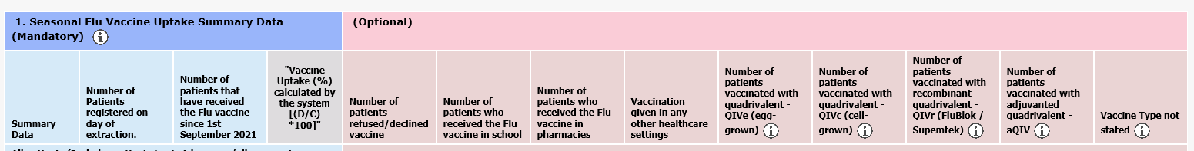

In the event of automatic extraction failing you are only required to complete the blue table (the mandatory part of the survey). Please see example tables below :

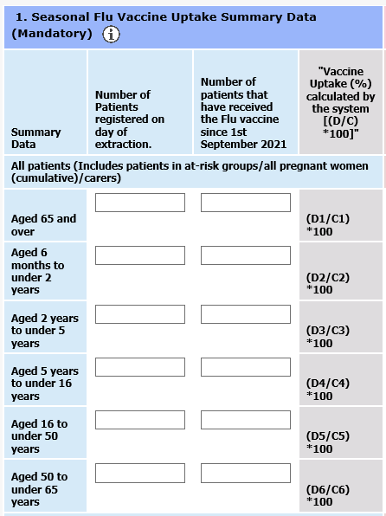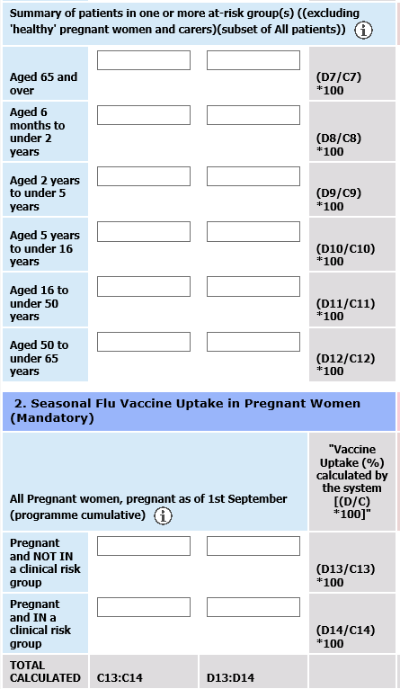

* Please note: this search should include all patients who are either 65 years or over at the time of the data extraction or will become 65 by 31st March 2024

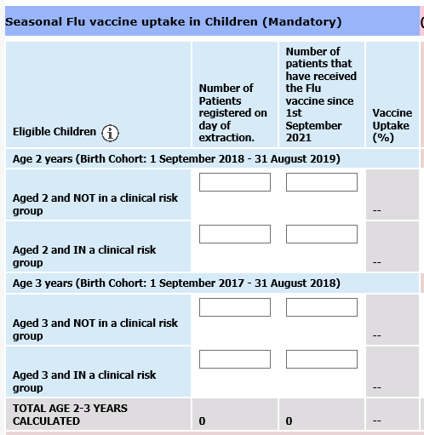

To complete the table, you will need to perform a series of searches using your practices patient record system. If you are unsure how to do this, please contact your IT provider.

Once you have completed inputting your data press submit and shortly afterwards ImmForm will automatically update.

If you are unable to access ImmForm or are still unsure how to submit your data, please contact South West Vaccination and Screening team who will be able to assist with your queries: england.swvast@nhs.net

Please note: once the deadline for manual submission has passed each month we will not be able to input data on behalf of your practice; your practice will display no data/ no vaccinations given and you will have to wait until the following month’s data upload to input your figures.

