Somerset School Aged Immunisation Pathways for the 2023/24 academic year

Introduction
This information aims to support local practices in understanding the school aged immunisations programme for the 2023/24 academic year, including any changes to the schedule. We hope you find this information useful and clear: if you have any comments, suggestions or queries please contact the Vaccination and Screening Team on England.swvast@nhs.net.

Overview of School Aged Immunisations
From September 2023, the following immunisations will be delivered by the school aged immunisation provider:

- Influenza: Reception up to Year 11 in mainstream schools (including home-schooled and other children not in mainstream education) and reception up to but not including 18 years old in special schools.
- HPV dose 1: Year 8 girls and boys
- Men ACWY: Year 9
- Td/IPV: Year 9
- Measles, Mumps and Rubella (MMR) catch up vaccinations

Please note that the flu community clinic schedule for the Somerset school aged immunisations provider is available at the end of this document.

GP Checklist

- Check that all data on immunisations delivered by the school aged immunisation provider that has been sent to you has been uploaded onto your GP practice patient records.

- Check that all data on immunisations you have given in your practice has been sent to the Child Health (CHIS) team. This includes any vaccination from the routine schedule given as a travel vaccination. If you are unsure, send it again or contact the Child Health (CHIS) team to discuss this with them.

- You will receive a summary report of any students with routine immunisations outstanding who are now outside of the school programme. These children will receive a letter from CHIS asking them to make an appointment with their GP practice.

- Review how young people are invited for vaccinations at your surgery and whether this meets their needs. Points to consider:

  - Are the sessions outside of school hours?
  - Can the young people get to your surgery for the appointments?
  - Consider evening or weekend sessions for parents to be able to attend appointments too.
  - Are you sending patient information leaflets (PILs) to ensure young people are aware of what they are being invited for?
  - Are you using text messaging reminders?

- Make sure you are promoting school aged immunisations through leaflets, posters and through links on your website.

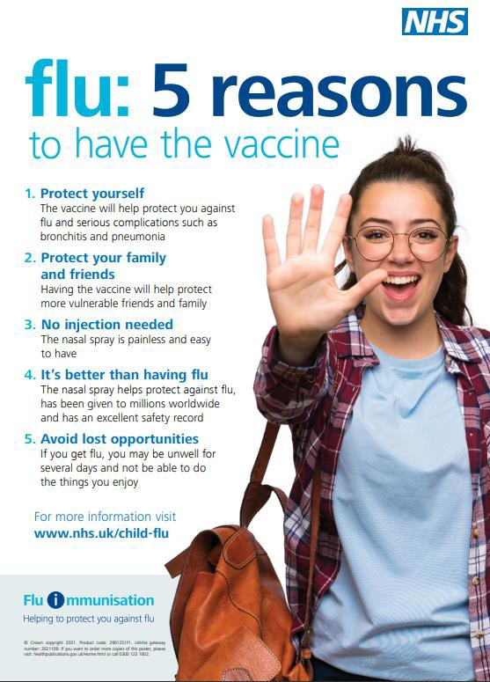

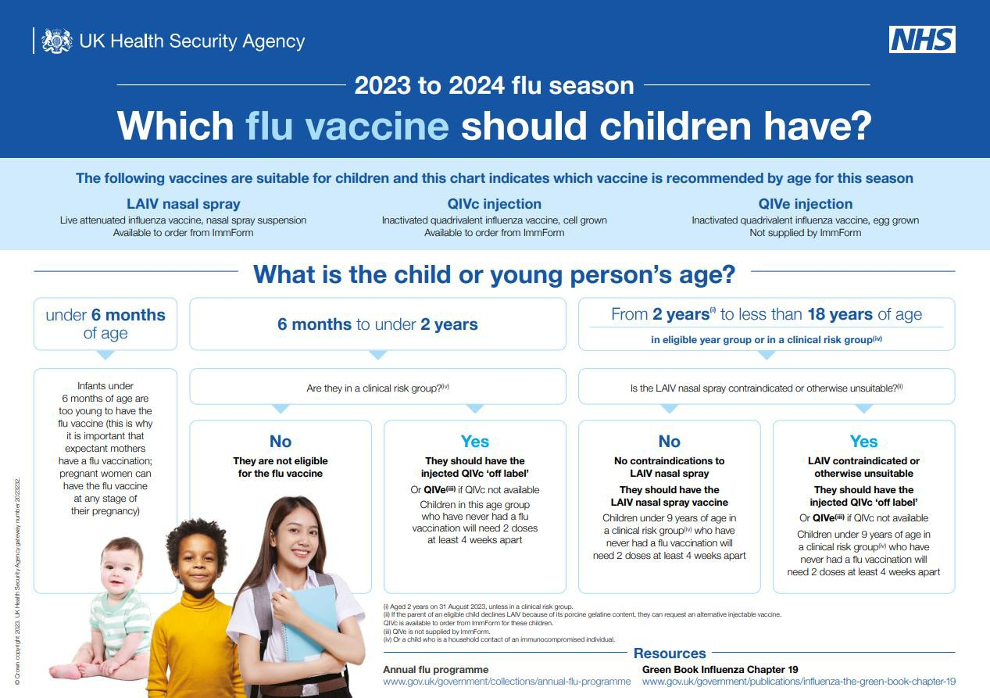

Changes to Vaccinations and Immunisations in 2023/24
These changes are to reflect forthcoming changes to the routine vaccination schedule recommended by JCVI (information on this found here: Letter: General Practice contract arrangements in 2023/24

HPV
As recommended by the JCVI, from 1st September 2023, the HPV vaccination programme will move from a 2 dose to 1 dose schedule for the routine adolescent programme including all those who remain eligible up to the age of 25. This change will not apply to those who are HIV positive or those who are immunocompromised for whom the three-dose schedule will remain.
This change will align HPV vaccine doses across age groups, as well as aligning school, sexual health, and general practice provision, thus minimising the risk of conflicting or missing doses.
As such, practices will deliver just one dose of the HPV vaccine in most cases from September 2023. Eligibility for girls is up to the age of 25 years. Eligibility for boys is based on age for those born on or after September 2006.

Migrant health - Vaccinating children
To support healthcare professionals, guidance on screening and immunisations for individuals who are fleeing conflict can be found here:

Further information on migrant health and immunisations can be found here: Moved to the UK: migrant immunisation - GOV.UK (www.gov.uk)
For children of refugees and asylum seekers, they may have had different vaccinations to the UK routine immunisation schedule. Please see the links below which may be helpful when

checking vacciVnataioncstcatuisn:

ation process for HPV

Vaccination of individuals with uncertain or incomplete immunisation status (publishing.service.gov.uk)
International-versus-UK-vaccination-schedules-August-2022.xlsx (live.com)
For immunisation queries and support, please contact the NHS England Vaccinations and Screening Team: England.swicars@nhs.net

Vaccination Process for HPV
For any child who misses an HPV dose the school aged immunisation team will offer catch-up clinics until the end of Year 11 either in the school or the community. If the child is in year 10 or above, they can also receive vaccination at their GP.
Information passed to CHIS
Child misses HPV
New Year 8 children, both boys and girls, will be invited to attend a vaccination session for their single HPV dose. If they miss this session, they will be invited to a mop-up session by the school aged immunisation provider.
Child attends session and receives HPV

For individuals who are HIV positive or those who are immunocompromised the three- dose schedule will remain. For more information please refer to the Green Book, Chapter 18a.

Eligible cohorts pre 2022/23 academic year who are completely unvaccinated will be consented as part of the HPV catch up programme on a one dose HPV vaccination schedule from September 2023. Only one dose of the HPV vaccine is needed to be considered fully vaccinated.

The school aged immunisation provider will continue to offer any outstanding HPV doses, regardless of the change from a 2 dose to 1 dose vaccination schedule, up until the end of Year 11 and not only up to the age of 16 years. The GP will be responsible for delivery of missed vaccinations for students after the end of Year 11 (up to their 25th birthday).
GP practices can also provide HPV vaccinations to adolescent girls and boys who have attained the age of 14 years but who have not attained the age of 25 years and have missed vaccination under the school’s programme. Please note that vaccination of boys commenced in 2019/20 without a catch-up programme, therefore GPs should only vaccinate boys born on or after 1st September 2006.

Vaccination Process for Meningitis ACWY
Usually, children from age 10 are not normally eligible for Men ACWY until they reach 13-15 years old
Has the child ever received a dose of MenC conjugate vaccine?
Yes
Explain child will be offered vaccination in school year 9
No
GP practice to vaccinate with Men ACWY.
No further Men ACWY vaccination is then required in school year 9.

Year 9 children will be invited to attend a vaccination session. If they miss this session, they will be invited to a mop-up session by the school aged immunisation team
Information passed to CHIS

Child misses Men ACWY

Child attends session and receives Men ACWY
The school aged immunisation team will attempt to catch-up any child who misses Men ACWY up to the end of year 11. If the child is in year 10 or above, they can receive vaccination at their GP.

Information passed to CHIS

Information passed to CHIS

By the end of year 9, children should have already been offered Men ACWY
vaccination
Has the child received a dose of Men ACWY
conjugate since the age of 10?
Yes
Child is up to date with vaccination and does not need another dose of Men ACWY
No
SAIS or GP to vaccinate with Men ACWY until end of year 11. GP can vaccinate anyone from age 14 up to age 25

Older groups eligible through opportunistic vaccination
Men ACWY vaccination should be offered by GP practices to eligible young adults aged 14 or older who have missed a school aged immunisation provider offer on an opportunistic basis or who self-present at the GP practice, unless immunisation is contraindicated.
Eligible patients must be under the age of 25 years at the time of vaccination and include:
- those attending university/further education for the first time at the time of vaccination
- those aged 19 years on 31 August 2023
- those eligible from August 2015 remain eligible up to the day before their 25th birthday
- those vaccinated at any time during the period 1 April 2023 to 31 March 2024

Vaccination Process for Td/IPV (Teenage Booster)

Children in year 8 or younger should not be routinely offered Td/IPV until they have reached year 9 where this will be offered by the school aged immunisation team.
Td/IPV should ideally be given 10 years after the first booster (around 13 years 4
months). However, there may

No

Is there a reason that the child should receive vaccination before the school age offer is made in year 9 (e.g. travel abroad)?

Explain child will be offered vaccination in school year 9

be circumstances where young people require this before year 9.
GP Practice to
Yes vaccinate with TD/IPV
Pass information to CHIS

Year 9 children will be invited to attend a vaccination session. If they miss this session, they will be invited to a mop-up session by the school aged immunisation team.
Child misses Td/IPV
The school aged immunisation team will attempt to catch-up any child who misses Td/IPV up to the end of year 11. If the child is in year 10 or above they can also receive vaccination at their GP.
Child attends session and receives TD/IPV
Information passed to CHIS

Any older children, young people or adults aged over 14 who have missed any dose of Td/IPV
opportunistically in general practice.
Please refer to the Green Book and the incomplete vaccination schedule for further information.
(from the sVchaoocl acgeidnimamtuinoisnationPprroovidceers sor sothfeorwirse)MshMouldRbe vaccinated

Vaccination Process for MMR
Child misses MMR
The school aged immunisation team will attempt to catch-up any child who misses MMR. The GP
can also give any missed doses.

Child attends session and receives MMR vaccine. If child has previously had one dose, then course is complete.
Child found to have had no doses of MMR or 1 dose of MMR to be offered vaccine(s) through consent process at same time as offer for HPV, Td/IPV & MenACWY.

Childs MMR vaccination status checked at same time as offer for HPV, Td/IPV, MenACWY.
If child has previously had no MMR doses, then 2nd MMR dose offered a minimum of 4 weeks from the 1st dose.

Information passed to CHIS and GP.

There is no upper age limit to catch up on MMR. The school aged immunisation team will continue to offer MMR alongside other school aged immunisations to complete the full course where possible.

Date of births and year groups for 2023/24 academic year

School Year | Date of birth | Age
Reception | 01.09.18 – 31.08.19 | 4 to 5
Year 1 | 01.09.17 – 31.08.18 | 5 to 6
Year 2 | 01.09.16 – 31.08.17 | 6 to 7
Year 3 | 01.09.15 – 31.08.16 | 7 to 8
Year 4 | 01.09.14 - 31.08.15 | 8 to 9
Year 5 | 01.09.13 - 31.08.14 | 9 to 10
Year 6 | 01.09.12 - 31.08.13 | 10 to 11
Year 7 | 01.09.11 – 31.08.12 | 11 to 12
Year 8 | 01.09.10 – 31.08.11 | 12 to 13
Year 9 | 01.09.09 – 31.08.10 | 13 to 14
Year 10 | 01.09.08 – 31.08.09 | 14 to 15
Year 11 | 01.09.07 - 31.08.08 | 15 to 16
Year 12 | 01.09.06 – 31.08.07 | 16 to 17
Year 13 | 01.09.05 - 31.08.06 | 17 to 18

Useful Contacts

South West Vaccination and Screening Team: England.swvast@nhs.net

Somerset Child Health Information Service (CHIS):

Provider | Address | Contact  number | Contact email / website
SW CHIS  Health Intelligence | The Exchange, Express Park, Bridgwater, TA6 4RN | 01278 589225 | Email: hil.bnsssg.swchis@nhs.net  Website: http://www.swchis.co.uk/  http://www.dorsethealthcare.nhs.uk/

Somerset school aged immunisation provider:

Provider | Address | Contact number | Contact email / website
School Aged Immunisation Nursing Team (Somerset NHS  Foundation Trust) | Lower Bracken House, Chard Hospital, Chard, Somerset, TA20 1YA | 0300 323 0032 | Email: somersetsaint@somersetft.nhs.uk  Website: https://www.somersetft.nhs.uk/saint s-school-age-immunisation-team/

Useful links

Training
- Men B and Men ACWY programmes: a video training guide for healthcare professionals (PHE, last updated September 2015)
- Immunisation and vaccination training update via e-learning (Skills for Health)

Resources
- Meningococcal leaflets, consent forms, information for healthcare practitioners and other Men ACWY-specific materials (UKHSA, last updated January 2023)
- Men ACWY GP invitation letter template (PHE, last updated August 2016)
- HPV and Men ACWY leaflets and posters, and the immunisations for young people leaflet (which includes information on Td/IPV) can be ordered from: https://www.healthpublications.gov.uk/Home.html
- HPV vaccination Information for healthcare practitioners (UKHSA, Last updated June 2023)
- MenACWY programme: information for healthcare professionals (PHE, Last updated June 2020)
- Complete Routine Immunisation Schedule (UKHSA, Last updated April 2023 to include links to translated versions)
- Vaccination of individuals with uncertain or incomplete immunisation status (UKHSA, Last updated May 2023)

Supporting guidance
- Immunisation against infectious disease (Green Book) (UKHSA, Last updated November 2020)
- Meningitis Research Foundation
- Meningitis Now
- Vaccine Knowledge Project

Financial information
- Letter: General Practice contract arrangements in 2023/24

Data
- Uptake data for HPV, Men ACWY and Td/IPV for the main cohorts can be found on the ImmForm website

PGDs
- PGDs can be accessed via the NHS England South (South West) website

Somerset school aged immunisation clinic schedule 2023/24
The school flu clinic schedule can be accessed here – please note that it is subject to change: https://www.somersetft.nhs.uk/saints-school-age-immunisation- team/somerset-school-aged-immunisation-nursing-team-saint/flu-vaccination- programme/ https://www.somersetft.nhs.uk/saints-school-age-immunisation-team/

Please direct any questions about the schedule and how to book to the Somerset school aged immunisation provider on 0300 323 0032.

