Who are we?
A specialist enhanced service working alongside Child Health Information Services (CHIS) who can offer support to your practice in the form of resources and bitesize masterclass sessions to help increase your 0-5 childhood immunisation uptake rates.
What can we offer?
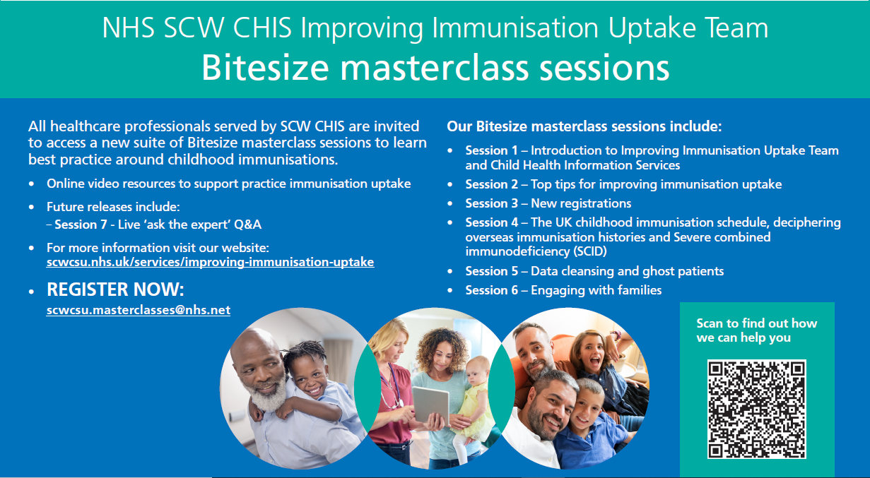

What would the benefits be to your practice?
- An increase in knowledge and understanding of the IIUT and CHIS
- An increase in knowledge and understanding of the UK childhood immunisation schedule
- Support in increasing immunisation uptake, achieving QOF targets and Improved data quality
- Support in best practice guidance and ensuring robust processes relating to immunisations
- Support to understand and address key challenges such as non-attenders, ghost patients and parental concerns around vaccinations
- Support Resources available on request, including GP Toolkit and Practice Immunisation SOP
For further information or to register now email
E: scwcsu.masterclasses@nhs.net T: 0300 561 1855
www.scwcsu.nhs.uk https://www.scwcsu.nhs.uk/services/improving-immunisation-uptake

