Pharmacy Closed

Due to operational difficulties, this pharmacy

will be closed until .

We apologise for the inconvenience this will cause.

If you need to collect a prescription from this pharmacy:

Do you have enough medication to last until we re-open?
  Yes | Please return when the pharmacy re-opens
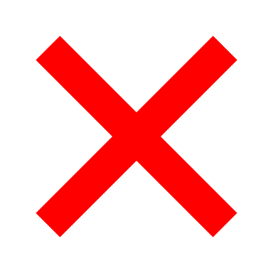  No | Go to a nearby pharmacy for advice

Worried you have an urgent medical concern?
Call 111 or visit 111.nhs.uk.

NHS 111 is available 24 hours a day, 365 days a year.
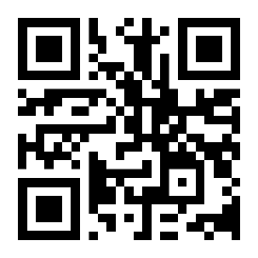
Calls are free from landlines and mobile phones.

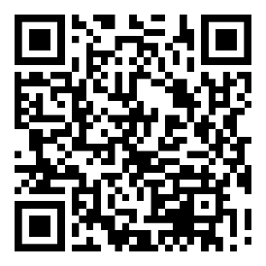
Need to find a pharmacy nearby? visit nhs.uk

