Statistical Note: Ambulance Quality Indicators (AQI)
The latest Systems Indicators for February 2017 for Ambulance Services in England showed the standards in the Handbook to the NHS constitution were not met.
The latest Clinical Outcomes data are stable for patients transported by Ambulance Services in November 2016.

A. Systems Indicators

A1 Emergency response in 8 minutes (Figure 1)
In February 2017, of Category, A Red 1 calls in England, resulting in an emergency response, the proportion arriving within 8 minutes was 69.3%.
In February 2017, of Category^{2, 3} A Red 2 calls in England resulting in an emergency response, the proportion arriving within 8 minutes was 61.7%.
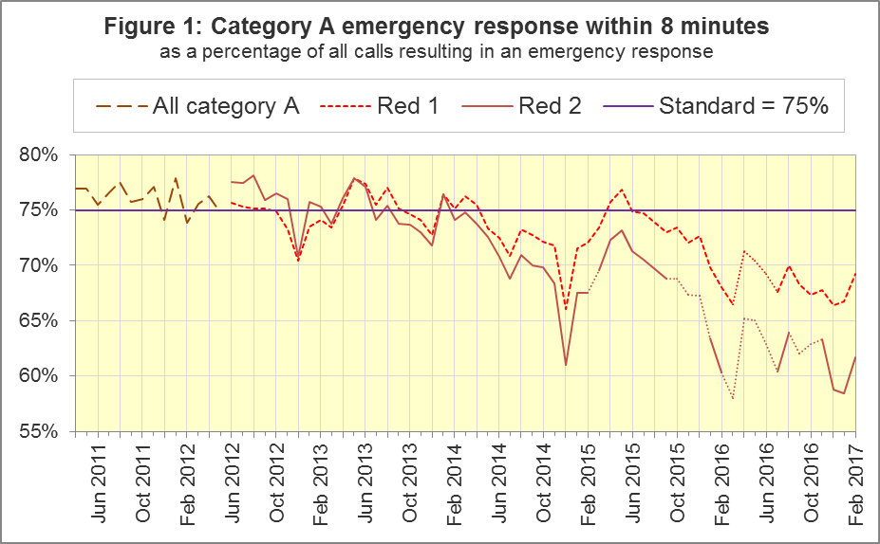
The standard for Ambulance Services is to send an emergency response, with a defibrillator, within 8 minutes to 75% of Category A calls. Figure 1 shows that for England, Red 1 performance in February 2017 was the highest proportion since August 2016.
For Red 1, out of the eight trusts where Category A still applies, only South Central Ambulance Service (SCAS) met the 75% standard in February 2017 (76.7%). North West (NWAS) and South East Coast (SECAmb) Ambulance Services had the lowest proportions, 64.7 % and 65.7% respectively.

A2 Dispatch on Disposition
In February 2015, the Secretary of State for Health announced the introduction of Dispatch on Disposition (DoD). This was the first change affecting the AQI due to the Ambulance Response Programme (ARP). It does not apply to Red 1 calls.
It meant that response data were still available across England, but for any affected Ambulance Service, Red 2 and Category A response data were no longer comparable before and after when DoD was introduced.
DoD increases the maximum time for triage, which means to identify the clinical situation and to take appropriate action. The change was based upon clinical advice that it would be likely to improve the overall outcomes for ambulance patients.
Until 10 February 2015, other than for Red 1 calls, the start time was the earliest of:
- chief complaint or NHS Pathways initial disposition (Dx) code obtained;
- first vehicle assigned;
- 60 seconds after call connect.
From 10 February 2015, option 3 was increased from 60 seconds to 180 seconds for London (LAS) and South Western (SWAS) Ambulance Services. From October 2015, further changes were tested in a variety of Ambulance Services on different dates, which are listed in full in the 8 December 2016 AQI Statistical Note. During October 2016, all Ambulance Services in England were aligned with a maximum start time of 240 seconds, except for Isle of Wight (IOW) which aligned on 7 February 2017.

A3 Clinical Coding Review
The second change affecting the AQI due to the ARP was the Clinical Coding Review (CCR). This was a clinically-led evidence based review of the call coding categorisations, to ensure patients receive the most appropriate response.
The existing Category A (Red 1 and Red 2) and Category C (Green 1, Green 2, Green 3, and Green 4) were replaced with new categories that were not comparable with those used previously.
The new categorisations were piloted by SWAS, Yorkshire (YAS) and West Midlands (WMAS) Ambulance Services from 19 April, 21 April and 8 June 2016 respectively. Therefore, from these dates, Red 1, Red 2 and Category A no longer apply to these Trusts, and consequently data for these categories are no longer available for these Trusts.

A4 Emergency Response in 8 minutes for Red 2 (Figure 2)
Figure 2 shows that in February 2017 the Red 2 measure for England was 61.7%, an increase of more than 3 percentage points on January 2017 (58.5%). However, the 75% standard has not been met since January 2014 and performance has been below 70% since August 2015.
NWAS, SECAmb, East Midlands (EMAS), and East of England (EastAmb) Ambulance Services have always used the same DoD maximum clock start time as each other. All other Ambulance Services implemented DoD according to a unique timetable.
Figure 2 indicates that the trend for England⁸ is reliable, despite its discontinuities, because it is very similar to the trend for the four Services where the Red 2 measure is always comparable.
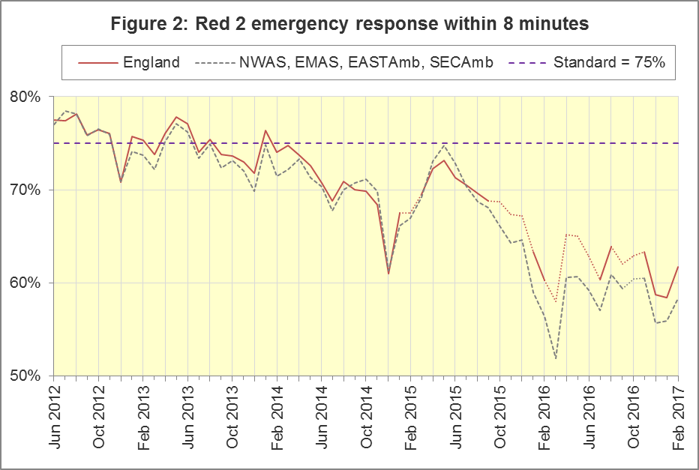

A5 Category A Ambulance response in 19 minutes (Figure 3)
The second ambulance standard in the Handbook to the NHS Constitution is for trusts to send, within 19 minutes, a fully-equipped ambulance vehicle, able to transport the patient in a clinically safe manner, to 95% of Category A calls. For England in February 2017 performance was 89.7%, an improvement on January 2017, which was the lowest proportion recorded in the time series. Figure 3 shows that, as for the Red 2 measure, the trend for England⁹ is very similar to that for the four trusts with the same DoD implementation timetable.
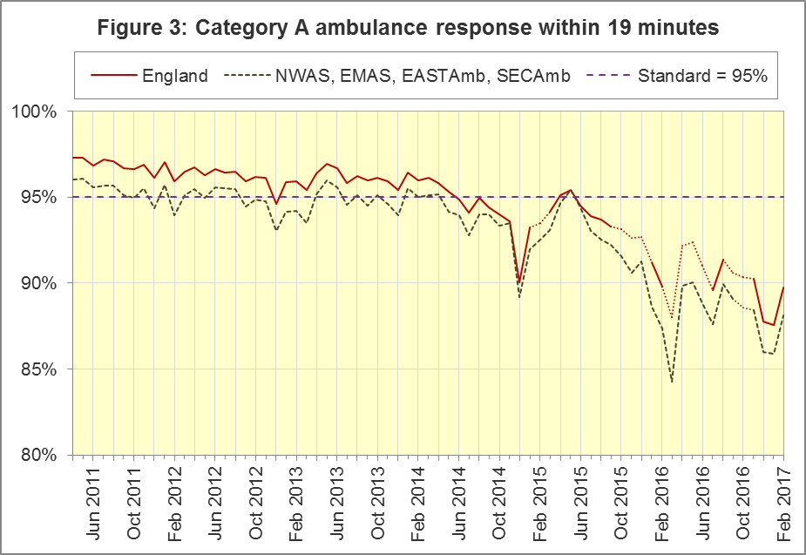
The numerators and denominators for Figures 2 and 3 are on the “DoD R2” and “DoD A19” tab respectively, in the Systems Indicators Time Series spreadsheet at http://bit.ly/NHSAQI.
In the trusts where Category A still applies, SCAS were the only Service to meet (with 75.5%) the 8 minute Red 2 standard of 75% and the only Service to meet (with 95.7%) the 19 minute Category A standard of 95%. SECAmb had the lowest proportion (49.8%) for Red 2 and EMAS had the lowest proportion (84.9%) for Category A.
For other Systems Indicators, DoD and the CCR do not affect comparability, but may lead to changes in levels. For example, a longer triage time may mean more calls are closed on the telephone, but the data for this measure remain comparable. Such changes may be difficult to detect within the habitual variation of the many AQI.

A6 Systems Indicators: Ambulance volumes (Figure 4)
The number of emergency telephone calls presented to the switchboard in February 2017 was 705,963, an average of 25.2 thousand per day.
There were 531,850 emergency calls that received a face-to-face response from the ambulance service in February 2017, an average of 19.0 thousand per day, a decrease on January 2017 (average of 19.5 thousand per day).
There were 375,907 incidents with a patient transported to Type 1 or Type 2 A&E in February 2017, a daily average of 13.4 thousand.
Figure 4 shows a general upward trend in all these measures, but also that each habitually reduces between December and February.
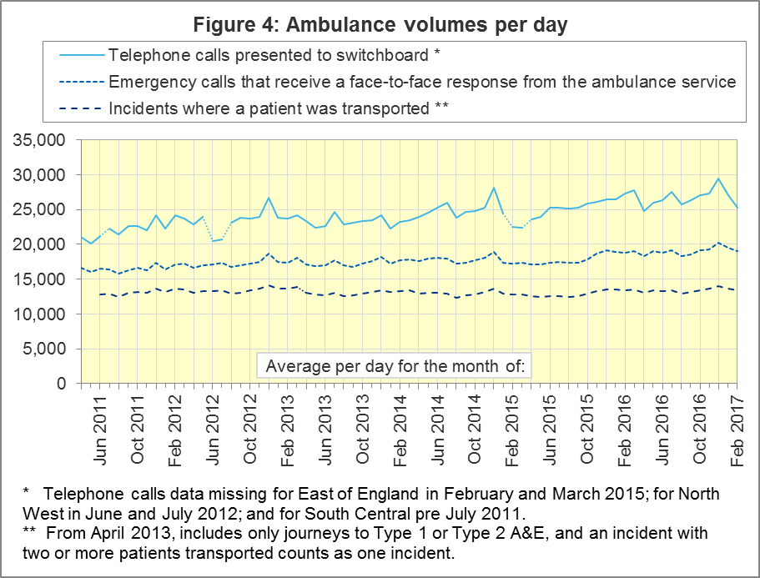

A7 Latest monthly data for other Systems Indicators, February 2017
All other Systems Indicators in February 2017 are stable and within their ranges from the previous twelve months.
Indicator | England | Lowest Trust |  | Highest Trust
Calls abandoned before being answered | 0.7% | LAS | 0.1% | SECAmb | 1.9%
Calls resolved through telephone assessment | 9.6% | WMAS | 4.9% | EMAS | 14.4%
Calls resolved without transport to Type 1 or Type 2 A&E | 37.4% | EMAS | 22.5% | SWAS¹² | 49.6%
Recontact rate following discharge by telephone advice | 6.4% | EMAS | 1.3% | WMAS | 16.2%
Recontact rate following face-to-face treatment at scene | 5.3% | YAS | 1.3% | LAS | 8.6%
Incidents where a patient was transported | 375,907 | NEAS¹² | 18,422 | LAS | 61,494

B. Clinical Outcomes
No thresholds to denote “poor” care are set for Clinical Outcomes. Commissioners are expected to examine trends in these data and work in collaboration with ambulance trusts to achieve sustained improvement in patient outcomes over time; but commissioners are not expected to use Clinical Outcomes to performance manage trusts, because there will be significant variations in the populations served.

B1 Cardiac arrest: return of spontaneous circulation (ROSC)
Patients in cardiac arrest will typically have no pulse and will not be breathing. In November 2016, in England, resuscitation was commenced or continued by ambulance staff out-of-hospital for 2,787 such patients. Of these, 798 (29%) had ROSC, with a pulse, on arrival at hospital (Figure 5), similar to the year ending September 2016 (28%). The largest proportion in November 2016 was 36% for NWAS and the smallest¹² proportion was 23% for SWAS.
The Utstein group comprises patients who had resuscitation commenced or continued by the Ambulance Services, following an out-of-hospital cardiac arrest of presumed cardiac origin, where the arrest was bystander witnessed, and the initial rhythm was Ventricular Fibrillation or Ventricular Tachycardia. The Utstein group therefore have a better chance of survival.
There were 409 such patients in England in November 2016, of which 223 (55%) had ROSC on arrival at hospital (Figure 5), greater than the year ending September 2016 (51%), but not significantly. The largest proportion in November 2016 was 72% for YAS and the smallest was 38% for SCAS.
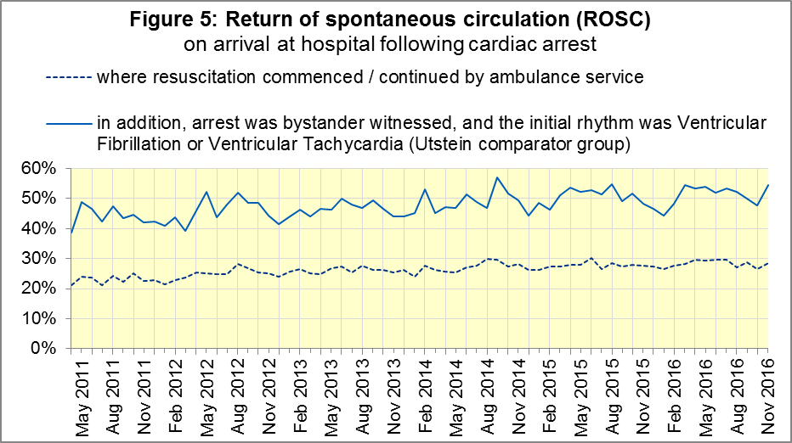

B2 Cardiac arrest: survival to discharge
The proportion of cardiac arrest patients in England discharged from hospital alive was 8% in November 2016 (Figure 6), the same as in the year ending September 2016. The largest proportion in November 2016 was 14% for YAS; the smallest was 2% for SECAmb.
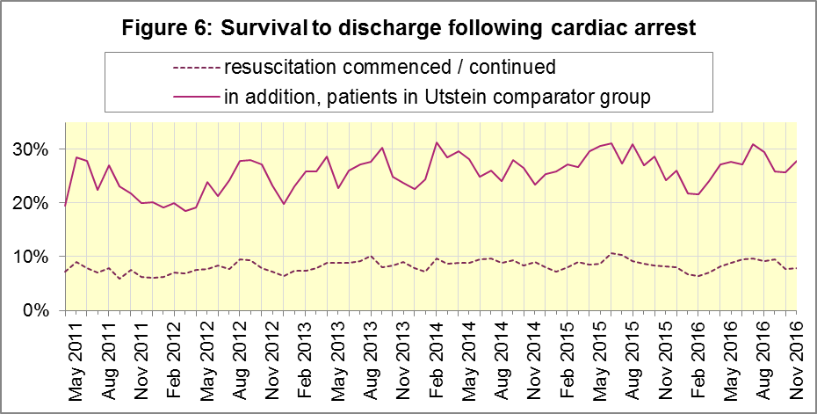
For the Utstein group, survival to discharge in November 2016 was 28%, similar to the year ending September 2016 (26%). The largest proportion was 54% for YAS; the smallest was 5% for SECAmb.

B3 ST-Elevation myocardial infarction
ST-segment elevation myocardial infarction (STEMI) is a type of heart attack, determined by an electrocardiogram (ECG) test. Early access to reperfusion, where blocked arteries are opened to re-establish blood flow, and other assessment and care interventions, are associated with reductions in STEMI mortality and morbidity.
903 STEMI patients received primary angioplasty in November 2016, in England. Of these patients, 768 (85%) of them received it within 150 minutes of the call being connected to the ambulance service (Figure 7), similar to the year ending September 2016 (87%). The largest proportion in November 2016 was 96% for North East Ambulance Service (NEAS) and the smallest was 68% for NWAS.
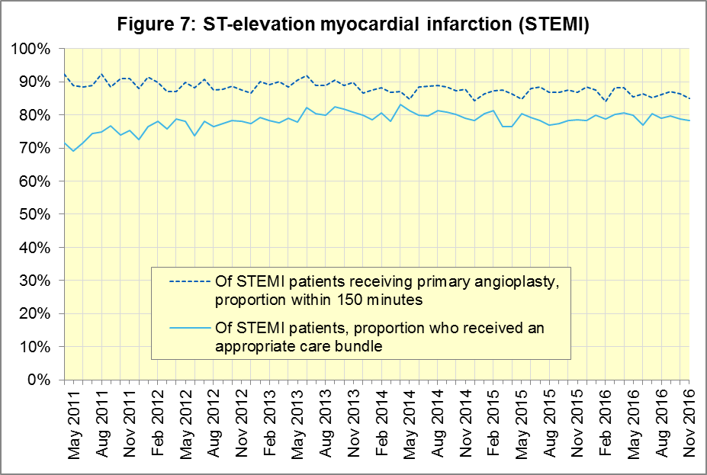
In November 2016, of 1,435 patients with an acute STEMI in England, 1,122 (78%) received the appropriate care bundle, similar to the year ending September 2016 (79%). EastAmb had the largest proportion with 89% and the smallest¹⁶ was SCAS with 65%.

B4 Stroke
The FAST procedure helps assess whether someone has suffered a stroke:
- Facial weakness: can the person smile? Has their mouth or eye drooped?
- Arm weakness: can the person raise both arms?
- Speech problems: can the person speak clearly and understand what you say?
- Time to call 999 for an ambulance if you spot any one of these signs.
In November 2016, of 3,458 FAST positive patients in England, assessed face to face, and potentially eligible for stroke thrombolysis within agreed local guidelines, 1,837 (53%) arrived at hospitals with a hyperacute stroke unit within 60 minutes of an emergency call connecting to the ambulance service, similar to the year ending September 2016 (54%). The largest proportion for November 2016 was 69% for WMAS and the smallest was 40% for SWAS.
There were 7,591 stroke patients assessed face to face in November 2016 in England, of these 7,379 (97%) received the appropriate care bundle, the same as the year ending September 2016.

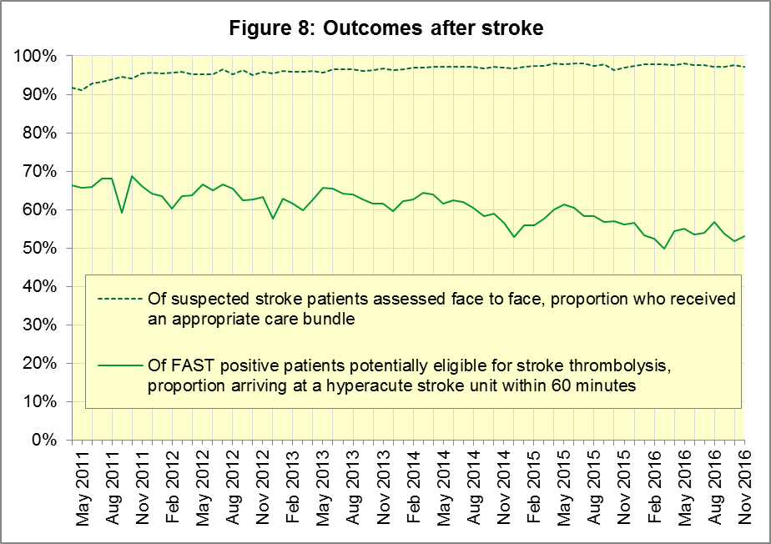

C. Further information on AQI

C1 The AQI landing page and Quality Statement
www.england.nhs.uk/statistics/statistical-work-areas/ambulance-quality-indicators, or http://bit.ly/NHSAQI, is the AQI landing page, and it holds:
- a Quality Statement for these statistics, which includes information on relevance, accuracy, timeliness, coherence, and user engagement;
- the specification guidance document for those who supply the data;
- timetables for data collection and publication;
- text files and time series spreadsheets containing all data from April 2011 up to the latest month;
- links to individual web pages for each financial year.
The web pages for each financial year hold:
- separate spreadsheets of each month’s data;
- this Statistical Note, and equivalent versions from previous months;
- the list of people with pre-release access to the data.
Publication dates are also at www.gov.uk/government/statistics/announcements.

C2 Revisions Timetable
Revisions usually follow a six-monthly cycle. The dates for past and future AQI Systems Indicators (SI) and Clinical Outcomes (CO) scheduled revisions are below. The AQI Quality Statement above contains a more detailed revisions policy.
Publication |  | Data |  | Months affected |  |  | Publication |  | Data |  | Months affected
11 May 2017 |  | SI |  | Apr ‘15 - Feb ‘17 |  |  | 6 Nov 2014 |  | SI |  | Apr ‘13 - Aug ‘14
9 Mar 2017 |  | CO |  | Apr ‘16 - Sep ‘16 |  |  | 5 Sep 2014 |  | CO |  | Apr ‘13 - Mar ‘14
10 Nov 2016 |  | SI |  | Apr ‘16 - Aug ‘16 |  |  | 2 May 2014 |  | SI |  | Apr ‘13 - Feb ‘14
8 Sep 2016 |  | CO |  | Apr ‘15 - Apr ‘16 |  |  | 7 Mar 2014 |  | CO |  | Apr ‘13 - Sep ‘13
12 May 2016 |  | SI |  | Apr ‘15 - Feb ‘16 |  |  | 1 Nov 2013 |  | SI |  | Apr ‘13 - Aug ‘13
10 Apr 2016 |  | CO |  | Apr ‘15 - Sep ‘15 |  |  | 2 Aug 2013 |  | CO |  | Apr ‘12 - Mar ‘13
10 Sep 2015 |  | CO |  | Apr ‘14 - Mar ‘15 |  |  | 3 May 2013 |  | SI |  | Apr ‘12 - Mar ‘13
4 Jun 2015 |  | SI |  | Apr ‘14 - Feb ‘15 |  |  | 1 Feb 2013 |  | CO |  | Apr ‘12 - Aug ‘12
30 Apr 2015 |  | SI |  | Apr ‘14 - Feb ‘15 |  |  | 11 Jan 2013 |  | SI |  | Apr ‘11 - Oct ‘12
5 Mar 2015 |  | CO |  | Apr ‘14 - Sep ‘14 |  |  | 31 Aug 2012 |  | CO |  | Apr ‘11 - Mar ‘12
 |  |  |  |  |  |  | 4 May 2012 |  | SI & CO |  | Apr ‘11 - Mar ‘12

C3 AQI Scope
The AQI include calls made by dialling either the usual UK-wide number 999 or its international equivalent 112.
As described in the specification guidance mentioned in section C1, calls made to NHS 111 are not included in the AQI measures for calls abandoned, re-contacts, frequent callers, time to answer calls, or calls resolved by telephone advice.
All other Systems Indicators involve the dispatch of an ambulance, and include ambulances dispatched as a result of a call to NHS 111, as well as 999 or 112.

C4 Related statistics in England
A Clinical Dashboard on the AQI landing page presents an alternative layout for the AQI data. Because of the lack of comparability due to the Ambulance Response Programme (section A2), NHS England last updated the dashboard in April 2016.
The AQI were also used in the “Ambulance Services” publications by NHS Digital, which included additional annual analysis and commentary, up to and including 2014-15 data. The Quality Statement described in section C1 has more information on this publication. It also contains details of weekly ambulance situation reports that NHS England collected for six months from November 2010.
Ambulance handover delays of over 30 minutes at each Emergency Department were collected and published by NHS England each winter until 2014-15: www.england.nhs.uk/statistics/statistical-work-areas/winter-daily-sitreps

C5 Rest of United Kingdom
Ambulance statistics for other countries of the UK can be found at the following websites. The AQI Quality Statement described in section C1 contains more information about the comparability of these statistics.
Wales: | http://wales.gov.uk/statistics-and-research/ambulance-services
Scotland: | See Quality Improvement Indicators (QII) documents at www.scottishambulance.com/TheService/BoardPapers.aspx
Northern Ireland: | www.health-ni.gov.uk/articles/emergency-care-and-ambulance-statistics

C6 Contact information
For press enquiries, please contact the NHS England press office on 0113 825 0958 or nhsengland.media@nhs.net.
The person responsible for producing this publication is:
Ian Kay, Operational Information for Commissioning (Central), NHS England
Room 5E24, Quarry House, Leeds, LS2 7UE; 0113 825 4606; i.kay@nhs.net

C7 National Statistics
The UK Statistics Authority has designated these statistics as National Statistics, in accordance with the Statistics and Registration Service Act 2007 and signifying compliance with the Code of Practice for Official Statistics.
Designation can be broadly interpreted to mean that the statistics:
- meet identified user needs;
- are well explained and readily accessible;
- are produced according to sound methods; and
- are managed impartially and objectively in the public interest.
Once statistics have been designated as National Statistics it is a statutory requirement that the Code of Practice shall continue to be observed.

Page 34 of the July 2015 Handbook to the NHS Constitution has Ambulance response time standards, www.gov.uk/government/publications/supplements-to-the-nhs-constitution-for-england.
From February 2015, changes in operational practice meant that Red 2 response data are still available but not always comparable; see section A2 on Dispatch on Disposition. Also, after June 2016, Category A only applies to 8 of the 11 Ambulance Services in England, so Red 1 and Red 2 response data are not available for the other 3; see section A3 on the Clinical Coding Review.
On 1 June 2012, Category A (immediately life-threatening) calls was split into Red 1 and Red 2. Red 1 calls are the most time critical, and cover cardiac arrest patients who are not breathing and do not have a pulse, and other severe conditions such as airway obstruction. Red 2 calls are serious, but less immediately time critical, and cover conditions such as stroke and fits. www.gov.uk/government/news/changes-to-ambulance-response-time-categories
England excludes YAS and SWAS after April 2016, and WMAS after June 2016. See section A3.
Due to its small size, performance on Isle of Wight (IOW) tends to vary more than other trusts. If it has the largest or smallest value a footnote marker shows that IOW is more extreme. The Clinical Outcomes in section B also use this system.
Dispatch on Disposition announcement: www.parliament.uk/business/publications/written-questions-answers-statements/written-statement/Commons/2015-01-16/HCWS201
Ambulance Response Programme information: www.england.nhs.uk/ourwork/qual-clin-lead/arp
England excludes YAS and SWAS after April 2016, and WMAS after June 2016. See section A3.
England excludes YAS and SWAS after April 2016, and WMAS after June 2016. See section A3.
The number of emergency calls presented to switchboard does not usually include calls made to NHS 111 requiring an ambulance. 111 calls requiring an ambulance are usually transferred electronically direct to ambulance dispatch and not routed via 999 call handlers. Occasionally, manual requests for ambulances are made between 111 and 999 call handlers and such calls are included in the numbers of emergency calls presented to switchboard.
Type 1 are consultant-led 24 hour emergency departments with full resuscitation facilities. Type 2 offer a consultant-led speciality A&E service such as ophthalmology or dental. Type 3 is A&E / minor injury activity that may be doctor-led or nurse-led. Type 4 are NHS walk-in centres. (www.datadictionary.nhs.uk/data_dictionary/attributes/a/acc/ accident_and_emergency_department_type_de.asp)
Excluding Isle of Wight. See footnote 5 on page 2.
This definition was proposed at Utstein Abbey in Norway by an international group of cardiologists and other health professionals in 1990. http://circ.ahajournals.org/content/110/21/3385
Significance calculations in this document are Student’s t-test with 95% significance.
Excluding Isle of Wight. See footnote 5 on page 2.
Excluding Isle of Wight. See footnote 5 on page 2.
Pages 27 to 30 of the specification guidance for data suppliers on the AQI landing page at www.england.nhs.uk/statistics/statistical-work-areas/ambulance-quality-indicators describe the care bundles, and certain exclusions, for the STEMI and stroke indicators.
Excluding Isle of Wight. See footnote 5 on page 2.
NHS Digital, Ambulance Services: http://content.digital.nhs.uk/article/2021/Website-Search?q=ka34

