
Diagnostic Imaging Dataset
Statistical Release

Annual experimental statistics

31st October 2013
Annual Diagnostic Imaging Dataset Statistics
April 2012 to March 2013, England

Experimental Official Statistics

Headline Messages
For all imaging activity
- Over 36 million imaging tests were reported in England in the 12 months from April 2012 to March 2013. Plain Radiography (X-ray) was most common, followed by Ultrasound and Computerized Axial Tomography (CT Scan).
- The median period between the request being made and the test being performed varied greatly for the different tests, from the same day for X-ray, Fluoroscopy and Medical Photography to around 3 weeks for Magnetic Resonance Imaging (MRI).
- Across all types of imaging, emergency admissions and inpatients have shorter waits than outpatients and referrals made under GP direct access arrangements. For example, more than 97% of CT scans on inpatients happen within a week, compared with 23% for outpatients and referrals by GP direct access.
- There is variation in the period from a test being performed to the report being issued. For example, the median period for the report to be issued after the test was the same day for CT scan, Ultrasound and Fluoroscopy, whereas the equivalent period for MRI is up to 3 days.
For the key tests¹ Chest X-ray, Brain MRI and Non-Obstetric Ultrasound of the Abdomen and/or Pelvis
- Roughly a quarter of all tests that might have been used to diagnose or discount cancer were requested by GPs under direct access arrangements. Of these tests, the most commonly requested by GPs was Chest X-ray, followed by ultrasounds that may have been used to diagnose ovarian cancer (46% of which were requested by GPs in 2012-2013).
- The median period between the request being made and the test being performed varied between each of the key tests under GP direct access arrangements. This ranged from the same day for Chest X-ray to at least three weeks for Brain MRI and Non-Obstetric Ultrasound of the abdomen and or pelvis.
- With the exception of Chest X-ray, for the key tests which may be used to diagnose or discount cancer, the median period from a test being requested to being performed is longer for GP direct access compared with all referrals. The main reason for this difference is that ‘all referrals’ includes tests on emergency admissions and inpatients, which have shorter waits.
1. Although these tests are used to diagnose cancer, many of the tests also have wider clinical uses. Within this dataset it is not possible to distinguish the different uses of these tests.

Introduction
The Diagnostic Imaging Dataset (DID) is a monthly data collection covering data on diagnostic imaging tests on NHS patients in England. It includes estimates of GP usage of direct access to key diagnostics tests for cancer – for example, chest imaging, non-obstetric ultrasound and MRI on the brain.

This publication finalises estimates of imaging activity in 2012/13. A summary of the changes from provisional estimates are given in the Revisions section of this document.

These statistics are undergoing evaluation and are therefore badged as Experimental. Whilst efforts have been made to ensure that the data are complete and accurately reflect activity, data issues may affect the correct analysis of data for some providers. Consequently, users should exercise care when interpreting the results. The Technical Report provides more detail on these issues.

Experimental Official Statistics
Experimental official statistics are new official statistics undergoing evaluation. They are published in order to involve users and stakeholders in their development and as a means to build in quality at an early stage. We welcome feedback to assist with evaluation, please contact us at did@dh.gsi.gov.uk

Data Quality Statement

These data are collated from Radiology Information Systems (RISs), which are hospital administrative systems used to manage the workflow of radiology departments.

Although the data were not originally intended for statistical purposes and have some shortfalls, they do provide a rich resource with great potential. This data collection is aligned with the Code of Practice for Official Statistics in making better use of administrative data and evaluating existing data sources to limit the burden on respondents.

There are a large number of validations built into the DID upload system, verifying that the data provided by organisations make sense. Although validations and other checks have been made to ensure that the data are complete and accurately reflect activity, data issues may affect activity for some providers. Therefore, users should exercise care when interpreting the results.

Details of coverage, completeness, comparability with other data sources, and a discussion on the types of data quality issues encountered are provided in the Technical Report.

Frequently Used Acronyms

Acronym | Full name
DID | Diagnostic Imaging Dataset
HSCIC | Health and Social Care Information Centre
RIS | Radiology Information System

Commissioner Data

Both PCT and CCG summaries are available from the DID.

The accompanying detailed tables to this report include summaries for PCTs. PCT summaries are given since these were the active commissioners in 2012/13 which the data is based on. Recognising there is an interest in also seeing 2012/13 data by CCGs, which became active from 1 April 2013, a set of summary tables are available for reference in Annex 4 (modality based summaries) and Annex 5 (body site summaries for early diagnosis of cancer) to the 2013 Technical Report.

For the DID, PCTs and CCGs are derived from a patient’s recorded GP practice as it appears in records submitted to the DID.

Imaging Activity
Over 36 million imaging tests were reported in England in the 12 months from April 2012 to March 2013.

Plain Radiography (X-ray) made up the majority of all tests performed during the year, with over 21 million X-rays being reported. The next most common procedures were Ultrasound and CT-scans, with about 7.7 and 3.3 million tests reported respectively. Medical Photography procedures accounted for the lowest amount of reported activity (about 6,000 tests).

October was the month with the most reported activity, followed by May. Both months reported over 3.2 million tests. December had the lowest number of reported tests, with a little over 2.7 million.

Please refer to the definitions section in the appendix for further information on the different procedures included in the DID.

Table 1.1 shows the amount of imaging activity in England, split by modality and by month.

Graphs 1.1-1.3 illustrate how the number of tests reported each month changed over the 12 month period for each modality. Graph 1.4 shows the number of tests reported for each Strategic Health Authority (SHA) over the 12 months.

Please see additional Table 1a-1l (separate Excel file) for a breakdown of imaging by modality and provider.
 | CT Scan  (Computerised Axial Tomography) | Ultrasound  (Diagnostic Ultrasonography) | Fluoroscopy | MRI  (Magnetic Resonance Imaging) | Medical Photography | Nuclear Medicine | X-ray  (Plain Radiography) | PET Scans  (Position Emission Tomography) | SPECT Scans  (Single Photon Emission Computerized Tomography) | % organisations included | Total
Apr | 251,425 | 586,040 | 79,785 | 173,140 | 540 | 33,755 | 1,656,110 | 5,265 | 880 | 97.4% | 2,786,940
May | 284,085 | 680,435 | 93,525 | 195,680 | 545 | 39,610 | 1,909,425 | 6,300 | 1,005 | 97.9% | 3,210,610
Jun | 258,245 | 589,030 | 80,165 | 181,700 | 495 | 33,735 | 1,725,540 | 5,510 | 885 | 97.4% | 2,875,305
Jul | 285,800 | 678,005 | 91,985 | 206,030 | 510 | 38,690 | 1,867,765 | 6,440 | 970 | 97.9% | 3,176,195
Aug | 285,625 | 659,780 | 88,190 | 202,585 | 500 | 37,560 | 1,770,060 | 6,410 | 900 | 98.4% | 3,051,610
Sep | 268,235 | 616,860 | 80,420 | 190,640 | 460 | 33,860 | 1,726,295 | 5,565 | 895 | 98.4% | 2,923,230
Oct | 296,755 | 702,250 | 92,110 | 207,085 | 525 | 40,050 | 1,884,225 | 6,720 | 1,035 | 97.9% | 3,230,755
Nov | 292,225 | 679,355 | 91,010 | 207,330 | 515 | 39,205 | 1,804,265 | 6,195 | 1,065 | 97.9% | 3,121,165
Dec | 263,860 | 571,410 | 74,355 | 185,660 | 405 | 30,275 | 1,585,735 | 5,370 | 765 | 98.9% | 2,717,835
Jan | 303,140 | 687,540 | 87,000 | 208,050 | 590 | 39,755 | 1,854,005 | 6,150 | 1,085 | 98.9% | 3,187,315
Feb | 271,520 | 607,755 | 78,595 | 191,525 | 505 | 35,165 | 1,654,835 | 5,390 | 975 | 96.8% | 2,846,265
Mar | 283,090 | 622,245 | 80,185 | 198,490 | 500 | 34,810 | 1,716,245 | 5,765 | 920 | 96.3% | 2,942,250
Total | 3,346,840 | 7,687,850 | 1,018,620 | 2,349,160 | 6,085 | 437,155 | 21,174,005 | 71,080 | 11,390 | - | 36,102,195
Table 1.1: Count of imaging activity in England, on NHS patients, for April 2012 – March 2013

Totals do not always equal the sum of parts due to rounding.
Graph 1.1: Graph of Medical Photography and SPECT Scans activity in England, on NHS patients, for April 2012 – March 2013

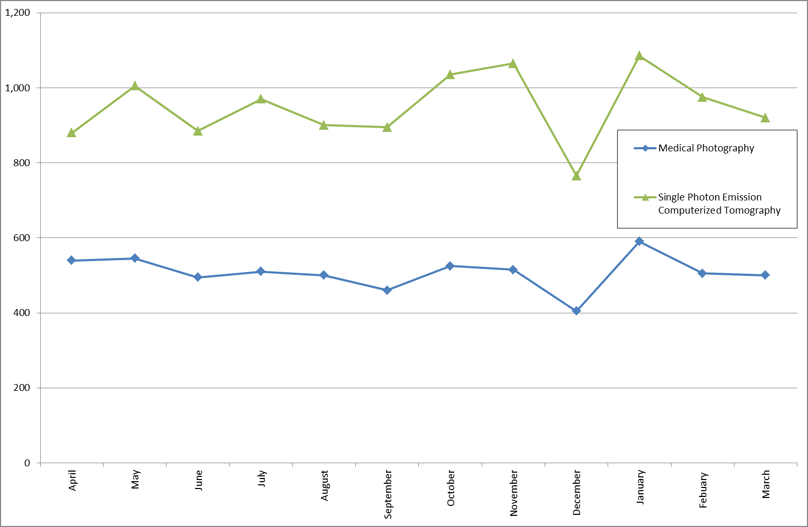

Graph 1.2: Graph of imaging activity in England, on NHS patients, by modality, for April 2012 – March 2013

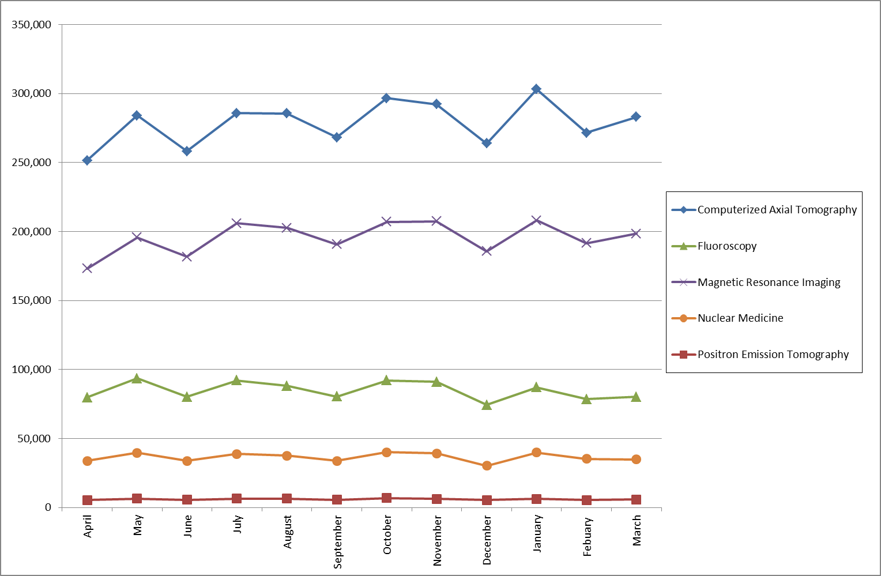

Graph 1.3: Graph of Plain Radiography and Ultrasound activity in England, on NHS patients, for April 2012 – March 2013

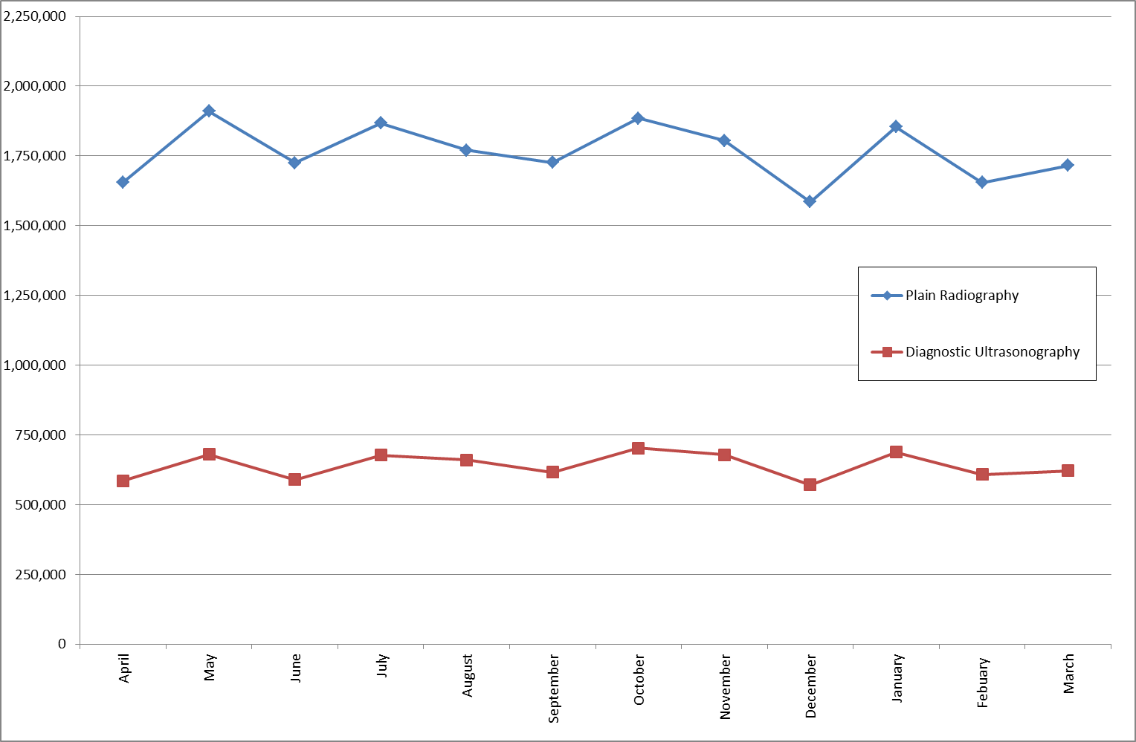

Graph 1.4: Graph of imaging activity by SHA, split by modality, for the period from April 2012-March 2013

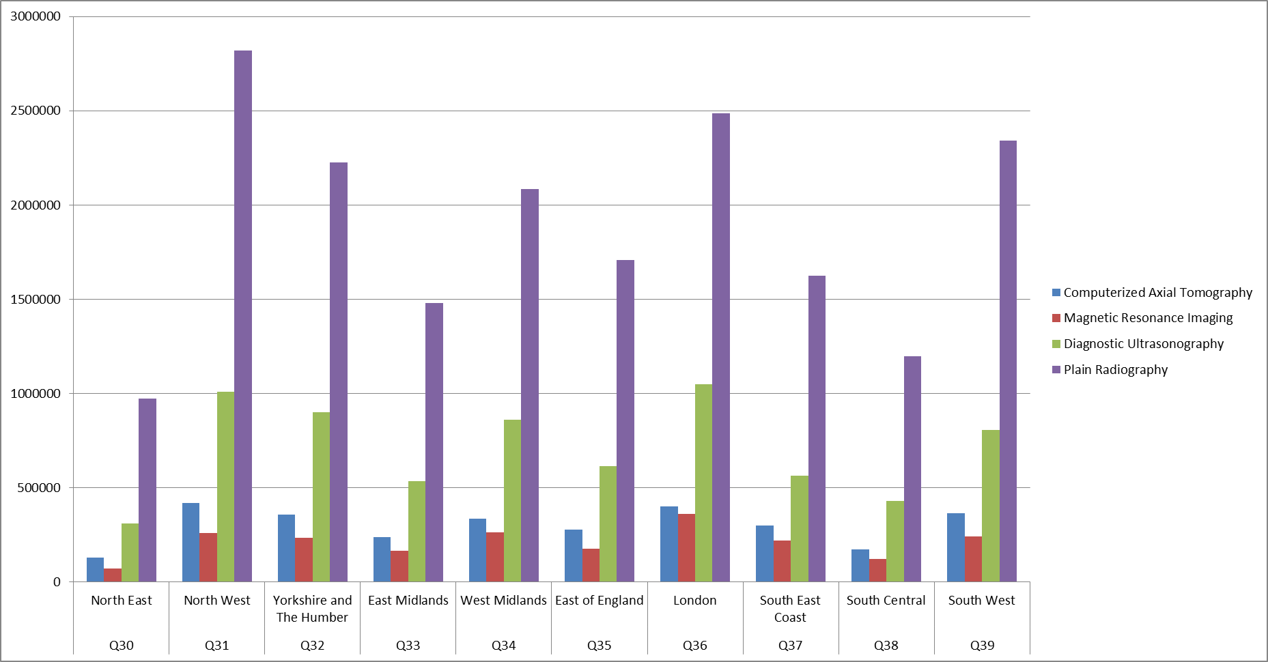

Please see Additional Table 1a-1l (separate Excel file) for a break-down of imaging by modality and by provider.

Imaging Activity by Gender

Table 1.2 show the gender of patients who have received diagnostic tests in 2012/13. More than 5.5 million tests were performed on females than on males, the largest difference occurring for ultrasound procedures. This difference is statistically significant.

Table 1.2: Count of imaging activity in England, on NHS patients, by gender, for April 2012 – March 2013
 | CT Scan  (Computerised Axial Tomography) | Ultrasound  (Diagnostic Ultrasonography) | Fluoroscopy | MRI  (Magnetic Resonance Imaging) | Medical Photogra-phy | Nuclear Medicine | X-ray  (Plain Radiography) | PET Scans  (Position Emission Tomography) | SPECT Scans  (Single Photon Emission Computerized Tomography) | Total
Female | 1,619,485 | 5,463,005 | 506,895 | 1,173,705 | 3,325 | 232,415 | 11,071,830 | 25,990 | 6,690 | 20,103,340
Male | 1,602,270 | 1,899,195 | 486,610 | 1,045,465 | 2,765 | 187,375 | 9,384,675 | 37,690 | 4,000 | 14,650,045
Not Specified | 185 | 4,480 | 60 | 120 | 0 | 45 | 2,285 | * | * | 7,175
Unknown | 121,400 | 311,030 | 23,585 | 127,835 | * | 16,465 | 695,265 | 7,400 | 700 | 1,303,670
“Not Specified” means that the patient did not want to reveal their gender. “Unknown” means that information of the patient’s gender was not available.
* = suppression: values of 1 or 2 are suppressed.
Totals do not always equal the sum of parts due to rounding.
Patient Test Times

The DID collects data on four dates that are associated with each imaging event:

- Date of Test Request (by a health care professional).
- Date of Test Request Received (by the organisation that provides the imaging necessary for the test).
- Date of Test
- Date of Test Report Issued (by a health care professional interpreting the imaging output).

This publication is based on all imaging which had a Date of Test between April 2012 and March 2013.

Table 2 shows the median number of days between the ‘date of test request’ and the ‘date of test’, split by modality, for each month between April 2012 and March 2013.

When a median value of 0 occurs in the table, at least 50% of the relevant activity reported had the 'date of test request' and 'date of test' recorded as the same day. Additionally, any records that do not include either of these dates are not used in calculations for the median values.

The figures in Table 2 should not be compared to “waiting time” statistics that measure how long patients are on a waiting list for a procedure, since the dataset consists of both planned and unplanned imaging activity. Additionally, these figures might not have been adjusted for cancellations or missed appointments. Note that they also count the period between dates for each individual test, not each patient appointment.

The median period between the test request being made and the test being performed varied between the different modalities. Three of the modalities, X-ray, Fluoroscopy and Medical Photography, all had a median difference between the two dates of 0 for the year. By contrast, the MRI-scans had the largest differences, which generally exceeded 3 weeks. The median differences for the other modalities were between these two values.

Table 2: Median number of days between ‘date of test request’ and ‘date of test’ for imaging activity, April 2012 – March 2013
 | CT Scan  (Computerised Axial Tomography) | Ultrasound  (Diagnostic Ultrasonography) | Fluoroscopy | MRI  (Magnetic Resonance Imaging) | Medical Photography | Nuclear Medicine | X-ray  (Plain Radiography) | PET Scans  (Position Emission Tomography) | SPECT Scans  (Single Photon Emission Computerized Tomography)
April | 1 | 13 | 0 | 25 | 0 | 15 | 0 | 8 | 11
May | 2 | 13 | 0 | 23 | 0 | 14 | 0 | 8 | 13
June | 1 | 13 | 0 | 25 | 0 | 15 | 0 | 8 | 13
July | 2 | 13 | 0 | 22 | 0 | 14 | 0 | 7 | 12
August | 2 | 13 | 0 | 23 | 0 | 15 | 0 | 8 | 13
September | 1 | 13 | 0 | 22 | 0 | 15 | 0 | 7 | 14
October | 2 | 12 | 0 | 21 | 0 | 14 | 0 | 7 | 15
November | 2 | 13 | 0 | 22 | 0 | 14 | 0 | 7 | 16
December | 1 | 12 | 0 | 24 | 0 | 14 | 0 | 7 | 13
January | 2 | 13 | 0 | 26 | 0 | 17 | 0 | 8 | 20
February | 2 | 12 | 0 | 21 | 0 | 14 | 0 | 7 | 17
March | 1 | 13 | 0 | 21 | 0 | 14 | 0 | 7 | 16
Please see Additional Tables 2a-2l (separate Excel file) for the median number of days between ‘date of test request’ and ‘date of test’ for imaging activity by modality and by provider.

The following maps highlights the proportion of imaging which occurred in less than a seven and less than fourteen days of the test being requested, split by modality, for each PCT in England. The maps show regional variation. The underlying figures for these charts are given in Table 7a-7h (separate Excel file). A CCG based summary of the same information is given in Annex 3 of the Technical Report to this publication.

Percentage of Computerised Axial Tomography imaging where the ‘Date of test request’ to the ‘Date of test’ is 7 days or less by PCT for all sources of referral
(Includes: A&E, Inpatient, Outpatient, GP Direct Access.)

London

Londonn
Percentage of patients having a Computerised Axial Tomography within 14 days or less
London
Percentage of Computerised Axial Tomography imaging where the ‘Date of test request’ to the ‘Date of test’ is 14 days or less by PCT for all sources of referral
(Includes: A&E, Inpatient, Outpatient, GP Direct Access.)

London
Percentage of Diagnostic Ultrasonography imaging where the ‘Date of test request’ to the ‘Date of test’ is 7 days or less by PCT for all sources of referral
(Includes: A&E, Inpatient, Outpatient, GP Direct Access.)

London
London
Percentage of Diagnostic Ultrasonography imaging where the ‘Date of test request’ to the ‘Date of test’ is 14 days or less by PCT for all sources of referral
(Includes: A&E, Inpatient, Outpatient, GP Direct Access.)

London
London
Percentage of Magnetic Resonance Imaging where the ‘Date of test request’ to the ‘Date of test’ is 14 days or less by PCT for all sources of referral
(Includes: A&E, Inpatient, Outpatient, GP Direct Access.)

London
The following charts show the amount of time from 'Date of Test Request' to 'Date of Test' by patient source setting for CT, Ultrasound, MRI and Plain Radiography. This shows that emergency admissions and inpatients have shorter waits than other sources of referral. Table 9 (separate Excel file) gives the underlying figures for these charts, and all other modalities.

Graph 2.1: Count of CT imaging activity by number of days from 'Date of Test Request' to 'Date of Test' by source of referral, April 2012 to March 2013 aggregated
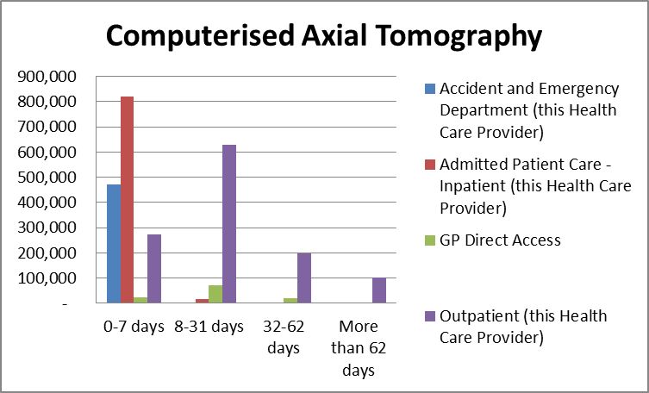

Graph 2.2: Count of Diagnostic Ultrasonography activity by number of days from 'Date of Test Request' to 'Date of Test' by source of referral, April 2012 to March 2013 aggregated
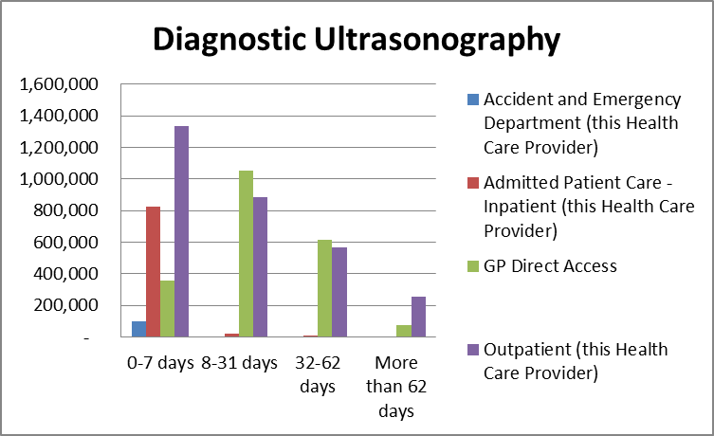

Graph 2.3: Count of MRI activity by number of days from 'Date of Test Request' to 'Date of Test' by source of referral, April 2012 to March 2013 aggregated
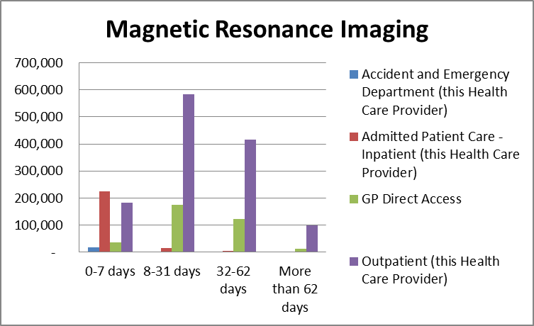

Graph 2.4: Count of Plain Radiography activity by number of days from 'Date of Test Request' to 'Date of Test' by source of referral, April 2012 to March 2013 aggregated
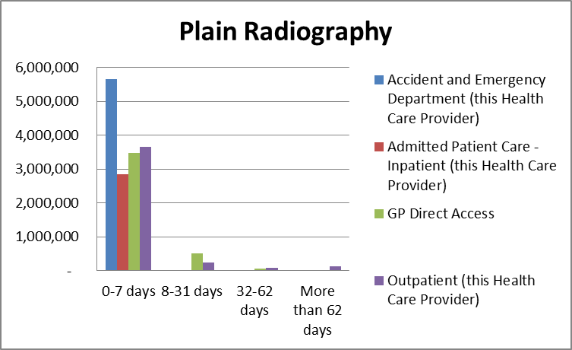

Table 3 shows the median number of days between the ‘date of test’ and the ‘date of test report issued’, split by modality, for each month between April 2012 and March 2013. When a median value of 0 occurs in the table, at least 50% of the relevant activity reported had the 'date of test request' and 'date of test' recorded as the same day. Additionally, any records that do not include either of these dates are not used in calculations for the median values.

As with the previous figures, the median period for the report to be issued after a test varied between the different modalities. CT scans, Ultrasound and Fluoroscopy procedures reported a median difference of 0 days. For MRI and, to a lesser extent, PET-scans, the median difference was 3 days during certain months. For the other modalities, the median difference was usually either one or two days. Within each modality, the waiting period for a test report remained fairly consistent throughout the 12 months.

Table 3: Median number of days between ‘date of test’ and ‘date of test report issued’ for imaging activity and percentage of records where date of test report issued equals date of test, split by modality, for April 2012 – March 2013

 | CT Scan  (Computerised Axial Tomography) |  | Ultrasound  (Diagnostic Ultrasonography) |  | Fluoroscopy |  | MRI  (Magnetic Resonance Imaging) |  | Medical Photography |  | Nuclear Medicine
 | Median | % Same day | Median | % Same day | Median | % Same day | Median | % Same day | Median | % Same day | Median | % Same day
April | 0 | 57% | 0 | 84% | 0 | 61% | 3 | 25% | 1 | 26% | 2 | 27%
May | 0 | 57% | 0 | 83% | 0 | 60% | 2 | 26% | 1 | 20% | 2 | 27%
June | 0 | 57% | 0 | 85% | 0 | 62% | 3 | 26% | 1 | 25% | 2 | 28%
July | 0 | 56% | 0 | 84% | 0 | 62% | 3 | 26% | 1 | 23% | 2 | 26%
August | 0 | 57% | 0 | 85% | 0 | 63% | 3 | 27% | 1 | 23% | 2 | 28%
September | 0 | 58% | 0 | 86% | 0 | 62% | 3 | 26% | 1 | 22% | 2 | 29%
October | 0 | 58% | 0 | 86% | 0 | 63% | 2 | 28% | 1 | 22% | 2 | 28%
November | 0 | 58% | 0 | 86% | 0 | 62% | 2 | 27% | 1 | 16% | 2 | 28%
December | 0 | 60% | 0 | 87% | 0 | 65% | 2 | 28% | 1 | 24% | 1 | 31%
January | 0 | 59% | 0 | 87% | 0 | 65% | 2 | 29% | 1 | 22% | 1 | 31%
February | 0 | 59% | 0 | 87% | 0 | 66% | 2 | 28% | 1 | 22% | 1 | 30%
March | 0 | 59% | 0 | 87% | 0 | 66% | 3 | 27% | 1 | 25% | 2 | 29%

Table 3: Median number of days between ‘date of test’ and ‘date of test report issued’ for imaging activity and percentage of records where date of test report issued equals date of test, split by modality, for April 2012 – March 2013
 | X-ray  (Plain Radiography) |  | PET Scans  (Position Emission Tomography) |  | SPECT Scans  (Single Photon Emission Computerized Tomography)
 | Median | % Same day | Median | % Same day | Median | % Same day
Apr | 2 | 29% | 2 | 7% | 1 | 42%
May | 1 | 29% | 2 | 7% | 1 | 45%
June | 2 | 28% | 3 | 7% | 1 | 44%
July | 2 | 29% | 2 | 6% | 1 | 38%
August | 2 | 30% | 2 | 7% | 1 | 39%
September | 2 | 29% | 2 | 7% | 1 | 42%
October | 1 | 32% | 2 | 6% | 1 | 42%
November | 1 | 32% | 2 | 7% | 1 | 42%
December | 1 | 33% | 2 | 7% | 1 | 48%
January | 1 | 35% | 2 | 8% | 1 | 42%
February | 1 | 34% | 2 | 5% | 1 | 34%
March | 1 | 32% | 2 | 4% | 1 | 41%

Please see Additional Tables 3a-3l (separate Excel file) for median number of days between ‘date of test’ and ‘date of test report issued’ for imaging activity by modality and by provider.
Imaging Tests that could contribute to Early Diagnosis of Cancer

One of the main drivers for the creation of the DID is to assess the use of diagnostic imaging that could contribute to the early diagnosis of cancer, and in particular, General Practitioner (GP) direct access to these tests. To enable this analysis a subset of procedures that are often used to identify or discount
a diagnosis of cancer has been identified:

Brain (MRI)
- This may diagnose brain cancer, this includes – MRI of brain (often with contrast);

Kidney or bladder (Ultrasound)
- This may diagnose kidney or bladder cancer, this includes – ultrasound of kidney, ultrasound scan of bladder or ultrasound and doppler scan of kidney;

Chest and/or abdomen (CT)
- CTs which may diagnose lung cancer, this includes - Chest + Abdominal CT, CT of chest (high resolution or other), CT thorax + abdomen with contrast, CT thorax with contrast or CT chest + abdomen;

Chest (X-ray)
- This may diagnose lung cancer, this includes – Plain chest X-ray only;

Abdomen and/or pelvis (Ultrasound)
- This may diagnose ovarian cancer, this includes – Ultrasonography of pelvis, Ultrasonography of abdomen (upper, lower or other) or abdomen + pelvis.

Note that brain MRI, chest x-ray, and ultrasounds of the abdomen and pelvis to diagnose Ovarian Cancer were three of the key tests outlined in Improving Outcomes: a Strategy for Cancer.

Although these tests are used to diagnose cancer, many of the tests also have wider clinical uses. Within this data, it is not possible to distinguish between the different uses of these tests.

In 2012/13, over 10 million tests that may have been used to diagnose or discount cancer were performed. Of those, almost 27% of tests were requested by GPs under direct access arrangements.

The most common test requested through all source settings was Chest X-rays, with approximately 7.7 million tests being requested. This was also the most common test requested by GPs. The next most common tests were ones that may have been used to diagnose ovarian cancers, with 46% of such tests being requested by a GP.

Table 4 shows the number of tests being carried out on NHS patients that might have been used to make an early diagnosis of cancer. It includes the total number of these tests carried out, regardless of patient source setting, as well as a subset of this total; where the patient source setting was recorded as “GP Direct Access”

Graphs 4.1-4.3 shows how the amount of imaging activity that could have been used to diagnose or discount cancer has changed over the previous year. Graph 4.4 compares the proportion of tests for each of the different subset of procedures that were requested by GPs.

Table 4: Count of imaging activity, using groups of tests suitable for diagnosing cancer, labelled by body site, for all patients referred and those directly referred by a GP, for April 2012 – March 2013

 | Brain (MRI) |  | Kidney or bladder (Ultrasound) |  | Chest and/or abdomen  (CT) |  | Chest (X-ray) |  | Abdomen and/or pelvis (Ultrasound)
 | All | GP | All | GP | All | GP | All | GP | All | GP
Apr | 35,100 | 2,090 | 16,990 | 5,275 | 28,650 | 2,145 | 606,840 | 144,140 | 89,515 | 41,070
May | 39,190 | 2,450 | 19,505 | 6,105 | 33,875 | 2,685 | 689,605 | 200,015 | 103,720 | 48,055
Jun | 36,395 | 2,420 | 16,580 | 4,820 | 30,285 | 2,400 | 637,350 | 179,090 | 90,085 | 40,500
Jul | 40,120 | 2,880 | 19,045 | 6,080 | 34,295 | 3,130 | 666,150 | 186,940 | 103,030 | 48,280
Aug | 40,395 | 2,780 | 18,710 | 5,600 | 33,240 | 2,980 | 610,650 | 160,685 | 100,855 | 47,070
Sep | 38,025 | 2,545 | 17,925 | 5,505 | 30,480 | 2,445 | 582,095 | 139,940 | 95,680 | 44,680
Oct | 41,950 | 2,790 | 20,530 | 6,485 | 34,580 | 2,805 | 657,905 | 166,830 | 106,210 | 50,045
Nov | 41,785 | 2,625 | 19,595 | 6,185 | 33,830 | 2,760 | 652,590 | 162,715 | 103,080 | 48,175
Dec | 37,385 | 2,545 | 16,690 | 4,975 | 29,680 | 2,390 | 625,505 | 131,300 | 84,840 | 38,310
Jan | 42,690 | 2,650 | 19,965 | 5,955 | 35,355 | 2,840 | 711,035 | 188,940 | 102,840 | 46,950
Feb | 39,160 | 2,560 | 17,315 | 5,195 | 31,780 | 2,720 | 624,060 | 165,175 | 92,340 | 42,075
Mar | 40,350 | 2,665 | 17,105 | 5,265 | 32,255 | 2,810 | 652,225 | 163,420 | 92,020 | 41,525
Total | 472,755 | 31,030 | 220,230 | 67,460 | 388,655 | 32,185 | 7,723,410 | 1,991,705 | 1,165,345 | 536,930

Totals do not always equal the sum of parts due to rounding
Graph 4.1: Graph of Chest X-Ray imaging activity, for patients directly referred by a GP, for April 2012 – March 2013
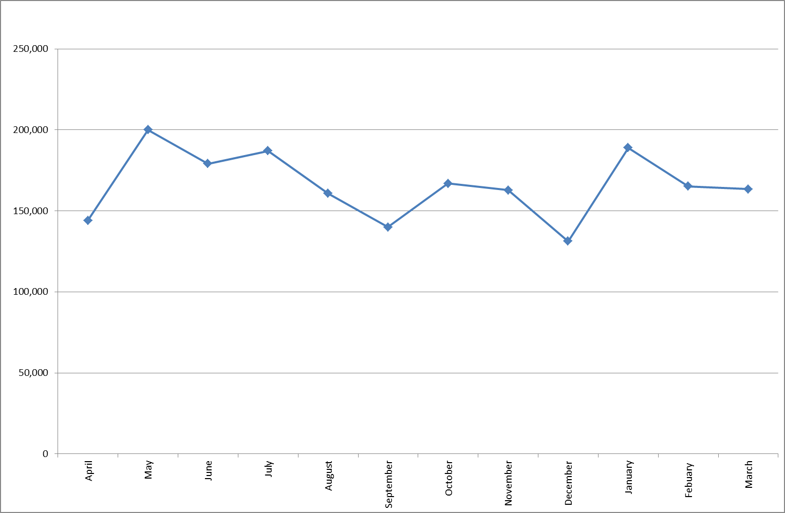

Graph 4.2: Graph of Abdomen and/or Pelvis Ultrasound imaging activity, for patients directly referred by a GP, for April 2012 – March 2013

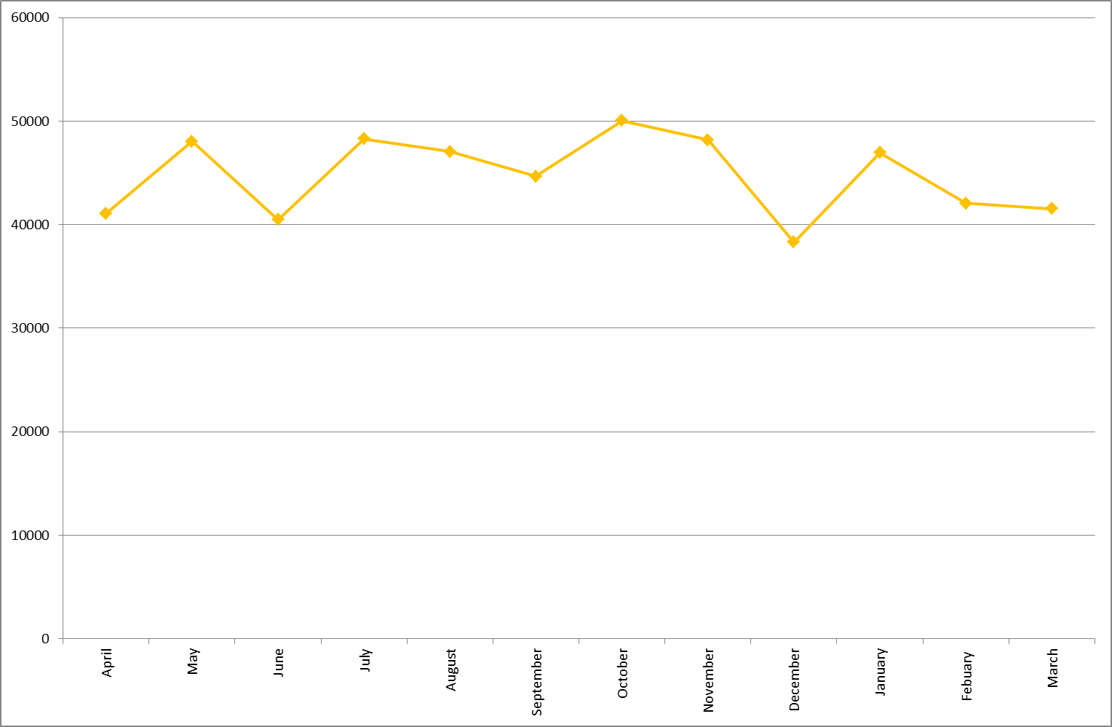
Graph 4.3: Graph of imaging activity for other listed tests, for patients directly referred by a GP, for April 2012 – March 2013

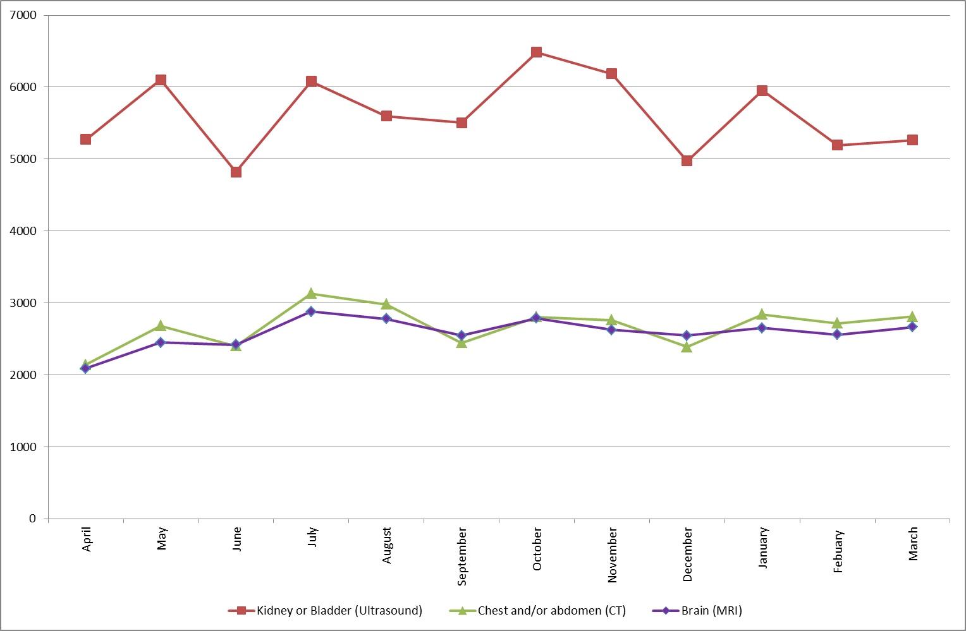

Graph 4.4: Graph of the percentage of referrals made by General Practitioners, by type of test, for April 2012 to March 2013 aggregated

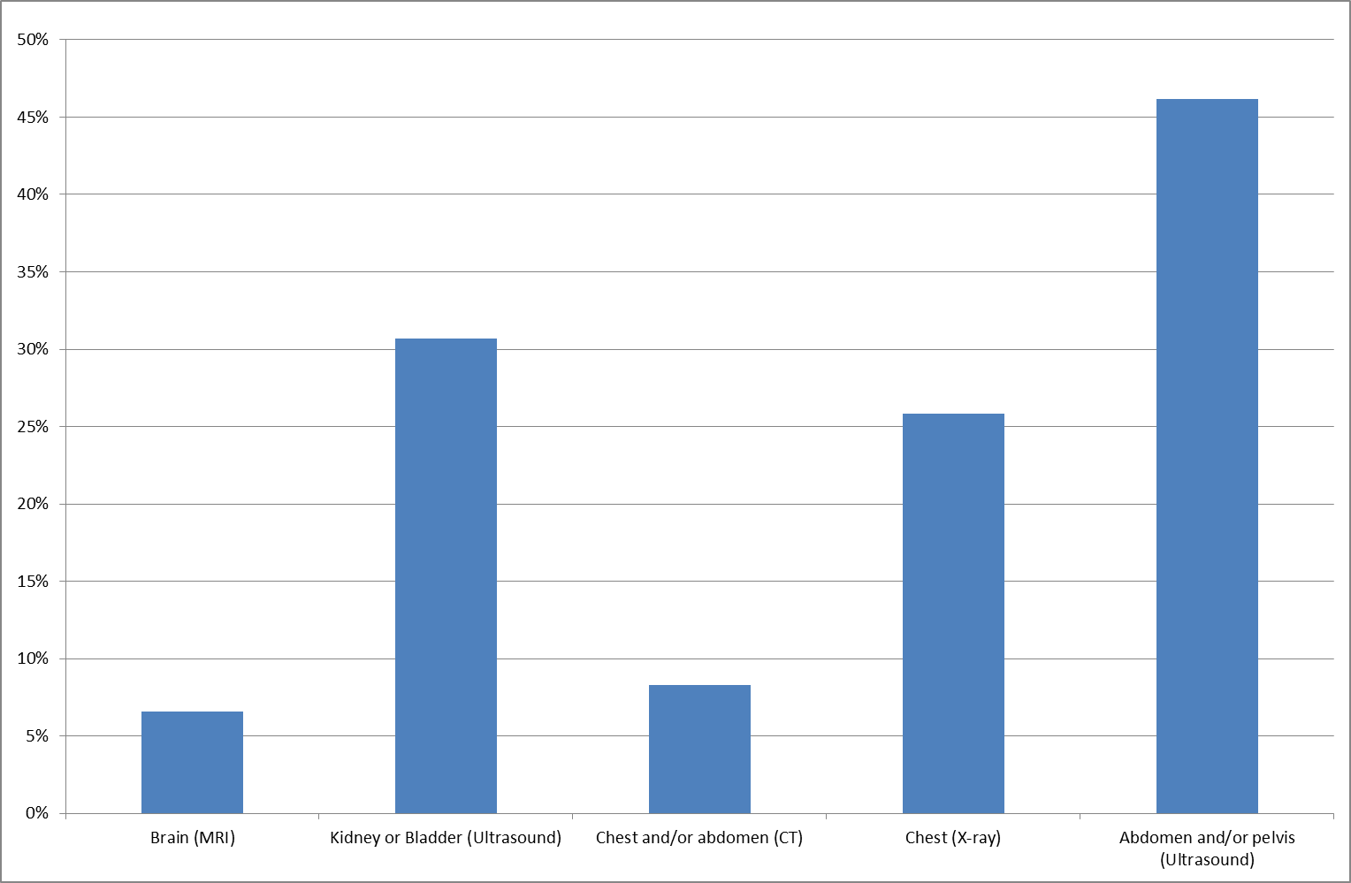

Please see Additional Tables 4a-4l (separate Excel file) for a count of imaging activity, using tests suitable for diagnosing Cancer, by body site, for all patients referred and those directly referred by a GP, by provider for April 2012 – March 2013

Table 5 shows the median number of days between the ‘date of test request’ and the ‘date of test’, split by the different groups of tests, for each month between April 2012 and March 2013. This includes both the data from all patient source settings and those that were referred through GP direct access.

Where a median value of 0 occurs in the table, at least 50% of the activity reported had the 'date of test request' and 'date of test' recorded as the same day. In addition, any records that do not include either of these dates are not used in calculations for median values.

With the exception of Chest X-ray, for the key tests that may be used to diagnose or discount cancer, the median period from a test being requested to being performed is longer for GP direct access compared with all referrals. The main reason for this difference is that ‘all referrals’ includes tests on emergency admissions and inpatients, which have shorter waits.

Graphs 5.1 – 5.2 shows how the median number of days between the ‘date of test request’ and ‘date of test’ have changed across each month for procedures diagnosing kidney or bladder cancers and abdomen and/or pelvis cancers respectively.

Table 5: Median number of days between ‘date of test request’ and ‘date of test’ for imaging activity using groups of tests suitable for diagnosing cancer, labelled by body site, split by
patient source setting “GP Direct Access”, for April 2012 – March 2013

 | Brain (MRI) |  | Kidney or bladder (Ultrasound) |  | Chest and/or abdomen  (CT) |  | Chest (X-ray) |  | Abdomen and/or pelvis (Ultrasound)
 | All | GP | All | GP | All | GP | All | GP | All | GP
Apr | 23 | 26 | 13 | 24 | 13 | 18 | 0 | 0 | 16 | 25
May | 21 | 25 | 13 | 21 | 12 | 15 | 0 | 0 | 15 | 23
Jun | 22 | 27 | 14 | 23 | 13 | 18 | 0 | 0 | 16 | 26
Jul | 20 | 27 | 14 | 27 | 12 | 17 | 0 | 0 | 15 | 23
Aug | 21 | 26 | 13 | 26 | 12 | 17 | 0 | 0 | 15 | 24
Sep | 20 | 24 | 14 | 26 | 12 | 16 | 0 | 0 | 15 | 23
Oct | 19 | 24 | 13 | 22 | 12 | 15 | 0 | 0 | 13 | 21
Nov | 20 | 25 | 13 | 22 | 12 | 16 | 0 | 0 | 14 | 21
Dec | 21 | 27 | 12 | 22 | 12 | 17 | 0 | 0 | 14 | 21
Jan | 24 | 27 | 14 | 24 | 14 | 19 | 0 | 0 | 14 | 23
Feb | 19 | 22 | 12 | 19 | 13 | 17 | 0 | 0 | 14 | 20
Mar | 20 | 23 | 12 | 21 | 12 | 17 | 0 | 0 | 14 | 22
Graph 5.1: Graph of the median number of days between ‘date of test request’ and ‘date of test’ for Kidney or Bladder Ultrasound imaging activity, split by patient source setting “GP Direct Access”, for April 2012 – March 2013
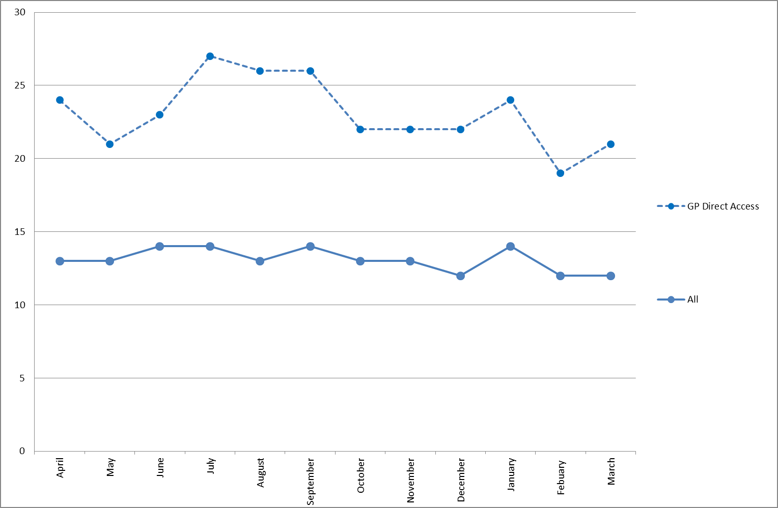

Graph 5.2: Graph of the median number of days between ‘date of test request’ and ‘date of test’ for Abdomen and/or Pelvis Ultrasound imaging activity, split by patient source setting “GP Direct Access”, for April 2012 – March 2013.

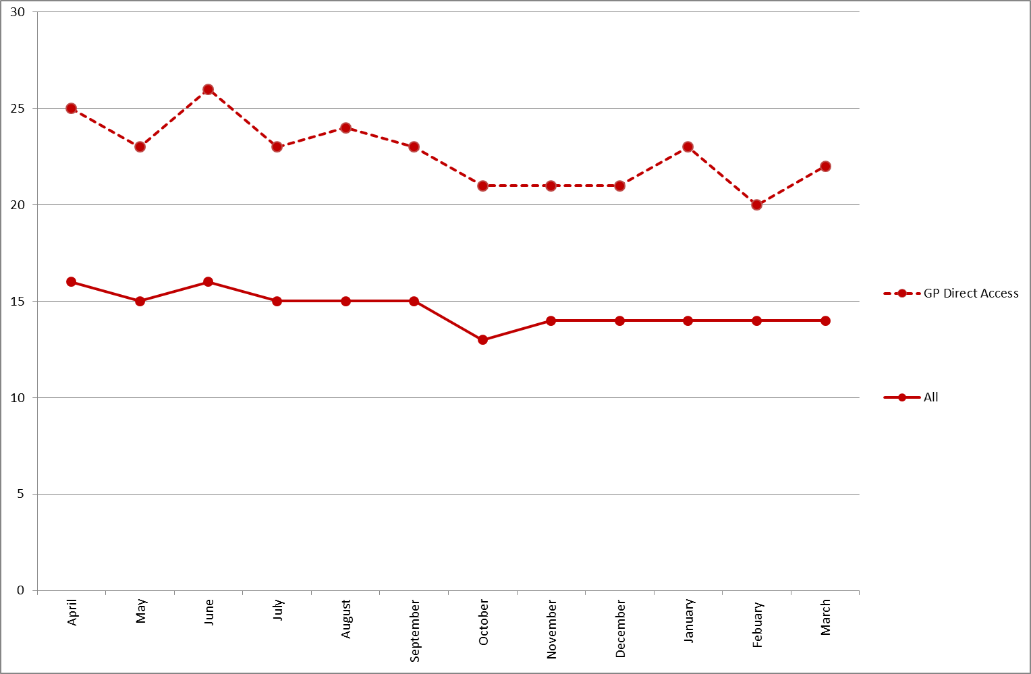
Please see Additional Table 5a-5l (separate Excel file) for median number of days between ‘date of test request’ and ‘date of test’.

The imaging activity for April 2012 until March 2013 in these tables is presented by body site, split by patient source setting (GP Direct Access) and by provider. Table 8a-8c (separate Excel file) give PCT summaries. A CCG based summary of the same information is given in Annex 3 of the Technical Report to this publication.

In the following table, median values of 0 occur where at least 50% of activity has a 'date of test' and 'date of test report issued date' which is recorded as the same day. Records where either of these dates is missing are excluded from the calculation of median values.

Table 6 shows the median number of days between the ‘date of test’ and the ‘date of test report issued’, split by the different groups of tests, for each month between April 2012 and March 2013. This includes both the data from all patient source settings and those that were referred through GP direct access.

When a median value of 0 occurs in the table, at least 50% of the relevant activity reported had the 'date of test request' and 'date of test' recorded as the same day. Additionally, any records that do not include either of these dates are not used in calculations for the median values.

Table 6: Median number of days between date of test and date of test report issued for imaging activity and percentage of records where date of test report issued equals date of test, using groups of tests suitable for diagnosing cancer, labelled by body site, split by patient source setting “GP Direct Access”, for April 2012 – March 2013

Month | Measure | Apr | May | Jun | Jul | Aug | Sep | Oct | Nov | Dec | Jan | Feb | Mar
Brain (MRI) | All Median | 2 | 2 | 2 | 2 | 2 | 2 | 1 | 2 | 2 | 1 | 1 | 2
Brain (MRI) | All % Same Day | 31% | 32% | 30% | 31% | 31% | 31% | 33% | 33% | 34% | 35% | 34% | 33%
Brain (MRI) | GP Median | 4 | 3 | 3 | 5 | 3 | 3 | 2 | 2 | 3 | 2 | 2 | 3
Brain (MRI) | GP % Same Day | 15% | 17% | 18% | 14% | 15% | 17% | 18% | 18% | 18% | 20% | 17% | 17%
Kidney or bladder (Ultrasound) | All Median | 0 | 0 | 0 | 0 | 0 | 0 | 0 | 0 | 0 | 0 | 0 | 0
Kidney or bladder (Ultrasound) | All % Same Day | 84% | 83% | 85% | 83% | 85% | 85% | 86% | 85% | 86% | 86% | 86% | 86%
Kidney or bladder (Ultrasound) | GP Median | 0 | 0 | 0 | 0 | 0 | 0 | 0 | 0 | 0 | 0 | 0 | 0
Kidney or bladder (Ultrasound) | GP % Same Day | 79% | 79% | 80% | 74% | 78% | 79% | 82% | 80% | 79% | 82% | 81% | 82%
Chest and/or abdomen  (CT) | All Median | 1 | 1 | 1 | 1 | 1 | 1 | 1 | 1 | 1 | 1 | 1 | 1
Chest and/or abdomen  (CT) | All % Same Day | 42% | 43% | 42% | 41% | 40% | 41% | 43% | 42% | 44% | 44% | 42% | 41%
Chest and/or abdomen  (CT) | GP Median | 2 | 1 | 2 | 2 | 2 | 2 | 1 | 1 | 2 | 1 | 2 | 2
Chest and/or abdomen  (CT) | GP % Same Day | 33% | 35% | 31% | 30% | 29% | 33% | 35% | 34% | 32% | 33% | 32% | 29%
Chest  (X-ray) | All Median | 2 | 2 | 2 | 2 | 2 | 2 | 2 | 2 | 2 | 1 | 2 | 2
Chest  (X-ray) | All % Same Day | 24% | 25% | 23% | 23% | 24% | 23% | 26% | 26% | 26% | 28% | 28% | 26%
Chest  (X-ray) | GP Median | 2 | 2 | 2 | 2 | 2 | 2 | 1 | 1 | 1 | 1 | 1 | 2
Chest  (X-ray) | GP % Same Day | 28% | 28% | 25% | 25% | 27% | 28% | 31% | 31% | 34% | 34% | 30% | 28%
Abdomen and/or pelvis (Ultrasound) | All Median | 0 | 0 | 0 | 0 | 0 | 0 | 0 | 0 | 0 | 0 | 0 | 0
Abdomen and/or pelvis (Ultrasound) | All % Same Day | 83% | 83% | 85% | 84% | 85% | 86% | 87% | 87% | 88% | 87% | 88% | 88%
Abdomen and/or pelvis (Ultrasound) | GP Median | 0 | 0 | 0 | 0 | 0 | 0 | 0 | 0 | 0 | 0 | 0 | 0
Abdomen and/or pelvis (Ultrasound) | GP % Same Day | 81% | 82% | 83% | 82% | 84% | 84% | 85% | 85% | 87% | 85% | 87% | 87%

Please see Additional Table 6a-6l (separate Excel file) for median number of days between date of test and date of test report issued for imaging activity specific to the early diagnosis of cancer, split by patient source setting “GP Direct Access” and by provider for April 2012 – March 2013.

Graphs 7.1 to 7.3 plot the average number of days from ‘date of test request’ to ‘date of test’ VERSUS average days from ‘date of test’ to ‘date of test report issued: Ultrasound of the Abdomen and/or Pelvis on females; Brain MRI; and Chest x-rays. Each data point represents a provider, and the size of the bubble indicates the amount of imaging activity.

Graph 7.1: Plot of average days from ‘date of test request’ to ‘date of test’ VERSUS average days from ‘date of test’ to ‘date of test report issued’ for Ultrasound of the Abdomen and/or Pelvis carried out on females, by source of referral, April 2012 to March 2013 aggregated
Graph 7.2: Plot of average days from ‘date of test request’ to ‘date of test’ VERSUS average days from ‘date of test’ to ‘date of test report issued’ for Brain MRIs, by source of referral, April 2012 to March 2013 aggregated
Graph 7.3: Plot of average days from ‘date of test request’ to ‘date of test’ VERSUS average days from ‘date of test’ to ‘date of test report issued’ for Chest x-rays, by source of referral, April 2012 to March 2013 aggregated
Note: These statistics should not be compared to diagnostic test waiting time statistics, as these are collected using different definitions. Unlike these statistics, the DM01 diagnostic test waiting times statistics exclude records where, for example:
- The patient is waiting for a planned (or surveillance) diagnostic test/procedure, i.e. a procedure or series of procedures as part of a treatment plan which is required for clinical reasons to be carried out at a specific time or repeated at a specific frequency, e.g. 6-month check cystoscopy;
- The patient is currently admitted to a hospital bed and is waiting for a diagnostic/test procedure as part of their inpatient treatment.

In addition, for the data published here, only approximately 80% of tests had a date of test request included and only approximately 90% of tests had a date of test report issue included.

Revisions: Key changes from provisional estimates

- A new lookup table has been introduced. Some of the figures previously published are reported under a different modality in this publication. For example, the Computerised Axial Tomography modality used to include Positron Emission Tomography, but these scans are now reported separately. In addition, some treatments that were not previously mapped to any modality have now been assigned to a modality, so they appear in these tables for the first time.
- In the original publications, many Trusts did not provide data on time, and their figures were either blank or "0" for certain fields. Many of these cases now show large numbers. This is a result of increased data coverage.
- We have previously suppressed organisations' data more widely. For example, Trusts' data have been suppressed if there have been problems with duplicates or with submissions from sites outside their jurisdiction. We provided Trusts with an opportunity to revise their data and improve their data quality before this annual publication. This data are now finalised and, as Trusts have no opportunity remaining to revise their data, suppressions have only been made in exceptional cases.

Data quality notes
- Some figures in Table 5b of the accompanying detailed tables have been suppressed, as the data suggested a negative median for the days between the request of a test and a test.
- The time series for some Trusts show exceptionally low or high values for certain months in an otherwise consistent series across other months. This may be a result of seasonal trends (e.g. there are usually fewer tests in December than in other months) but it may be a result of problems for the submitter in a particular month, in which case the data would be less reliable. This issue is most apparent in Table 5.
- Some trusts are outliers: for example, Hull & East Yorkshire NHS Trust for the time between a test and a report’s being issued.
- Over the course of 2012/13, some trusts have merged. For example, Barts & the London, Newham and Whipps Cross have merged to form a new Barts NHS Health Trust. In some months, both the old and the new organisations are on the list of data, so there may be some duplication.
- Some patient records have no known commissioner. Data are submitted by provider, so data quality is better for providers than for commissioners.

Definitions
Computerised Axial Tomography (CT Scan)
Computed tomography (CT), sometimes called CAT scan, uses special x-ray equipment to obtain image data from different angles around the body, then uses computer processing of the information to show a cross-section of body tissues and organs. In the DID this means all codes mentioning CAT or computed tomography, including PET CT.

Diagnostic Ultrasonography (Ultrasound)
The use of ultrasonic waves for diagnostic or therapeutic purposes, specifically to image an internal body structure, monitor a developing foetus, or generate localised deep heat to the tissues. In the DID this means any code relating to ultrasound.

Fluoroscopy
Fluoroscopy is an imaging technique commonly used by physicians to obtain real-time images of the internal structures of a patient through the use of a fluoroscope. In its simplest form, a fluoroscope consists of an x-ray source and fluorescent screen between which a patient is placed. In the DID this is a collection of codes mentioning fluoroscopy or using fluoroscopic guidance, Barium enema or swallow. Interventional procedures are classified under imaging modalities which provide guidance. Almost all interventional procedures are under fluoroscopy procedure. A very small number of interventional procedures are under CT or MRI procedures.

Magnetic Resonance Imaging (MRI)
Magnetic resonance imaging (MRI) is a method of producing extremely detailed pictures of body tissues and organs without the need for x-rays. The electromagnetic energy that is released when exposing a patient to radio waves in a strong magnetic field is measured and analysed by a computer, which forms two- or three-dimensional images that may be viewed on a TV monitor. In the DID this means all codes mentioning MRI.

Plain Radiography (X-ray)
A Radiograph is an image produced on a radiosensitive surface, such as a detector, by radiation other than visible light, especially by x-rays passed through an object or by photographing a fluoroscopic image. In the DID this means any code referring to radiography or X-ray.

Medical Photography
A Photograph is an image recorded on sensitized material by energy from the light spectrum, which is then processed to create a print that can be viewed clearly. Medical Photography is used in order to document a variety of different medical conditions and their treatment.

Nuclear Medicine
Nuclear medicine (NM) is a branch of medicine and medical imaging that uses unsealed radioactive substances in diagnosis and therapy. These substances consist of radionuclides, or pharmaceuticals that have been labelled with radionuclides (radiopharmaceuticals). In diagnosis, radioactive substances are administered to patients and the radiation emitted is measured.

Nuclear medicine imaging tests differ from most other imaging modalities in that the tests primarily show the physiological function of the system being investigated, as opposed to the anatomy. It has both diagnostic and therapeutic uses, such as planning cancer treatments and evaluating how well a patient has responded to a treatment. It can be used with other diagnostic methods, including CT scans and MRI, where the images are superimposed to produce complex cross-sectional, three-dimensional scans.

Position Emission Tomography (PET Scans)
Position Emission Tomography (PET Scans) is an imaging technique used in the diagnosis and treatment of cancer. The method is similar to CT scans, but uses gamma cameras to produce three-dimensional images highlighting radionuclide concentration in a specific part of the body. PET scans can be used to show how far a cancer has spread, and can determine if a patient is responding positively to a treatment.

Single Photon Emission Computerised Tomography (SPECT scans)
Single Photon Emission Computerised Tomography (SPECT scans) is an imaging method that allows for analysis of internal organs. Gamma photon-emitting radionuclides are administered to a patient prior to being exposed to gamma cameras that rotate around a patient to produce cross-sectional slices that can then be reformatted into a true three-dimensional image of the patient.

Median
The median is the preferred measure of the average time between pairs of dates within records as it is less susceptible to extreme values than the mean. The median number of days between pairs of dates is calculated by ordering the values obtained by subtracting the dates for each record and selecting the middle value when all records are ranked by these number of days. For example, to calculate the median number of days between date of test and data of test request, for all records where the date of test falls into the month of interest, the number of days between the two dates is calculated. The number of days for all records are ordered from lowest to highest; the middle number in the list is the median.

Modality
The broad procedure or method used for examination, for example MRI. This may include procedures assisted by the method, e.g. biopsy or injection. In the DID the modality of the examination is derived from SNOMED or NICIP.

Patient source setting
This is a categorisation of the department or organisation making the referral for the imaging activity. It includes categories for admitted patient care, outpatients, GP Direct Access, A&E and health care providers different to the organisation providing the imaging activity, as well as an ‘other’ category.

Contact Us
Restricted Statistics – These Statistics are restricted until 9:30 22nd November 2012

Feedback

We welcome feedback on this publication. Please contact us at did@dh.gsi.gov.uk

iView
The HSCIC will be allowing health sector colleagues to access DID information through their web-based reporting tool, iView. Registered users will be able to access anonymised data at aggregate level in a consistent and flexible format:
• Access Information – choose from a variety of data areas.
• Build Reports – select data to suit your needs.
• Generate Charts – customise report tables and graphs.
• Export Data – copy to Excel and manipulate data your way.
• Save Reports – store your favourite views for future use.
If you would like to register to use iView for DID, please email enquiries@ic.nhs.uk (subject: DID iView Access). For more information, please visit the iView website http://www.hscic.gov.uk/iview

Website

The DID website can be found here: https://did.hscic.gov.uk/

The DID Additional Tables and Technical Report can be found here:
http://www.england.nhs.uk/statistics/diagnostic-imaging-dataset/

Additional Information
For media enquiries contact the NHS England media team. Please refer to the NHS England website for the relevant contact details:
http://www.england.nhs.uk/contact-us/

The Government Statistical Service (GSS) statistician responsible for producing these data is:
Mark Svenson
Analytical Service (Operations)
NHS England
Room 8E28, Quarry House, Quarry Hill, Leeds LS2 7UE
Email: did@dh.gsi.gov.uk

A comparison test was performed to compare the rate of imaging tests per male and per female in different NHS trusts. Assumptions were made that the population variance across trusts was unknown, and that each trust had equal numbers of male and female patients. The analysis showed that in 2013/14 an average of 0.67 imaging tests was performed on each female. This is compared to an average of 0.47 imaging tests performed on each male. A t-test confirmed that this result was ‘statistically significant’ at the 5% level. Other non-parametric tests lead to the same conclusion.

