**NHS 111 MDS Monthly Data: July 2013**











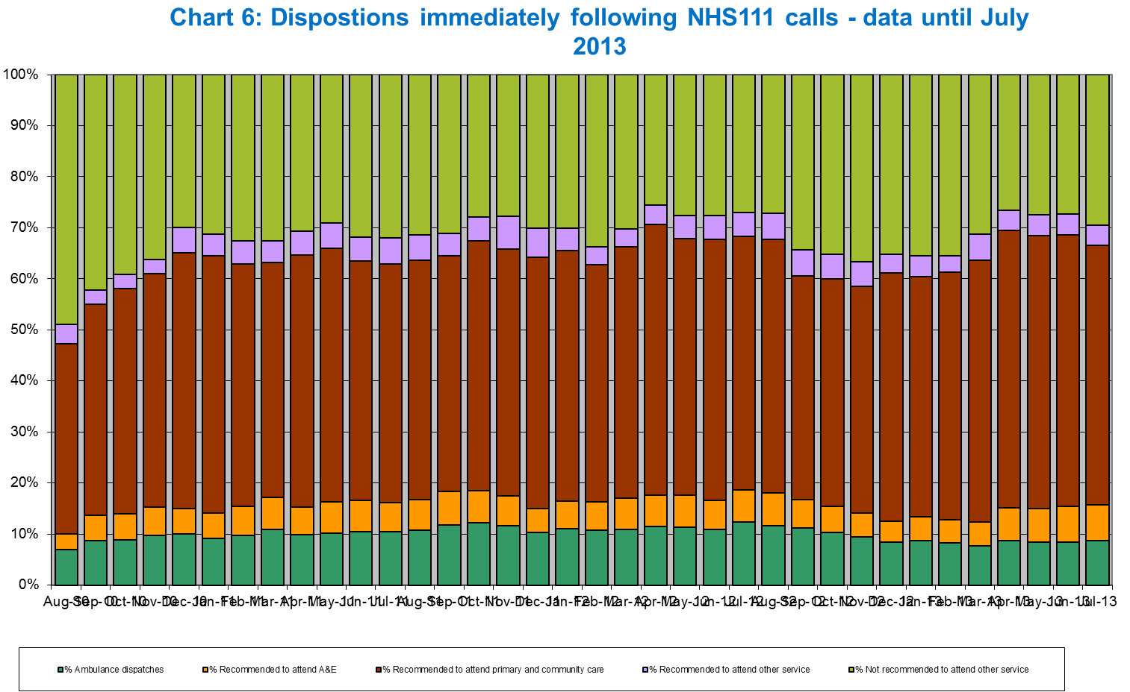

**Statistical Notes:**

**Additional Information:**

Further details of the NHS 111 minimum dataset for individual organisations is available at:

http://transparency.dh.gov.uk/category/statistics/nhs-111-statistics/

**Data Sources:**

NHS111 pilot sites, NHS111 Commissioners, Department of Health, NHS Direct

**Announced Changes:**

We are continuing to work with all data providers involved in this return to further improve data availability and quality. All published

data are the latest position available rather than the definitive position. If historical data are revised in any way then this will be

reflected in the NHS 111 Minimum Data Set.

Key areas of ongoing work are listed below. Any material changes to the data or presentation of the NHS 111 Minimum Data Set

are listed below by month of publication, beginning with the most recent update.

**1. Ongoing data quality work:**

**Data tagging:** There is currently some variability in how some MDS data items are calculated between pilot sites. We are

continually working with providers to understand these variations and a big part of this work are data tagging exercises that take

place with each new provider. This work includes mapping the data collection process and identifying where each MDS data

item is to be collected. These process maps can then be used to compare how data items are calculated between different

providers.

**MDS Format**: The format, in which the data is presented, is currently being reviewed. This is to help incorporate a number of new sites into the statistical release as new sites go live.

**2. Material Changes**

Release date, 6th September 2013 – July data

* North West London has started to submit calls data this month under the provider Harmoni.
* Systems Impact data has started to become available for Wandsworth PCT

Release date, 2 Aug, 2013 – June data.

* Some areas are unable to provide accurate “calls not triaged: other” because of a discrepancy between calls answered and

the number of calls being reported for. Any minus figures have been replaced with a 0 in this field.

* South Essex and Oxfordshire have only been able to provide a partial return because of data problems. We are working the

provider and commissioners on this.

* ONEL have now been able to provide call level data.

Release date, 5 July, 2013 – May data.

* South Essex and Oxfordshire have only been able to provide a partial return because of data problems. We are working the

provider and commissioners on this.

Release date, 7 June, 2013 – April data.

* Systems impact data has now become available for Herts and GY&W.
* South Essex and Oxfordshire have only been able to provide a partial return because of data problems. We are working the

provider and commissioners on this.

* Patient Satisfaction Survey Results have also been published for up to March 2013.

Release date, 10 May, 2013 – March data.

*  Oxfordshire are still struggling to report on times. We are working with the provider to rectify this.

Release date, 11 Apr, 2013 – February data.

*  S&M have had problems providing a full set of data, Caller Not Triaged data cannot be accurately reported at this time. The

problem has now been rectified for next month’s submission.

Release date, 08 Mar, 2013 – January data.

*  Harmoni revised their data to provide more accurate Caller Not Triaged figures. This is now rectified for future submissions.
* Population figures for Lancashire were revised to show a more accurate estimate.

Release date, 01 Feb, 2013 – December data.

* INWL Revised data for their total call backs to accurately reflect calls transferred.
* The most recent patient satisfaction survey results are now available for April – October 2012.
* Systems impact data for INWL is now available.

Release date, 11 Jan, 2013 – November data.

*  Both Hillingdon and Croydon sites are unable to provider “Average Live Transfer” and “Average Episode Length” times. We

are working with providers to ensure this is corrected.

*  Derby revised their calls offered to account for missing calls in the ‘abandoned in under 30 seconds calls’ field.

Release date, 30 Nov, 2012 – October data.

*  Both Hillingdon and Croydon sites are unable to provider “Average Live Transfer” and “Average Episode Length” times. We

are working with providers to ensure this is corrected.

*  The population figure for The North West has been changed to show the most up to date figure.

Release date, 02 Nov, 2012 – September data.

*  In Reasons not triaged, we have amended the figures in “reason for non-triage: other” to a balancing figure to ensure all

answered calls are accounted for. Previously there were missing calls, which were not recorded in the MDS submission.

*  INWL revised call volume data for August 2012, giving a more accurate account of calls offered.
*  From September, ‘Calls not triaged: other reason’ is now a balancing figure to ensure all answered calls are accounted for in the MDS. There has therefore been an increase in this data field.

Release date, 04 Oct, 2012 – August data.

*  Systems impact data and patient satisfaction survey results have now become available for Derbyshire. This is the first

month Derbyshire have been able to provide a full set of data, including answered with 60 seconds.

*  The population figure for Derbyshire has been changed to reflect them being in the final stage of their roll out process.

Release date, 31 Aug, 2012 – July data.

*  As detailed last month, we have had to use estimated figures for CDD from 23rd June – 11th of July. This problem has now been resolved. (see below for more details).
*  CDD have revised the disposition break down of triaged calls, from January 2012 – June 2012. This was due to a miscalculation.
* Systems impact data for Isle of Wight has now become available.

Release date, 3 Aug, 2012 – June data.

*  We have had to use estimated figures for CDD for part of the month. From 23rd June – 11th of July, Cable and Wireless could not remove phantom calls from CDD, this meant that call volume looked to have doubled. Using estimated figures has given the most accurate data set possible. This problem has now been resolved.

Release date, 6 July, 2012 – May data.

*  CDD revised their “recommend to attend primary care” figures for December - May 2012. This is because they uncovered an error with how it was being calculated. This has now been rectified.
*  Isle of Wight reported 0 calls under “reasons not triaged”. This is due to a misunderstanding of what to record under that field. We are working with the provider to get an accurate figure.
*  Data from one new live site will be included in the MDS, Inner North West London. Call level data has been included to the MDS publication.
*  Hillingdon and Croydon both revised their call level data for April 2012. While reporting for May, April’s figures were

discovered to be incorrect. This was due to how they submitted their figures to DH. This has now been rectified.

Release date, 8 June, 2012 – April data.

*  CDD revised their “answered through 111” and “answered through other” figures for March 2012. This is because they

uncovered an error with how it was being calculated. This has now been rectified.

*  Patient experience data from October to March of 2012 has been finalised and a full set of figures included.
* Derbyshire’s data is not currently available. we are working with the provider to get this data. It will be included in the MDS when it has been finalised.
*  Data from two new live sites will be included in the MDS, Croydon and Hillingdon. Call level data has been included to the MDS publication.

Release date, 4 May, 2012 – March data.

*  This month shows revised data for County Durham and Darlington. The ‘Average episode length’ figures for Dec – Feb were changed due to erroneous data being found.
*  Population data has been updated for Derbyshire to show a more accurate population figure.

Release date, 30 March, 2012 – February data.

*  This month shows the refreshed MDS data for: County Durham and Darlington, Lincolnshire, Luton and Nottingham City. Providers revised data from their go live date to December 2011 to ensure the most accurate data possible is being used.

Release date, 2 March, 2012 – January data.

*  The presentation of the system impact data on the “Providers-indicators” tab has changed. Some additional context has been added to show the actual A&E attendance and ambulance incident figures. The actual number of NHS111 referrals for the relevant month are also shown. All of these figures are already included in the MDS but they have been introduced into this presentation to provide some contextual information.
*  Some corrections were made to the last edition of the MDS. The amended version is available on the NHS111 statistics website and a summary of these amendments included in this workbook.
*  Refreshed data from the first four sites (County Durham and Darlington, Lincolnshire, Luton and Nottingham City), from go live to Dec 2011, will be included in the next release of the MDS (March 30).

Release date, 3 February, 2012 – December data.

* Data from a new live site will be included in the MDS, Cumbria and Lancashire – 1st phase. Call level data has been included to the MDS publication.
* Population figures have been updated to reflect those in the ONS mid 2010 estimates for resident populations of Primary Care Organisations (PCOs). These were previously based on mid-2009 figures.
*  The time series for Lincolnshire and Nottingham City A&E attendances have been updated. The East Midlands Quality

Observatory were providing this data but now it is being provided by Nottingham City PCT. We have been working with analysts from these teams to ensure that we source the most appropriate data. The PCT analytical teams are closer to the data and have a more thorough understanding of the data quality issues surrounding it, for this reason they will now be providing all future A&E data for Lincolnshire and Nottingham City.

Release date, 6 January, 2012 – November data.

*  Patient experience data from April to October of 2011 will be finalised and a full set of figures included.
*  Data from two new live sites will be included in the MDS, namely Isle of Wight and Derbyshire.

Release date, 2 December, 2011 – October data.

*  Patient experience data from April to October of 2011 will be included. The full data set was not available for inclusion at the time of publication, any missing items will be included in the next release.
*  To clarify what is happening to calls that have not been answered a data value has been added into the MDS. This figure, titled “Abandoned calls (within 30 seconds waiting time)” shows the total number of calls offered where the caller hung up before reaching 30 seconds following being queued for an advisor. Abandoned calls (after 30 seconds waiting time) are already included in the MDS as this is a NQR standard and a key performance measure of the NHS111 service.

Release date, 4 November, 2011 – September data.

*  Renamed “NHS 111 Warm transfer Time” to “NHS 111 live transfer time”.
*  A new measure for warm transfer time has been included. This is in addition to the “NHS 111 live transfer time” as described above. This measure looks at the transfer time on the telephony system, i.e. the time between when the call handler dials the queue until the clinician answers the phone. This measure gives an indication of whether the ratio of clinicians to call handlers is appropriate e.g. if this figure is high then it would suggest that there were not enough clinicians available to take calls transferred by call handlers.
* GPOOH data from Luton has been split out so we can report on the UCC and WiC attendance levels as well.

Release date, 30 September, 2011 – August data.

* Throughout the data set dispositions are aggregated into five groups. One of these groups “Not recommended to attend other services” includes calls not triaged. A new line has been added to show the percentage of calls not triaged.
*  Updated system data has been received for Lincolnshire and Nottingham City. This data has been used to update previous figures.

Release date, 2 September, 2011 – July data.

* Renamed “Warm Transfer Time” to “NHS 111 Warm transfer Time”. The definitions used to describe warm transfer times for each pilot site has also been edited to reflect ongoing work in this area. These definitions can be seen in the “About the MDS” worksheet and in the notes under relevant tables.
* Found some issues with the recording of the number of calls answered from direct 111 dials. Have worked to rectify this issue and updated the data as required. Please note that this issue did not affect the total number of calls received or the total number of calls received through direct 111 dials.

Release date, 29 July, 2011 – June data.

*  System data for the most recent pilot sites (Lincolnshire, Luton and Nottingham City) have now been included.
* A further breakdown of “recommended to attend primary care” and “not recommended to attend other service” dispositions has been included.
*  A new worksheet titled “About the MDS” has been added to help provide further context to the MDS and the data it contains.
*  The definitions page of the MDS has been updated to correct some truncated definitions present in the May edition.

Release date, 1 July, 2011 – May data.

* Update of population figures for each pilot area. These data have been updated using the ONS mid 2009 estimates for resident populations of Primary Care Organisations (PCOs).
*  The breakdown of call handling time by clinical and call handling staff has now been included for County Durham and Darlington.

**Contacts:**

Press enquiries contact:

Press Office

NHS England

Telephone: 020 7210 5010

The Government Statistical Service (GSS) statistician responsible for producing these data is:

Thomas Kent

Commissioning Analysis and Intelligence Team

NHS England

G18 Wellington House

Email: NHS111@dh.gsi.gov.uk