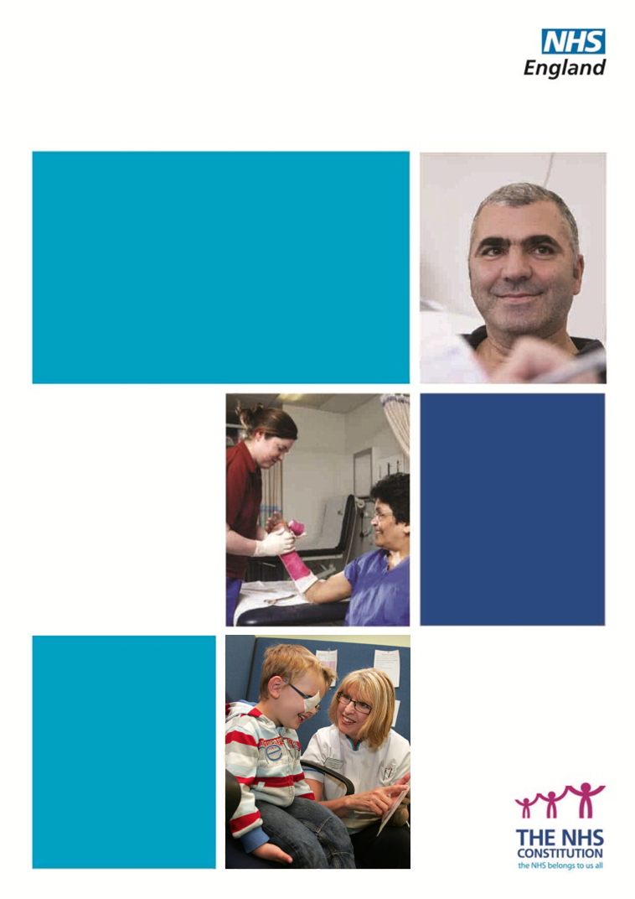
Diagnostic Imaging Dataset -
2013 Technical Report

Diagnostic Imaging Dataset
Technical Report

First Published: 31st October 2013

All data tables are based on the data extract used to produce “The Diagnostics Imaging Dataset Annual Statistical Release –31st October 2013”, extracted October 9th 2013.

Contents
Introduction 4
Methodology 4
Data Source 6
Data Quality 9
Revision Policy 16
Uses of the data 19
Contact Us 20
Annexes 20

Frequently Used Terms:
Acronym | Full name
DID | Diagnostic Imaging Dataset
HES | Hospital Episodes Statistics
HSCIC | Health and Social Care Information Centre
NHS Number | Everyone registered with the NHS in England and Wales has their own unique number
Patient Source Setting | The type of setting that the patient came from at the time of request for Diagnostic Imaging for use in the DID. This can be one of 7 options: Accident and Emergency Department, Admitted Patient Care – Day Case, Admitted Patient Care – Inpatient, GP Direct Access – outpatient, Other and Other Health Care Provider.
Referrer | The code of the person making the referral. This will normally be a Care Professional - a General Medical Practitioner or a Consultant.
RIS | Radiology Information System
TRUD | Technology Reference data Update Distribution

Introduction

On 22nd November 2012 the first Statistical Release of the Diagnostic Imaging Dataset (DID) was published. It contained monthly summaries for April to July 2012, based on data submitted from May to October 2012. On 31st October 2013, the first year of the DID was confirmed in a publication that finalised 2012-13 data. Although data have been published previously for each of these twelve months, the data have been updated in some cases and some of the earlier publications did not include figures for all modalities. The annual publication serves as the final record, after which there will be no further amendments.

The data are collected from hospital administrative data sources at patient level and consequently will allow for a rich variety of analyses.

The data are published as experimental data. The Office for National Statistics define experimental statistics as “…new official statistics undergoing evaluation. They are published in order to involve users and stakeholders in their development and as a means to build in quality at an early stage”.

This Technical Report gives information on the methodology and data source of this data collection as well as covering data quality issues to give users an understanding of the useability of these data.

Methodology

The information collected by the DID is sourced from the local Radiology Information System (RIS) of each provider. The aim of this collection is to collate these data nationally, through the monthly submission of a standard extract of RIS data to a central data system. The data are extracted through the automated running of a query and then submitted manually via the Health and Social Care Information Centre (HSCIC) website.

The DID is a monthly collection of detailed information about diagnostic imaging tests carried out on NHS patients. The dataset captures information about referral source and patient type, details of the test (type of test and body site), demographic information such as the patient’s registered GP practice, postcode, ethnicity, gender and date of birth, plus dates for each diagnostic imaging event giving periods eg from test request through to reporting. The dataset is collected at record level (a record being one test for one patient) and includes patient identifiers to enable linkage to other datasets, most notably cancer registration data.

The data required is already held locally, within each provider’s RIS. The DID has been structured around the processes and timings of diagnostic imaging tests recorded in RISs, ensuring that the data items specified are already captured in these local systems. Providers of NHS-funded diagnostic imaging tests produce a standard extract of data from their RIS on a monthly basis then submit to a secure central system provided by the HSCIC.
An illustration of the system for data flow and data access is shown in figure 1.

DB = Database
PI = Patient Identifiable
DBA = Database Administration
Figure 1
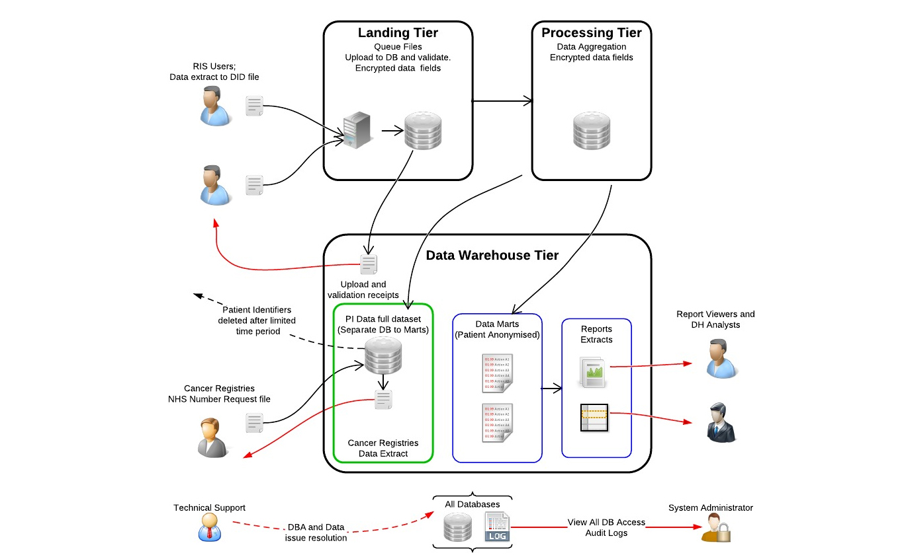

The system allows secure upload of data, which once transmitted is contained in the central database controlled by the HSCIC. The HSCIC provide for secure transmission of data and access to aggregated and annonymised datasets. Two points in the system involve patient-identifiable (PI) data – the landing tier and a secure area accessed only by Cancer Registry staff with section 251 approval to enable data linkage. Such staff are only able to input NHS number and DOB for patients already listed on a Cancer Registry - they do not have access to the entire dataset. All other data items are held separately, in another database. This database is used for reporting (and eventually querying, using a tool called iView) by all other end-users of the data.

Data quality is checked at different stages in the system:
- On landing, the file credentials are verified
- The structure of the file is checked against the schema definition
- Codes are validated against HSCIC reference data
- Cross field validation checks are carried out. (e.g. the patient’s Date of Test cannot be before the date of the patients test request. Another example is the patient’s NHS number must have the same date of birth if previously entered into the system.)
The system accepts CSV files but is designed to receive XML files and to apply XML schema validation. To enable a common workflow and approach to validating data submissions, on receipt of data in CSV format the system converts it to XML. Prior to conversion, the data structure of the CSV file is checked to ensure a logical conversation to XML is possible.

Data Source
The information contained in the DID is sourced directly from the RIS of each organisation that returns data.
A RIS is a computer system used in radiology departments to record, store and manage records of patient’s radiological events. The system generally includes demographic information, examination details and scheduling events. The RIS interfaces with an organisation’s Patient Administration System (PAS) and Picture Archiving and Communications System (PACS) where required. Different organisations use different brands of RIS, but all have the same remit.
It is intended that each record within a RIS is unique and contains a number of data items, recorded using standard coding systems. This should allow the data to be queried, aggregated or categorised and reports to be produced. Examination details should be recorded using SNOMED CT and/or NICIP codes.
SNOMED CT (Systematised Nomenclature of Medicine -- Clinical Terms), is a systematically organised, computer processable collection of medical terms providing codes, terms, synonyms and definitions covering diseases, findings, procedures, microorganisms, substances, etc. It allows a consistent way to index, store, retrieve, and aggregate clinical data across specialties and sites of care. The codes consist of a string of digits.

NICIP (National Interim Clinical Imaging Procedure) codes are a comprehensive, national standard set of codes and descriptions for imaging procedures. They are maintained by the UK Terminology Centre of NHS Connecting for Health. The list is designed to cover all imaging specialties in the scope of the National PACS programme and currently includes all conventional imaging modalities found in diagnostic imaging departments, such as CT and MR as well as nuclear medicine and bone densitometry. The codes consist of 5 or 6 characters (for example XANKR is X-ray of the right ankle)

In some cases, local codes, which are recognised only by that organisation, are used to record examination details. An interim conversion service is provided by the HSCIC, which maps local codes into the relevant NICIP code. This means that records that contain local codes can be submitted to the DID, and will be mapped to the relevant NICIP code. In order to use this service, an organisation must, in advance of submission, provide a table that shows which NICIP code their local code maps to.

Data derivation

Examination codes which are submitted are validated against over 3,000 valid NICIP and over 2,000 valid SNOMED codes.

For reporting purposes, data are aggregated for key groups based on SNOMED codes. The groups are described fully in the lookup table provided at Annex 1. This table provides lookup information from SNOMED clinical terms (‘SCT_ID’ for code and ‘SCT_FSN’ for description) to impute modality, laterality, region, etc of the imaging test and whether it has use for early diagnosis of cancer. It also provides NICIP codes (‘short codes’) and descriptions matched to SNOMED.

The process of validation of examination codes and derivation of aggregations of these codes is described in figure 2.

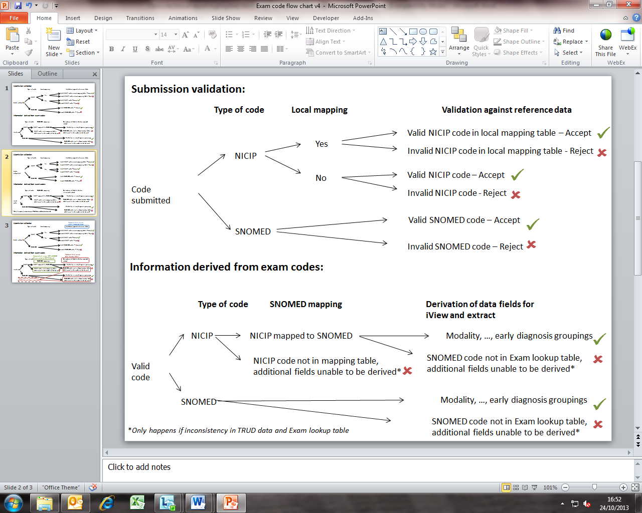
Figure 2

A modality is a broad procedure based on NICIP or SNOMED codes provided in the DID data submission. The modalities for the DID are: Plain Radiography (X-ray), Diagnostic Ultrasonography (Ultrasound), Computerized Axial Tomography (CT Scan), Magnetic Resonance Imaging (MRI), Fluoroscopy, Medical Photography, Nuclear Medicine, Positron Emission Tomography (PET Scan) and Single Photon Emission Computerized Tomography (SPECT Scan). These aggregations are fully described in the lookup table provided at Annex 1. Each modality is describes a group of codes with a common set of characteristics, for example, Fluoroscopy – a collection of codes mentioning fluoroscopy or using fluoroscopic guidance, Barium enema or swallow.

Some imaging codes submitted to the DID are grouped under the modality ‘Endoscopy’, however, this only provides partial coverage of the broader definition of endoscopy, therefore does not feature in the main report. Additionally, some examination codes submitted to the DID are not mapped to any modality – this occasions when this occurs is shown in Figure 2.

Annex 3 gives the amount of imaging activity submitted to the DID which is identified as endoscopy and that without a modality by provider.

Imaging Tests that could contribute to Early Diagnosis of Cancer

Brain (MRI)
- This may diagnose brain cancer, this includes – MRI of brain (often with contrast);

Kidney or bladder (Ultrasound)
- This may diagnose kidney or bladder cancer, this includes – ultrasound of kidney, ultrasound scan of bladder or ultrasound and doppler scan of kidney;

Chest and/or abdomen (CT)
- CTs which may diagnose lung cancer, this includes - Chest + Abdominal CT, CT of chest (high resolution or other), CT thorax + abdomen with contrast, CT thorax with contrast or CT chest + abdomen;

Chest (X-ray)
- This may diagnose lung cancer, this includes – Plain chest X-ray only;

Abdomen and/or pelvis (Ultrasound)
- This may diagnose ovarian cancer, this includes – Ultrasonography of pelvis, Ultrasonography of abdomen (upper, lower or other) or abdomen + pelvis.

Although these tests are regularly used to diagnose cancer, many of the tests also have wider clinical uses. Within the DID data it is not possible to distinguish between the different uses of these tests.

Most codes are grouped into a modality, although results are not reported for modalities where data was thought to be significantly incomplete. Codes not grouped into a modality are excluded from the analysis as they may be insufficiently precise, not generally stored in RISs or covered more fully in other data.

Exam code look-up table status

In April 2013, Version 7 of the DID SNOMED lookup up table was loaded into iView. It was noticed that there were some SNOMED codes submitted to the DID that were not in Version 7 of the lookup table. After investigation 20 SNOMED codes were found that covered almost all records with their SNOMED codes missing from Version 7. To rectify this Version 7 was modified which took into account these 20 SNOMEDs and was loaded into iView in June 2013 as Version 8. The data provided for the DID annual report uses Version 8 of the lookup table – this is given in Annex 1. There may still be some SNOMEDs not mapping to an exam lookup field. These though should only account for a very small proportion of the overall number of records.

Version 9 of the lookup table is now in production and is expected to be loaded into iView as of autumn 2013.

Data Quality

This is the first time that data from RISs have been collated and published at a national level so they must be used and interpreted with care.

Validations

There are a large number of validations built into the DID upload system, verifying that the data provided by organisations makes sense. Hard validations (meaning that data provided will fail to upload) are given in the following table. There are also a number of soft validations (which draw the submitters attention to potentially illogical data, but do not cause the upload to fail) built into the system.

Table A: Diagnostic Imaging Dataset Hard Validations

Data Item | M/R/M* | Hard Validations
NHS number | M* | Must be 10 numeric digits in length and an unbroken sequence. In line with NHS Number specification it must satisfy the modulus 11 algorithm and is not allowed be 1234567890, 0123456789 or N00000000N, where N is a non-zero number.
NHS number status | R | Must be one of the nationally defined codes^
Date of birth | M* | Must be given in the format CCYY-MM-DD.  It must be:  before “Date of test”, and  before Today, and  before “Date test report issued”
Ethnicity | M* | Must be one of the nationally defined codes^. This includes the option “National code Z - Not Stated should be used where the person has been given the opportunity to state their ethnic category but chose not to.”
Patient gender | M* | Must be one of the defined national codes^, including the option for Not Known and Not Specified.
Patient home postcode | M* | Must only have 1 space between 2 parts of postcode. This does not check that the postcode provided is a valid postcode.
Patient registered GP practice | M* | Must be one of the defined national codes^, including codes for “Not Registered”, “Not Applicable” and “Not Known”
Patient Type  (Patient Source Setting) | M | Must be one of the defined national codes^, which includes an option for other, but no option for unknown.
Referrer | R | Must be from defined national values^, which includes an option for not known.
Referring organisation | R | Must be from defined national values^, which includes an option for not known and for not applicable.
Date of test request | R | <=”Date test request received”
Date test request received | R | Must be given in the format CCYY-MM-DD.  It must be  >= “Date of test request”
Date of test | M | Must be given in the format CCYY-MM-DD. It must be:  after ”Date test request received”, and  after”Date of test request”, and  before ”Date test report issued”
Imaging code (NICIP) | M | Must be from defined national codes^
Imaging code (SNOMED-CT) | M | Must be from defined national codes^
Date test report issued | R | Must be in the format CCYY-MM-DD.
Provider site code | M | Must be from defined national codes^
RIS accession number | M | Must be a unique alphanumeric code of up to 20 characters, which is validated after submission to the DID

^Links to nationally defined codes and value can be found in Annex 1

Each data item is either Mandatory = M or Required = R. Excluding a data field which is a mandatory field would cause the data upload to fail. At least one of the fields marked M* is required eg If NHS Number is not available, this field can be left blank as long as at least one of the other fields marked M* have been provided. Excluding all fields marked M* would cause the data upload to fail.

Further information about these 18 fields can be found in Annex 2 “Diagnostic Imaging Dataset Data items” and in the DID submitters guidance, available here https://did.hscic.gov.uk/Main/Guidance.

These hard and soft validations help to ensure that the data are fit for purpose. However, not all validations were fully applied from the start of the collection and some earlier data may not meet current validation rules. Information on data field completeness, on page 14, shows where required data were missing or invalid.

The validations built into the DID system are not designed to ensure that the data submitted by an organisation reflects the total activity carried out by the organisation. There is a dependency on the data provider to upload all records within their RIS relating to NHS funded patients. There is anecdotal evidence that some data providers are removing a small number of records that are failing hard validations, rather than amending the records to meet the validations. This problem is still unresolved but the data collection team at the HSCIC are continuing to support data providers to upload all the required data and are now being encouraged to use default codes for GP practices and trusts.

Data Quality Issues

Throughout the year 2012/13 numerous data quality issues were noticed, and this have been investigated and mostly corrected.

Duplicate Records & Archived Errors

In order to be able to revise a record submitted to the DID, (for example in the case where a report has not been issued when a record is first submitted to the DID but the following month a report has been issued, and hence report issue date can be included), each record needs a unique identifier. Within each RIS every record should have an accession number which is unique to each test and this should be reported to the DID. However, for some organisations this field is not consistently available, which has lead to two or more records being submitted with the same accession number or the same record being submitted twice with different accession numbers.

Total activity counts may include duplicates for some providers, this was due to them submitting the data more than once. Data for providers who were duplicating data was removed from the provisional data, and providers have now had the chance to revise this data for the 2012/13 annual report.

Another data quality issue comes with some provider reusing previous accession numbers. These accession numbers should be unique to each individual imaging test, but these providers are reusing previous accession numbers. The majority of these cases have been put down to surveillance imaging tests, where a patient has been asked to have an imaging test at regular intervals. This has resulted in a degradation in 2012/13 data because with each time the same accession number is provided the ‘Date of Test’ field is altered to the latest test date,

Ethnicity for XML submissions

Where data is submitted by providers using XML the ethnicity code is incorrectly currently set to unknown. This affects the data for the six providers who submit by XML: Salisbury NHS Foundation Trust, Sandwell and West Birmingham Hospitals NHS Trust, University Hospitals of Leicester NHS Trust, Wye Valley NHS Trust, Colchester Hospital University NHS Trust and Direct Medical Imaging Limited. The ethnicity data for these trusts has not been involved in any analysis throughout the annual report for 2012/13.

NHS Number

In approximately 2% of cases the DID record does not contain the most up-to-date NHS Number submitted by the provider. This is due to issues in the system with how updated records are handled. This does not have a direct impact on the data used for this publication.

Age and Date of Birth

When a provider doesn’t send a valid date of birth the system currently classifies the field as an empty string. When these empty strings are encountered by the system when calculating age, it uses the default date of 01/01/1901 as the data of birth which means that the record is attributed to the top age band in the grouping. This currently affects approximately 2% of records and results in the top age band in the field having a higher than expected count whilst the number of records where the age is not known is lower than expected.

Organisational Variation

The data within each organisation’s RIS is primarily held for the management of workflow within hospitals, rather than for national statistics purposes. Consequently, the coding methods used to record imaging within organisations vary. One of the key data items collected in the DID is information relating to the examination, i.e. the exam code.

The rollout of PACS/RIS to imaging departments was part of the National Programme for IT in the NHS (NPfIT). The adoption of common standards, including exam codes, was an essential requirement to enable full interoperability between systems. To ensure this, since 2010 providers have been required to use National Interim Clinical Imaging Procedure Codes (NICIP codes (ISB 0148)). These codes provide a uniform way of describing the examination performed.

However, prior to the rollout of PACS/RIS and a uniform code set, there was not such consistency in describing examinations. Some local codes remain in use now for a variety of reasons. This means that an examination that would be described by a single NICIP code, and therefore exist as a single record of imaging, may be described by a local code in a variety of different ways. This could generate multiple records.

Furthermore, it is planned to replace NICIP codes with Systematized Nomenclature of Medicine Clinical Terms code (SNOMED- CT) in 2015. This could also lead to inconsistency in the number of discrete imaging records generated to capture an examination.

Organisation Coverage

Any organisation in England with a RIS that carries out imaging activity on NHS funded patients is required to submit to the DID. There are 185 organisations that have been identified as required to submit data throughout 2012/13. The following table gives a breakdown of the number of organisations which successfully submitted data to the DID, split by Quarter in which activity took place and the commercial supplier of the RIS (as at 2011) the providing organisation uses.

Note, figures for the quarter are simply a sum over the three months, therefore, for example there are 101 organisations with HSS/CRIS, and each successfully submitted data in Q1.

Table B: Number of organisations successfully submitting to the Diagnostic Imaging Dataset, by quarter of activity and type of RIS

RIS Type | Q1 |  | Q2
 | Passed | Failed/No Attempt | Passed | Failed/No Attempt
HSS/CRIS | 303 | 0 | 303 | 0
iSOFT | 66 | 0 | 66 | 0
Agfa | 30 | 0 | 30 | 0
Other | 61 | 2 | 60 | 3
Unknown | 84 | 6 | 84 | 6
Total | 544 | 8 | 543 | 9
RIS Type | Q3 |  | Q4
 | Passed | Failed/No Attempt | Passed | Failed/No Attempt
HSS/CRIS | 300 | 3 | 299 | 4
iSOFT | 66 | 0 | 66 | 0
Agfa | 27 | 3 | 27 | 3
Other | 62 | 1 | 63 | 0
Unknown | 84 | 6 | 85 | 5
Total | 539 | 13 | 540 | 12

In the following table the number of successful submissions is split by Strategic Health Authority (SHA).

Table C: Number of organisations successfully submitting to the Diagnostic Imaging Dataset, by quarter of activity and by region

SHA | Number of Submitters | Q1 |  | Q2
 |  | Passed | Failed/No Attempt | Passed | Failed/No Attempt
Q30 | 8 | 24 | 0 | 24 | 0
Q31 | 30 | 90 | 0 | 90 | 0
Q32 | 15 | 45 | 0 | 45 | 0
Q33 | 9 | 27 | 0 | 27 | 0
Q34 | 19 | 55 | 2 | 54 | 3
Q35 | 19 | 57 | 0 | 57 | 0
Q36 | 30 | 90 | 0 | 90 | 0
Q37 | 13 | 39 | 0 | 39 | 0
Q38 | 9 | 27 | 0 | 27 | 0
Q39 | 19 | 57 | 0 | 57 | 0
England* | 185 | 538 | 5 | 537 | 6

SHA | Number of Submitters | Q3 |  | Q4
 |  | Passed | Failed/No Attempt | Passed | Failed/No Attempt
Q30 | 8 | 24 | 0 | 24 | 0
Q31 | 30 | 90 | 0 | 90 | 0
Q32 | 15 | 45 | 0 | 45 | 0
Q33 | 9 | 27 | 0 | 26 | 1
Q34 | 19 | 56 | 1 | 57 | 0
Q35 | 19 | 57 | 0 | 57 | 0
Q36 | 30 | 87 | 3 | 87 | 3
Q37 | 13 | 36 | 3 | 36 | 3
Q38 | 9 | 27 | 0 | 27 | 0
Q39 | 19 | 57 | 0 | 57 | 0
England* | 185 | 533 | 10 | 538 | 9

*England total does not equal SHA total, as England total include Independent Sector Healthcare Providers.

Data field completeness

Only five data fields are mandatory (please refer back to table A for details), whilst all other fields can be left blank if the data is not available.

The following table gives the percentage of records that contain each of the following data items.

Table D: Percentage of records with a given field¹

Field | Underlying Data Item | M/R/M* | 2012/13
NHS Number |  | M* | 96.0%
NHS Number Status Description |  | R | 44.2%
Number not present and trace not required |  | - | 0.1%
Number present and verified |  | - | 35.2%
Number present but not traced |  | - | 7.7%
Trace attempted - No match or multiple match found |  | - | 0.1%
Trace in progress |  | - | 0.2%
Trace needs to be resolved - (NHS Number or patient detail conflict) |  | - | 0.1%
Trace postponed (baby under six weeks old) |  | - | 0.0%
Trace required |  | - | 0.8%
Date of Birth |  | M* | 97.9%
Ethnic Category Code |  | M* | 87.7%
Ethnicity known/stated |  | - | 73.7%
Gender Code |  | M* | 97.4%
Gender known/stated |  | - | 96.4%
MSOA | Postcode of Patient Usual Address | M* | 94.5%
GP Code |  | M* | 92.8%
Patient Source Setting² |  | M | 99.9%
Diagnostic Test Date Request |  | R | 80.9%
Diagnostic Test Req Rec Date |  | R | 86.4%
Diagnostic Test Date |  | M | 100.0%
Imaging Code SNOMED and/or NICIP |  | M | 99.9%
valid NICIP description |  | - | 96.9%
Service Report Issue Date |  | R | 88.8%
Provider Site Code |  | M | 99.0%

1 This table does not include Referrer Code and Referrer organisation code.

2 Patient Source Setting is a mandated field, however, due to a technical issue a small number of Patient Source Setting fields did not flow through to the DID data extract used in this publication.

Note that for certain data items, as outlined in table A above, the values “not known”, “not applicable” etc is an acceptable value.

Revision Policy

This revision protocol relates to the DID which is collected by the HSCIC and disseminated by NHS England via a statistical notice ‘Diagnostic Imaging Dataset Statistics’ and by the HSCIC via the online tool ‘iView’.

All data collected may be revised.

This policy is consistent with the National Statistics Code of Practice and the UK Statistics Authority’s guidance on revisions.

Revisions to provisional estimates
DID statistics are published on a monthly basis and were provisional and therefore subject to changes until the first full year of data had been collected – this covers imaging activity taking place from April 2012 to March 2013. The data was finalised in the October 2013 annual publication.

During the first year of the collection and whilst the statistics are designated as experimental, revisions for some providers were significant as data providers improved the quality and completeness of the information submitted.

Revisions to finalised estimates
Once data have been finalised, revisions will only be made in exceptional circumstances if not doing so would materially distort the historical time series.

Decisions about revisions
The data publishers, HSCIC data collections team and business owners reserve the right to refuse any revisions that do not make material differences to published data. The normal pre-release procedure will apply to revisions.

Process for making revisions
Revisions can be made by resubmitting data to the DID system according to the timetable and guidance provided by HSCIC. Revisions outside of this period can be requested by emailing the HSCIC contacts given at the DID website https://did.ic.nhs.uk/

Related Statistics

England

The Department of Health produces other statistics regarding diagnostics waiting times and activity data through three collections:
- The monthly diagnostics collection collects data on waiting times and activity for 15 key diagnostic tests and procedures. Data for this collection is available back to Jan-06.
- The quarterly diagnostics census collects data on patients waiting over 6 weeks for a diagnostic test. Data for this collection is available back to Feb-06.
- The annual diagnostics collection collects data on the number of imaging and radiological examinations or tests carried out during the year. Data for this collection is available back to 1995-96.

Further information and data can be accessed via the following link.

http://www.england.nhs.uk/statistics/statistical-work-areas/diagnostics-waiting-times-and-activity/

Currently the HSCIC are doing analysis on HES-DID Data Linkage and more information on this analysis can be found at:

http://www.hscic.gov.uk/hesdid

The annual diagnostics collection contains data covering similar tests to that of the DID. It includes yearly counts of tests by modality including X-rays, Ultrasounds, CT Scans, MRI Scans, Fluoroscopies and Radio-isotopes.

Although this annual data collection provides counts of diagnostic activity in similar modality groupings to those published in the DID there are a number of reasons why the DID data does not provide comparable figures:
- Definitional differences: For the annual collection, each organisation is required to calculate an aggregate figure for each modality. As explained in the data source, different organisations use different coding systems, and consequently will have also used different coding aggregations.
- Difference in organisational coding systems: In line with the PACS/RIS programme (explained in Organisation Variation) many organisations have recently changed their internal method for coding tests, this will cause year on year changes in their measurements on activity.
- Difference in scope: The annual data collection includes all patients treated whereas the DID only collects information about NHS funded patients.
- Difference in frequencies: The DID is collected and published monthly, and to compare to the annual figures DID figures would need to be aggregated up. When the DID has been collected for a whole year, there will be a greater understanding of seasonality within imaging activity and a more rigorous comparisons with the annual collection will be possible.
- The DID is a new data collection, and is currently published as experimental data, it is likely that some differences will be down to the low data quality of information provided by some organisations.

Comparison with KH12

The Annual Diagnostic Collection (KH12) is a report that contains data for the total number of imaging tests for the year, covering similar tests to that of the DID. It includes yearly counts of tests by modality including X-rays, Ultrasounds, CT Scans, MRI Scans, Fluoroscopies and Radio-isotopes

One of the original aims of the DID was to replicate, and ultimately replace, the KH12 report. Due to the provisional nature of the DID, it was expected that reaching the quality to replicate KH12 would take some time

The general trend in 2012/13 was that fewer tests were reported in the DID than in KH12. The KH12 reported 41,051,167 imaging tests, compared to the 36,102,195 reported in the annual DID. For each modality that appears in both publications, the number of tests reported in KH12 is greater than the number reported in the annual DID. In addition, 88% of organisations submitting to both publications reported fewer tests in KH12 than in the DID, the rest reporting a higher figure in the DID.

Comparisons of the Organisation submitting data to both the DID and KH12 are summarised in the graphs below.

Reasons to explain these differences exist are currently under investigation, although the following reasons have been suggested.
- Methods of counting: Trusts might record the number of imaging sites in KH12 and the number of procedures in the DID, causing differences.
- Underrepresentation of specific tests: For example, there is evidence to suggest that some organisations have not been submitting obstetric ultrasound tests to the DID.
- Use of local coding systems: Some trusts may have used local codes that hasn’t been mapped to either a NICIP or SNOMED-CT code.
- Differences in scope: The DID only collects information regarding NHS funded patients, and only considers tests reported on a trust’s RIS.

Differences in structure: There are differences in the number of modalities and organisations for both tests. Comparisons have been used when appropriate.

Graphs of the ratio of imaging tests reported by an organisation to the DID to imaging tests reported by an organisation to KH12, separated by modality.

X-axis gives the ratio of counts of DID activity to KH12 activity
Y-axis gives the number of organisations

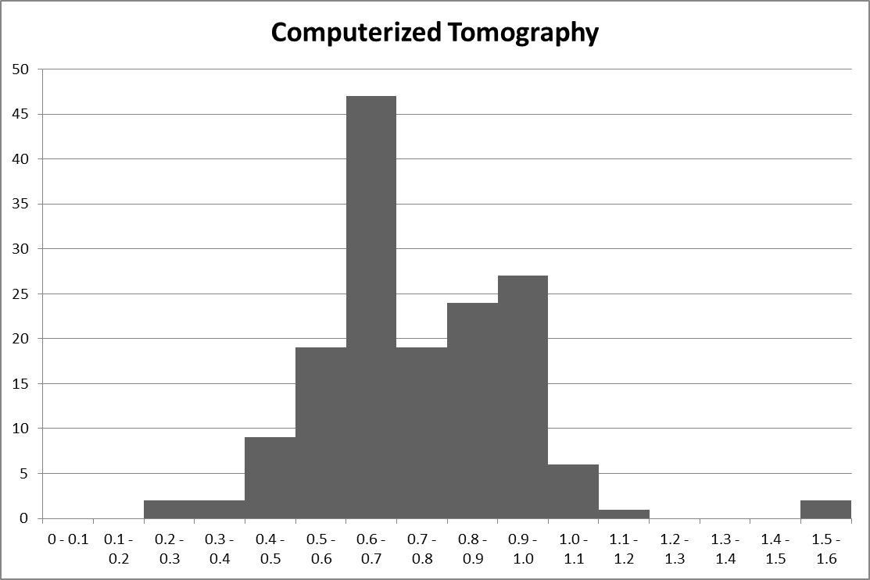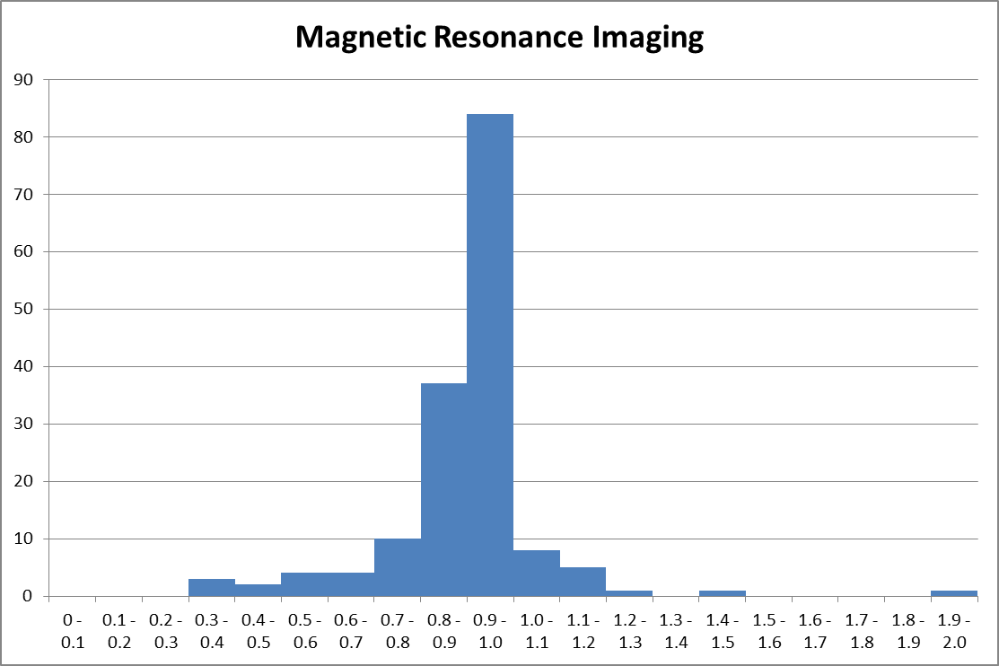
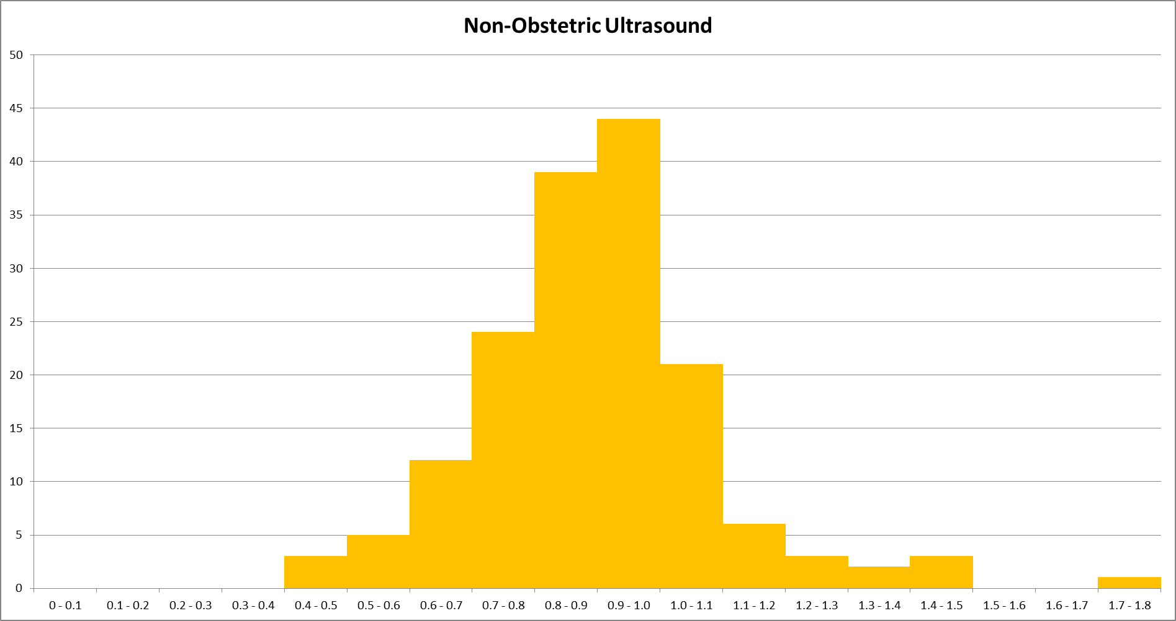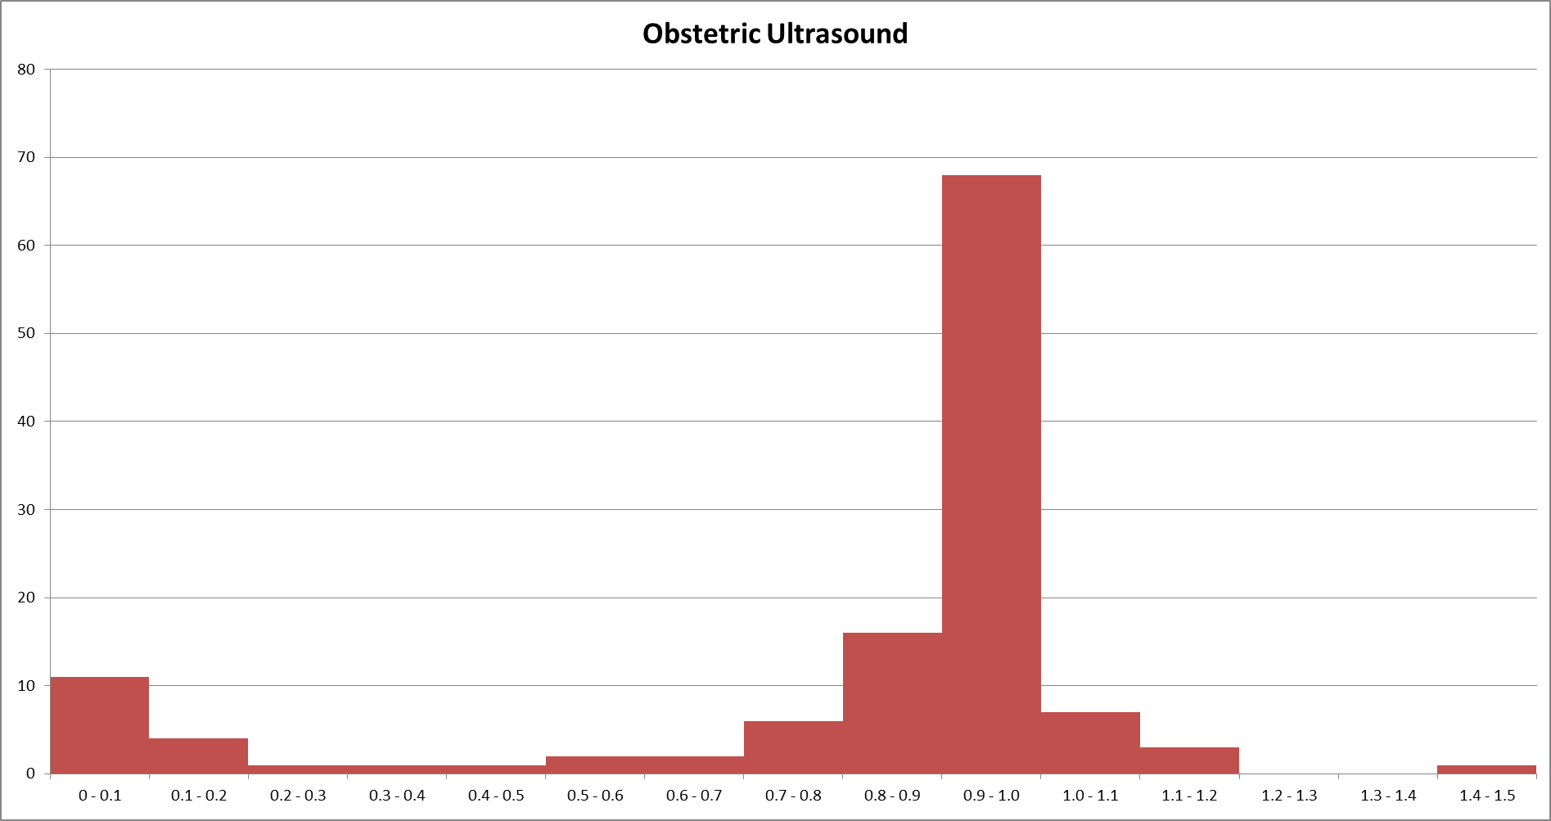

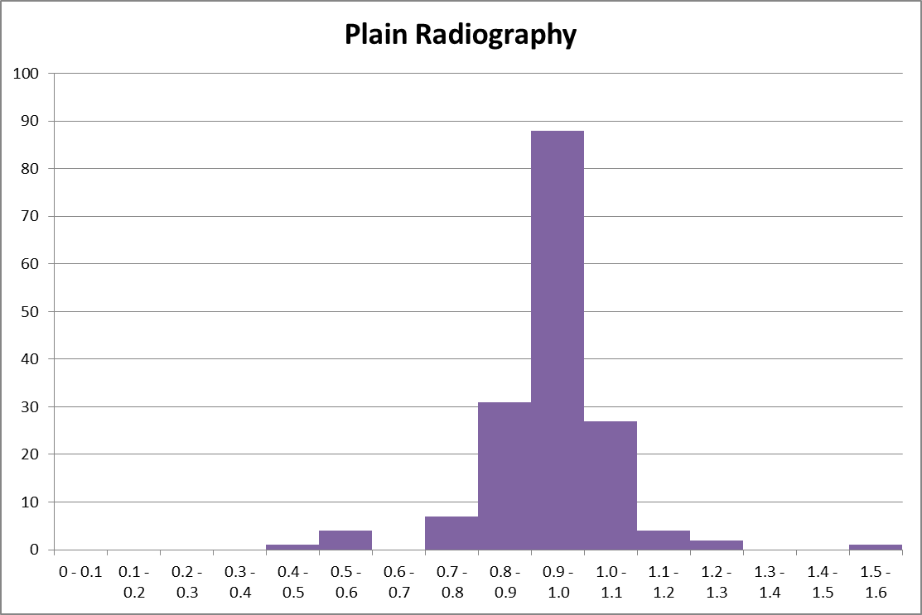

Devolved Administrations

The DID includes data about imaging activity carried out in England on NHS funded patients. It does not contain information about imaging activity carried out on NHS funded patients in the devolved administrations. Similar data is not collected and published by the Devolved Administrations.

Uses of the data

Data is collected to meet the following needs:
- To provide national data on GPs’ direct access to tests, as well as tests requested via other referral sources. Benchmarking data will be fed back to GPs and, where appropriate, used to encourage increased use of tests, leading to earlier diagnosis and hence improved outcomes
- To provide more detailed national data than is currently available on test type (modality), body site of test and patient demographics
- To enable analysis of demographic and geographic access to diagnostic imaging tests
- To enable analysis of turnaround times for tests
- To enable better analysis of cancer pathways by linking Cancer Registry data to diagnostic imaging test data for cancer patients
- To allow the Health Protection Agency (HPA) to calculate more accurate estimates of the distribution of individual radiation dose estimates from medical exposures
- To inform work on development of accurate tariffs for all diagnostic imaging tests
- In the longer term, to replace the existing annual KH12 dataset

However, there are limitations to how the data can be used. For example, users should exercise caution when considering time series since:
- At a national level, there are variations in coverage from month to month
- At a provider level there are some instances of high levels of variation form month to month which are unlikely to reflect genuine changes in activity
Additionally, due to scope and definitional requirements the data is not directly comparable with ‘Diagnostic Test Waiting Time Statistics’.

Due to data quality issues discussed in this report the statistics published should not be used for performance monitoring at this time. However, it is intended that in the future these statistics will be appropriate for this use.

Commissioner Data
The main DID report includes summaries by PCT since at the time which published data refers, PCTs were active.
Recognising there is an interest in also seeing 2012/13 data by CCGs a set of summary tables are available for reference in Annex 4 (modality based summaries) and Annex 5 (body site summaries for early diagnosis of cancer).

Contact Us

Feedback

We welcome feedback on this publication. Please contact us at did@dh.gsi.gov.uk

iView
The HSCIC will be allowing health sector colleagues to access DID information through their web-based reporting tool, iView. Registered users will be able to access anonymised data at aggregate level in a consistent and flexible format:
• Access Information – choose from a variety of data areas.
• Build Reports – select data to suit their needs.
• Generate Charts – customise report tables and graphs.
• Export Data – copy to Excel and manipulate data.
• Save Reports – store favourite views for future use.
If you would like to register to use iView for DID, please email enquiries@ic.nhs.uk (subject: DID iView Access). For more information, please visit the iView website http://www.hscic.gov.uk/iview

DID Website

The DID website is https://did.hscic.gov.uk/

Annexes

Annex 1 – DID Lookup Table Version 8

Annex 2 – DID Data items table

Annex 3 – DID Activity of excluded Modalities

Annex 4 – DID Activity by Modality by CCG 2012/13

Annex 5 – DID Activity by Body Site by CCG 2012/13

