Statistical Note
Ambulance Systems Indicators up to 31 May 2014 and
Ambulance Clinical Outcomes up to 28 February 2014

Main findings – Ambulance Systems Indicators May 2014

  - The proportion of Category A (Red 1) calls resulting in an emergency response arriving within 8 minutes was 73.3% nationally, less than the expected standard of 75%. It was the first time since December 2013 that the Red 1 standard has been missed.

  - Six of the eleven ambulance trusts (North West, Yorkshire, East Midlands, East of England, London, and South East Coast) did not achieve the 75% standard.

  - The proportion of Category A (Red 2) calls resulting in an emergency response arriving within 8 minutes was 72.5% nationally, less than the expected standard of 75%.

  - Only four Trusts achieved the 75% standard; North East, West Midlands, Isle of Wight and South Western.

  - The national 19 minute response time performance for Category A calls this month of 95.3% and so the national standard of 95% was achieved this month.

  - Two Trusts failed to achieve the standard for 95% of patients receiving an ambulance within 19 minutes; East of England, and South East Coast.

  - The total number of emergency calls presented to switchboard this month was 748,195, or 24 thousand per day. The average in 2013/14 was 23 thousand per day.

  - In May 2014, there were 405,078 emergency journeys to a Type 1 or 2 A&E, or 13 thousand per day. The average in 2013/14 was also 13 thousand per day.

Detailed tables of all ambulance Systems Indicators and Clinical Outcomes data are available at:

www.england.nhs.uk/statistics/statistical-work-areas/ambulance-quality-indicators/

Table 1: May 2014 Systems Indicators trust averages and extremes

Indicator | All England | Lowest Trust | Highest Trust
Category A Red 1: 8 minute response | 73.3% | 66.3% | * 82.0%
Category A Red 2: 8 minute response | 72.5% | 61.0% | 77.7%
Category A: 19 minute response | 95.3% | 90.1% | 97.2%
Calls abandoned before being answered | 1.0% | 0.2% | 2.9%
Calls resolved through telephone assessment | 6.8% | 3.4% | 10.0%
Calls resolved without transport to Type 1 or Type 2 A&E | 36.7% | 27.4% | 51.5%
Recontact rate following discharge by telephone advice | 7.9% | 1.6% | 15.1%
Recontact rate following face-to-face treatment at scene | 6.0% | * 3.9% | 13.2%
Number of emergency journeys | 405,078

* Due to its small size, performance on the Isle of Wight tends to vary more than other Trusts. If the Isle of Wight has the lowest or highest value, Table 1 shows the second lowest or highest value, but with an asterisk to show that the Isle of Wight is more extreme.

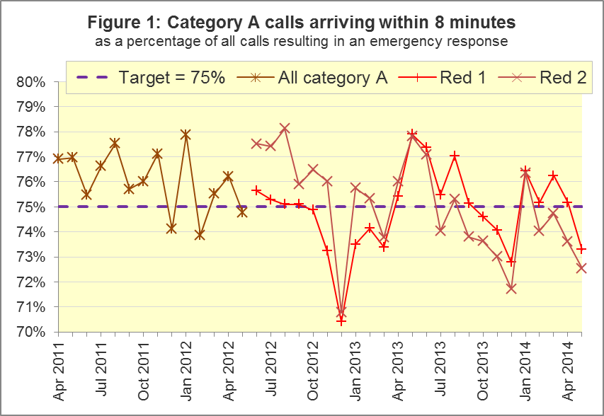

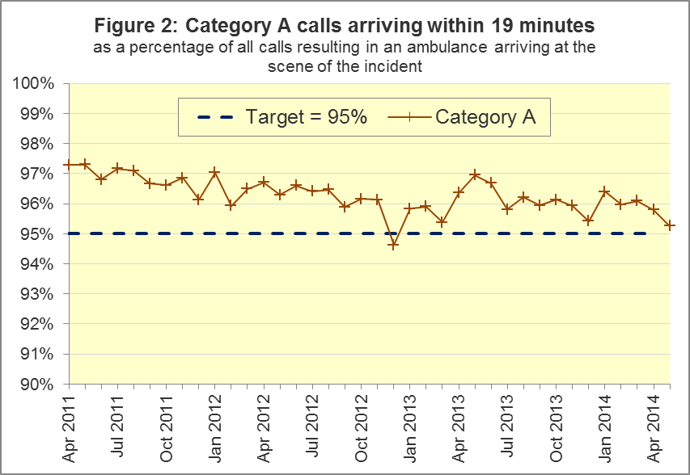

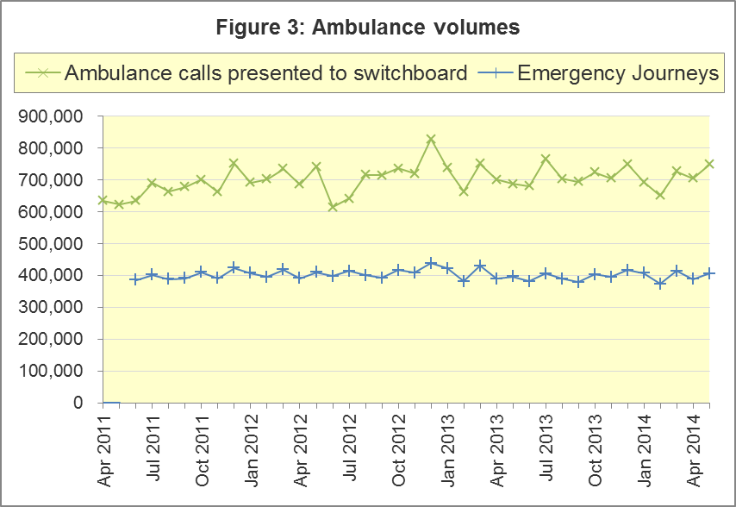

Main Findings – Ambulance Clinical Outcomes February 2014

  - For patients who had an out-of-hospital cardiac arrest, where ambulance staff commenced / continued resuscitation, 27.5% had a return of spontaneous circulation (ROSC) on arrival at hospital. For the sub-group of these patients in the Utstein comparator group, this proportion was 53.0%.

  - For patients who had an out-of-hospital cardiac arrest and where the outcome is known, the proportion of patients who were subsequently discharged from hospital alive was 9.3%. For the Utstein comparator group, this proportion was 29.3%.

  - Of patients with an acute ST-Elevation myocardial infarction (STEMI), and receiving primary angioplasty, 87.9% received this within 150 minutes of the call being connected to the ambulance service. Of all patients with an acute STEMI, 80.7% received the appropriate care bundle.

  - Of Face Arm Speech Test (FAST) positive patients potentially eligible for stroke thrombolysis, 62.7% arrived at a hyperacute stroke unit within 60 minutes. Of suspected stroke patients that were assessed face to face, 96.8% received the appropriate care bundle.

Table 2: February 2014 Clinical Outcomes trust averages and extremes

Indicator |  | All England | Lowest Trust | Highest Trust
Return of spontaneous circulation:
 | All patients | 27.5% | 18.8% | 36.9%
† | Utstein group | 53.0% | 27.3% | 70.0%
Survival to discharge following cardiac arrest:
 | All patients | 9.3% | * 2.0% | 13.8%
† | Utstein group | 29.3% | * 10.0% | 50.0%
Outcome from acute STEMI:
† | Angioplasty within 150 minutes | 87.9% | * 77.0% | 98.9%
† | Received appropriate care bundle | 80.7% | 72.3% | * 89.4%
Outcome from stroke:
† | Thrombolysis in 60 minutes | 62.7% | 39.5% | * 73.3%
 | Received appropriate care bundle | 96.8% | 94.0% | 99.8%

† Shows an indicator where several trusts have fewer than 100 patients to calculate a percentage out of, and indicators consequently have large variations.

* Due to its small size, performance on the Isle of Wight tends to vary more than other Trusts. If the Isle of Wight has the lowest or highest value, Table 2 shows the second lowest or highest value, but with an asterisk to show that the Isle of Wight is more extreme.

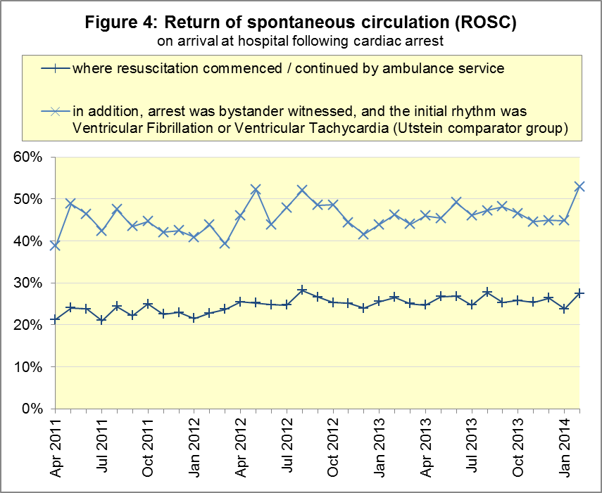

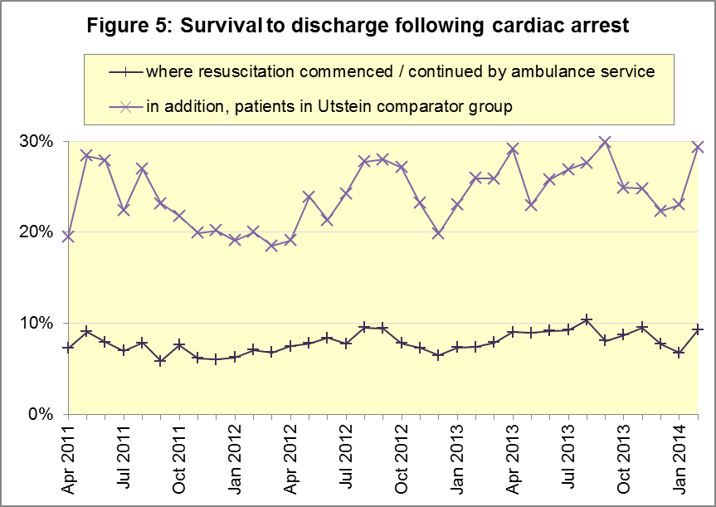

ANNEX

Ambulance Quality Indicators: Overview
The Ambulance Quality Indicators data is an aggregate data collection collected from the 11 Ambulance Trusts in England each month. The collection is divided into two complimentary parts, Systems Indicators (AmbSYS) and Clinical Outcomes (AmbCO).

The indicators that make up the Ambulance Systems Indicators relate to the initial 999 call, and as such cover indicators such as the 8 minute response time for Category A calls (Red 1 and 2) and the number of emergency journeys.

Clinical Outcomes data covers a range of key clinical indicators, and corresponding performance by ambulance trust, such as survival to discharge following cardiac arrest. Clinical Outcomes performance is published on a 3 month lag relative to the Systems Indicators to allow time for patient outcomes to be resolved.

With the exception of the 8-minute response time standard and the 19-minute transportation standard for Category A (immediately life-threatening) calls, no thresholds to denote “poor” care have been set for these indicators. Instead, the data on the indicators will be used to reduce variation in performance across trusts (where clinically appropriate) and drive continuous improvement in patient outcomes over time.

Ambulance Quality Indicators: Key Terms

Category A Calls
This is a call where the patient is presenting a condition which is serious and life threatening, and where an immediate emergency response is required. For Category A calls, an emergency response should arrive at the scene of the incident within 8 minutes on at least 75% of cases.

These calls are further sub-divided into Red 1 and Red 2 based on the level of urgency of the incident. Due to differences in clock start definitions for the different call types it is not possible to aggregate performance of Red 1 and 2 into a total Category A performance.

Category A Red 1
Red 1 calls are the most time critical, and cover cardiac arrest patients who are not breathing and do not have a pulse, and other severe conditions such as airway obstruction.

Category A Red 2
Red 2 calls are serious, but less immediately time critical, and cover conditions such as stroke and fits. See www.gov.uk/government/news/changes-to-ambulance-response-time-categories.
Emergency Journey
An emergency or urgent incident that results in a patient being transported to a Type 1 or Type 2 A&E.

Emergency Call
The number of emergency and urgent calls presented to switchboard. This includes calls passed manually from 111 as requiring an ambulance response, but excludes calls that have been passed electronically from 111.

Return of Spontaneous Circulation (ROSC)
The proportion of patients who have had a return of spontaneous circulation on arrival at hospital where resuscitation (either Advanced or Basic Life Support) was commenced / continued by the ambulance service following an out-of hospital cardiac arrest.

Utstein Comparator Group
The Utstein comparator group is a sub-group for the cardiac arrest indicators. It refers to patients who had resuscitation (Advanced or Basic Life Support) commenced / continued by the ambulance service following an out of hospital cardiac arrest of presumed cardiac origin, where the arrest was bystander witnessed and the initial rhythm was Ventricular Fibrillation or Ventricular Tachycardia.

For full details of each indicator and definition please consult the AQI technical guidance document at:
www.england.nhs.uk/statistics/ambulance-quality-indicators/

Clinical Dashboards
The Ambulance Quality Indicators continue to be published in a clinical care dashboard in line with recommendations from the National Ambulance Director and the National Clinical Director for Urgent and Emergency Care. One of the aims of the dashboard is to use statistical process control to indicate whether variation in performance reflects underlying change or merely natural variance, which is unavoidable even when a health system is performing well.
These statistical process control measures will take at least seven months’ worth of data to be reliable, but they will help ensure that performance changes over time are seen in the proper clinical context. Dashboards containing data for April 2011 to December 2013 have already been published on several ambulance trust websites.

Revision timetable
Future revisions will be made on a six-monthly cycle. Revisions to previous month’s data are made in line with the Department of Health’s revisions protocol for performance monitoring data: www.england.nhs.uk/statistics/code-compliance/

Previous Revisions
2 May 2014 | AmbSYS April 2013 to February 2014
7 March 2014 | AmbCO April 2013 to September 2013
1 November 2013 | AmbSYS April 2013 to August 2013
2 August 2013 | AmbCO April 2012 to March 2013
3 May 2013 | AmbSYS April 2012 to March 2013
1 February 2013 | AmbCO April 2012 to August 2012
11 January 2013 | AmbSYS April 2012 to October 2012
11 January 2013 | AmbSYS April 2011 to March 2012
31 August 2012 | AmbCO April 2011 to March 2012

Related Statistics
The total number of category A and category B calls made to ambulance trusts in England, and of these how many were responded to within 8 minutes (category A) or 19 minutes (category B), and the number of urgent and emergency journeys, were previously collected in Weekly Situation Reports. The collection also included data on instances of delayed handover to A&E staff. Data from 8 November 2010 to 29 May 2011 are at:
http://webarchive.nationalarchives.gov.uk/20130107105354/http://www.dh.gov.uk/en/Publicationsandstatistics/Statistics/Performancedataandstatistics/WeeklySituationReports/DH_128506

Performance statistics on ambulance services in other countries of the UK can be found at:

Wales: http://wales.gov.uk/topics/statistics/headlines/health2012/120307/?lang=en

Scotland: www.scottishambulance.com/Performance

Northern Ireland: www.niamb.co.uk/docs/corporate_info.html

Additional Information
For press enquiries, please contact the NHS England press office on 0113 825 0958 or nhsengland.media@nhs.net.

The Government Statistical Service (GSS) statistician responsible for producing these data is:

Ian Kay
0113 824 9411
Analytical Services (Operations), NHS England
Room 8E12, Quarry House, Quarry Hill, Leeds, LS2 7UE
E-mail: Unify2@dh.gsi.gov.uk

Red 1 calls are the most time critical, and cover cardiac arrest patients who are not breathing and do not have a pulse, and other severe conditions such as airway obstruction. Red 2 calls are serious, but less immediately time critical, and cover conditions such as stroke and fits. www.gov.uk/government/news/changes-to-ambulance-response-time-categories

