Statistical Note

Ambulance Systems Indicators up to 30 June 2014 Ambulance Clinical Outcomes up to 31 March 2014

Main findings – Ambulance Systems Indicators for June 2014
  - The proportion of Category A Red 1 calls resulting in an emergency response arriving within 8 minutes was 72.5% nationally, less than the expected standard of 75%. It was the second time since December 2013 that the Red 1 standard has been missed and the fifth of the last twelve months in which the Red 1 standard has been missed.

  - Five of the eleven ambulance trusts (North West, Yorkshire, East Midlands, East of England and London did not achieve the 75% standard for Red 1.

  - The proportion of Category A Red 2 calls resulting in an emergency response arriving within 8 minutes was 70.7% nationally, less than the expected standard of 75%.

  - Only four Trusts achieved the 75% standard for Red 2; North East, West Midlands, Isle of Wight and South Western, the same four that met it in May 2014.

  - The national 19 minute response time performance for Category A calls this month of 94.8% is below the 95% standard. It was the first time since December 2012 that the national 19 minute response time standard has been missed.

  - Four Trusts failed to achieve the standard for 95% of a calls resulting in an ambulance arriving within 19 minutes; East Midlands, East of England, London, and South East Coast.

  - The total number of emergency calls presented to switchboard this month was 746,939, or 25 thousand per day. The average in 2013/14 was 23 thousand per day.

  - In June 2014, there were 390,526 emergency journeys to a Type 1 or 2 A&E, or 13 thousand per day. The average in 2013/14 was also 13 thousand per day.

Detailed tables of all Ambulance Systems Indicators and Clinical Outcomes data are available at:

www.england.nhs.uk/statistics/statistical-work-areas/ambulance-quality-indicators

Table 1: June 2014 Systems Indicators trust averages and extremes
Indicator | All England | Lowest Trust | Highest Trust
Category A Red 1: 8 minute response | 72.5% | 65.7% | * 80.9%
Category A Red 2: 8 minute response | 70.7% | 60.5% | 75.7%
Category A: 19 minute response | 94.8% | 90.3% | 97.1%
Calls abandoned before being answered | 1.5% | 0.1% | 5.5%
Calls resolved through telephone assessment | 7.3% | 3.6% | 10.7%
Face to face responses resolved without transport to Type 1 or Type 2 A&E | 37.2% | 27.2% | 52.4%
Recontact rate following discharge by telephone advice | 7.9% | 2.2% | 13.6%
Recontact rate following face-to-face treatment at scene | 5.2% | * 4.0% | 6.8%
Number of emergency journeys | 390,526

* Due to its small size, performance on the Isle of Wight tends to vary more than other Trusts. If the Isle of Wight has the lowest or highest value, Table 1 shows the second lowest or second highest value, but with an asterisk to show that the Isle of Wight is more extreme.

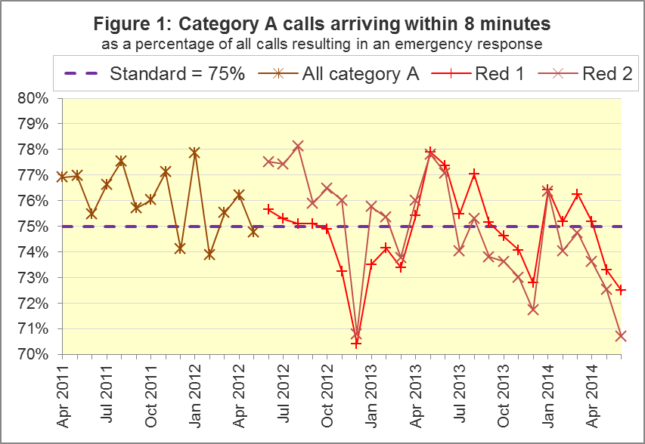

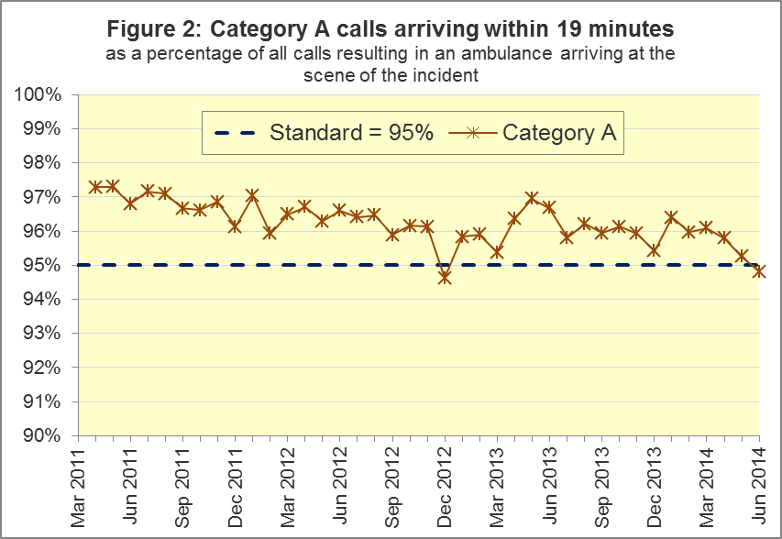

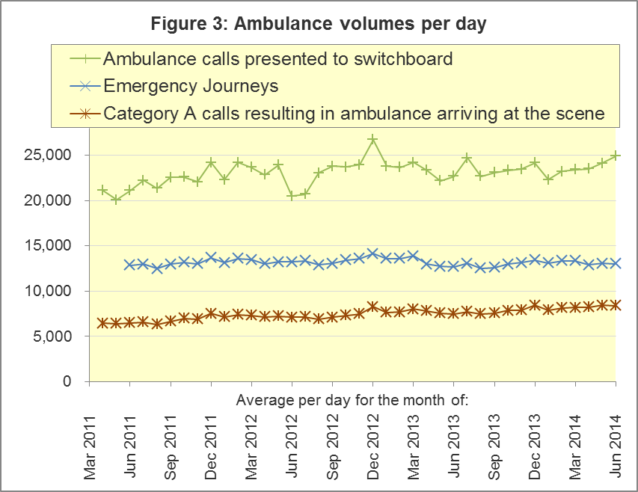

Main Findings – Ambulance Clinical Outcomes March 2014
  - For patients who had an out-of-hospital cardiac arrest, where ambulance staff commenced / continued resuscitation, 26.1% had a return of spontaneous circulation (ROSC) on arrival at hospital. For the sub-group of these patients in the Utstein comparator group, this proportion was 45.0%.

  - For patients who had an out-of-hospital cardiac arrest and where the outcome is known, the proportion of patients who were subsequently discharged from hospital alive was 8.6%. For the Utstein comparator group, this proportion was 28.1%.

  - Of patients with an acute ST-Elevation myocardial infarction (STEMI), and receiving primary angioplasty, 86.9% received this within 150 minutes of the call being connected to the ambulance service. Of all patients with an acute STEMI, 78.1% received the appropriate care bundle.

  - Of Face Arm Speech Test (FAST) positive patients potentially eligible for stroke thrombolysis, 64.4% arrived at a hyperacute stroke unit within 60 minutes. Of suspected stroke patients that were assessed face to face, 96.9% received the appropriate care bundle.

Table 2: March 2014 Clinical Outcomes trust averages and extremes
Indicator |  | All England | Lowest Trust | Highest Trust

Return of spontaneous circulation:
 | All patients | 26.1% | * 13.5% | 42.2%
† | Utstein group | 45.0% | 26.1% | 66.7%

Survival to discharge following cardiac arrest:
 | All patients | 8.6% | * 3.0% | 25.2%
† | Utstein group | 28.1% | * 7.1% | 69.6%

Outcome from acute STEMI:
† | Angioplasty within 150 minutes | 86.9% | * 77.7% | 96.9%
† | Received appropriate care bundle | 78.1% | 64.8% | 93.1%

Outcome from stroke:
† | Thrombolysis in 60 minutes | 64.4% | 50.5% | 79.8%
 | Received appropriate care bundle | 96.9% | 91.8% | 100.0%

† Shows an indicator where several trusts often have fewer than 100 patients to calculate a percentage out of, and indicators consequently have large variations.

* Due to its small size, performance on the Isle of Wight tends to vary more than other Trusts. If the Isle of Wight has the lowest or highest value, Table 2 shows the second lowest or highest value, but with an asterisk to show that the Isle of Wight is more extreme.

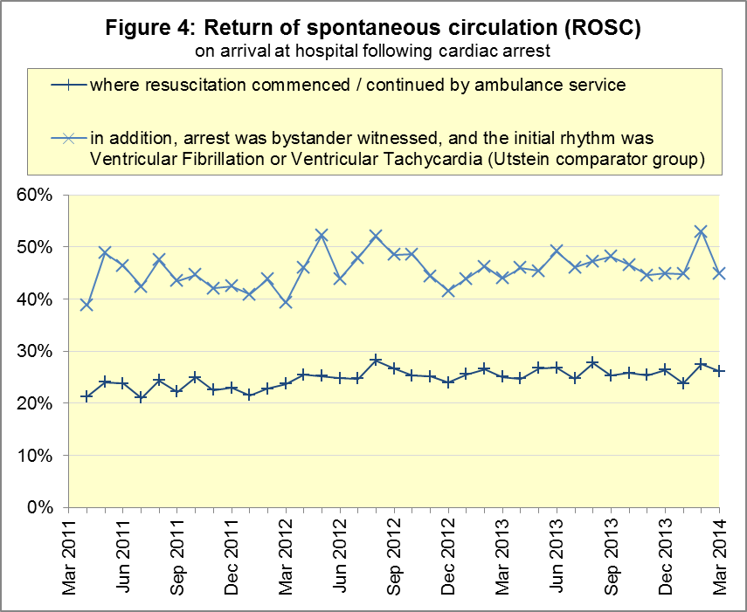

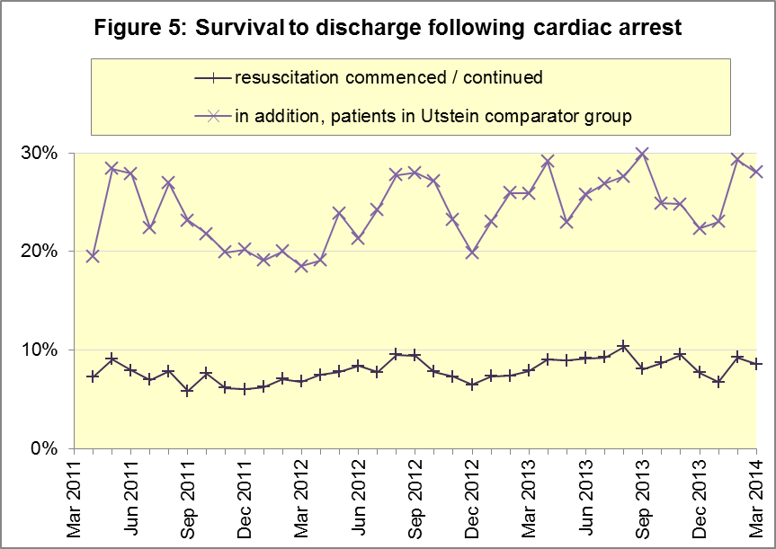

Overview
Ambulance Quality Indicators are collected from the 11 Ambulance Trusts in England each month. The collection is divided into two complementary parts; Systems Indicators, and Clinical Outcomes.

Systems Indicators relate to the initial 999 call, and as such cover indicators such as the 8 minute response time for Category A calls (Red 1 and 2) and the number of emergency journeys.

Clinical Outcomes include information on patients beyond ambulance journeys, and are therefore published on a 3 month lag relative to the Systems Indicators, to allow time for patient outcomes to be resolved.

With the exception of the 8-minute response time standard and the 19-minute transportation standard for Category A (immediately life-threatening) calls, no thresholds to denote “poor” care have been set for these indicators. Instead, the data on the indicators will be used to reduce variation in performance across trusts (where clinically appropriate) and drive continuous improvement in patient outcomes over time.

Key Terms

Category A
This is a call where the patient is presenting a condition which is serious and life threatening, and where an immediate emergency response is required.

From 1 June 2012, Ambulance Trusts sub-divided their Category A calls into Red 1 and Red 2, with different clock start times for the 8 minute response measure. The differences in the clock start times mean that it is not possible to aggregate performance of Red 1 and Red 2 into a total Category A performance.

Category A Red 1
Red 1 calls are the most time critical, and cover cardiac arrest patients who are not breathing and do not have a pulse, and other severe conditions such as airway obstruction. The clock starts when the call is presented to the control room telephone switch.

Category A Red 2
Red 2 calls are serious, but less immediately time critical, and cover conditions such as stroke and fits. The clock starts at the earliest of the following options:
  - chief complaint or Pathways initial DX code information is obtained;
  - first vehicle assigned;
  - sixty seconds after the time at which the call is presented to the control room telephone switch.
.

Emergency Call
The number of emergency and urgent calls presented to switchboard. This includes calls passed manually from 111 as requiring an ambulance response, but excludes calls that have been passed electronically from 111.

Emergency Journey
An emergency or urgent incident that results in a patient being transported to a Type 1 or Type 2 A&E.

Percentile
Take, for example, the 95th percentile for time to arrival of ambulance. This means that for every 100 ambulances dispatched, 95 arrived in less than the time shown, and 5 arrived in more than the time shown.

Utstein Comparator Group
The Utstein comparator group is a sub-group for the cardiac arrest indicators. It refers to patients who had resuscitation (Advanced or Basic Life Support) commenced / continued by the ambulance service following an out of hospital cardiac arrest of presumed cardiac origin, where the arrest was bystander witnessed and the initial rhythm was Ventricular Fibrillation or Ventricular Tachycardia.

For full details of each indicator and definition please consult the AQI technical guidance document at www.england.nhs.uk/statistics/ambulance-quality-indicators.

Further information

Clinical Dashboards
The Ambulance Quality Indicators continue to be published in a clinical care dashboard in line with recommendations from the National Ambulance Director and the National Clinical Director for Urgent and Emergency Care. One of the aims of the dashboard is to use statistical process control to indicate whether variation in performance reflects underlying change or merely natural variance, which is unavoidable even when a health system is performing well.

These statistical process control measures will take at least seven months’ worth of data to be reliable, but they will help ensure that performance changes over time are seen in the proper clinical context. Dashboards containing data for April 2011 to May 2014 have already been published on several ambulance trust websites.

Revision timetable
By default, revisions will be made on a six-monthly cycle. Revisions to previous month’s data are made according to the NHS England Unify revisions policy at www.england.nhs.uk/statistics/code-compliance/#Unifypolicy.

However, the Myocardial Ischaemia National Audit Project (MINAP) has led to acute trusts re-examining data which affects Ambulance Trusts’ Clinical Outcomes. The MINAP timetable meant that Trusts received revised data from hospitals too late for the planned publication of revisions on 8 August 2014.

Therefore, NHS England has discussed the situation, via a facilitator in the National Ambulance Service Clinical Quality Group, and agreed to accept the revisions during August rather than July, and publish them on 5 September 2014. This means that the revisions from MINAP will be available to users at the earliest opportunity, rather than waiting for the next six-monthly update in the schedule, 6 February 2015.

Previous Revisions
2 May 2014 | Systems Indicators | April 2013 to February 2014
7 March 2014 | Clinical Outcomes | April 2013 to September 2013
1 November 2013 | Systems Indicators | April 2013 to August 2013
2 August 2013 | Clinical Outcomes | April 2012 to March 2013
3 May 2013 | Systems Indicators | April 2012 to March 2013
1 February 2013 | Clinical Outcomes | April 2012 to August 2012
11 January 2013 | Systems Indicators | April 2011 to October 2012
31 August 2012 | Clinical Outcomes | April 2011 to March 2012

Related Statistics
Category A response times from 8 November 2010 to 29 May 2011 were previously collected in Weekly Situation Reports, including instances of delayed handover to A&E:
http://webarchive.nationalarchives.gov.uk/20130107105354/http://www.dh.gov.uk/en/Publicationsandstatistics/Statistics/Performancedataandstatistics/WeeklySituationReports/DH_128506

Ambulance statistics for other countries of the UK can be found at:
Wales: | http://wales.gov.uk/statistics-and-research/ambulance-services/?lang=en
Scotland: | Quality Improvement Indicators (QII) documents at www.scottishambulance.com/TheService/BoardPapers.aspx
Northern Ireland: | www.dhsspsni.gov.uk/index/stats_research/hospital-stats/emergency_care-3/emergency-care-stats.htm

Contacts
For press enquiries, please contact the NHS England press office on 0113 825 0958 or nhsengland.media@nhs.net.

The Government Statistical Service (GSS) statistician responsible for these data is:
Ian Kay
0113 824 9411
Analytical Services (Operations), NHS England
Room 5E24, Quarry House, Leeds, LS2 7UE
E-mail: i.kay@nhs.net

Published on Friday 8 August 2014

www.gov.uk/government/news/changes-to-ambulance-response-time-categories.
Definition of Type 1 and 2 A&E: www.datadictionary.nhs.uk/data_dictionary/attributes/a/acc/‌accident_and_emergency_department_type_de.asp

