Statistical Note: Ambulance Quality Indicators (AQI)
Published by NHS England on 5 September 2014

A. Systems Indicators

A1. Emergency response in 8 minutes
In July 2014, of Category A Red 1 calls in England resulting in an emergency response, the proportion arriving within 8 minutes was 70.8%.
In July 2014, of Category A Red 2 calls in England resulting in an emergency response, the proportion arriving within 8 minutes was 68.7%.
The standard for Ambulance trusts is to send an emergency response, with a defibrillator, within eight minutes, to 75 per cent of Category A calls; so this standard was not met for either Red 1 or Red 2.
Both measures have decreased in each of the last four months. In July 2014, the Red 2 measure was at its lowest value since these categories were introduced in June 2012, while the Red 1 measure was at its second lowest value over this period (the lowest was 70.4% in December 2012).
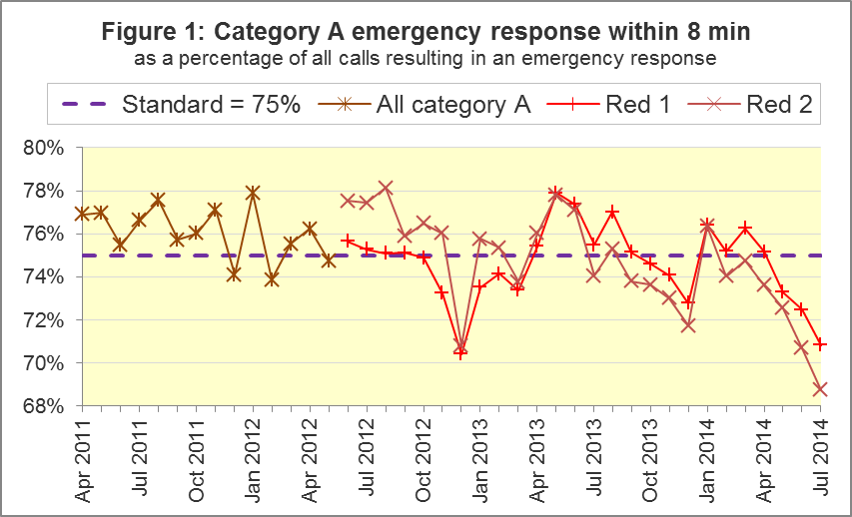
Most Ambulance Trusts failed to meet the standard in July 2014, with only West Midlands (77.7%), South Central (75.5%) and Isle of Wight (85.3%) meeting the Red 1 standard, and only Isle of Wight (75.6%) meeting the Red 2 standard.
In the East of England, the Red 1 measure was 66.3% and Red 2 was 59.6% for Red 2. Of the eleven Trusts, it has had the lowest value for both measures for five consecutive months.
Due to differences in clock start definitions for Red 1 and Red 2, it is not possible to aggregate them into a total Category A performance.

A2. Systems Indicators: Ambulance response in 19 minutes
The other standard for Ambulance Trusts in the Handbook to the NHS Constitution is for trusts to send a fully-equipped ambulance vehicle within 19 minutes to 95 per cent of Category A calls. This standard was not met nationally. The July 2014 value for all England was 94.0%, the lowest for more than three years.
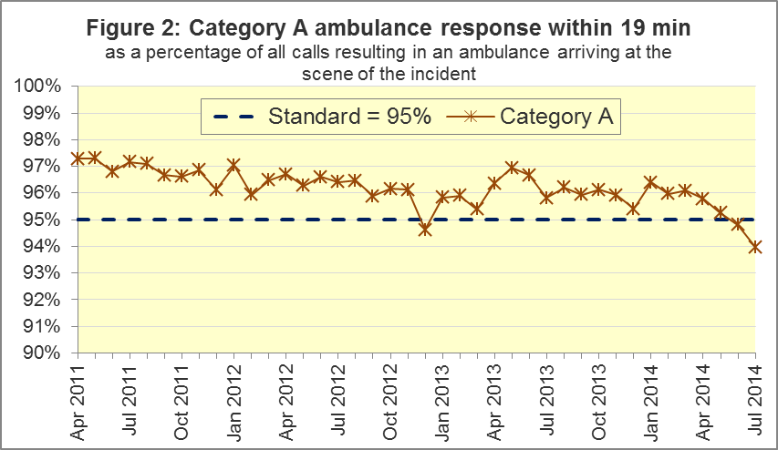
East Midlands, East of England, London, and South East Coast, which each missed this standard in June 2014, each missed it again in July 2014, and by more than one percentage point.
North East, North West, and South Western, each missed the standard in July 2014, but by less than one percentage point, and had achieved it for the previous six consecutive months, at least.
The West Midlands Ambulance Service had the highest measure of 19 minute ambulance response in July 2014, with 96.7%.

A3. Systems Indicators: Ambulance volumes
The total number of emergency calls presented to switchboard in July 2014 was 803,820 (26 thousand per day), the largest figure for three years apart from December 2012 (828,194). This includes calls passed manually from 111 as requiring an ambulance response, but excludes calls that have been passed electronically from 111.
The number of category A calls resulting in an ambulance arriving at the scene also increased, albeit more slowly and more steadily than the number of calls, and reached 261,324 in July 2014, or 8,430 per day.
Despite these increases, the number of incidents requiring emergency patient journeys to Type 1 or Type 2 A&E remained stable at 399,983 in July 2014, and has averaged 13 thousand per day each month since April 2013.
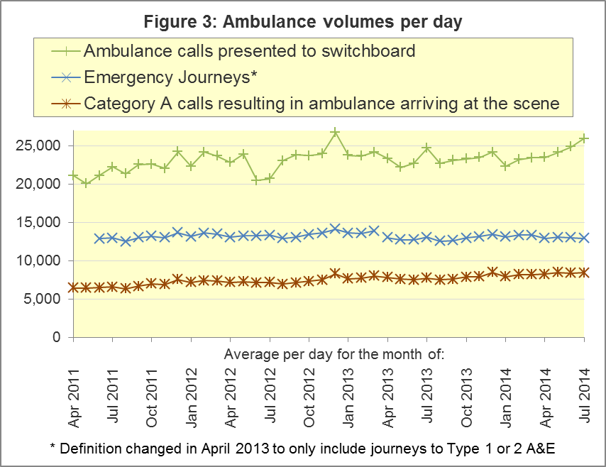

A4. Trust averages and extremes for all Systems Indicators, July 2014
Indicator | All England | Lowest Trust | Highest Trust
Category A Red 1: 8 minute emergency response | 70.8% | 66.3% | 77.7%
Category A Red 2: 8 minute emergency response | 68.7% | 59.6% | 74.2% ⁵
Category A: 19 minute ambulance response | 94.0% | 89.3% | 96.7%
Calls abandoned before being answered | 2.2% | 0.7% | 7.1%
Calls resolved through telephone assessment | 7.7% | 3.6% | 12.6%
Calls resolved without transport to Type 1 or Type 2 A&E | 37.6% | 28.1% | 52.1%
Recontact rate following discharge by telephone advice | 8.4% | 2.6% | 13.9%
Recontact rate following face-to-face treatment at scene | 5.2% | 3.9% | 7.2%
Number of emergency journeys | 399,983 | 20,751 ⁵ | 64,519

⁵ Due to its small size, performance on the Isle of Wight tends to vary more than other Trusts. If the Isle of Wight has the lowest or highest value, the Table in A4 shows the second lowest or highest value, but with an asterisk to show that the Isle of Wight is more extreme. This system is also used in the following Clinical Outcomes section.

B. Clinical Outcomes
No thresholds to denote “poor” care are set for Clinical Outcomes (CO). Instead, Trusts are expected to use the data on to reduce variation in performance across trusts (where clinically appropriate), and drive continuous improvement in patient outcomes over time.

B1. Cardiac arrest: return of spontaneous circulation (ROSC)
In April 2014, of 2,604 patients with resuscitation commenced or continued by ambulance staff following an out-of-hospital cardiac arrest, 667 (25.6%) had ROSC on arrival at hospital. This was similar to 26.1% in 2013-14.
In April 2014, the largest proportion was 42.8% for South Central and the smallest⁵ was 16.5% for East Midlands.
The Utstein group comprises patients who had resuscitation commenced or continued by ambulance service, following an out-of-hospital cardiac arrest of presumed cardiac origin, where the arrest was bystander witnessed, and the initial rhythm was Ventricular Fibrillation or Ventricular Tachycardia. They therefore have a better chance of survival.
In this group, 47.2% had ROSC in April 2014, similar to the 2013-14 proportion of 46.9%. The largest proportion in April 2014 was 64.3% for North East, and the smallest was 28.1% for East Midlands.

B2. Cardiac arrest: survival to discharge
London Ambulance Service has not had access to the Summary Care Records needed to measure survival to discharge for April 2014, both for all patients, and for the Utstein group. We have therefore excluded it this month from these national numerators and denominators. We expect the missing statistics soon, and will include them in future publications as soon as possible, rather than waiting for the next scheduled CO revisions in 2015.
For the rest of England, 7.9% of cardiac arrest patients in April 2014 were discharged from hospital alive, similar to the 2013-14 proportion of 8.7% (which was 8.4% with London excluded). The largest proportion in April 2014 was 15.1% for South Central and the smallest was 3.6% for North East.
In the Utstein group, 25.9% were discharged from hospital alive in April 2014, similar to the 26.3% for 2013-14 (which was 25.2% with London excluded). The largest proportion in April 2014 was 34.6% for North West and the smallest⁶ was 17.2% for East Midlands.

B3. ST-Elevation myocardial infarction (STEMI)
ST segment elevation myocardial infarction is a type of heart attack, determined by an electrocardiogram (ECG) test. Early access to reperfusion, where blocked arteries are opened to re-establish blood flow, and other assessment and care interventions, are associated with reductions in STEMI mortality and morbidity.
In April 2014, of 1,390 patients with an acute STEMI, 1,144 (82.3%) received the appropriate care bundle, an increase upon 80.1% for 2013-14. North East had the largest proportion, with 95.1%, and the smallest was 67.3% in South Central.
Of 968 STEMI patients receiving primary angioplasty, 844 (87.2%) of them received it within 150 minutes of the call being connected to the ambulance service, similar to the 2013-14 figure of 88.9%. The largest⁶ proportion was 96.0% in London, and the smallest, 78.4% in South West.

B4. Stroke
The FAST procedure helps assess whether someone has suffered a stroke:
- Facial weakness – can the person smile? Has their mouth or eye drooped?
- Arm weakness – can the person raise both arms?
- Speech problems – can the person speak clearly and understand what you say?
- Time to call 999 for an ambulance if you spot any one of these signs.
In April 2014, of 3,176 FAST positive patients, assessed face to face, and potentially eligible for stroke thrombolysis within agreed local guidelines, 2,023 (63.7%) arrived at hospitals with a hyperacute stroke unit within 60 minutes of an emergency call connecting to the ambulance service. This was similar to 63.0% in 2013/14. The largest proportion in April 2014 was 82.3% in North East, and the smallest was 53.0% in South Central.
Of 6,927 stroke patients assessed face to face, 6,730 (97.2%) received the appropriate care bundle, compared with 96.4% in 2013/14. The smallest proportion in April 2014 was 94.7% in South East Coast.

B5. Trust averages and extremes for all Clinical Outcomes, April 2014
Indicator |  | All England | Lowest Trust | Highest Trust
Cardiac arrest, ROSC:
 | All patients | 25.6% | 16.5% | 42.8%
 | Utstein group | 47.2% | 28.1% | 64.3%
Cardiac arrest, Survival to discharge:
 | All patients | 7.9% | 3.6% ⁸ | 15.1%
 | Utstein group⁹ | 25.9% | 17.2% ⁸ | 34.6%
Outcome from acute STEMI:
 | Angioplasty within 150 minutes⁹ | 87.2% | 78.4% | 96.0% ⁸
 | Received appropriate care bundle⁹ | 82.3% | 67.3% | 95.1%
Outcome from stroke:
 | Thrombolysis in 60 minutes⁹ | 63.7% | 53.0% | 82.3%
 | Received appropriate care bundle | 97.2% | 94.7% | 99.6% ⁸

B6. Revisions
As described in our 8 August 2014 Statistical Note, we delayed revisions to CO data for the months of 2013-14 until now, in order to use improved data resulting from the Myocardial Ischaemia National Audit Project (MINAP).
All Trusts submitted revisions except for Yorkshire, East of England, South Central, and Isle of Wight. East Midlands revisions are only for STEMI angioplasty and cardiac arrest survival to discharge. The Midlands Trusts did not revise February or March data.
For all England, the eight revisions charts on page 8 show that the largest revisions are to the two indicators for Utstein comparator groups, where monthly national denominators are typically fewer than one thousand.
National monthly percentages revised by more than one percentage point are:
Indicator | Month in 2013-14 | From | To
Cardiac arrest: ROSC (Utstein) | July | 46.1 | 47.9
Cardiac arrest: ROSC (Utstein) | September | 48.2 | 49.4
Cardiac arrest: Survival to discharge (Utstein) | November | 24.8 | 23.7
Cardiac arrest: Survival to discharge (Utstein) | January | 23.1 | 24.5
Cardiac arrest: Survival to discharge (Utstein) | February | 29.3 | 31.2

The effects upon national annual percentages for 2013-14 are:

Indicator |  | From | To
Cardiac arrest: ROSC (All) |  | 25.9 | 26.1
Cardiac arrest: ROSC (Utstein) |  | 46.7 | 46.9
Cardiac arrest: Survival to discharge (All) |  | 8.7 | 8.7
Cardiac arrest: Survival to discharge (Utstein) |  | 26.1 | 26.3
STEMI: Primary angioplasty within 150 minutes |  | 89.0 | 88.9
STEMI: Received appropriate care bundle |  | 80.1 | 80.1
Stroke: Arrival at a hyperacute stroke unit within 60 minutes |  | 62.9 | 63.0
Stroke: Received appropriate care bundle |  | 96.4 | 96.4

Revisions charts for 2013-14 Clinical Outcome data, all England
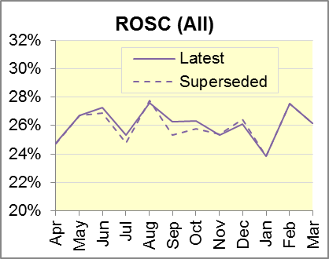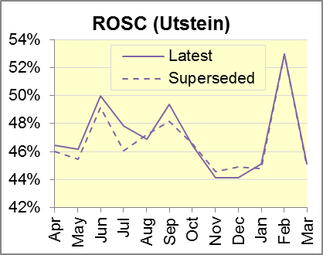
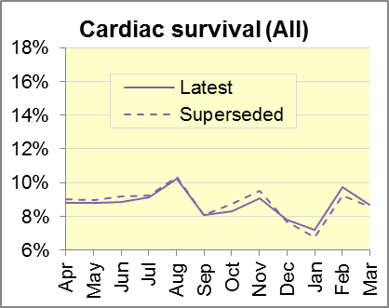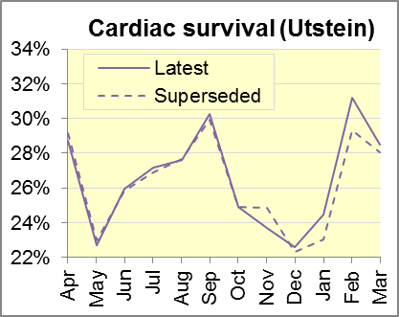
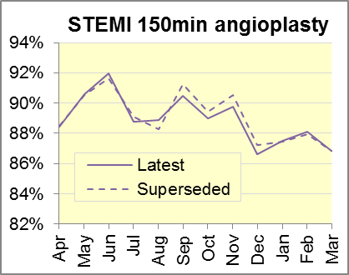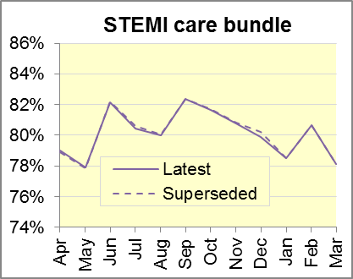
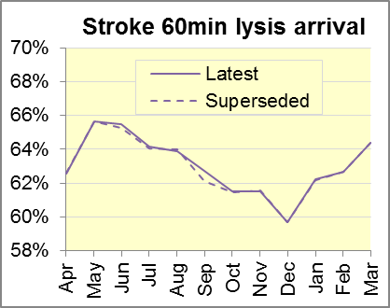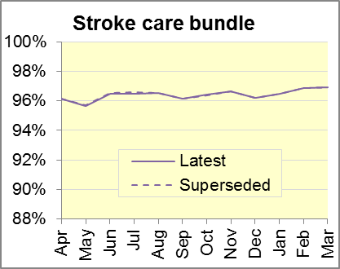

C. Further information on AQI

C1. Quality Statement and data specification
The Ambulance Quality Indicators (AQI) landing page holds the specification guidance for those who supply the data:
www.england.nhs.uk/statistics/statistical-work-areas/ambulance-quality-indicators
This web page also holds a Quality Statement for these statistics, which includes information on relevance, accuracy, timeliness, coherence, and user engagement.
The web page also holds text files and time series spreadsheets containing all data from April 2011 up to the latest month.

C2. Revisions
The Quality Statement above contains more information on the revisions policy. In general, future revisions will be made on a six-monthly cycle, starting with revisions to the April to August 2014 Systems Indicators on 31 October 2014. However, we hope to include, in our next publication on 3 October 2014, the missing April 2014 London data, for survival to discharge following cardiac arrest.
Dates for previous revisions:
5 September 2014: AmbCO April 2013 to March 2014
2 May 2014: AmbSYS April 2013 to February 2014
7 March 2014: AmbCO April 2013 to September 2013
1 November 2013: AmbSYS April 2013 to August 2013
2 August 2013: AmbCO April 2012 to March 2013
3 May 2013: AmbSYS April 2012 to March 2013
1 February 2013: AmbCO April 2012 to August 2012
11 January 2013: AmbSYS April 2011 to October 2012
31 August 2012: AmbCO April 2011 to March 2012

C3. Related statistics in England
The AQI appear in a Clinical Dashboard, available from http://aace.org.uk/national-performance/national-clinical-dashboards, and the websites of most Ambulance Trusts. One of the aims of these Dashboards is to use statistical process control, to indicate whether variation in performance reflects underlying change, or merely natural variance, unavoidable even when a health system is performing well.
The AQI also appear in the latest annual KA34 publication www.hscic.gov.uk/article/2021/Website-Search?productid=15165 by the Health and Social Care Information Centre. The KA34 was a set of similar Systems Indicators, not quite comparable with the AQI, that ceased collection in March 2013. The Quality Statement above contains more information.
Data from 8 November 2010 to 29 May 2011 were collected in Weekly Situation Reports, including:
- Category A and Category B calls made to ambulance trusts in England;
- of those calls, how many were responded to within 8 minutes (category A) or 19 minutes (category B);
- the number of urgent and emergency journeys;
- instances of delayed handover to A&E staff.
These are available at http://webarchive.nationalarchives.gov.uk/
20130107105354/http://www.dh.gov.uk/en/Publicationsandstatistics/Statistics/Performancedataandstatistics/WeeklySituationReports/DH_128506.

C4. Rest of UK
Other ambulance statistics can be found at the following websites. The Quality Statement described in section C1 contains more information about the comparability of these statistics:
Wales: | http://wales.gov.uk/statistics-and-research/ambulance-services/?lang=en
Scotland: | See Quality Improvement Indicators (QII) documents at www.scottishambulance.com/TheService/BoardPapers.aspx
Northern Ireland: | www.dhsspsni.gov.uk/index/stats_research/hospital-stats/emergency_care-3/emergency-care-stats.htm

C5. Contact information
For press enquiries, please contact the NHS England press office on 0113 825 0958 or nhsengland.media@nhs.net.
The Government Statistical Service (GSS) statistician responsible for producing these data is:
Ian Kay, Analytical Services (Operations), NHS England, Room 5E24, Quarry House, Leeds, LS2 7UE
0113 824 9411
i.kay@nhs.net

On 1 June 2012, Category A (immediately life-threatening) calls were split into Red 1 and Red 2. Red 1 calls are the most time critical, and cover cardiac arrest patients who are not breathing and do not have a pulse, and other severe conditions such as airway obstruction. Red 2 calls are serious, but less immediately time critical, and cover conditions such as stroke and fits. www.gov.uk/government/news/changes-to-ambulance-response-time-categories
The standards for Ambulance response times are in the Handbook to the NHS Constitution at www.nhs.uk/choiceintheNHS/Rightsandpledges/NHSConstitution/Pages/Overview.aspx.
Clock definitions appear in the specification guidance for data suppliers on the AQI landing page at www.england.nhs.uk/statistics/statistical-work-areas/ambulance-quality-indicators.
Type 1 A&E means consultant-led 24 hour emergency departments with full resuscitation facilities. Type 2 offer a consultant-led speciality A&E service such as ophthalmology or dental. Type 3 are A&E/minor injury activity that may be doctor-led or nurse-led. Type 4 are NHS walk-in centres. www.datadictionary.nhs.uk/data_dictionary/attributes/a/acc/ accident_and_emergency_department_type_de.asp
Excluding Isle of Wight.
Excluding Isle of Wight.
Pages 21 to 25 of the specification guidance for data suppliers on the AQI landing page at www.england.nhs.uk/statistics/statistical-work-areas/ambulance-quality-indicators describe, for STEMI and stroke, the care bundles and certain exclusions.
Excluding Isle of Wight.
For these indicators, several trusts have fewer than 100 patients to calculate a percentage from, and so percentages can vary greatly between Trusts.
www.england.nhs.uk/statistics/statistical-work-areas/ambulance-quality-indicators/ambulance-quality-indicators-data-2014-15

