Statistical Note: Ambulance Quality Indicators (AQI)
Published by NHS England on 3 October 2014

A. Systems Indicators

A1. Emergency response in 8 minutes
In August 2014, of Category A Red 1 calls in England resulting in an emergency response, the proportion arriving within 8 minutes was 73.2%.
In August 2014, of Category A Red 2 calls in England resulting in an emergency response, the proportion arriving within 8 minutes was 70.9%.
The standard for Ambulance trusts is to send an emergency response, with a defibrillator, within eight minutes, to 75 per cent of Category A calls; so this standard was not met for either Red 1 or Red 2.
Both measures decreased by at least five percentage points between March and July 2014, but increased by at least one percentage point in August 2014.
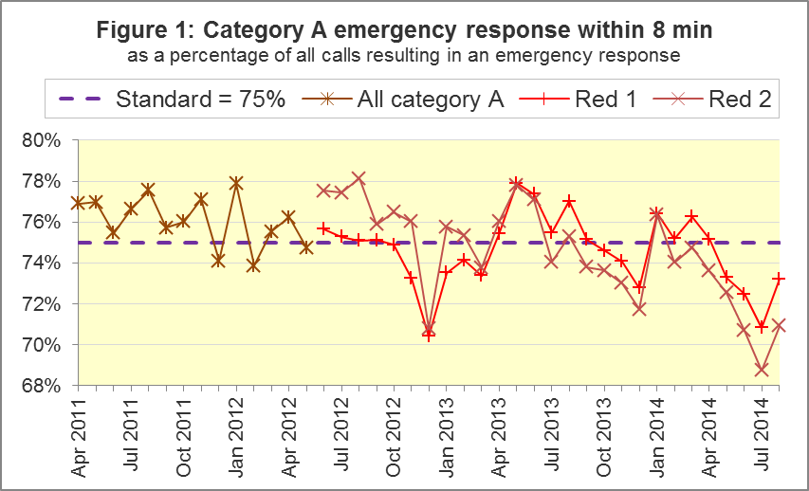
Five Trusts (North East, West Midlands, South East Coast, South Central and South West) met the Red 1 standard in August 2014, and West Midlands had the highest proportion of 81.9%. Apart from South East Coast, they all met the Red 2 standard too, for which the highest proportion was 76.5% in South Western.
Six Trusts failed to meet the Red 1 standard, and the lowest proportion was 68.7% in London. These Trusts all failed to meet the Red 2 standard too, and East of England had the lowest proportion for the seventh consecutive month, with 61.1% in August.

A2. Systems Indicators: Ambulance response in 19 minutes
The other standard for Ambulance Trusts in the Handbook to the NHS Constitution is for trusts to send a fully-equipped ambulance vehicle within 19 minutes to 95 per cent of Category A calls.
As with the national Red 1 and Red 2 proportions, the ambulance response proportion increased in August 2014 after four months of decreases. However, it remained just below the standard, at 94.9%.

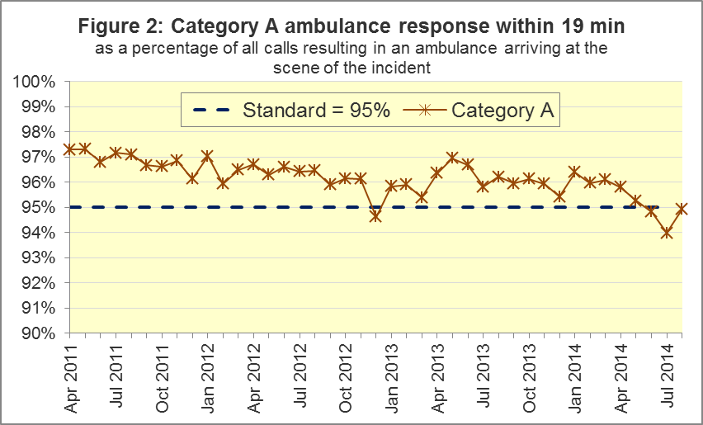

Eight trusts met the standard, and for the fifth consecutive month, West Midlands had the highest proportion, with 97.2% in August 2014.
East Midlands, East of England, and London all failed to meet the standard. East of England had 90.3%, the lowest proportion for the twelfth consecutive month. Apart from the highest and lowest, the other nine Trusts had similar proportions, between 93.9% and 96.1%.

A3. Systems Indicators: Ambulance volumes
The total number of emergency calls presented to switchboard in August 2014 was 733,347 (24 thousand per day).Therefore, following increases in June and July, this has decreased back to the volumes seen in spring 2014.
The number of category A calls that resulted in an ambulance arriving at the scene was 247,959 in August 2014. This was 7,999 per day, fewer than most months in 2014, but more than most months in the previous three years.
The number of incidents requiring emergency patient journeys to Type 1 or Type 2 A&E decreased to 383,824 in August 2014, or 12,381 per day, the lowest volume per day in 2014.
In each year from 2011 to 2014, category A calls and patient journeys were fewer in August than in July.
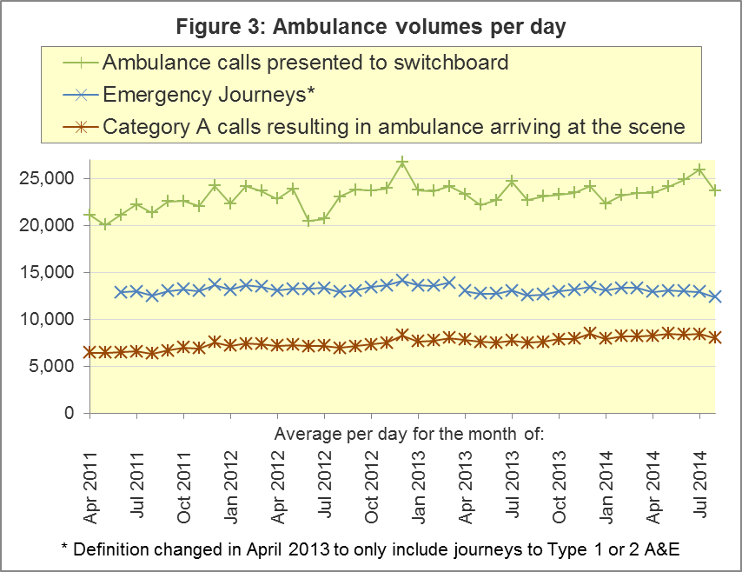

A4. Trust averages and extremes for Systems Indicators, August 2014
Indicator | All England | Lowest Trust | Highest Trust
Category A Red 1: 8 minute emergency response | 73.2% | 68.7% | 81.9%
Category A Red 2: 8 minute emergency response | 70.9% | 61.1% | 76.5%
Category A: 19 minute ambulance response | 94.9% | 90.3% | 97.2%
Calls abandoned before being answered | 1.3% | 0.1% | 4.0%
Calls resolved through telephone assessment | 7.5% | 3.3% | 12.6%
Calls resolved without transport to Type 1 or Type 2 A&E | 37.3% | 27.6% | 52.4%
Recontact rate following discharge by telephone advice | 7.3% | 0.3% | 14.9%
Recontact rate following face-to-face treatment at scene | 5.3% | 3.7% | 7.4%
Number of emergency journeys | 383,824 | 20,239 ⁵ | 61,393

⁵ Due to its small size, performance on the Isle of Wight tends to vary more than other Trusts. If the Isle of Wight has the lowest or highest value, the Table in A4 shows the second lowest or highest value, but with a footnote marker to show that the Isle of Wight is more extreme. This system is also used in the following Clinical Outcomes section.

B. Clinical Outcomes
No thresholds to denote “poor” care are set for Clinical Outcomes (CO). Instead, Trusts are expected to use the data on to reduce variation in performance across trusts (where clinically appropriate), and drive continuous improvement in patient outcomes over time.

B1. Cardiac arrest: return of spontaneous circulation (ROSC)
In May 2014, there were 2,534 patients with resuscitation commenced or continued by ambulance staff following an out-of-hospital cardiac arrest. Of these, 642 (25.3%) had ROSC on arrival at hospital. This was similar to 26.1% in 2013-14.
In May 2014, the largest proportion was 33.1% for South Central and the smallest was 16.7% for East of England.
The Utstein group comprises patients who had resuscitation commenced or continued by ambulance service, following an out-of-hospital cardiac arrest of presumed cardiac origin, where the arrest was bystander witnessed, and the initial rhythm was Ventricular Fibrillation or Ventricular Tachycardia. They therefore have a better chance of survival.
In this group, 46.6% had ROSC in May 2014, similar to the 2013-14 proportion of 46.9%. The largest proportion in May 2014 was 54.7% for London, and the smallest was 25.0% for East Midlands.

B2. Cardiac arrest: survival to discharge, including revisions
We now have a complete set of data for April 2014 with the arrival of delayed London Ambulance Service data. The percentage of patients discharged from hospital alive for all England in April 2014 has consequently been revised from 7.9% to 7.6%. For the Utstein group, the revision is from 25.9% to 25.7%.
In May 2014, 7.8% of cardiac arrest patients were discharged from hospital alive, similar to the 2013-14 proportion of 8.7%. The largest proportion in May 2014 was 15.7% for South Central and the smallest was 2.5% for North East.
For the Utstein group, 25.5% were discharged from hospital alive in May 2014. The largest⁶ proportion was 41.2% for Yorkshire and the smallest was 9.4% for East of England.

B3. ST-Elevation myocardial infarction (STEMI)
ST segment elevation myocardial infarction is a type of heart attack, determined by an electrocardiogram (ECG) test. Early access to reperfusion, where blocked arteries are opened to re-establish blood flow, and other assessment and care interventions, are associated with reductions in STEMI mortality and morbidity.
In May 2014, of 1,467 patients with an acute STEMI, 1,190 (81.1%) received the appropriate care bundle, similar to the proportion of 80.1% for 2013-14. North East had the largest⁶ proportion, with 97.1%, and the smallest was 70.9% in South Central.
Of 1,011 STEMI patients receiving primary angioplasty, 870 (86.1%) of them received it within 150 minutes of the call being connected to the ambulance service, less than the 2013-14 proportion of 88.9%. The largest proportion was 91.5% in East of England, and the smallest⁶, 79.1% in South West.

B4. Stroke
The FAST procedure helps assess whether someone has suffered a stroke:
- Facial weakness – can the person smile? Has their mouth or eye drooped?
- Arm weakness – can the person raise both arms?
- Speech problems – can the person speak clearly and understand what you say?
- Time to call 999 for an ambulance if you spot any one of these signs.
In May 2014, of 3,217 FAST positive patients, assessed face to face, and potentially eligible for stroke thrombolysis within agreed local guidelines, 1,985 (61.7%) arrived at hospitals with a hyperacute stroke unit within 60 minutes of an emergency call connecting to the ambulance service. This was similar to 63.0% in 2013/14. The largest proportion in May 2014 was 73.8% in North East, and the smallest was 52.1% in East of England.
Of 7,240 stroke patients assessed face to face, 7,027 (97.1%) received the appropriate care bundle, compared with 96.4% in 2013/14. The smallest proportion in May 2014 was 91.3% in West Midlands.

B5. Trust averages and extremes for all Clinical Outcomes, May 2014
Indicator |  | All England | Lowest Trust | Highest Trust
Cardiac arrest, ROSC:
 | All patients | 25.3% | 16.7% | 33.1%
 | Utstein group | 46.6% | 25.0% | 54.7%
Cardiac arrest, Survival to discharge:
 | All patients | 7.8% | 2.5% | 15.7% ⁸
 | Utstein group⁹ | 25.5% | 9.4% | 41.2% ⁸
Outcome from acute STEMI:
 | Angioplasty within 150 minutes⁹ | 86.1% | 79.1% ⁸ | 91.5%
 | Received appropriate care bundle⁹ | 81.1% | 70.9% | 97.1% ⁸
Outcome from stroke:
 | Thrombolysis in 60 minutes⁹ | 61.7% | 52.1% | 73.8%
 | Received appropriate care bundle | 97.1% | 91.3% | 99.6%

C. Further information on AQI
AQI include calls made by dialling either 999 or 112.

C1. Quality Statement and data specification
The Ambulance Quality Indicators (AQI) landing page holds the specification guidance for those who supply the data:
www.england.nhs.uk/statistics/statistical-work-areas/ambulance-quality-indicators
This web page also holds a Quality Statement for these statistics, which includes information on relevance, accuracy, timeliness, coherence, and user engagement.
The web page also holds text files and time series spreadsheets containing all data from April 2011 up to the latest month.

C2. Revisions
The Quality Statement above contains more information on the revisions policy. In general, future revisions will be made on a six-monthly cycle, starting with revisions to the April to August 2014 Systems Indicators on 7 November 2014.
Dates for previous revisions:
5 September 2014: AmbCO April 2013 to March 2014
2 May 2014: AmbSYS April 2013 to February 2014
7 March 2014: AmbCO April 2013 to September 2013
1 November 2013: AmbSYS April 2013 to August 2013
2 August 2013: AmbCO April 2012 to March 2013
3 May 2013: AmbSYS April 2012 to March 2013
1 February 2013: AmbCO April 2012 to August 2012
11 January 2013: AmbSYS April 2011 to October 2012
31 August 2012: AmbCO April 2011 to March 2012

C3. Related statistics in England
The AQI appear in a Clinical Dashboard, available from http://aace.org.uk/national-performance/national-clinical-dashboards, and the websites of most Ambulance Trusts. One of the aims of these Dashboards is to use statistical process control, to indicate whether variation in performance reflects underlying change, or merely natural variance, unavoidable even when a health system is performing well.
The AQI also appear in the latest annual KA34 publication www.hscic.gov.uk/article/2021/Website-Search?productid=15165 by the Health and Social Care Information Centre. The KA34 was a set of similar Systems Indicators, not quite comparable with the AQI, that ceased collection in March 2013. The Quality Statement above contains more information.
Data from 8 November 2010 to 29 May 2011 were collected in Weekly Situation Reports, including:
- Category A and Category B calls made to ambulance trusts in England;
- of those calls, how many were responded to within 8 minutes (category A) or 19 minutes (category B);
- the number of urgent and emergency journeys;
- instances of delayed handover to A&E staff.
These are available at http://webarchive.nationalarchives.gov.uk/
20130107105354/http://www.dh.gov.uk/en/Publicationsandstatistics/Statistics/Performancedataandstatistics/WeeklySituationReports/DH_128506.

C4. Rest of UK
Other ambulance statistics can be found at the following websites. The Quality Statement described in section C1 contains more information about the comparability of these statistics:
Wales: | http://wales.gov.uk/statistics-and-research/ambulance-services/?lang=en
Scotland: | See Quality Improvement Indicators (QII) documents at www.scottishambulance.com/TheService/BoardPapers.aspx
Northern Ireland: | www.dhsspsni.gov.uk/index/stats_research/hospital-stats/emergency_care-3/emergency-care-stats.htm

C5. Contact information
For press enquiries, please contact the NHS England press office on 0113 825 0958 or nhsengland.media@nhs.net.
The Government Statistical Service (GSS) statistician responsible for producing these data is:
Ian Kay, Analytical Services (Operations), NHS England, Room 5E24, Quarry House, Leeds, LS2 7UE
0113 824 9411
i.kay@nhs.net

On 1 June 2012, Category A (immediately life-threatening) calls were split into Red 1 and Red 2. Red 1 calls are the most time critical, and cover cardiac arrest patients who are not breathing and do not have a pulse, and other severe conditions such as airway obstruction. Red 2 calls are serious, but less immediately time critical, and cover conditions such as stroke and fits. www.gov.uk/government/news/changes-to-ambulance-response-time-categories Due to differences in clock start definitions for Red 1 and Red 2, it is not possible to aggregate them into a total Category A performance. Clock definitions appear in the specification guidance for data suppliers on the AQI landing page at www.england.nhs.uk/statistics/statistical-work-areas/ambulance-quality-indicators
The standards for Ambulance response times are in the Handbook to the NHS Constitution at www.nhs.uk/choiceintheNHS/Rightsandpledges/NHSConstitution/Pages/Overview.aspx.
The majority of calls to NHS 111 that require an ambulance are not included in the above total number of calls presented to switchboard. This is because they are not routed via 999 call handlers, but transferred electronically direct to ambulance dispatch. Occasionally, a manual request for an ambulance is made from a 111 call handler to a 999 call handler, and such calls are included in the above total number of calls presented.
Type 1 are consultant-led 24 hour emergency departments with full resuscitation facilities. Type 2 offer a consultant-led speciality A&E service such as ophthalmology or dental. Type 3 are A&E/minor injury activity that may be doctor-led or nurse-led. Type 4 are NHS walk-in centres. (www.datadictionary.nhs.uk/data_dictionary/attributes/a/acc/ accident_and_emergency_department_type_de.asp)
Excluding Isle of Wight.
Excluding Isle of Wight.
Pages 21 to 25 of the specification guidance for data suppliers on the AQI landing page at www.england.nhs.uk/statistics/statistical-work-areas/ambulance-quality-indicators describe, for STEMI and stroke, the care bundles and certain exclusions.
Excluding Isle of Wight.
For these indicators, several trusts have fewer than 100 patients to calculate a percentage from, and so percentages can vary greatly between Trusts.

