Statistical Note: Ambulance Quality Indicators (AQI)
Published by NHS England on 6 November 2014.

A. Systems Indicators

A1. Emergency response in 8 minutes
In September 2014, of Category A Red 1 calls in England resulting in an emergency response, the proportion arriving within 8 minutes was 72.7%.
In September 2014, of Category A Red 2 calls in England resulting in an emergency response, the proportion arriving within 8 minutes was 70.0%.
The standard for Ambulance trusts is to send an emergency response, with a defibrillator, within 8 minutes, to 75 per cent of Category A calls.
Figure 1 shows that this standard has not been met for Red 1 since April 2014, and has not been met for Red 2 since January 2014.
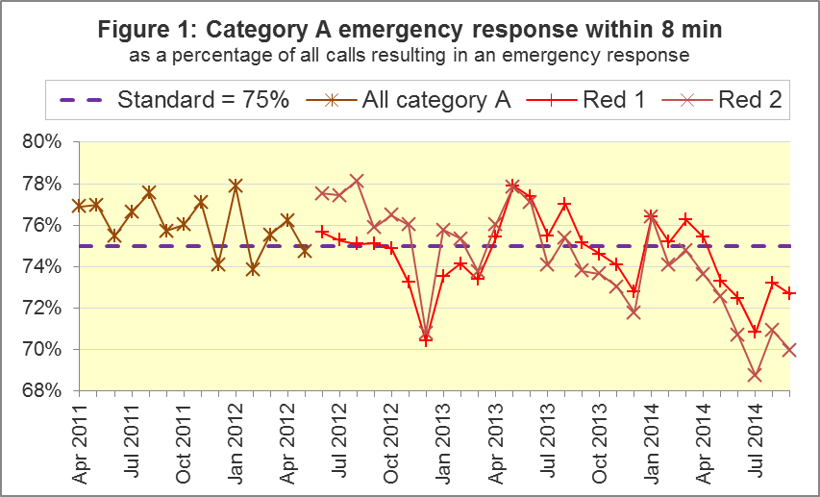
Six Trusts (North East, West Midlands, South East Coast, South Central, South Western, and Isle of Wight) met the Red 1 standard in September 2014, and West Midlands had the highest proportion, 83.0%. Apart from South East Coast, these Trusts met the Red 2 standard too, for which the highest proportion was 76.9% in South Western.
Five Trusts (North West, Yorkshire, East of Midlands, East of England and London) failed to meet the Red 1 standard, and the lowest proportion was 61.9% in London.
These five Trusts all failed to meet the Red 2 standard too, and in September 2014 London had 54.0%, the lowest proportion since Red 2 was defined.

A2. Systems Indicators: Ambulance response in 19 minutes
The other standard for Ambulance Trusts in the Handbook to the NHS Constitution is for trusts to send a fully-equipped ambulance vehicle within 19 minutes to 95 per cent of Category A calls.
The proportion for September 2014 was 94.4%. Figure 2 shows that this was below the standard for the fourth month in a row.

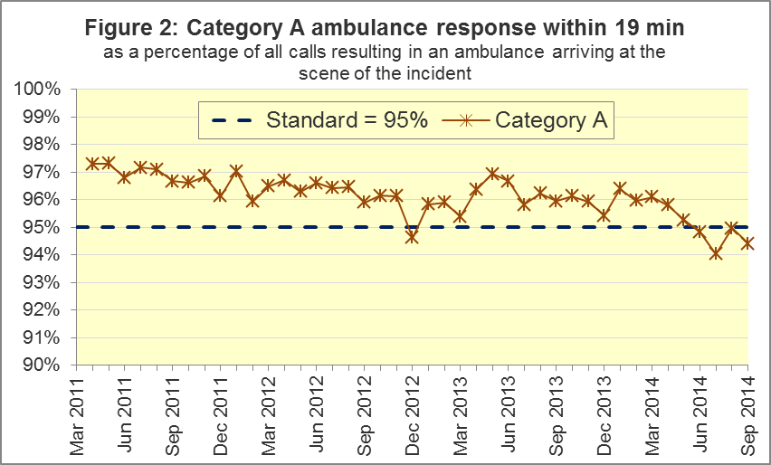

Eight trusts met the standard. Isle of Wight had the highest proportion, with 98.2% in September 2014. West Midlands had the second highest proportion, with 97.3%, after having the highest proportion in the previous five months.
East Midlands (93.6%), East of England (91.5%), and London (90.5%) all failed to meet the standard.

A3. Systems Indicators: Ambulance volumes
The number of emergency calls presented to switchboard in September 2014 was 671,166 (22 thousand per day), fewer than most months in 2014.
There were 378,954 incidents requiring emergency patient journeys to Type 1 or Type 2 A&E in September 2014, or 12,632 per day, less than average for the previous twelve months, but almost identical to September 2013.
The number of category A calls that resulted in an ambulance arriving at the scene was 246,883 in September 2014. This was 8,229 per day, close to the highest rate of 8,450 per day in May 2014.
In each year from 2011 to 2014, September had more incidents requiring patient journeys per day, and more category A calls per day, than the August immediately before.
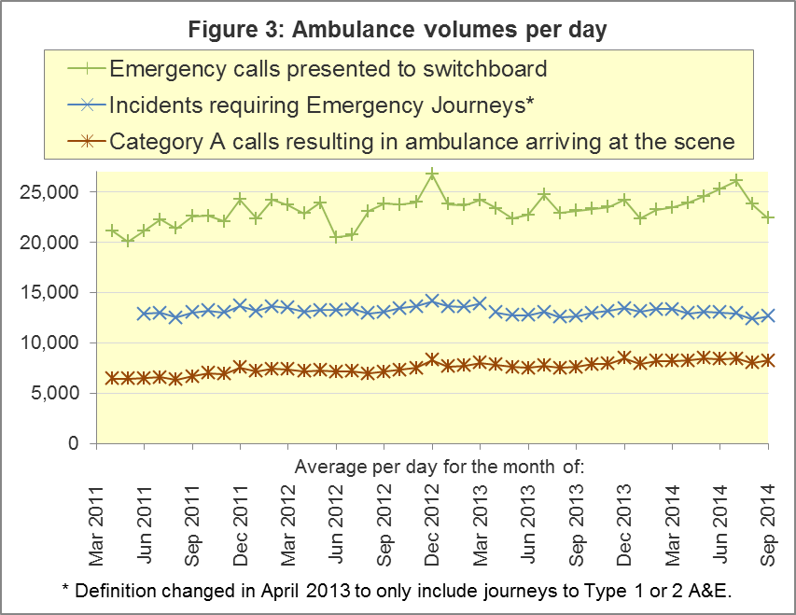

A4. Trust averages and extremes for System Indicators, September 2014
Indicator | All England | Lowest Trust | Highest Trust
Red 1: 8 minute emergency response | 72.7% | 61.9% | 83.0%
Red 2: 8 minute emergency response | 70.0% | 54.0% | 76.9%
Category A: 19 minute ambulance response | 94.4% | 90.5% | 97.3%
Calls abandoned before being answered | 1.7% | 0.5% | 4.6%
Calls resolved through telephone assessment | 7.7% | 3.3% | 14.5%
Calls resolved without transport to Type 1 or Type 2 A&E | 37.1% | 27.2% | 51.9%
Recontact rate following discharge by telephone advice | 6.9% | 0.3% | 14.5%
Recontact rate following face-to-face treatment at scene | 5.3% | 3.7% | 7.5%
Number of emergency journeys | 378,954 | 19,892 ⁵ | 60,347

A5. Revisions
Systems Indicators are revised every six month. The full set of revised data are in the Systems Indicators Time Series spreadsheet on the AQI landing page; and also in the pages linked on that site, holding separate spreadsheets for each month of 2013-14 and 2014-15.
Revisions in today’s publication affect:
Trust | Items | Months
North East | Red 2, category A | 2013-14 except September
Yorkshire | Abandoned calls | April to June 2014
East Midlands | All except emergency journeys | May 2013, August 2013, April 2014, May 2014
South East Coast | All except abandoned calls | April to August 2014
South Central | Abandoned calls | April to August 2014
Isle of Wight | Red 2 | April 2014

The only percentages revised by more than 1 percentage point are:
Trust | Item | Month | From | To
South East Coast | Red 1 response | April 2014 | 75.4% | 77.8%
East Midlands | Abandoned calls | April 2014 | 3.4% | 0.3%
 | Re-contact after discharge on the scene | April 2014 | 7.0% | 4.2%
 |  | May 2014 | 13.2% | 4.2%
Isle of Wight | Red 2 response | April 2014 | 74.5% | 76.9%

The only national percentages revised by more than 0.1 percentage points are:
 | Item | Month | From | To
All England | Red 1 response | April 2014 | 75.2% | 75.4%
 | Abandoned calls | April 2014 | 1.2% | 0.9%
 | Re-contact after discharge on the scene | April 2014 | 4.9% | 4.6%
 |  | May 2014 | 6.0% | 5.2%

The Red 1 response revision would not be perceptible if shown in Figure 1. Figures 4 and 5 demonstrate the revisions at national level to abandoned calls, and re-contact after discharge on the scene.

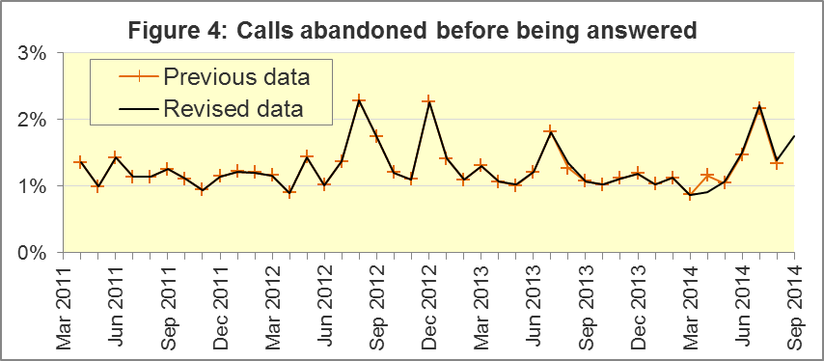

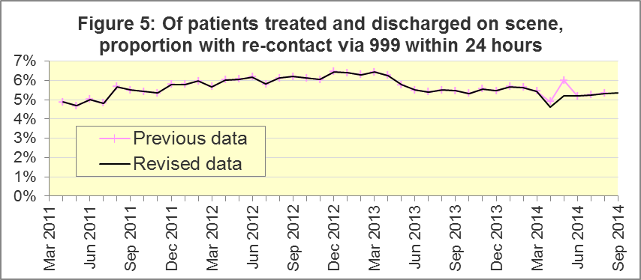

B. Clinical Outcomes
No thresholds to denote “poor” care are set for Clinical Outcomes (CO). Commissioners are expected to examine trends in these data, and work in collaboration with ambulance trusts to achieve sustained improvements over time improvement in patient outcomes over time; but commissioners are not expected to use Clinical Outcomes to performance manage trusts, because there will be significant variations in the populations served.

B1. Cardiac arrest: return of spontaneous circulation (ROSC) (Figure 6)
In June 2014, there were 2,417 patients with resuscitation commenced or continued by ambulance staff following an out-of-hospital cardiac arrest. Of these, 640 (26.5%) had ROSC on arrival at hospital. This was similar to the average of 26.1% for 2013-14. In June 2014, the largest proportion was 47.1% for South Central and the smallest was 14.2% for Yorkshire.
The Utstein group comprises patients who had resuscitation commenced or continued by ambulance service, following an out-of-hospital cardiac arrest of presumed cardiac origin, where the arrest was bystander witnessed, and the initial rhythm was Ventricular Fibrillation or Ventricular Tachycardia. They therefore have a better chance of survival.
In this group, 51.4% had ROSC in June 2014. The average for 2013-14 was 46.9%. The largest⁷ proportion in June 2014 was 83.3% for North East, and the smallest was 24.0% for East Midlands.
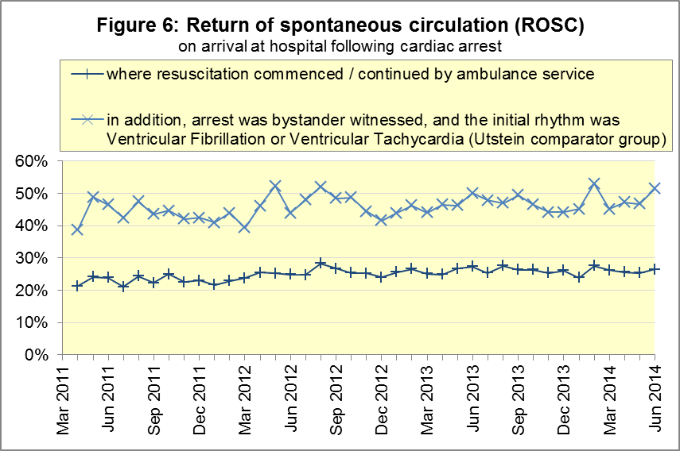

B2. Cardiac arrest: survival to discharge (Figure 7)
In June 2014, 8.5% of cardiac arrest patients were discharged from hospital alive, similar to the average for 2013-14 proportion of 8.7%. The largest proportion in June 2014 was 15.3% for South Central, and the smallest was 3.9% for North East.
For the Utstein group, 23.2% were discharged from hospital alive in June 2014. The average for 2013-14 was 26.3%. The largest⁸ proportion in June 2014 was 51.6% for Yorkshire, and the smallest was 4.8% for East Midlands.
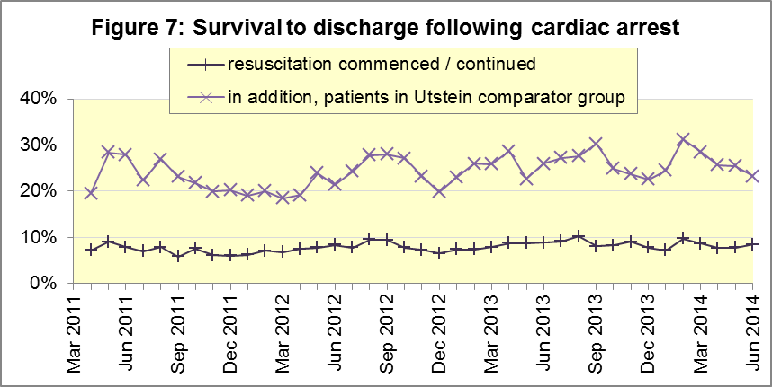

B3. ST-Elevation myocardial infarction (STEMI) (Figure 8)
ST-segment elevation myocardial infarction is a type of heart attack, determined by an electrocardiogram (ECG) test. Early access to reperfusion, where blocked arteries are opened to re-establish blood flow, and other assessment and care interventions, are associated with reductions in STEMI mortality and morbidity.
In June 2014, of 1,304 patients with an acute STEMI, 1,040 (79.8%) received the appropriate care bundle, similar to the proportion of 80.1% for 2013-14. North East had the largest proportion, with 93.4%, and the smallest was 66.0% in South Central.
Of 926 STEMI patients receiving primary angioplasty, 824 (89.0%) of them received it within 150 minutes of the call being connected to the ambulance service, similar to the 2013-14 proportion of 88.9%. The largest⁸ proportion was 95.7% in South Central, and the smallest was 81.4% in North West.
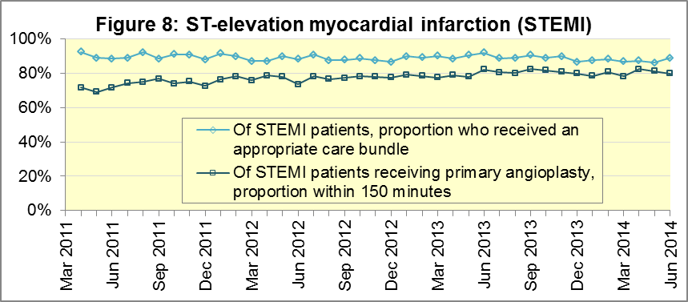

B4. Stroke (Figure 9)
The FAST procedure helps assess whether someone has suffered a stroke:
- Facial weakness – can the person smile? Has their mouth or eye drooped?
- Arm weakness – can the person raise both arms?
- Speech problems – can the person speak clearly and understand what you say?
- Time to call 999 for an ambulance if you spot any one of these signs.
In June 2014, of 3,096 FAST positive patients, assessed face to face, and potentially eligible for stroke thrombolysis within agreed local guidelines, 1,951 (63.0%) arrived at hospitals with a hyperacute stroke unit within 60 minutes of an emergency call connecting to the ambulance service. This was the same as 63.0% in 2013/14. The largest proportion in June 2014 was 76.0% in North West, and the smallest was 48.4% in West Midlands.
Of 7,312 stroke patients assessed face to face, 7,101 (97.1%) received the appropriate care bundle, similar to the average of 96.4% for 2013/14. The smallest proportion in June 2014 was 92.9% in South East Coast, and the largest was 100% in South Central.
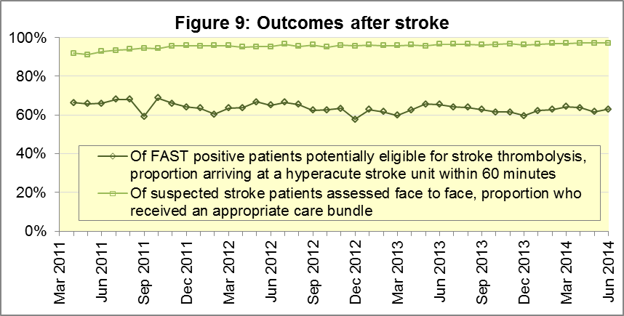

C. Further information on AQI
AQI include calls made by dialling either 999 or 112.

C1. Quality Statement and data specification
www.england.nhs.uk/statistics/statistical-work-areas/ambulance-quality-indicators is the Ambulance Quality Indicators (AQI) landing page, which holds:
- The specification guidance for those who supply the data;
- A Quality Statement for these statistics, which includes information on relevance, accuracy, timeliness, coherence, and user engagement;
- Publication timetables;
- Statistical Notes from previous months;
- Text files and time series spreadsheets containing all data from April 2011 up to the latest month.

C2. Revisions
The Quality Statement above contains more information on the revisions policy. Future revisions will usually continue the six-monthly cycle:
Publication date |  | Series revised |  | Months affected
November 2015 |  | Systems Indicators |  | April 2015 to August 2015
September 2015 |  | Clinical Outcomes |  | April 2014 to March 2015
30 April 2015 |  | Systems Indicators |  | April 2014 to February 2015
5 March 2015 |  | Clinical Outcomes |  | April 2014 to September 2014
6 November 2014 |  | Systems Indicators |  | April 2013 to August 2014
5 September 2014 |  | Clinical Outcomes |  | April 2013 to March 2014
2 May 2014 |  | Systems Indicators |  | April 2013 to February 2014
7 March 2014 |  | Clinical Outcomes |  | April 2013 to September 2013
1 November 2013 |  | Systems Indicators |  | April 2013 to August 2013
2 August 2013 |  | Clinical Outcomes |  | April 2012 to March 2013
3 May 2013 |  | Systems Indicators |  | April 2012 to March 2013
1 February 2013 |  | Clinical Outcomes |  | April 2012 to August 2012
11 January 2013 |  | Systems Indicators |  | April 2011 to October 2012
31 August 2012 |  | Clinical Outcomes |  | April 2011 to March 2012

C3. Related statistics in England
The AQI appear in a Clinical Dashboard, available from the AQI landing page, and http://aace.org.uk/national-performance/national-clinical-dashboards, and the websites of most Ambulance Trusts. One of the aims of these Dashboards is to use statistical process control, to indicate whether variation in performance reflects underlying change, or merely natural variance, unavoidable even when a health system is performing well.
The AQI also appear in the latest annual KA34 publication www.hscic.gov.uk/article/2021/Website-Search?productid=15165 by the Health and Social Care Information Centre. The KA34 was an annual set of similar Systems Indicators, not quite comparable with the AQI, that ceased collection in March 2013, and therefore this publication now uses the same data as the AQI, with additional annual analysis and commentary. The Quality Statement above contains more information.
Similar data from 8 November 2010 to 29 May 2011 were collected in Weekly Situation Reports, including:
- Category A and Category B calls made to ambulance trusts in England;
- of those calls, how many were responded to within 8 minutes (category A) or 19 minutes (category B);
- the number of urgent and emergency journeys;
- instances of delayed handover to A&E staff.
These are available at http://webarchive.nationalarchives.gov.uk/
20130107105354/http://www.dh.gov.uk/en/Publicationsandstatistics/Statistics/Performancedataandstatistics/WeeklySituationReports/DH_128506.

C4. Rest of UK
Other ambulance statistics can be found at the following websites. The Quality Statement described in section C1 contains more information about the comparability of these statistics:
Wales: | http://wales.gov.uk/statistics-and-research/ambulance-services/?lang=en
Scotland: | See Quality Improvement Indicators (QII) documents at www.scottishambulance.com/TheService/BoardPapers.aspx
Northern Ireland: | www.dhsspsni.gov.uk/index/stats_research/hospital-stats/emergency_care-3/emergency-care-stats.htm

C5. Contact information
For press enquiries, please contact the NHS England press office on 0113 825 0958 or nhsengland.media@nhs.net.
The Government Statistical Service (GSS) statistician responsible for producing these data is:
Ian Kay, Analytical Services (Operations), NHS England, Room 5E24, Quarry House, Leeds, LS2 7UE
0113 824 9411
i.kay@nhs.net

On 1 June 2012, Category A (immediately life-threatening) calls were split into Red 1 and Red 2. Red 1 calls are the most time critical, and cover cardiac arrest patients who are not breathing and do not have a pulse, and other severe conditions such as airway obstruction. Red 2 calls are serious, but less immediately time critical, and cover conditions such as stroke and fits. www.gov.uk/government/news/changes-to-ambulance-response-time-categories Due to differences in clock start definitions for Red 1 and Red 2, it is not possible to aggregate them into a total Category A performance. Clock definitions appear in the specification guidance for data suppliers on the AQI landing page at www.england.nhs.uk/statistics/statistical-work-areas/ambulance-quality-indicators
Ambulance response time standards are on page 30, Handbook to the NHS Constitution, www.nhs.uk/choiceintheNHS/Rightsandpledges/NHSConstitution/Pages/Overview.aspx.
The number of calls presented to switchboard does not usually include calls made to NHS 111 that require an ambulance. This is because 111 calls requiring an ambulance are usually transferred electronically direct to ambulance dispatch, and not routed via 999 call handlers. Occasionally, a manual request for an ambulance may be made from a 111 call handler to a 999 call handler, and such calls are included in the number of calls presented to switchboard.
Type 1 are consultant-led 24 hour emergency departments with full resuscitation facilities. Type 2 offer a consultant-led speciality A&E service such as ophthalmology or dental. Type 3 is A&E / minor injury activity that may be doctor-led or nurse-led. Type 4 are NHS walk-in centres. (www.datadictionary.nhs.uk/data_dictionary/attributes/a/acc/ accident_and_emergency_department_type_de.asp)
Due to its small size, performance on the Isle of Wight tends to vary more than other Trusts. If the Isle of Wight has the lowest or highest value, the Table in A4 shows the second lowest or highest value, but with a footnote marker to show that the Isle of Wight is more extreme. This system is also used for Clinical Outcomes in section B.
East of England Ambulance Service was unable to extract data on abandoned calls or frequent callers, prior to a change to its telephony system, to improve how calls are routed to call handlers.
Excluding Isle of Wight. See note 5 on page 4.
Excluding Isle of Wight. See note 5 on page 4.
Pages 21 to 25 of the specification guidance for data suppliers on the AQI landing page at www.england.nhs.uk/statistics/statistical-work-areas/ambulance-quality-indicators describe, for STEMI and stroke, the care bundles, and certain exclusions.

