Statistical Note: Ambulance Quality Indicators (AQI)
- The latest data for October 2014 on emergency responses by Ambulance Services in generally show performance deteriorated, and did not meet the standards in the NHS constitution.
- This month did see improvements for emergency calls closed without the need for transportation.
- The latest data for July 2014 show that clinical outcomes of patients transported by Ambulance Services remain stable.

A. Systems Indicators
Emergency response times in October 2014 may have been affected by a four-hour strike by NHS staff on 13 October and further action for the rest of that week. Similar action in November may affect next months’ data.

A1 Emergency response in 8 minutes
In October 2014, of Category A Red 1 calls in England resulting in an emergency response, the proportion arriving within 8 minutes was 72.1%.
In October 2014, of Category A Red 2 calls in England resulting in an emergency response, the proportion arriving within 8 minutes was 69.8%.
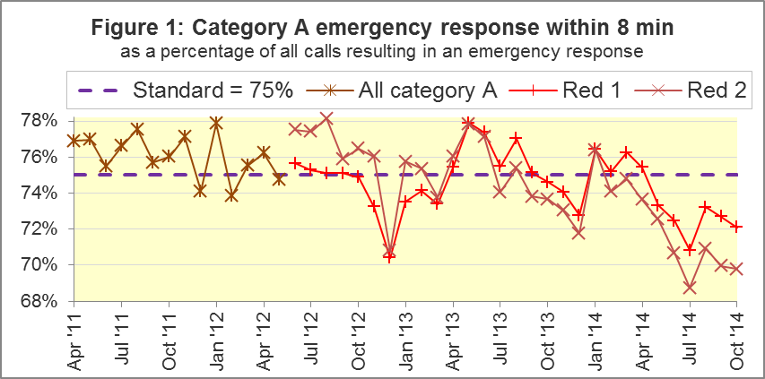
The standard for Ambulance Services is to send an emergency response, with a defibrillator, within 8 minutes, to 75% of Category A calls. Figure 1 shows that for England as a whole, this standard has not been met for Red 1 since April 2014, and has not been met for Red 2 since January 2014.
Four Trusts (West Midlands, South East Coast, South Western, and Isle of Wight) met the Red 1 standard in October 2014. Only two Trusts (South East Coast and Isle of Wight) met the Red 2 standard. Isle of Wight had the highest proportion for both: 80.5% for Red 1 and 75.9% for Red 2.
Of the seven Trusts that failed to meet the Red 1 standard of 75%, two (North East, 65.9%; and London, 64.1%) had proportions below 70%. There were also two Trusts that had proportions below 70% for Red 2: East of England (62.6%) and London (57.5%).

A2 Systems Indicators: Ambulance response in 19 minutes
The other standard for Ambulance Services in the Handbook to the NHS Constitution is for Trusts to send a fully-equipped ambulance vehicle within 19 minutes to 95 per cent of Category A calls. The proportion for October 2014 was 94.0%. Figure 2 shows that this was the joint lowest proportion since the series began, and below the standard for the fifth month in a row.
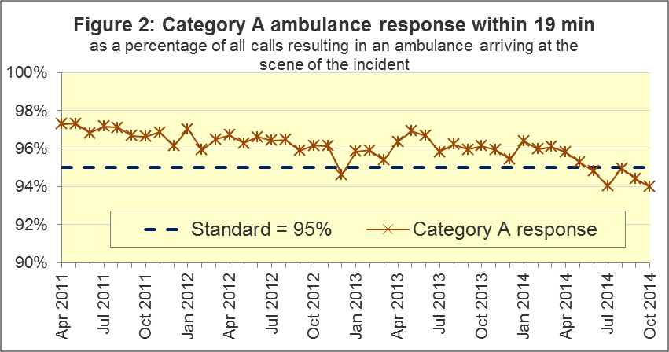

Five Trusts met the standard in October 2014: Yorkshire, West Midlands, South Central, South East Coast, and Isle of Wight (highest with 97.5%). Two Trusts had less than 93%: East of England (90.5%), and London (91.4%).

A3 Systems Indicators: Ambulance volumes (Figure 3)
The number of emergency calls presented to switchboard is a volatile measure, but was 774,454 in October 2014, 25 thousand per day, more than in most months of 2014.
The number of incidents requiring emergency patient journeys to Type 1 or Type 2 A&E is more stable. This was 398,477 in October 2014, which is 12,854 per day; more than in August and September, but fewer than in the other months of 2014.
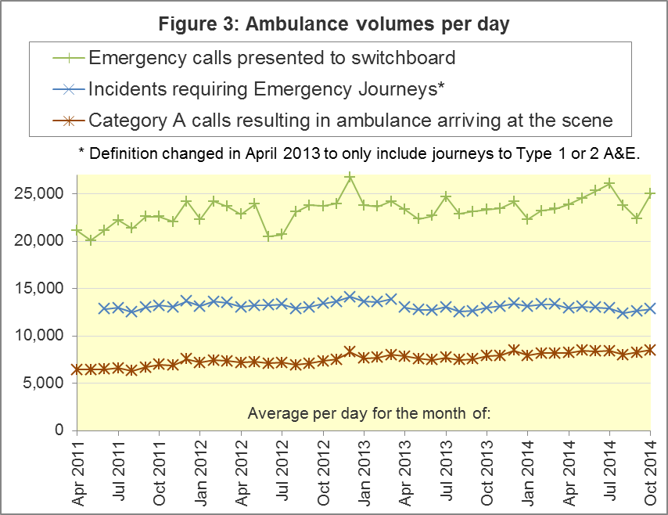
The number of category A calls that resulted in an ambulance arriving at the scene is also a stable measure, but one that continued to increase slowly. It was 263,448 in October 2014, or 8,498 per day, which exceeded the previous largest value (8,450 per day in May 2014).

A4 Trust averages and extremes for System Indicators, October 2014
Indicator | All England | Lowest Trust | Highest Trust
Red 1: 8 minute emergency response | 72.1% | 64.1% | 76.7%
Red 2: 8 minute emergency response | 69.8% | 57.5% | 75.1% ⁹
Category A: 19 minute ambulance response | 94.0% | 90.5% | 96.9% ⁹
Calls abandoned before being answered | 1.3% | 0.4% | 3.5%
Calls resolved through telephone assessment | 8.2% | 3.4% | 15.1%
Calls resolved without transport to Type 1 or Type 2 A&E | 37.0% | 27.6% | 52.3%
Recontact rate following discharge by telephone advice | 6.8% | 0.1% | 13.2%
Recontact rate following face-to-face treatment at scene | 5.4% | 3.4% ⁹ | 7.7%
Number of emergency journeys | 398,477 | 20,700 ⁹ | 64,445

B Clinical Outcomes
No thresholds to denote “poor” care are set for Clinical Outcomes. Commissioners are expected to examine trends in these data, and work in collaboration with Ambulance Trusts to achieve sustained improvements over time improvement in patient outcomes over time; but commissioners are not expected to use Clinical Outcomes to performance manage Trusts, because there will be significant variations in the populations served.

B1 Cardiac arrest: return of spontaneous circulation (ROSC) (Figure 4)
In July 2014, there were 2,332 patients with resuscitation commenced or continued by ambulance staff following an out-of-hospital cardiac arrest. Of these, 639 (27.4%) had ROSC on arrival at hospital. This was similar to the average of 26.1% for 2013-14. In July 2014, the largest proportion was 40.7% for South Central and the smallest was 20.5% for East Midlands.
The Utstein group comprises patients who had resuscitation commenced or continued by the Ambulance Services, following an out-of-hospital cardiac arrest of presumed cardiac origin, where the arrest was bystander witnessed, and the initial rhythm was Ventricular Fibrillation or Ventricular Tachycardia. They therefore have a better chance of survival.
In this group, 48.5% had ROSC in July 2014. The average for 2013-14 was 46.9%. The largest proportion in July 2014 was 67.6% for North East, and the smallest was 36.4% for East Midlands.
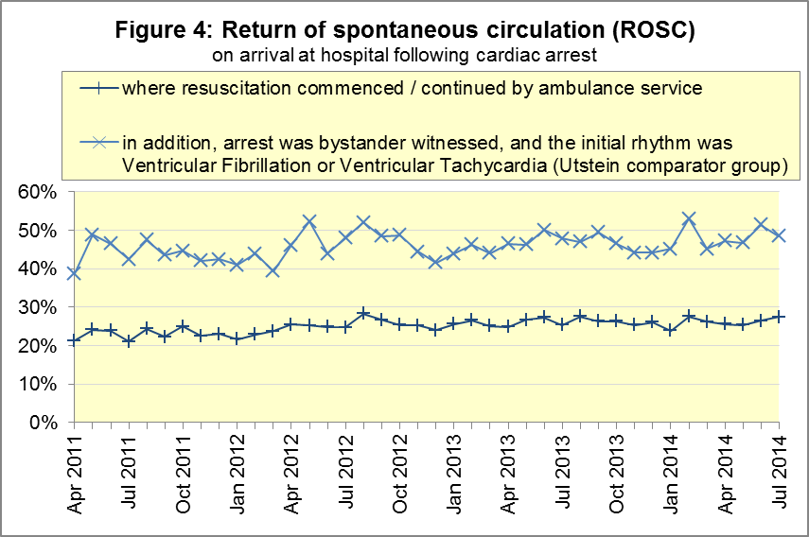

B2 Cardiac arrest: survival to discharge (Figure 5)
In July 2014, 9.0% of cardiac arrest patients were discharged from hospital alive, similar to the average for 2013-14 proportion of 8.7%. The largest proportion in July 2014 was 21.0% for South Central, and the smallest¹⁰ was 4.2% for North East.
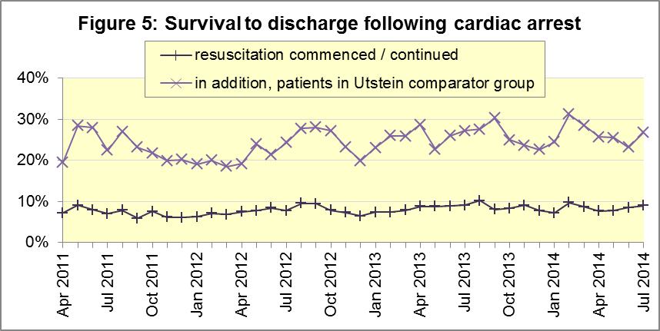
For the Utstein group, 26.8% were discharged from hospital alive in July 2014, similar to the average for 2013-14 of 26.3%. The largest proportion in July 2014 was 45.5% for Yorkshire, and the smallest was 10.8% for East Midlands.

B3 ST-Elevation myocardial infarction (STEMI) (Figure 6)
ST-segment elevation myocardial infarction is a type of heart attack, determined by an electrocardiogram (ECG) test. Early access to reperfusion, where blocked arteries are opened to re-establish blood flow, and other assessment and care interventions, are associated with reductions in STEMI mortality and morbidity.
In July 2014, of 1,329 patients with an acute STEMI, 1,047 (78.8%) received the appropriate care bundle, similar to the proportion of 80.1% for 2013-14. The largest¹¹ proportion was 91.0% for North East, and the smallest was 64.6% for South Central.
Of 871 STEMI patients receiving primary angioplasty, 773 (88.7%) of them received it within 150 minutes of the call being connected to the ambulance service, similar to the 2013-14 proportion of 88.9%. London had the largest proportion, with 100%, and the smallest¹¹ was 78.7% for North West.

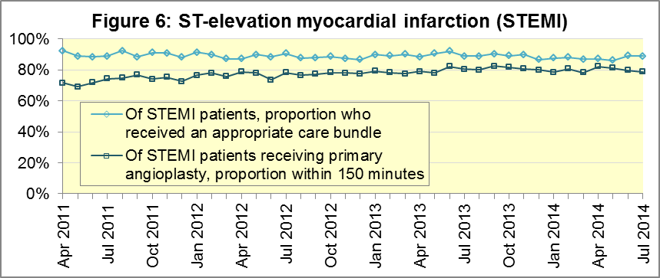

B4 Stroke (Figure 7)
The FAST procedure helps assess whether someone has suffered a stroke:
- Facial weakness: can the person smile? Has their mouth or eye drooped?
- Arm weakness: can the person raise both arms?
- Speech problems: can the person speak clearly and understand what you say?
- Time to call 999 for an ambulance if you spot any one of these signs.
In July 2014, of 3,099 FAST positive patients, assessed face to face, and potentially eligible for stroke thrombolysis within agreed local guidelines, 1,886 (60.9%) arrived at hospitals with a hyperacute stroke unit within 60 minutes of an emergency call connecting to the ambulance service. The figure for 2013/14 was 63.0%. The largest proportion in July 2014 was 69.4% for South East Coast, and the smallest was 45.1% for West Midlands.
Of 6,966 stroke patients assessed face to face, 6,751 (96.9%) received the appropriate care bundle, similar to the average of 96.4% for 2013/14. The smallest proportion in July 2014 was 91.1% for West Midlands, and the largest was 99.0% for North East.
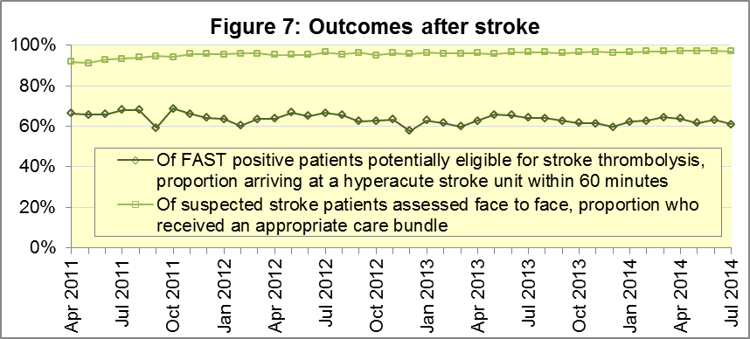

C Further information on AQI
The AQI include calls made by dialling either the usual UK-wide number 999 or its EU equivalent 112.

C1 Quality Statement and data specification
www.england.nhs.uk/statistics/statistical-work-areas/ambulance-quality-indicators is the Ambulance Quality Indicators (AQI) landing page, holding:
- A Quality Statement for these statistics, which includes information on relevance, accuracy, timeliness, coherence, and user engagement;
- The specification guidance for those who supply the data;
- Publication timetables;
- Text files and time series spreadsheets containing all data from April 2011 up to the latest month;
- Links to individual pages for each financial year, which hold Statistical Notes from previous months, and pre-release access lists.

C2 Revisions
The Quality Statement above contains a more detailed revisions policy. Revisions usually continue a six-monthly cycle:
Publication date |  | Series revised |  | Months affected
November 2015 |  | Systems Indicators |  | April 2015 to August 2015
September 2015 |  | Clinical Outcomes |  | April 2014 to March 2015
30 April 2015 |  | Systems Indicators |  | April 2014 to February 2015
5 March 2015 |  | Clinical Outcomes |  | April 2014 to September 2014
6 November 2014 |  | Systems Indicators |  | April 2013 to August 2014
5 September 2014 |  | Clinical Outcomes |  | April 2013 to March 2014
2 May 2014 |  | Systems Indicators |  | April 2013 to February 2014
7 March 2014 |  | Clinical Outcomes |  | April 2013 to September 2013
1 November 2013 |  | Systems Indicators |  | April 2013 to August 2013
2 August 2013 |  | Clinical Outcomes |  | April 2012 to March 2013
3 May 2013 |  | Systems Indicators |  | April 2012 to March 2013
1 February 2013 |  | Clinical Outcomes |  | April 2012 to August 2012
11 January 2013 |  | Systems Indicators |  | April 2011 to October 2012
31 August 2012 |  | Clinical Outcomes |  | April 2011 to March 2012

C3 Related statistics in England
The AQI appear in a Clinical Dashboard, available from the AQI landing page, and http://aace.org.uk/national-performance/national-clinical-dashboards, and the websites of most Ambulance Trusts. One of the aims of these Dashboards is to use statistical process control, to indicate whether variation in performance reflects underlying change, or merely natural variance, unavoidable even when a health system is performing well.
The AQI also appear in the latest annual KA34 publication www.hscic.gov.uk/article/2021/Website-Search?productid=15165 by the Health and Social Care Information Centre. The KA34 was an annual set of similar Systems Indicators, not quite comparable with the AQI, that ceased collection in March 2013, and therefore this publication now uses the same data as the AQI, with additional annual analysis and commentary. The Quality Statement above contains more information.
Similar data from 8 November 2010 to 29 May 2011 were collected in Weekly Situation Reports, including:
- Category A and Category B calls made to Ambulance Trusts in England;
- of those calls, how many were responded to within 8 minutes (category A) or 19 minutes (category B);
- the number of urgent and emergency journeys;
- instances of delayed handover to A&E staff.
These are available at http://webarchive.nationalarchives.gov.uk/
20130107105354/http://www.dh.gov.uk/en/Publicationsandstatistics/Statistics/Performancedataandstatistics/WeeklySituationReports/DH_128506.

C4 Rest of UK
Other ambulance statistics can be found at the following websites. The Quality Statement described in section C1 contains more information about the comparability of these statistics:
Wales: | http://wales.gov.uk/statistics-and-research/ambulance-services/?lang=en
Scotland: | See Quality Improvement Indicators (QII) documents at www.scottishambulance.com/TheService/BoardPapers.aspx
Northern Ireland: | www.dhsspsni.gov.uk/index/stats_research/hospital-stats/emergency_care-3/emergency-care-stats.htm

C5 Contact information
For press enquiries, please contact the NHS England press office on 0113 825 0958 or nhsengland.media@nhs.net.
The Government Statistical Service (GSS) statistician responsible for producing these data is:
Ian Kay, Analytical Services (Operations), NHS England, Room 5E24, Quarry House, Leeds, LS2 7UE
0113 824 9411
i.kay@nhs.net

www.unitetheunion.org/how-we-help/list-of-sectors/healthsector/healthsectorcampaigns/ nhs-workers-deserve-a-pay-rise/nhs-pay-reps-checklist
www.unison.org.uk/content/ConNewsArticle/5481
www.gmb.org.uk/newsroom/nhs-13-October-strike
On 1 June 2012, Category A (immediately life-threatening) calls were split into Red 1 and Red 2. Red 1 calls are the most time critical, and cover cardiac arrest patients who are not breathing and do not have a pulse, and other severe conditions such as airway obstruction. Red 2 calls are serious, but less immediately time critical, and cover conditions such as stroke and fits. www.gov.uk/government/news/changes-to-ambulance-response-time-categories
Ambulance response time standards are on page 30, Handbook to the NHS Constitution, www.nhs.uk/choiceintheNHS/Rightsandpledges/NHSConstitution/Pages/Overview.aspx.
Due to differences in clock start definitions for Red 1 and Red 2, it is not possible to aggregate them into a total Category A performance. Definitions appear in the specification guidance for data suppliers, on the AQI landing page at www.england.nhs.uk/statistics/statistical-work-areas/ambulance-quality-indicators.
The number of emergency calls presented to switchboard does not usually include calls made to NHS 111 requiring an ambulance. 111 calls requiring an ambulance are usually transferred electronically direct to ambulance dispatch, and not routed via 999 call handlers. Occasionally, manual requests for ambulance are made between 111 and 999 call handlers, and such calls are included in the number of emergency calls presented to switchboard.
Type 1 are consultant-led 24 hour emergency departments with full resuscitation facilities. Type 2 offer a consultant-led speciality A&E service such as ophthalmology or dental. Type 3 is A&E / minor injury activity that may be doctor-led or nurse-led. Type 4 are NHS walk-in centres. (www.datadictionary.nhs.uk/data_dictionary/attributes/a/acc/ accident_and_emergency_department_type_de.asp)
Due to its small size, performance on Isle of Wight tends to vary more than other Trusts. If Isle of Wight has the lowest or highest value, the Table in A4 shows the second lowest or highest value, but with a footnote marker to show that Isle of Wight is more extreme. This system is also used for Clinical Outcomes in section B.
Excluding Isle of Wight. See note 9 on page 4.
Excluding Isle of Wight. See note 9 on page 4.
Pages 21 to 25 of the specification guidance for data suppliers on the AQI landing page at www.england.nhs.uk/statistics/statistical-work-areas/ambulance-quality-indicators describe, for STEMI and stroke, the care bundles, and certain exclusions.

