Statistical Note: Ambulance Quality Indicators (AQI)
- The latest data for November 2014 on emergency responses by Ambulance Services in generally show performance deteriorated, and did not meet the standards in the NHS constitution.
- The latest data for August 2014 show that clinical outcomes of patients transported by Ambulance Services generally remain stable.

A. Systems Indicators
Emergency response times in November 2014 may have been affected by the four-hour strike by NHS staff between 07:00 and 11:00 on 24 November, followed by some days of working to rule, similar to the industrial action in the week starting 13 October.

A1 Emergency response in 8 minutes
In November 2014, of Category A Red 1 calls in England resulting in an emergency response, the proportion arriving within 8 minutes was 71.8%.
In November 2014, of Category A Red 2 calls in England resulting in an emergency response, the proportion arriving within 8 minutes was 68.4%.
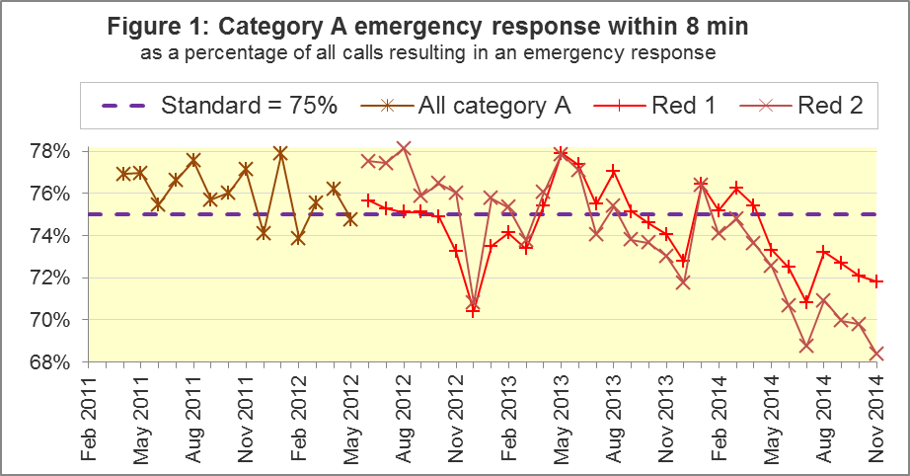
The standard for Ambulance Services is to send an emergency response, with a defibrillator, within 8 minutes, to 75% of Category A calls. Figure 1 shows that for England as a whole, this standard has not been met for Red 1 since April 2014, and has not been met for Red 2 since January 2014.
Three Trusts achieved the Red 1 standard in November 2014: West Midlands, South East Coast, and Isle of Wight. London (64.3%) had the smallest proportion for the fourth month running.
Two Trusts, South East Coast and Isle of Wight, met the Red 2 standard in November 2014. The smallest proportions were in London (55.0%) and East of England (64.2%).

A2 Systems Indicators: Ambulance response in 19 minutes
The other standard for Ambulance Services in the Handbook to the NHS Constitution is for Trusts to send a fully-equipped ambulance vehicle within 19 minutes to 95% of Category A calls. In November 2014, 93.6% of such responses were within 19 minutes, the smallest figure in the time series, and less than the standard for the sixth month in a row.
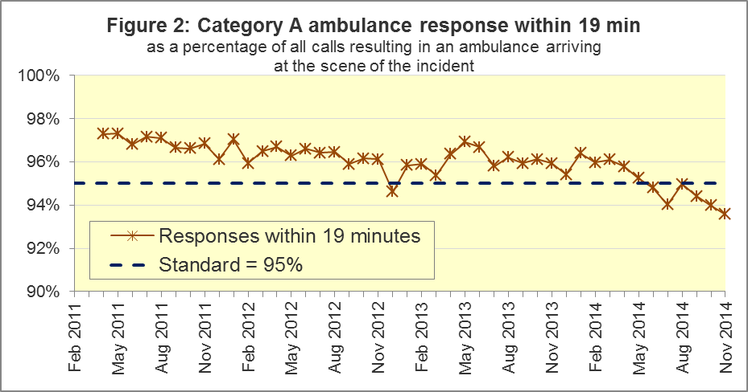

Four Trusts, Yorkshire, West Midlands, South East Coast, and Isle of Wight, met this standard in November 2014. Two Trusts had proportions less than 93%: East of England (91.9%) and London (89.2%).

A3 Systems Indicators: Ambulance volumes (Figure 3)
The number of emergency calls presented to switchboard was 770,549 in November 2014, or 26 thousand per day, more than the 2012-13 and 2013-14 averages of 23 thousand per day, although Figure 3 shows that this number varies considerably from month to month.
The number of incidents requiring emergency patient journeys to Type 1 or Type 2 A&E is more stable. This was 395,105 in November 2014, or 13,170 per day, and almost identical to 394,363 in November 2013.
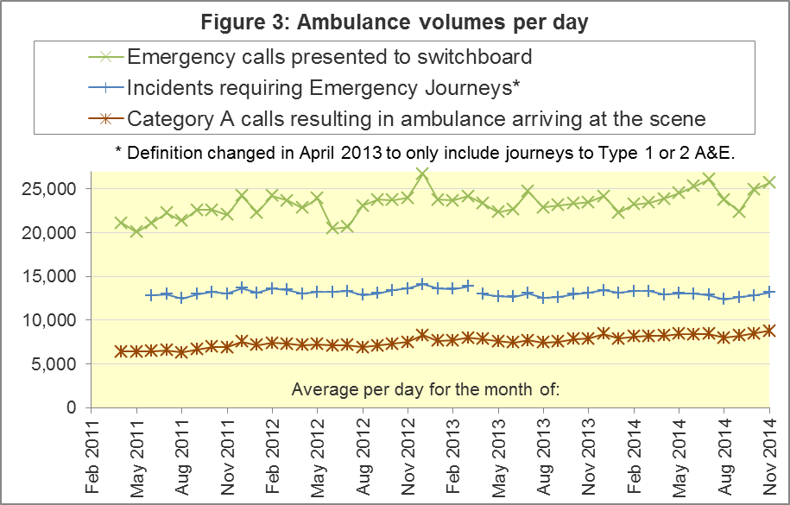
The number of category A calls that resulted in an ambulance arriving at the scene is also a stable measure, but one that continued to increase steadily. It was 264,276 in November 2014, or 8,809 per day, which exceeded the previous largest value (8,498 per day in October 2014).
Table A4 shows the latest monthly data for other Systems Indicators in the collection:

A4 Trust averages and extremes for System Indicators, November 2014
Indicator | All England | Lowest Trust | Highest Trust
Red 1: 8 minute emergency response | 71.8% | 64.3% | 78.1%
Red 2: 8 minute emergency response | 68.4% | 55.0% | 75.1% ⁹
Category A: 19 minute ambulance response | 93.6% | 89.2% | 96.6%
Calls abandoned before being answered | 1.3% | 0.2% | 4.1%
Calls resolved through telephone assessment | 8.6% | 3.1% | 15.3%
Calls resolved without transport to Type 1 or Type 2 A&E | 36.8% | 27.1% | 52.5%
Recontact rate following discharge by telephone advice | 8.1% | 2.8% | 14.5%
Recontact rate following face-to-face treatment at scene | 5.6% | 3.5% | 8.2%
Number of emergency journeys | 395,105 | 20,612 ⁹ | 62,862

B. Clinical Outcomes
No thresholds to denote “poor” care are set for Clinical Outcomes. Commissioners are expected to examine trends in these data, and work in collaboration with Ambulance Trusts to achieve sustained improvements over time improvement in patient outcomes over time; but commissioners are not expected to use Clinical Outcomes to performance manage Trusts, because there will be significant variations in the populations served.

B1 Cardiac arrest: return of spontaneous circulation (ROSC) (Figure 4)
In August 2014, there were 2,303 patients with resuscitation commenced or continued by ambulance staff following an out-of-hospital cardiac arrest. Of these, 693 (30.1%) had ROSC on arrival at hospital, the largest national proportion since collection started in April 2011. In August 2014, the largest proportion was 37.5% for London, and the smallest was 22.8% for East Midlands.
The Utstein group comprises patients who had resuscitation commenced or continued by the Ambulance Services, following an out-of-hospital cardiac arrest of presumed cardiac origin, where the arrest was bystander witnessed, and the initial rhythm was Ventricular Fibrillation or Ventricular Tachycardia. They therefore have a better chance of survival.
In the Utstein group, 47.9% of patients had ROSC in August 2014, similar to the average for 2013-14 of 46.9%. The largest proportion in August 2014 was 66.7% for London, and the smallest¹⁰ was 38.0% for South Western.
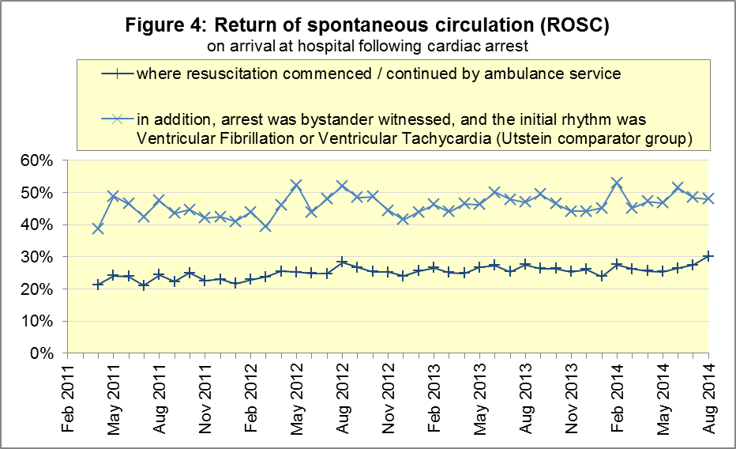

B2 Cardiac arrest: survival to discharge (Figure 5)
The proportion of cardiac arrest patients discharged from hospital alive was 8.2% in August, similar to the average for 2013-14 of 8.7%, despite the increased proportion with ROSC in August 2014. The largest proportion for survival to discharge was 19.4% for South Central, and the smallest¹⁰ was 4.2% for North East.
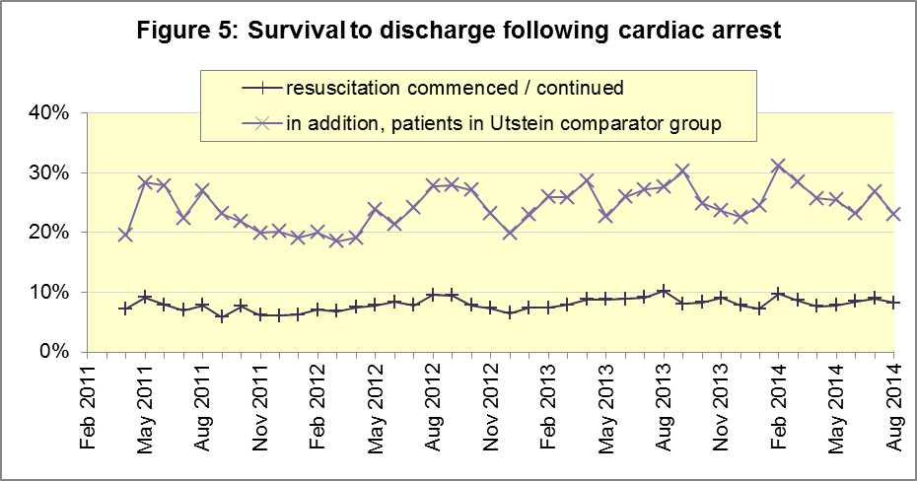
For the Utstein group, 23.0% were discharged from hospital alive in August 2014, not significantly different to the average for 2013-14 of 26.3%. The largest proportion in August 2014 was 34.6% for West Midlands, and the smallest was 11.1% for North East.

B3 ST-Elevation myocardial infarction (STEMI) (Figure 6)
ST-segment elevation myocardial infarction is a type of heart attack, determined by an electrocardiogram (ECG) test. Early access to reperfusion, where blocked arteries are opened to re-establish blood flow, and other assessment and care interventions, are associated with reductions in STEMI mortality and morbidity.
In August 2014, of 1,284 patients with an acute STEMI, 1,030 (80.2%) received the appropriate care bundle, similar to the proportion of 80.1% for 2013-14. The largest proportion was 91.2% for North West, and the smallest¹¹ was 71.6% for London.
Of 865 STEMI patients receiving primary angioplasty, 774 (89.5%) of them received it within 150 minutes of the call being connected to the ambulance service, similar to the 2013-14 proportion of 88.9%. East of England had the largest proportion, with 97.7%, and the smallest¹¹ was 77.9% for South Western.
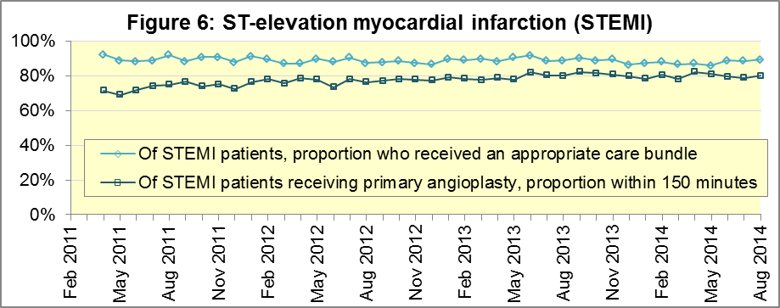

B4 Stroke (Figure 7)
The FAST procedure helps assess whether someone has suffered a stroke:
- Facial weakness: can the person smile? Has their mouth or eye drooped?
- Arm weakness: can the person raise both arms?
- Speech problems: can the person speak clearly and understand what you say?
- Time to call 999 for an ambulance if you spot any one of these signs.
In August 2014, of 2,941 FAST positive patients, assessed face to face, and potentially eligible for stroke thrombolysis within agreed local guidelines, 1,776 (60.4%) arrived at hospitals with a hyperacute stroke unit within 60 minutes of an emergency call connecting to the ambulance service. The figure for 2013/14 was 63.0%. The largest proportion in August 2014 was 74.5% for North West, and the smallest was 43.0% for West Midlands.
Of 6,779 stroke patients assessed face to face, 6,576 (97.0%) received the appropriate care bundle. The 2013/14 average was 96.4%. The largest proportion in August 2014 was 99.0% (North West), and the smallest 94.3% (South East Coast).
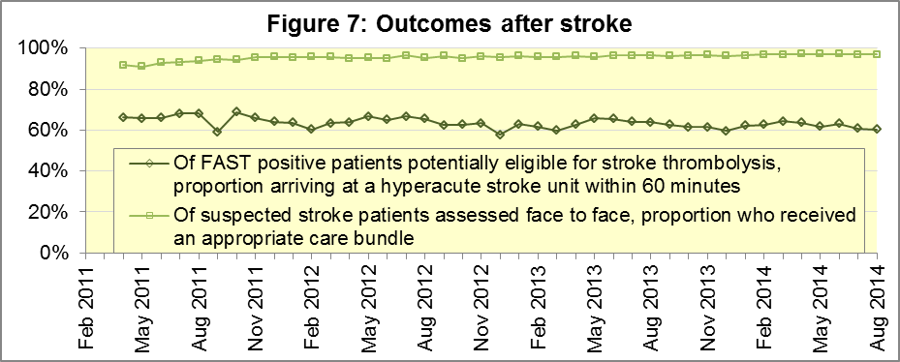

C. Further information on AQI
The Ambulance Quality Indicators (AQI) include calls made by dialling either the usual UK-wide number 999 or its EU equivalent 112.

C1 The AQI Quality Statement, specifications, and other information
www.england.nhs.uk/statistics/statistical-work-areas/ambulance-quality-indicators is the AQI landing page, holding:
- A Quality Statement for these statistics, which includes information on relevance, accuracy, timeliness, coherence, and user engagement;
- The specification guidance for those who supply the data;
- Data collection and publication timetables;
- Text files and time series spreadsheets containing all data from April 2011 up to the latest month;
- Links to individual pages for each financial year, which hold separate spreadsheets of each month’s data, Statistical Notes from previous months, and pre-release access lists.

C2 Revisions
Revisions usually follow a six-monthly cycle. However, we discussed and agreed with our data suppliers, in the National Ambulance Service Clinical Quality Group (NASCQG), to collect and publish revisions to Clinical Outcomes one month later than previously. This is to allow revisions to March data, which would otherwise never be revised. The revisions schedule for Systems Indicators is unchanged.
The dates for past and future AQI revisions are below. The AQI Quality Statement above contains a more detailed revisions policy.
Publication date |  | Series revised |  | Months affected
November 2015 |  | Systems Indicators |  | April 2015 to August 2015
September 2015 |  | Clinical Outcomes |  | April 2014 to March 2015
30 April 2015 |  | Systems Indicators |  | April 2014 to February 2015
5 March 2015 |  | Clinical Outcomes |  | April 2014 to September 2014
6 November 2014 |  | Systems Indicators |  | April 2013 to August 2014
5 September 2014 |  | Clinical Outcomes |  | April 2013 to March 2014
2 May 2014 |  | Systems Indicators |  | April 2013 to February 2014
7 March 2014 |  | Clinical Outcomes |  | April 2013 to September 2013
1 November 2013 |  | Systems Indicators |  | April 2013 to August 2013
2 August 2013 |  | Clinical Outcomes |  | April 2012 to March 2013
3 May 2013 |  | Systems Indicators |  | April 2012 to March 2013
1 February 2013 |  | Clinical Outcomes |  | April 2012 to August 2012
11 January 2013 |  | Systems Indicators |  | April 2011 to October 2012
31 August 2012 |  | Clinical Outcomes |  | April 2011 to March 2012

C3 Related statistics in England
The AQI appear in a Clinical Dashboard, available from the AQI landing page, http://aace.org.uk/national-performance/national-clinical-dashboards, and the websites of the Ambulance Trusts (links are listed in the AQI Quality Statement). One of the aims of these Dashboards is to use statistical process control, to indicate whether variation in performance reflects underlying change, or merely natural variance, unavoidable even when a health system is performing well.
The AQI also appear in the latest annual Ambulance Services publication www.hscic.gov.uk/article/2021/Website-Search?productid=15165 by the Health and Social Care Information Centre (HSCIC), which includes additional annual analysis and commentary. Originally, this publication used the KA34 data collection, which was similar to the AQI Systems Indicators, but annual, and which ceased collection in March 2013. The HSCIC release therefore uses AQI data thereafter.
The AQI Quality Statement described in section C1 contains more information on HSCIC publication. It also contains details of weekly ambulance situation reports that NHS England collected for six months from November 2010.

C4 Rest of UK
Other ambulance statistics can be found at the following websites. The AQI Quality Statement described in section C1 contains more information about the comparability of these statistics:
Wales: | http://wales.gov.uk/statistics-and-research/ambulance-services/?lang=en
Scotland: | See Quality Improvement Indicators (QII) documents at www.scottishambulance.com/TheService/BoardPapers.aspx
Northern Ireland: | www.dhsspsni.gov.uk/index/statistics/hospital/emergency-care/ambulance-statistics.htm

C5 Contact information
For press enquiries, please contact the NHS England press office on 0113 825 0958 or nhsengland.media@nhs.net.
The Government Statistical Service (GSS) statistician responsible for producing these data is:
Ian Kay, Analytical Services (Operations), NHS England, Room 5E24, Quarry House, Leeds, LS2 7UE
0113 824 9411
i.kay@nhs.net

www.unitetheunion.org/news/unitenewsdigest/news-digest-24-november-2014/
www.unison.org.uk/at-work/health-care/news/health-branches-prepare-for-action
www.gmb.org.uk/newsroom/november-strike-in-nhs-over-pay
On 1 June 2012, Category A (immediately life-threatening) calls were split into Red 1 and Red 2. Red 1 calls are the most time critical, and cover cardiac arrest patients who are not breathing and do not have a pulse, and other severe conditions such as airway obstruction. Red 2 calls are serious, but less immediately time critical, and cover conditions such as stroke and fits. www.gov.uk/government/news/changes-to-ambulance-response-time-categories
Ambulance response time standards are on page 30, Handbook to the NHS Constitution, www.nhs.uk/choiceintheNHS/Rightsandpledges/NHSConstitution/Pages/Overview.aspx.
Due to differences in clock start definitions for Red 1 and Red 2, it is not possible to aggregate them into a total Category A performance. Definitions appear in the specification guidance for data suppliers, on the AQI landing page at www.england.nhs.uk/statistics/statistical-work-areas/ambulance-quality-indicators.
The number of emergency calls presented to switchboard does not usually include calls made to NHS 111 requiring an ambulance. 111 calls requiring an ambulance are usually transferred electronically direct to ambulance dispatch, and not routed via 999 call handlers. Occasionally, manual requests for ambulance are made between 111 and 999 call handlers, and such calls are included in the number of emergency calls presented to switchboard.
Type 1 are consultant-led 24 hour emergency departments with full resuscitation facilities. Type 2 offer a consultant-led speciality A&E service such as ophthalmology or dental. Type 3 is A&E / minor injury activity that may be doctor-led or nurse-led. Type 4 are NHS walk-in centres. (www.datadictionary.nhs.uk/data_dictionary/attributes/a/acc/ accident_and_emergency_department_type_de.asp)
Due to its small size, performance on Isle of Wight tends to vary more than other Trusts. If Isle of Wight has the largest or smallest value, the Table in A4 shows the second largest or smallest value, but with a footnote marker to show that Isle of Wight is more extreme. This system is also used for Clinical Outcomes in section B.
Excluding Isle of Wight. See note 9 on page 4.
Excluding Isle of Wight. See note 9 on page 4.
Pages 21 to 25 of the specification guidance for data suppliers on the AQI landing page at www.england.nhs.uk/statistics/statistical-work-areas/ambulance-quality-indicators describe, for STEMI and stroke, the care bundles, and certain exclusions.
Excluding Isle of Wight. See note 9 on page 4.

