Statistical Note: Ambulance Quality Indicators (AQI)
- The latest data for December 2014 show that emergency responses by Ambulance Services in England did not meet the NHS constitution standards, and the proportions arriving in the required time decreased considerably.
- The latest clinical outcomes data for September 2014 for patients transported by Ambulance Services are generally stable.

A. Systems Indicators

A1 Emergency response in 8 minutes
In December 2014, of Category A Red 1 calls in England resulting in an emergency response, the proportion arriving within 8 minutes was 66.0%.
In December 2014, of Category A Red 2 calls in England resulting in an emergency response, the proportion arriving within 8 minutes was 61.1%.
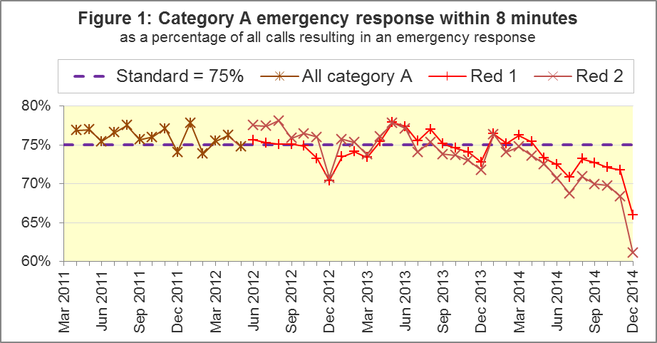
The standard for Ambulance Services is to send an emergency response, with a defibrillator, within 8 minutes, to 75% of Category A calls. Figure 1 shows that for England as a whole, this standard has not been met for Red 1 since April 2014, and has not been met for Red 2 since January 2014.
For the months covered by this data collection, the 8 minute measures always decrease between November and December. However, the decreases between November and December 2014 were larger than in any previous year.
Isle of Wight achieved both the Red 1 and 2 standards in December 2014. The other ten Ambulance Trusts all failed to achieve either standard, and all had lower proportions in December 2014 than in November 2014. In December 2014, excepting Isle of Wight, Red 1 proportions ranged from 58.9% for North West to 72.8% for West Midlands, and Red 2 proportions ranged from 47.7% for London to 71.4% for West Midlands.

A2 Systems Indicators: Ambulance response in 19 minutes
The other standard for Ambulance Services in the Handbook to the NHS Constitution is for Trusts to send, within 19 minutes, a fully-equipped ambulance vehicle, able to transport the patient in a clinically safe manner, to 95% of Category A calls.
In December 2014, 90.1% of such responses were within 19 minutes. Figure 2 shows that this was the lowest proportion since the series began in 2011, and less than the standard for the seventh month in a row.
Isle of Wight had the largest proportion, 96.3%, and was also the only Ambulance Service to increase its proportion from November 2014. West Midlands, with 95.7%, was the only other Trust to achieve the standard in December 2014. London had the lowest proportion, 84.8%.
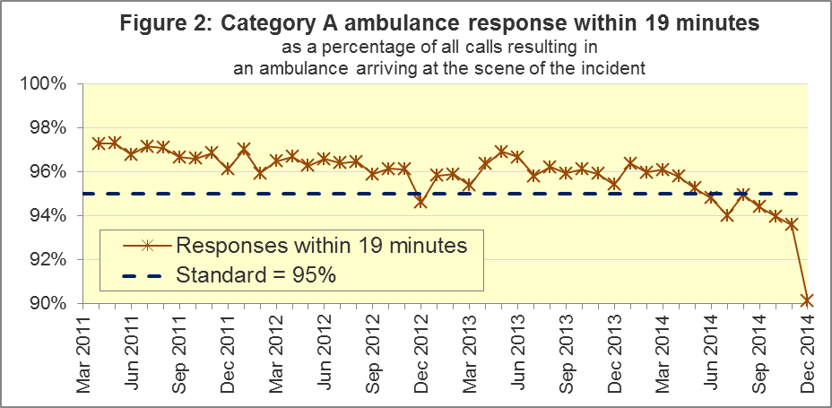

A3 Systems Indicators: Ambulance volumes (Figure 3)
The number of emergency telephone calls presented to switchboard in December 2014, 883,741, or 29 thousand per day, was the largest since the series began. The previous largest figure was 828,194 in December 2012.
Figure 3 shows that this number varies considerably from month to month, unlike the number of incidents requiring emergency patient journeys to Type 1 or Type 2 A&E, which was 422,964 in December 2014, or 14 thousand per day. This was slightly larger than most months in 2014 which had 13 thousand per day.
The number of category A calls that resulted in an ambulance arriving at the scene is also more stable than the number of telephone calls. However, it continued to increase, and the December 2014 value was the first to exceed 300,000. The average for December 2014 was 9,779 per day. This was 11% larger than the previous largest average, which was 8,809 per day in November 2014.
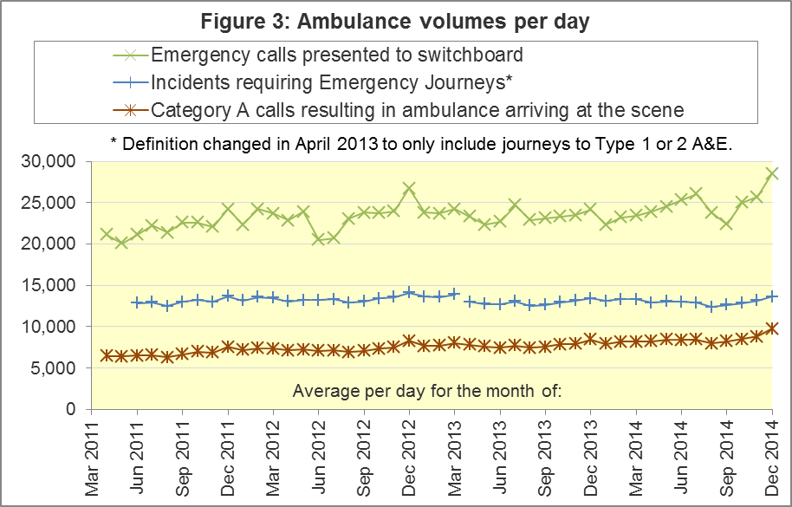
Table A4 shows the latest monthly data for all the Systems Indicators in the AQI:

A4 Trust averages and extremes for System Indicators, December 2014
Indicator | All England | Lowest Trust | Highest Trust
Red 1: 8 minute emergency response | 66.0% | 58.9% | 72.8%
Red 2: 8 minute emergency response | 61.1% | 47.7% | 71.4%⁶
Category A: 19 minute ambulance response | 90.1% | 84.8% | 95.7%⁶
Calls abandoned before being answered | 1.9% | 0.5% | 5.1%
Calls resolved through telephone assessment | 9.9% | 3.9% | 17.6%
Calls resolved without transport to Type 1 or Type 2 A&E | 37.9% | 27.7% | 54.1%
Recontact rate following discharge by telephone advice | 8.3% | 3.4% | 14.8%
Recontact rate following face-to-face treatment at scene | 5.9% | 3.6%⁶ | 9.0%
Number of emergency journeys | 422,964 | 22,418⁶ | 66,686

A5 Pilot of possible changes to emergency response measures
In January 2015, the Secretary of State for Health announced a pilot of possible changes to the way Ambulance Services respond to 999 calls, based on clinical advice that this will improve the chances of survival for patients. The latest data in this Statistical release are not yet affected by this pilot.

B. Clinical Outcomes
No thresholds to denote “poor” care are set for Clinical Outcomes. Commissioners are expected to examine trends in these data, and work in collaboration with Ambulance Trusts to achieve sustained improvements over time improvement in patient outcomes over time; but commissioners are not expected to use Clinical Outcomes to performance manage Trusts, because there will be significant variations in the populations served.

B1 Cardiac arrest: return of spontaneous circulation (ROSC) (Figure 4)
In September 2014, there were 2,190 patients with resuscitation commenced or continued by ambulance staff following an out-of-hospital cardiac arrest. Of these, 648 (29.6%) had ROSC on arrival at hospital. The average for the year ending September 2014 was 26.5%. In the month of September 2014, the largest proportion was 47.7% for South Central, and the smallest was 22.7% for East Midlands.
The Utstein group comprises patients who had resuscitation commenced or continued by the Ambulance Services, following an out-of-hospital cardiac arrest of presumed cardiac origin, where the arrest was bystander witnessed, and the initial rhythm was Ventricular Fibrillation or Ventricular Tachycardia. They therefore have a better chance of survival. This definition was proposed by an international group of cardiologists and other health professionals meeting at Utstein Abbey in Norway in 1990.
Of the 308 such patients in September 2014, 57.1% had ROSC on arrival at hospital, significantly larger than the average of 47.9% for the year ending September 2014. The largest proportion in the month of September 2014 was 66.7% for South Central, and the smallest was 43.5% for East Midlands.
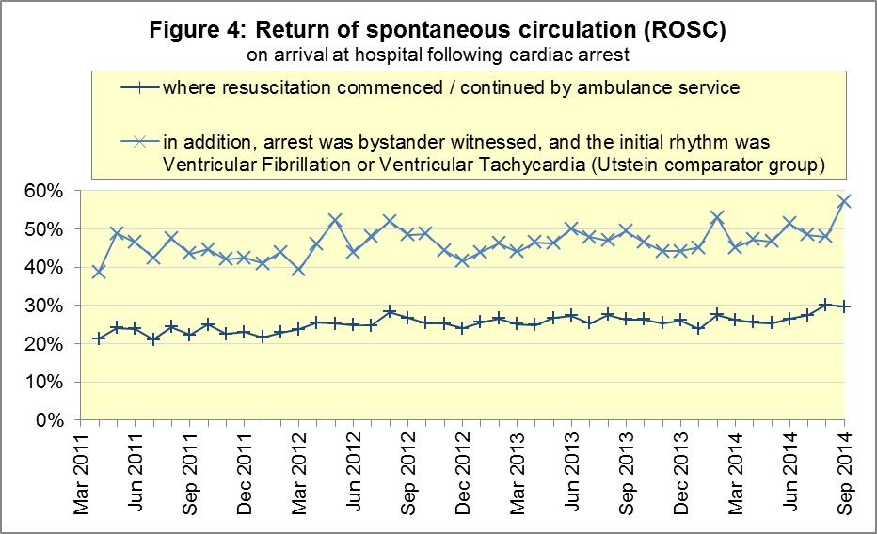

B2 Cardiac arrest: survival to discharge (Figure 5)
The proportion of cardiac arrest patients discharged from hospital alive was 8.2% in September 2014, very similar to the average of 8.3% for the year ending September 2014. The largest proportion for survival to discharge in the month of September 2014 was 19.5% for South Central, and the smallest was 1.9% for East Midlands.
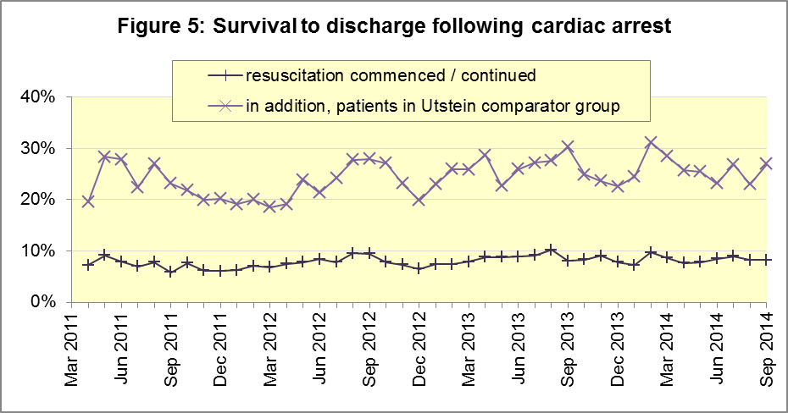
Although the Utstein group had an increase in ROSC in September 2014, this did not result in a similarly large increase in survival to discharge, which was 27.0%, not significantly larger than the average of 25.5% for the year ending September 2014.
The largest proportion in the month of September 2014 was 38.1% for South Central, and the smallest was 11.8% for East Midlands.

B3 ST-Elevation myocardial infarction (STEMI) (Figure 6)
ST-segment elevation myocardial infarction is a type of heart attack, determined by an electrocardiogram (ECG) test. Early access to reperfusion, where blocked arteries are opened to re-establish blood flow, and other assessment and care interventions, are associated with reductions in STEMI mortality and morbidity.
In September 2014, of 1,382 patients with an acute STEMI, 1,089 (78.8%) received the appropriate care bundle, similar to the proportion of 80.1% for 2013-14 for the year ending September 2014. The largest proportion for the month of September 2014 was 90.5% for South Western, and the smallest was 62.2% for West Midlands.
Of 924 STEMI patients receiving primary angioplasty, 818 (88.5%) of them received it within 150 minutes of the call being connected to the ambulance service, similar to the 2013-14 proportion of 88.9% and 88.0% by the year ending September 2014. London had the largest proportion for the month of September 2014, with 97.8%, and the smallest was 76.6% for South Western.
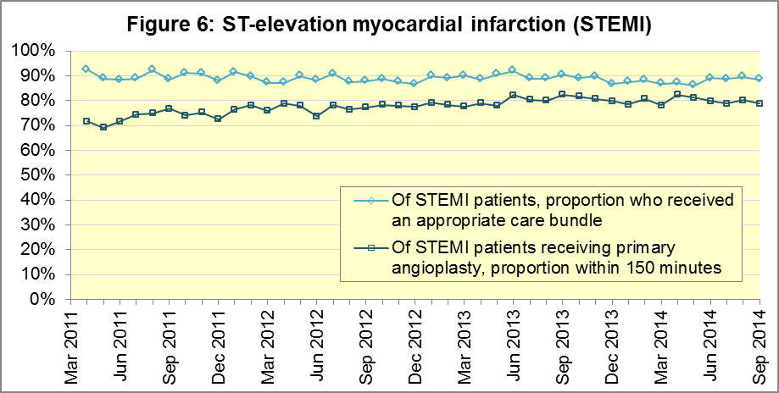

B4 Stroke (Figure 7)
The FAST procedure helps assess whether someone has suffered a stroke:
- Facial weakness: can the person smile? Has their mouth or eye drooped?
- Arm weakness: can the person raise both arms?
- Speech problems: can the person speak clearly and understand what you say?
- Time to call 999 for an ambulance if you spot any one of these signs.
In September 2014, of 2,795 FAST positive patients, assessed face to face, and potentially eligible for stroke thrombolysis within agreed local guidelines, 1,615 (57.8%) arrived at hospitals with a hyperacute stroke unit within 60 minutes of an emergency call connecting to the ambulance service. This was significantly less than the average of 61.7% for the year ending September 2014.
The largest¹² proportion in the month of September 2014 was 65.5% for North East, and the smallest was 45.6% for West Midlands.
Although the thrombolysis proportion decreased, the increase since 2011 was maintained for stroke patients, assessed face to face, receiving the appropriate care bundle. In the month of September 2014, this proportion was 96.8% out of 6,543 such patients, the same as the average for the year ending September 2014. The largest proportion in the month of September 2014 was 99.6% for North West and the smallest¹² was 93.7% for West Midlands.
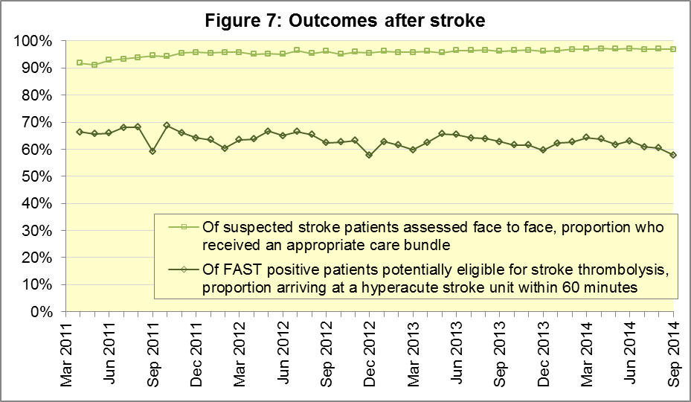

C. Further information on AQI

C1 The AQI landing page and Quality Statement
www.england.nhs.uk/statistics/statistical-work-areas/ambulance-quality-indicators is the AQI landing page, and it holds:
- a Quality Statement for these statistics, which includes information on relevance, accuracy, timeliness, coherence, and user engagement;
- the specification guidance for those who supply the data;
- timetables for data collection and publication;
- text files and time series spreadsheets containing all data from April 2011 up to the latest month;
- links to individual pages for each financial year.
The pages for each financial year hold:
- separate spreadsheets of each month’s data;
- this Statistical Note, and equivalent versions from previous months;
- the list of people with pre-release access to the data.

C2 Revisions
Revisions usually follow a six-monthly cycle. The dates for past and future AQI revisions are overleaf. The AQI Quality Statement above contains a more detailed revisions policy.
Publication date |  | Series revised |  | Months affected
5 November 2015 |  | Systems Indicators |  | April 2015 to August 2015
3 September 2015 |  | Clinical Outcomes |  | April 2014 to March 2015
30 April 2015 |  | Systems Indicators |  | April 2014 to February 2015
5 March 2015 |  | Clinical Outcomes |  | April 2014 to September 2014
6 November 2014 |  | Systems Indicators |  | April 2013 to August 2014
5 September 2014 |  | Clinical Outcomes |  | April 2013 to March 2014
2 May 2014 |  | Systems Indicators |  | April 2013 to February 2014
7 March 2014 |  | Clinical Outcomes |  | April 2013 to September 2013
1 November 2013 |  | Systems Indicators |  | April 2013 to August 2013
2 August 2013 |  | Clinical Outcomes |  | April 2012 to March 2013
3 May 2013 |  | Systems Indicators |  | April 2012 to March 2013
1 February 2013 |  | Clinical Outcomes |  | April 2012 to August 2012
11 January 2013 |  | Systems Indicators |  | April 2011 to October 2012
31 August 2012 |  | Clinical Outcomes |  | April 2011 to March 2012

C3 AQI Scope
The Ambulance Quality Indicators (AQI) include calls made by dialling either the usual UK-wide number 999 or its EU equivalent 112.
As described in the specification guidance mentioned above, calls made to NHS 111 are not included in AQI telephony data items. These comprise the measures for calls abandoned (SQU03_1_1), re-contacts (SQU03_2_1 and SQU03_2_2), frequent callers (SQU03_2_3), time to answer calls (SQU03_8_1_1) and calls resolved by telephone advice (SQU03_10_1).
All other Systems Indicators involve the dispatch of an ambulance, and they include ambulances dispatched as a result of a call to NHS 111, as well as 999 or 112. Footnotes in the published spreadsheets reiterate which data items do and do not include ambulances dispatched as a result of a call to NHS 111.

C4 Related statistics in England
The AQI appear in a Clinical Dashboard, available from the AQI landing page, the websites of the Ambulance Trusts (listed in the AQI Quality Statement), and http://aace.org.uk/national-performance/national-clinical-dashboards. One of the aims of these Dashboards is to use statistical process control, to indicate whether variation in performance reflects underlying change, or merely natural variance, unavoidable even when a health system is performing well.
The AQI are also used in the latest annual Ambulance Services publication www.hscic.gov.uk/article/2021/Website-Search?productid=15165 by the Health and Social Care Information Centre (HSCIC), which includes additional annual analysis and commentary. Originally, this publication used the KA34 data collection. This was similar to the AQI Systems Indicators, but annual, and ceased collection in March 2013. The HSCIC release therefore uses AQI data thereafter.
The AQI Quality Statement described in section C1 contains more information on the HSCIC publication. It also contains details of weekly ambulance situation reports that NHS England collected for six months from November 2010.

C5 Rest of UK
Ambulance statistics for other countries of the UK can be found at the following websites. The AQI Quality Statement described in section C1 contains more information about the comparability of these statistics.
Wales: | http://wales.gov.uk/statistics-and-research/ambulance-services/?lang=en
Scotland: | See Quality Improvement Indicators (QII) documents at www.scottishambulance.com/TheService/BoardPapers.aspx
Northern Ireland: | www.dhsspsni.gov.uk/index/statistics/hospital/emergency-care/ambulance-statistics.htm

C6 Contact information
For press enquiries, please contact the NHS England press office on 0113 825 0958 or nhsengland.media@nhs.net.
The Government Statistical Service (GSS) statistician responsible for producing these data is:
Ian Kay, Analytical Services (Operations), NHS England, Room 5E24, Quarry House, Leeds, LS2 7UE
0113 824 9411
i.kay@nhs.net

On 1 June 2012, Category A (immediately life-threatening) calls were split into Red 1 and Red 2. Red 1 calls are the most time critical, and cover cardiac arrest patients who are not breathing and do not have a pulse, and other severe conditions such as airway obstruction. Red 2 calls are serious, but less immediately time critical, and cover conditions such as stroke and fits. www.gov.uk/government/news/changes-to-ambulance-response-time-categories
Ambulance response time standards are on page 30, Handbook to the NHS Constitution, www.nhs.uk/choiceintheNHS/Rightsandpledges/NHSConstitution/Pages/Overview.aspx.
Due to differences in clock start definitions for Red 1 and Red 2, it is not possible to aggregate them into a total Category A performance. Definitions appear in the specification guidance for data suppliers, on the AQI landing page at www.england.nhs.uk/statistics/statistical-work-areas/ambulance-quality-indicators.
The number of emergency calls presented to switchboard does not usually include calls made to NHS 111 requiring an ambulance. 111 calls requiring an ambulance are usually transferred electronically direct to ambulance dispatch, and not routed via 999 call handlers. Occasionally, manual requests for ambulance are made between 111 and 999 call handlers, and such calls are included in the number of emergency calls presented to switchboard.
Type 1 are consultant-led 24 hour emergency departments with full resuscitation facilities. Type 2 offer a consultant-led speciality A&E service such as ophthalmology or dental. Type 3 is A&E / minor injury activity that may be doctor-led or nurse-led. Type 4 are NHS walk-in centres. (www.datadictionary.nhs.uk/data_dictionary/attributes/a/acc/ accident_and_emergency_department_type_de.asp)
Due to its small size, performance on Isle of Wight tends to vary more than other Trusts. If Isle of Wight has the largest or smallest value, the Table in A4 shows the second largest or smallest value, but with a footnote marker to show that Isle of Wight is more extreme. This system is also used for Clinical Outcomes in section B.
www.parliament.uk/business/publications/written-questions-answers-statements/written-statement/Commons/2015-01-16/HCWS201
Excluding Isle of Wight. See note 6 on page 4.
http://circ.ahajournals.org/content/84/2/960.citation
Pages 21 to 25 of the specification guidance for data suppliers on the AQI landing page at www.england.nhs.uk/statistics/statistical-work-areas/ambulance-quality-indicators describe the care bundles, and certain exclusions, for the STEMI and stroke indicators.
Excluding Isle of Wight. See note 6 on page 4.
Excluding Isle of Wight. See note 6 on page 4.

