Statistical Note: Ambulance Quality Indicators (AQI)
- The latest data for Ambulance Services in England for January 2015 show that emergency responses did not meet the standards in the Handbook to the NHS constitution, although they did increase upon the very low figures for December 2014.
- The latest clinical outcomes data for October 2014 for patients transported by Ambulance Services are stable.

A. Systems Indicators

A1 Emergency response in 8 minutes
In January 2015, of Category A Red 1 calls in England resulting in an emergency response, the proportion arriving within 8 minutes was 71.4%.
In January 2015, of Category A Red 2 calls in England resulting in an emergency response, the proportion arriving within 8 minutes was 68.0%.
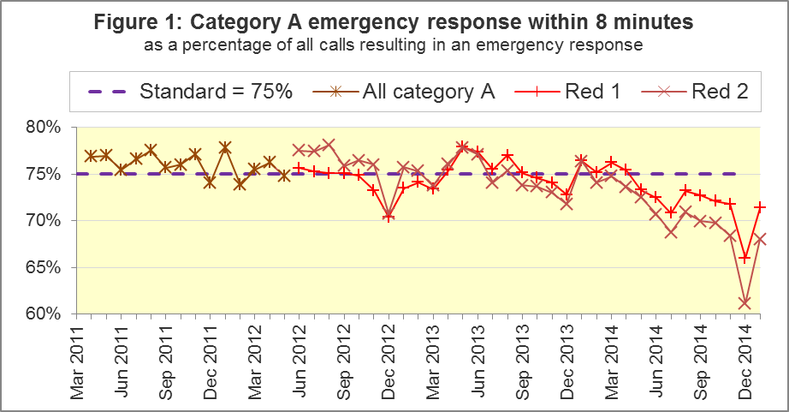
The standard for Ambulance Services is to send an emergency response, with a defibrillator, within 8 minutes, to 75% of Category A calls. Figure 1 shows that for England as a whole, this standard has not been met for Red 1 since April 2014, and has not been met for Red 2 since January 2014.
In January 2015, the Red 1 proportion was above the standard for three of the eleven Ambulance Services in England: West Midlands, South East Coast and Isle of Wight. The Red 2 proportion was above the standard in South East Coast, South Central and Isle of Wight.

A2 Systems Indicators: Ambulance response in 19 minutes
The other standard for Ambulance Services in the Handbook to the NHS Constitution is for Trusts to send, within 19 minutes, a fully-equipped ambulance vehicle, able to transport the patient in a clinically safe manner, to 95% of Category A calls.
Figure 2 shows that in January 2015, 93.3% of such responses were within 19 minutes, and the standard has not been met since May 2014.
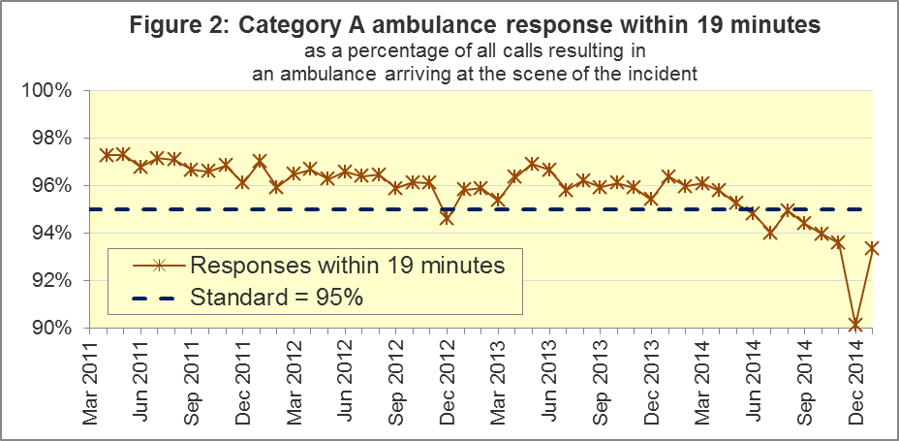

The measure was highest in West Midlands (96.9%) and Isle of Wight (96.8%), and lowest in East Midlands (90.4%) and North West (90.9%).
Since 2011, the national Red 1, Red 2 and 19 minute measures have always decreased in December, and increased in January. The decreases in December 2014 were larger than in previous years, and the increases in January 2015 were also larger than in previous years.

A3 Systems Indicators: Ambulance volumes (Figure 3)
The number of emergency telephone calls presented to switchboard in January 2015 was 763,025, or 25 thousand per day, very similar to the average for 2014, but a decrease from the December 2014 figure of 883,741.
Figure 3 shows that this number varies considerably from month to month, unlike the number of incidents requiring emergency patient journeys to Type 1 or Type 2 A&E. There were 400,310 such incidents in January 2015, so this remains stable at 13 thousand per day.
The number of category A calls that resulted in an ambulance arriving at the scene was also more stable over the last three years than the number of telephone calls, but arrivals at the scene have increased slowly, with additional temporary increases each December. The January 2015 value of 273,251 arrivals, or 8,815 per day, was fewer than 9,779 in December 2014, but larger than every other previous value for this indicator.
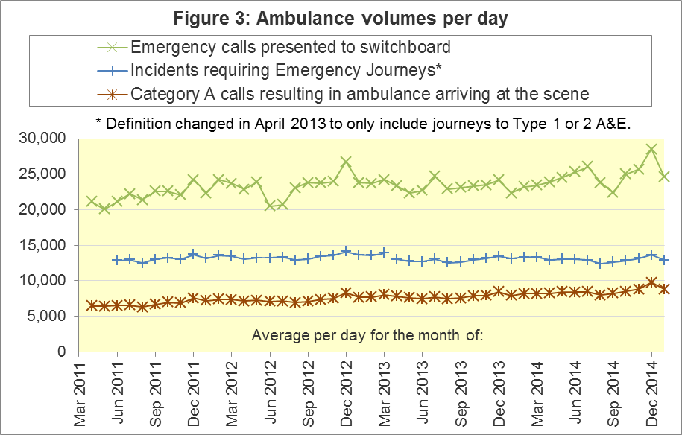
Figure A4 shows the latest monthly data for all the Systems Indicators in the AQI:

A4 Trust averages and extremes for System Indicators, January 2015
Indicator | All England | Lowest Trust |  |  | Highest Trust
Red 1: 8 minute emergency response | 71.4% | North West |  | 65.5% | South East Coast | 76.2%
Red 2: 8 minute emergency response | 68.0% | London |  | 59.8% | South Central | 76.7%
Category A: 19 minute ambulance response | 93.3% | East Midlands |  | 90.4% | West Midlands | 96.9%
Calls abandoned before being answered | 1.0% | London |  | 0.1% | Yorkshire | 3.8%
Calls resolved through telephone assessment | 8.7% | North West |  | 3.3% | London | 14.2%
Calls resolved without transport to Type 1 or Type 2 A&E | 37.2% | North West |  | 27.4% | South Western | 53.2%
Recontact rate following discharge by telephone advice | 7.6% | London⁶ |  | 2.4% | North East | 14.0%
Recontact rate following face-to-face treatment at scene | 5.9% | York-shire⁶ |  | 3.9% | London | 8.7%
Number of emergency journeys | 400,310 | South Central | 21,551 |  | London | 62,593

A5 Pilot of possible changes to emergency response measures
In January 2015, the Secretary of State for Health announced a pilot of possible changes to the way Ambulance Services respond to 999 calls, based on clinical advice that this will improve the chances of survival for patients.
The pilot started in February 2015, so the latest data in this Statistical release are not yet affected by this pilot.

B. Clinical Outcomes
No thresholds to denote “poor” care are set for Clinical Outcomes. Commissioners are expected to examine trends in these data, and work in collaboration with Ambulance Trusts to achieve sustained improvements over time improvement in patient outcomes over time; but commissioners are not expected to use Clinical Outcomes to performance manage Trusts, because there will be significant variations in the populations served.
As planned in the AQI revisions policy, this month’s publication includes revisions to Clinical Outcomes data for 2014-15. These are described in section B5 below.

B1 Cardiac arrest: return of spontaneous circulation (ROSC) (Figure 4)
In October 2014, there were 2,640 patients with resuscitation commenced or continued by ambulance staff following an out-of-hospital cardiac arrest in England. Of these, 723 (27.4%) had ROSC on arrival at hospital, which was similar to the average for the year ending September 2014 of 26.6%. In the month of October 2014, the largest proportion was 40.6% for South Central, and the smallest was 16.7% for East Midlands.
The Utstein group comprises patients who had resuscitation commenced or continued by the Ambulance Services, following an out-of-hospital cardiac arrest of presumed cardiac origin, where the arrest was bystander witnessed, and the initial rhythm was Ventricular Fibrillation or Ventricular Tachycardia. They therefore have a better chance of survival.
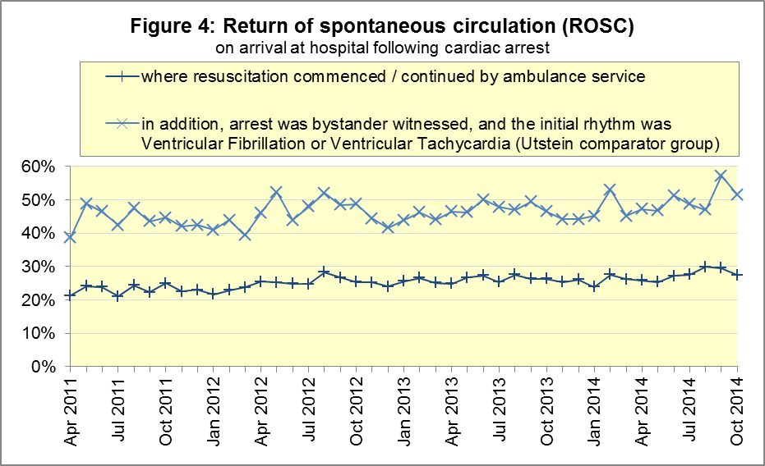
Of the 336 Utstein patients in England in October 2014, 51.5% had ROSC on arrival at hospital, not significantly different to the average for the year ending September 2014 of 47.8%. The largest proportion in the month of October 2014 was 72.7% for North East, and the smallest was 35.6% for South Western.

B2 Cardiac arrest: survival to discharge (Figure 5)
The proportion of cardiac arrest patients in England discharged from hospital alive was 8.2% in October 2014, similar to the average of 8.6% for the year ending September 2014. The largest proportion for survival to discharge in the month of October 2014 was 17.3% for South Central, and the smallest was 3.8% for East Midlands.
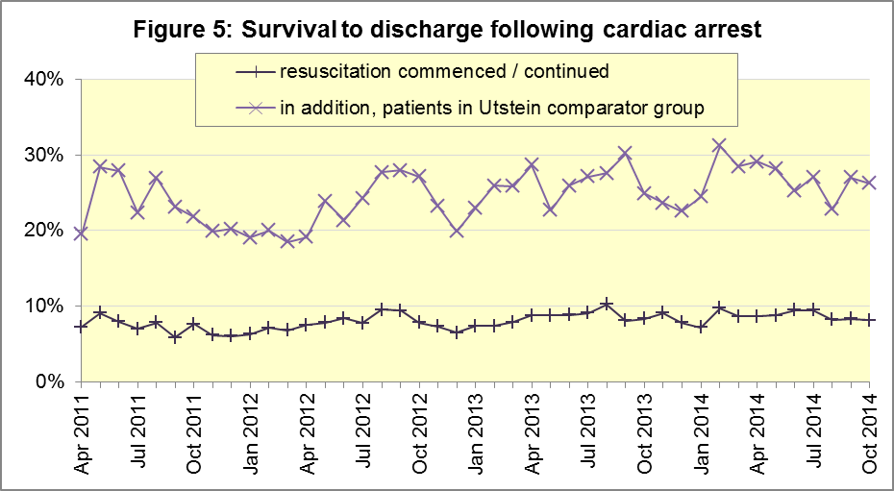
For the Utstein group in October 2014, survival to discharge was 26.3% in England, similar to the average of 26.2% for the year ending September 2014. The largest proportion in the month of October 2014 was 42.3% for South East Coast, and the smallest was 13.3% for South Western.

B3 ST-Elevation myocardial infarction (STEMI) (Figure 6)
ST-segment elevation myocardial infarction is a type of heart attack, determined by an electrocardiogram (ECG) test. Early access to reperfusion, where blocked arteries are opened to re-establish blood flow, and other assessment and care interventions, are associated with reductions in STEMI mortality and morbidity.
In October 2014, of 1,431 patients with an acute STEMI in England, 1,146 (80.1%) received the appropriate care bundle, similar to the proportion of 80.5% for the year ending September 2014. The largest proportion for the month of October 2014 was 93.0% for North East, and the smallest was 70.2% for South Central.
Of 1,015 STEMI patients receiving primary angioplasty in October 2014 in England, 890 (87.7%) of them received it within 150 minutes of the call being connected to the ambulance service, similar to the average for the year ending September 2014 of 87.4%. East of England had the largest proportion for the month of October 2014, with 96.9%, and the smallest was 77.5% for South Western.
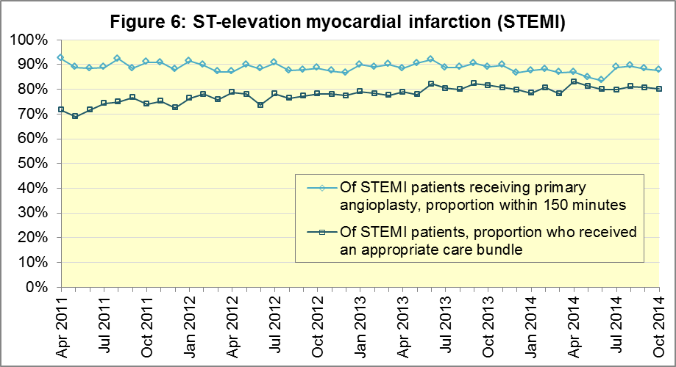

B4 Stroke (Figure 7)
The FAST procedure helps assess whether someone has suffered a stroke:
- Facial weakness: can the person smile? Has their mouth or eye drooped?
- Arm weakness: can the person raise both arms?
- Speech problems: can the person speak clearly and understand what you say?
- Time to call 999 for an ambulance if you spot any one of these signs.
In October 2014, of 3,367 FAST positive patients in England, assessed face to face, and potentially eligible for stroke thrombolysis within agreed local guidelines, 1,984 (58.9%) arrived at hospitals with a hyperacute stroke unit within 60 minutes of an emergency call connecting to the ambulance service. The average for the year ending September 2014 was 61.8%.
The largest proportion in the month of October 2014 was 70.7% for North East, and the smallest was 42.6% for West Midlands.
There were 7,708 stroke patients assessed face to face in October 2014 in England, and 7,494 (97.2%) received the appropriate care bundle, similar to the average for the year ending September 2014 of 96.8%. The largest proportion in the month of October 2014 was 99.6% for North West, and the smallest was 93.6% for West Midlands.

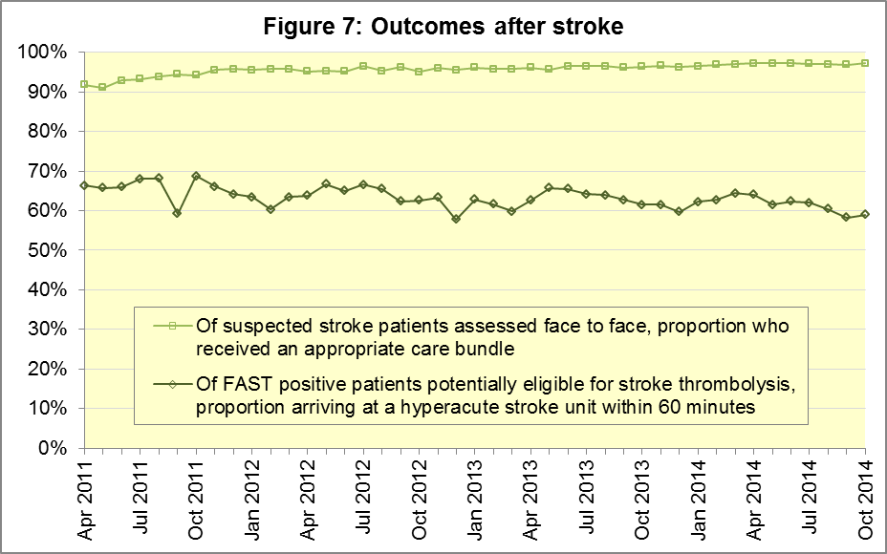

B5 Revisions to Clinical Outcomes
Five of the eleven Ambulance Services made no revisions this month. East Midlands, South East Coast and South Western Ambulance Services made small revisions, which for East Midlands and South East Coast, were only for the survival to discharge. There were larger revisions for North West, West Midlands and London Ambulance Services, often affecting all six months from April to September 2014.
Figures 8 to 15 demonstrate that at national level, the largest revisions were to the survival to discharge for the Utstein comparator group in spring 2014 (Figure 11), and the STEMI angioplasty indicator in June 2014 (Figure 12).

Figure 8: ROSC after cardiac arrest, England, 2014

Figure 9: ROSC after cardiac arrest, England, 2014 (Utstein comparator group)
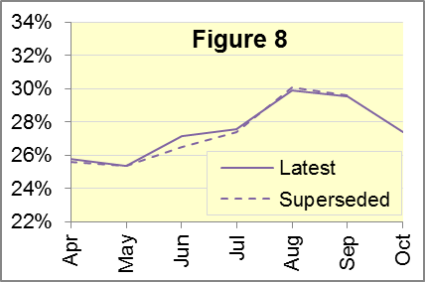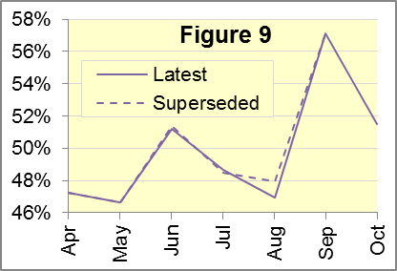

Figure 10: Survival to discharge after cardiac arrest, England, 2014

Figure 11: Survival to discharge after cardiac arrest, England, 2014 (Utstein)
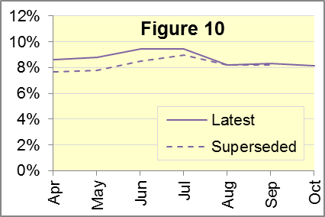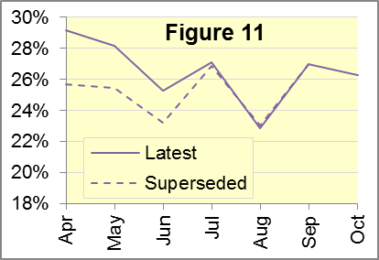

Figure 12: STEMI patients: angioplasty in 150 minutes, England, 2014

Figure 13: STEMI patients receiving appropriate care bundle, England, 2014
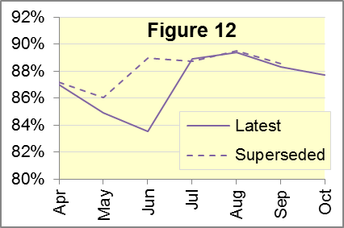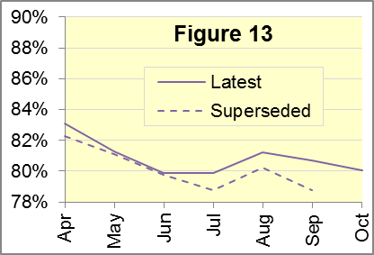

Figure 14: Stroke patients: thrombolysis in 60 minutes, England, 2014

Figure 15: Stroke patients receiving appropriate care bundle, England, 2014
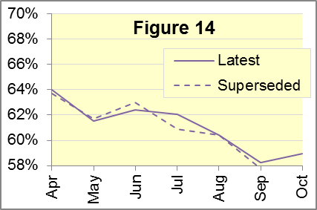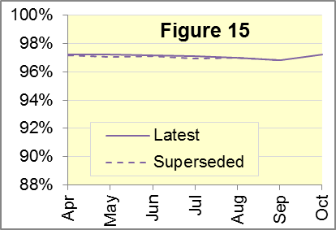

Some revisions at Trust-level were larger, with the following monthly data in 2014 revised by more than five percentage points:
Service | Month | Indicator | From | To
North West | June | STEMI angioplasty | 81.4% | 53.8%
West Midlands | August | ROSC (Utstein) | 57.7% | 44.1%
West Midlands | August | Survival to discharge (Utstein) | 34.6% | 26.5%
West Midlands | April | STEMI care bundle | 74.5% | 82.4%
West Midlands | July | STEMI care bundle | 66.4% | 73.3%
West Midlands | August | STEMI care bundle | 72.7% | 83.2%
West Midlands | September | STEMI care bundle | 62.2% | 83.1%
London | April | Survival to discharge (Utstein) | 24.1% | 45.2%
London | May | Survival to discharge (Utstein) | 13.5% | 33.3%
London | June | Survival to discharge (Utstein) | 14.3% | 29.4%
London | May | STEMI angioplasty | 86.7% | 92.2%

C. Further information on AQI

C1 The AQI landing page and Quality Statement
www.england.nhs.uk/statistics/statistical-work-areas/ambulance-quality-indicators, or http://bit.ly/NHSAQI, is the AQI landing page, and it holds:
- a Quality Statement for these statistics, which includes information on relevance, accuracy, timeliness, coherence, and user engagement
- the specification guidance for those who supply the data;
- timetables for data collection and publication;
- text files and time series spreadsheets containing all data from April 2011 up to the latest month;
- links to individual pages for each financial year.
A new version 1.1 of the Quality Statement was released on 28 January 2015.
The pages for each financial year hold:
- separate spreadsheets of each month’s data;
- this Statistical Note, and equivalent versions from previous months;
- the list of people with pre-release access to the data.

C2 Revisions
Revisions usually follow a six-monthly cycle. The dates for past and future AQI revisions are overleaf. The AQI Quality Statement above contains a more detailed revisions policy.
Publication date |  | Series revised |  | Months affected
5 November 2015 |  | Systems Indicators |  | April 2015 to August 2015
3 September 2015 |  | Clinical Outcomes |  | April 2014 to March 2015
30 April 2015 |  | Systems Indicators |  | April 2014 to February 2015
5 March 2015 |  | Clinical Outcomes |  | April 2014 to September 2014
6 November 2014 |  | Systems Indicators |  | April 2013 to August 2014
5 September 2014 |  | Clinical Outcomes |  | April 2013 to March 2014
2 May 2014 |  | Systems Indicators |  | April 2013 to February 2014
7 March 2014 |  | Clinical Outcomes |  | April 2013 to September 2013
1 November 2013 |  | Systems Indicators |  | April 2013 to August 2013
2 August 2013 |  | Clinical Outcomes |  | April 2012 to March 2013
3 May 2013 |  | Systems Indicators |  | April 2012 to March 2013
1 February 2013 |  | Clinical Outcomes |  | April 2012 to August 2012
11 January 2013 |  | Systems Indicators |  | April 2011 to October 2012
31 August 2012 |  | Clinical Outcomes |  | April 2011 to March 2012

C3 AQI Scope
The Ambulance Quality Indicators (AQI) include calls made by dialling either the usual UK-wide number 999 or its EU equivalent 112.
As described in the specification guidance mentioned above, calls made to NHS 111 are not included in AQI telephony data items. These comprise the measures for calls abandoned (SQU03_1_1), re-contacts (SQU03_2_1 and SQU03_2_2), frequent callers (SQU03_2_3), time to answer calls (SQU03_8_1_1) and calls resolved by telephone advice (SQU03_10_1).
All other Systems Indicators involve the dispatch of an ambulance, and they include ambulances dispatched as a result of a call to NHS 111, as well as 999 or 112. Footnotes in the published spreadsheets reiterate which data items do and do not include ambulances dispatched as a result of a call to NHS 111.

C4 Related statistics in England
The AQI appear in a Clinical Dashboard, available from the AQI landing page, the websites of the Ambulance Trusts (listed in the AQI Quality Statement), and http://aace.org.uk/national-performance/national-clinical-dashboards. One of the aims of these Dashboards is to use statistical process control, to indicate whether variation in performance reflects underlying change, or merely natural variance, unavoidable even when a health system is performing well.
The AQI are also used in the latest annual Ambulance Services publication www.hscic.gov.uk/article/2021/Website-Search?productid=15165 by the Health and Social Care Information Centre (HSCIC), which includes additional annual analysis and commentary. Originally, this publication used the KA34 data collection. This was similar to the AQI Systems Indicators, but annual, and ceased collection in March 2013. The HSCIC release therefore uses AQI data thereafter.
The AQI Quality Statement described in section C1 contains more information on the HSCIC publication. It also contains details of weekly ambulance situation reports that NHS England collected for six months from November 2010.

C5 Rest of UK
Ambulance statistics for other countries of the UK can be found at the following websites. The AQI Quality Statement described in section C1 contains more information about the comparability of these statistics.
Wales: | http://wales.gov.uk/statistics-and-research/ambulance-services/?lang=en
Scotland: | See Quality Improvement Indicators (QII) documents at www.scottishambulance.com/TheService/BoardPapers.aspx
Northern Ireland: | www.dhsspsni.gov.uk/index/statistics/hospital/emergency-care/ambulance-statistics.htm

C6 Contact information
For press enquiries, please contact the NHS England press office on 0113 825 0958 or nhsengland.media@nhs.net.
The Government Statistical Service (GSS) statistician responsible for producing these data is:
Ian Kay, Analytical Services (Operations), NHS England, Room 5E24, Quarry House, Leeds, LS2 7UE
0113 824 9411
i.kay@nhs.net

Ambulance response time standards are on page 30, Handbook to the NHS Constitution, www.nhs.uk/choiceintheNHS/Rightsandpledges/NHSConstitution/Pages/Overview.aspx.
On 1 June 2012, Category A (immediately life-threatening) calls were split into Red 1 and Red 2. Red 1 calls are the most time critical, and cover cardiac arrest patients who are not breathing and do not have a pulse, and other severe conditions such as airway obstruction. Red 2 calls are serious, but less immediately time critical, and cover conditions such as stroke and fits. www.gov.uk/government/news/changes-to-ambulance-response-time-categories
Due to differences in clock start definitions for Red 1 and Red 2, it is not possible to aggregate them into a total Category A performance. Definitions appear in the specification guidance for data suppliers, on the AQI landing page at http://bit.ly/NHSAQI.
The number of emergency calls presented to switchboard does not usually include calls made to NHS 111 requiring an ambulance. 111 calls requiring an ambulance are usually transferred electronically direct to ambulance dispatch, and not routed via 999 call handlers. Occasionally, manual requests for ambulance are made between 111 and 999 call handlers, and such calls are included in the number of emergency calls presented to switchboard.
Type 1 are consultant-led 24 hour emergency departments with full resuscitation facilities. Type 2 offer a consultant-led speciality A&E service such as ophthalmology or dental. Type 3 is A&E / minor injury activity that may be doctor-led or nurse-led. Type 4 are NHS walk-in centres. (www.datadictionary.nhs.uk/data_dictionary/attributes/a/acc/ accident_and_emergency_department_type_de.asp)
Due to its small size, performance on Isle of Wight tends to vary more than other Trusts. If Isle of Wight has the largest or smallest value, Figure A4 shows the second largest or smallest value, but with a footnote marker to show that Isle of Wight is more extreme. This system is also used for Clinical Outcomes in section B.
Pilot announcement, January 2015: www.parliament.uk/business/publications/written-questions-answers-statements/written-statement/Commons/2015-01-16/HCWS201
This definition was proposed by an international group of cardiologists and other health professionals meeting at Utstein Abbey in Norway in 1990. http://circ.ahajournals.org/content/84/2/960.citation
Excluding Isle of Wight. See note 6 on page 4.
Excluding Isle of Wight. See note 6 on page 4.
Pages 21 to 25 of the specification guidance for data suppliers on the AQI landing page at www.england.nhs.uk/statistics/statistical-work-areas/ambulance-quality-indicators describe the care bundles, and certain exclusions, for the STEMI and stroke indicators.
Excluding Isle of Wight. See note 6 on page 4.

