Statistical Note: Ambulance Quality Indicators (AQI)
- The latest emergency response data for Ambulance Services in England for February 2015 were similar to January 2015, and did not meet the standards in the Handbook to the NHS constitution.
- The latest clinical outcomes data for November 2014 for patients transported by Ambulance Services are stable, other than for stroke thrombolysis.

A. Systems Indicators

A1 Emergency response in 8 minutes (Figure 1)
In February 2015, of Category A Red 1 calls in England resulting in an emergency response, the proportion arriving within 8 minutes was 72.0%.
In February 2015, of Category A Red 2 calls in England resulting in an emergency response, the proportion arriving within 8 minutes was 67.5%.
Red 2 data for February 2015 are not completely comparable across England; see section A2 on the Dispatch on Disposition pilot.
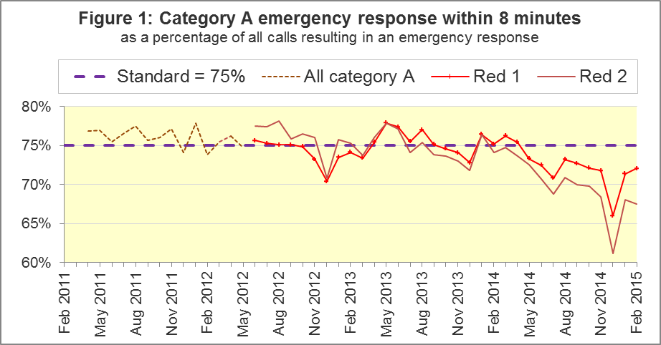
The standard for Ambulance Services is to send an emergency response, with a defibrillator, within 8 minutes, to 75% of Category A calls. Figure 1 shows that for England as a whole, the standard has not been met for Red 1 since April 2014.
The February 2015 Red 1 proportion was above the standard for three of the eleven Ambulance Services in England: West Midlands, East of England, and Isle of Wight. The Red 1 proportion was below 70% for North West, East Midlands and London.

A2 Dispatch on Disposition (DoD) pilot
In January 2015, the Secretary of State for Health announced the Dispatch on Disposition (DoD) pilot, allowing more time to triage (to identify the clinical situation and take appropriate action), based upon clinical advice that this would be likely to improve the overall outcomes for ambulance patients.
The pilot covered all calls received by London Ambulance Service (LAS) and South Western Ambulance Service (SWAS), and started on 10 February 2015, continuing into March 2015.
For Red 1 calls, the clock start time remains as soon as the telephone call connects.
However, to allow more time for triage, the clock start time changed for Red 2 calls:
Usual pre-pilot Red 2 start time | DoD pilot Red 2 start time
Earliest of:  - chief complaint, or Pathways initial Dx code information, is obtained;  - first vehicle assigned;  - 60 seconds after call connect. | Earliest of:  - chief complaint, or Pathways initial Dx code information, is obtained;  - first vehicle assigned;  - 180 seconds after call connect.

This AQI publication uses the same data that the Ambulance Services report to their Boards. For the pilot period, LAS data use the new pilot start times, so their data are not comparable with the rest of England.
For the pilot period, SWAS data use the old pre-pilot start times, even though the extra time used for triage during the pilot means the clock can often start more than a minute before an ambulance is allocated to a call. A further consequence of this is, unlike other areas, SWAS data for the pilot period do not include calls where clinical assistance arrived on scene, while telephone triage was still ongoing. So, although SWAS data are measured using the same clock start time as other Trusts (except LAS), these factors will reduce their Red 2 proportion in comparison with other trusts.
To accurately measure the effect of the pilot would have required running the pilot system simultaneously alongside the previous system within a single place, which was impossible. However, the Systems Indicators Time Series spreadsheet on the AQI landing page http://bit.ly/NHSAQI now includes an extra tab with numerators, denominators, and percentages, for the Red 2 time series, for all England, and for all England excluding LAS and SWAS.

A3 Red 2 emergency response within 8 minutes
Figure 2 shows that for all England, the Red 2 measure decreased from 68.0% to 67.5%. With LAS and SWAS excluded, the measure increased from 69.7% to 70.2%.
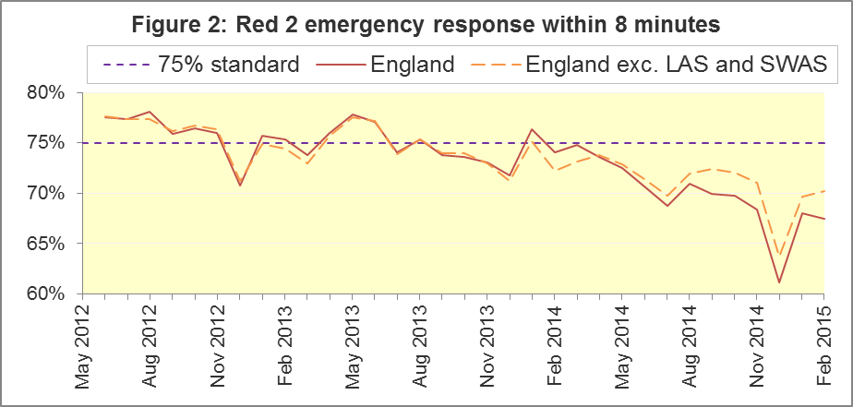
There will inevitably always be uncertainty over what the Red 2 measure for all England would have been without the DoD pilot. However, LAS and SWAS take about a quarter of Category A calls in England each month. Therefore, they would have had to have provided an emergency response within 8 minutes to more than 88% of Red 2 calls, in order for the 75% standard to be met in February 2015. This would have been unprecedented, and a very large increase upon their previous 2014-15 averages for Red 2 of 60% (LAS) and 72% (SWAS).
Of the Trusts unaffected by the pilot in February 2015, three had fewer than 70% of Red 2 responses within 8 minutes: North West, East Midlands and East of England. This was despite each of their proportions increasing by 1 percentage point between January and February. Three trusts achieved the Red 2 standard in February 2015: North East, South Central, and Isle of Wight. All three achieved it in January, too.
The vast majority of Category A calls are Red 2 calls, so the pilot affected both the 8 minute Red 2 measure, and the 19 minute Category A measure.

A4 Category A Ambulance response in 19 minutes
The other standard for Ambulance Services in the Handbook to the NHS Constitution is for Trusts to send, within 19 minutes, a fully-equipped ambulance vehicle, able to transport the patient in a clinically safe manner, to 95% of Category A calls.
Of the Trusts unaffected by the DoD pilot, three did not achieve this standard in February 2015: North West (91.4%), East Midlands (91.7%), East of England (93.2%), although each had a proportion that increased from the previous month.
Figure 3 shows that for all England, the 19 minute proportion increased slightly from 93.3% to 93.5%. Excluding LAS and SWAS, it still increased slightly, from 93.8% to 94.2%.
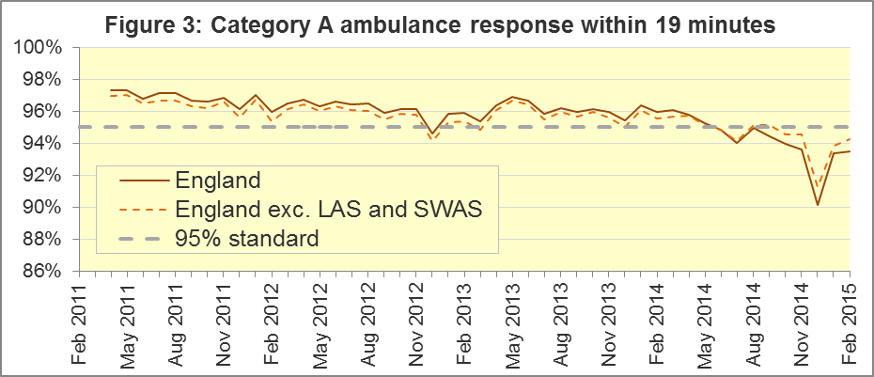
Without the DoD pilot, for the 95% standard to have been met for all England in February 2015, LAS and SWAS would have had to have provided an ambulance response within 19 minutes to more than 97% of category A calls, which would have been unprecedented for them in 2014-15.
Other Systems Indicators are still measured consistently during the pilot. The extra triage time may have increased the proportion of calls closed with telephone advice. For SWAS, this was 11.4% in February 2015, its largest proportion in the series; it was always less than 8% before November 2014.

A5 Systems Indicators: Ambulance volumes (Figure 4)
The number of emergency telephone calls presented to switchboard in February 2015 was 628,898, an average of 22 thousand per day. However, East of England (normally about 10% of calls in England) did not provide this value, so the average would probably have been the same as the average of 24 thousand per day in 2014.
There were 359,188 incidents requiring emergency patient journeys to Type 1 or Type 2 A&E in February 2015, which was 13 thousand per day, the same as in most months of 2014.
There were 241,338 Category A calls that resulted in a full-equipped ambulance vehicle arriving at the scene of the incident in February 2015. With the exception of temporary increases each December, this figure has increased steadily over the last four years. The average for February 2015 was 8,619 per day, fewer than each of the previous three months, but more than in each of the 43 months before those.
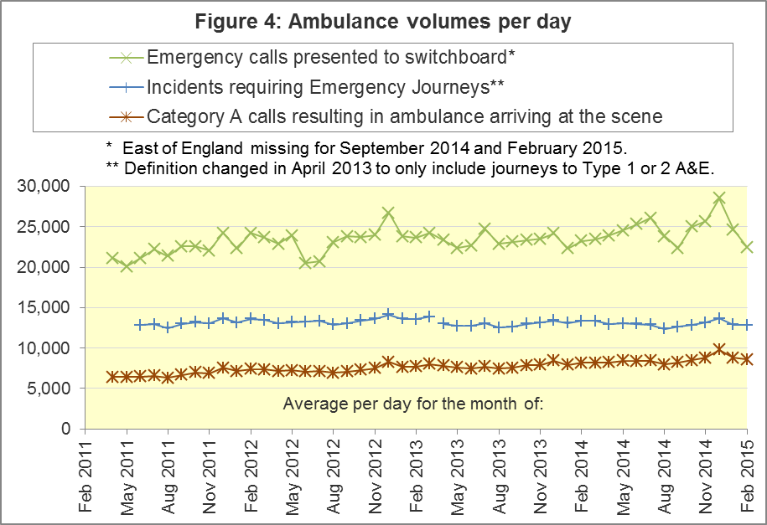

A6 Latest monthly data for other Systems Indicators
Indicator | All England | Lowest Trust |  |  | Highest Trust
Calls abandoned before being answered | 0.9% | London |  | 0.1% | North West | 2.2%
Calls resolved through telephone assessment | 8.9% | North West |  | 3.0% | London | 15.0%
Calls resolved without transport to Type 1 or Type 2 A&E | 36.6% | North West |  | 26.5% | South Western | 52.6%
Recontact rate following discharge by telephone advice | 7.6% | London |  | 2.9% | North East | 14.2%
Recontact rate following face-to-face treatment at scene | 5.7% | York-shire |  | 3.4% | London | 8.6%
Number of emergency journeys | 359,188 | North East | 19,319 |  | London | 57,536

B. Clinical Outcomes
No thresholds to denote “poor” care are set for Clinical Outcomes. Commissioners are expected to examine trends in these data, and work in collaboration with Ambulance Trusts to achieve sustained improvements over time improvement in patient outcomes over time; but commissioners are not expected to use Clinical Outcomes to performance manage Trusts, because there will be significant variations in the populations served.
The latest Clinical Outcome data are for November 2014, so these do not yet overlap with the DoD pilot. The pilot will not affect how they are measured anyway.

B1 Cardiac arrest: return of spontaneous circulation (ROSC) (Figure 5)
In November 2014, there were 2,544 patients with resuscitation commenced or continued by ambulance staff following an out-of-hospital cardiac arrest in England. Of these, 705 (28%) had ROSC on arrival at hospital, which was similar to the average for the year ending September 2014 of 27%. The largest proportion in November 2014 was 42% for South Central, and the smallest was 20% for East Midlands.
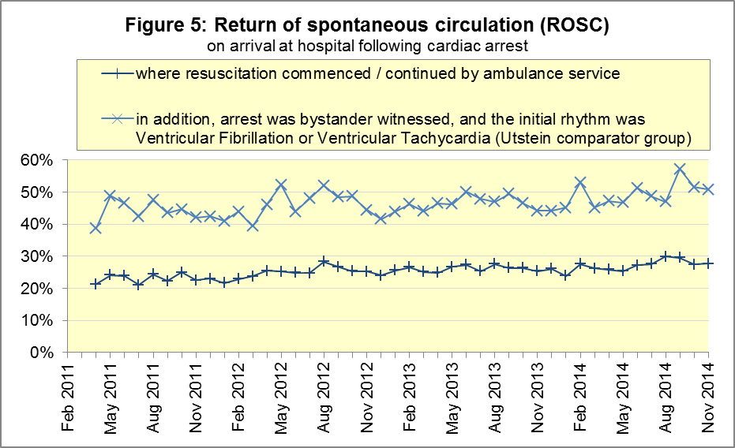
The Utstein group comprises patients who had resuscitation commenced or continued by the Ambulance Services, following an out-of-hospital cardiac arrest of presumed cardiac origin, where the arrest was bystander witnessed, and the initial rhythm was Ventricular Fibrillation or Ventricular Tachycardia.
The Utstein group therefore have a better chance of survival. There are generally fewer than 50 such patients in each trust each month, so percentages calculated for them can vary considerably, and changes are often not statistically significant.
Of the 309 Utstein patients in England in November 2014, 51% had ROSC on arrival at hospital, not significantly different to the average for the year ending September 2014 of 48%. The largest proportion in the month of November 2014 was 64% for South Central, and the smallest was 35% for East Midlands.

B2 Cardiac arrest: survival to discharge (Figure 6)
The proportion of cardiac arrest patients in England discharged from hospital alive was 9% in November 2014, the same as the average for the year ending September 2014. The largest proportion for survival to discharge in the month of November 2014 was 16% for South Central, and the smallest was 4% for North East.
For the Utstein group in November 2014, survival to discharge was 24% in England, not significantly different to the average of 26% for the year ending September 2014. The largest proportion in the month of November 2014 was 54% for South Central, and the smallest⁹ was 7% for West Midlands.
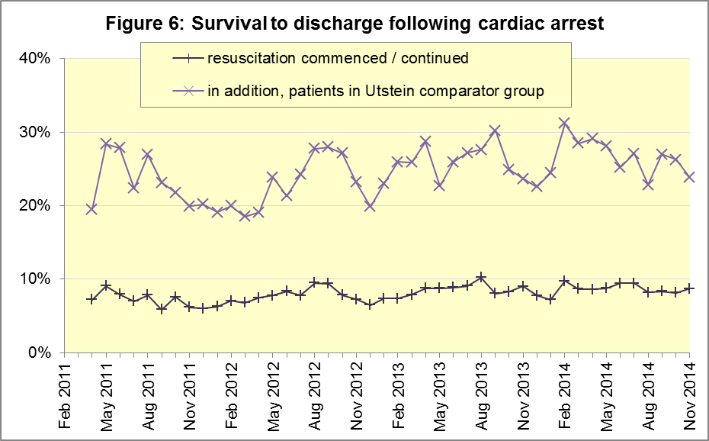

B3 ST-Elevation myocardial infarction (Figure 7)
ST-segment elevation myocardial infarction (STEMI) is a type of heart attack, determined by an electrocardiogram (ECG) test. Early access to reperfusion, where blocked arteries are opened to re-establish blood flow, and other assessment and care interventions, are associated with reductions in STEMI mortality and morbidity.
In November 2014, of 1,400 patients with an acute STEMI in England, 1,109 (79%) received the appropriate care bundle, similar to the proportion of 80% for the year ending September 2014. The largest proportion for the month of November 2014 was 90% for North West, and the smallest was 69% for South Central.
Of 951 STEMI patients receiving primary angioplasty in November 2014 in England, 843 (89%) of them received it within 150 minutes of the call being connected to the ambulance service, similar to the average for the year ending September 2014 of 87%. London had the largest proportion for the month of November 2014, with 100%, and the smallest was 75% for South Western.
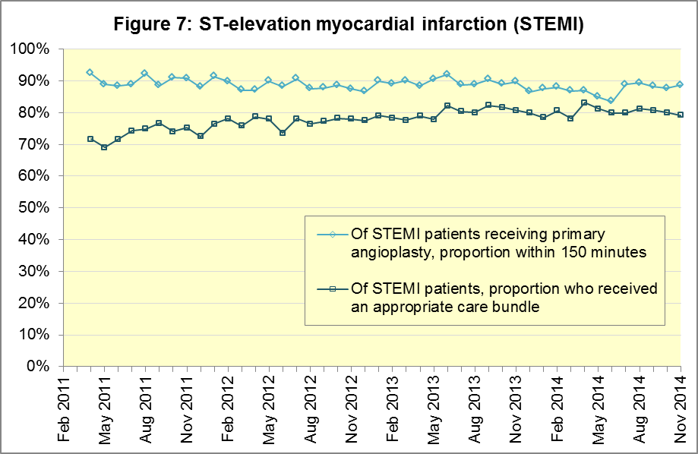

B4 Stroke (Figure 8)
The FAST procedure helps assess whether someone has suffered a stroke:
- Facial weakness: can the person smile? Has their mouth or eye drooped?
- Arm weakness: can the person raise both arms?
- Speech problems: can the person speak clearly and understand what you say?
- Time to call 999 for an ambulance if you spot any one of these signs.
In November 2014, of 3,177 FAST positive patients in England, assessed face to face, and potentially eligible for stroke thrombolysis within agreed local guidelines, 1,797 (57%) arrived at hospitals with a hyperacute stroke unit within 60 minutes of an emergency call connecting to the ambulance service.
This was the lowest figure since the time series began, and significantly less than the average for the year ending September 2014 of 62%.
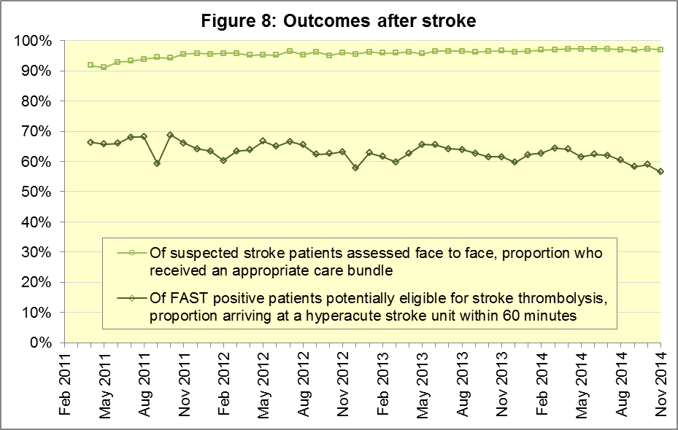
The largest proportion in the month of November 2014 was 68% for North East, and the smallest was 45% for West Midlands.
There were 7,573 stroke patients assessed face to face in November 2014 in England, and 7,339 (97%) received the appropriate care bundle, the same proportion as the average for the year ending September 2014. The largest proportion in the month of November 2014 was 99% for North West, and the smallest was 93% for West Midlands.

C. Further information on AQI

C1 The AQI landing page and Quality Statement
www.england.nhs.uk/statistics/statistical-work-areas/ambulance-quality-indicators, or http://bit.ly/NHSAQI, is the AQI landing page, and it holds:
- a Quality Statement for these statistics, which includes information on relevance, accuracy, timeliness, coherence, and user engagement;
- the specification guidance for those who supply the data;
- timetables for data collection and publication;
- text files and time series spreadsheets containing all data from April 2011 up to the latest month;
- links to individual web pages for each financial year.
The web pages for each financial year hold:
- separate spreadsheets of each month’s data;
- this Statistical Note, and equivalent versions from previous months;
- the list of people with pre-release access to the data.

C2 Revisions
Revisions usually follow a six-monthly cycle. The dates for past and future AQI revisions are below. The AQI Quality Statement above contains a more detailed revisions policy.
Publication date |  | Series revised |  | Months affected
5 November 2015 |  | Systems Indicators |  | April 2015 to August 2015
3 September 2015 |  | Clinical Outcomes |  | April 2014 to March 2015
30 April 2015 |  | Systems Indicators |  | April 2014 to February 2015
5 March 2015 |  | Clinical Outcomes |  | April 2014 to September 2014
6 November 2014 |  | Systems Indicators |  | April 2013 to August 2014
5 September 2014 |  | Clinical Outcomes |  | April 2013 to March 2014
2 May 2014 |  | Systems Indicators |  | April 2013 to February 2014
7 March 2014 |  | Clinical Outcomes |  | April 2013 to September 2013
1 November 2013 |  | Systems Indicators |  | April 2013 to August 2013
2 August 2013 |  | Clinical Outcomes |  | April 2012 to March 2013
3 May 2013 |  | Systems Indicators |  | April 2012 to March 2013
1 February 2013 |  | Clinical Outcomes |  | April 2012 to August 2012
11 January 2013 |  | Systems Indicators |  | April 2011 to October 2012
31 August 2012 |  | Clinical Outcomes |  | April 2011 to March 2012

C3 AQI Scope
The Ambulance Quality Indicators (AQI) include calls made by dialling either the usual UK-wide number 999 or its EU equivalent 112.
As described in the specification guidance document mentioned above, calls made to NHS 111 are not included in AQI telephony data items. These comprise the measures for calls abandoned (SQU03_1_1), re-contacts (SQU03_2_1 and SQU03_2_2), frequent callers (SQU03_2_3), time to answer calls (SQU03_8_1_1) and calls resolved by telephone advice (SQU03_10_1).
All other Systems Indicators involve the dispatch of an ambulance, and they include ambulances dispatched as a result of a call to NHS 111, as well as 999 or 112.

C4 Related statistics in England
The AQI appear in a Clinical Dashboard, available from the AQI landing page, the websites of the Ambulance Trusts (listed in the AQI Quality Statement), and http://aace.org.uk/national-performance/national-clinical-dashboards. One of the aims of these Dashboards is to use statistical process control, to indicate whether variation in proportions reflects underlying change, or merely natural variance, unavoidable even when a health system is performing well.
The AQI are also used in the latest annual Ambulance Services publication www.hscic.gov.uk/article/2021/Website-Search?productid=15165 by the Health and Social Care Information Centre (HSCIC), which includes additional annual analysis and commentary. Originally, this publication used the KA34 data collection, which was similar to the AQI Systems Indicators, but annual, and ceased collection in March 2013. The HSCIC publication therefore uses AQI data thereafter.
The AQI Quality Statement described in section C1 contains more information on the HSCIC publication. It also contains details of weekly ambulance situation reports that NHS England collected for six months from November 2010.

C5 Rest of United Kingdom
Ambulance statistics for other countries of the UK can be found at the following websites. The AQI Quality Statement described in section C1 contains more information about the comparability of these statistics.
Wales: | http://wales.gov.uk/statistics-and-research/ambulance-services/?lang=en
Scotland: | See Quality Improvement Indicators (QII) documents at www.scottishambulance.com/TheService/BoardPapers.aspx
Northern Ireland: | www.dhsspsni.gov.uk/index/statistics/hospital/emergency-care/ambulance-statistics.htm

C6 Contact information
For press enquiries, please contact the NHS England press office on 0113 825 0958 or nhsengland.media@nhs.net.
The Government Statistical Service (GSS) statistician responsible for producing these data is:
Ian Kay, Analytical Services (Operations), NHS England, Room 5E24, Quarry House, Leeds, LS2 7UE; 0113 824 9411; i.kay@nhs.net

Page 30 of the Handbook to the NHS Constitution has Ambulance response time standards, www.nhs.uk/choiceintheNHS/Rightsandpledges/NHSConstitution/Pages/Overview.aspx.
On 1 June 2012, Category A (immediately life-threatening) calls were split into Red 1 and Red 2. Red 1 calls are the most time critical, and cover cardiac arrest patients who are not breathing and do not have a pulse, and other severe conditions such as airway obstruction. Red 2 calls are serious, but less immediately time critical, and cover conditions such as stroke and fits. www.gov.uk/government/news/changes-to-ambulance-response-time-categories
Due to differences in clock start definitions for Red 1 and Red 2 (see section A2), it is not possible to aggregate them into a single proportion for Category A against the 8 minute standard.
DoD pilot announcement in January 2015: www.parliament.uk/business/publications/written-questions-answers-statements/written-statement/Commons/2015-01-16/HCWS201
The number of emergency calls presented to switchboard does not usually include calls made to NHS 111 requiring an ambulance. 111 calls requiring an ambulance are usually transferred electronically direct to ambulance dispatch, and not routed via 999 call handlers. Occasionally, manual requests for ambulance are made between 111 and 999 call handlers, and such calls are included in the number of emergency calls presented to switchboard.
Type 1 are consultant-led 24 hour emergency departments with full resuscitation facilities. Type 2 offer a consultant-led speciality A&E service such as ophthalmology or dental. Type 3 is A&E / minor injury activity that may be doctor-led or nurse-led. Type 4 are NHS walk-in centres. (www.datadictionary.nhs.uk/data_dictionary/attributes/a/acc/ accident_and_emergency_department_type_de.asp)
Excluding Isle of Wight.
This definition was proposed by an international group of cardiologists and other health professionals at Utstein Abbey in Norway in 1990. http://circ.ahajournals.org/content/84/2/960.citation
Due to its small size, proportions for Isle of Wight tends to vary more than other Trusts. If Isle of Wight has the largest or smallest value, Section B states the second largest or smallest value, but with a footnote marker to show that Isle of Wight is more extreme.
Pages 21 to 25 of the specification guidance for data suppliers on the AQI landing page at www.england.nhs.uk/statistics/statistical-work-areas/ambulance-quality-indicators describe the care bundles, and certain exclusions, for the STEMI and stroke indicators.
Excluding Isle of Wight. See note 9 on page 7.
Excluding Isle of Wight. See note 9 on page 7.

