Statistical Note: Ambulance Quality Indicators (AQI)
- The latest Systems Indicators for Ambulance Services in England (including revisions to 2014-15 data in section A10), showed an increase in March 2015 for emergency responses within 8 minutes, but not enough to meet the standards in the Handbook to the NHS constitution.
- The latest clinical outcomes data for patients transported by Ambulance Services, for December 2014, showed fewer arrivals at hyperacute stroke units within 60 minutes (section B4).

A. Systems Indicators

A1 Emergency response in 8 minutes (Figure 1)
In March 2015, of Category A Red 1 calls in England resulting in an emergency response, the proportion arriving within 8 minutes was 73.4%.
In March 2015, of Category A Red 2 calls in England resulting in an emergency response, the proportion arriving within 8 minutes was 69.6%.
Red 2 data for February and March 2015 are not completely comparable across England; see section A2 on the Dispatch on Disposition pilot.
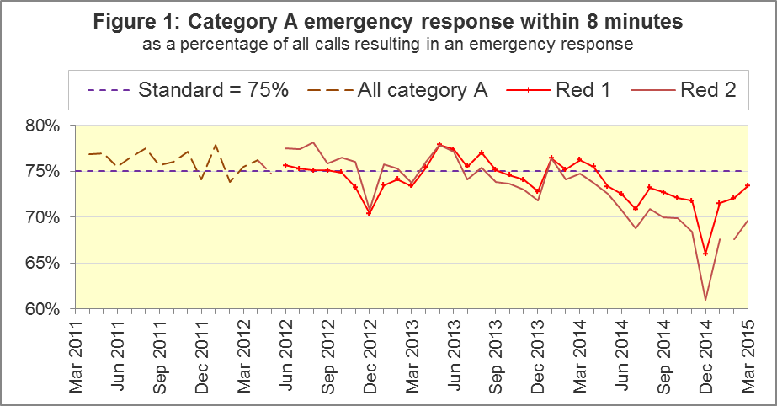
The standard for Ambulance Services is to send an emergency response, with a defibrillator, within 8 minutes, to 75% of Category A calls. Figure 1 shows that for England as a whole, the standard has not been met for Red 1 since April 2014.
The March 2015 Red 1 proportion was above the standard for five of the eleven Ambulance Services in England: West Midlands, South East Coast, South Central, South Western and Isle of Wight.
The Red 1 proportion was below 70% for North West and London.

A2 Dispatch on Disposition (DoD) pilot
In January 2015, the Secretary of State for Health announced the Dispatch on Disposition (DoD) pilot, allowing more time to triage (to identify the clinical situation and take appropriate action), based upon clinical advice that this would be likely to improve the overall outcomes for ambulance patients.
The pilot covered all calls received by London Ambulance Service (LAS) and South Western Ambulance Service (SWAS). It started on 10 February 2015 and continued throughout March 2015.
For Red 1 calls, the clock start time remains as soon as the telephone call connects.
However, to allow more time for triage, the clock start time changed for Red 2 calls:
Usual pre-pilot Red 2 start time | DoD pilot Red 2 start time
Earliest of:  - chief complaint, or Pathways initial Dx code information, is obtained;  - first vehicle assigned;  - 60 seconds after call connect. | Earliest of:  - chief complaint, or Pathways initial Dx code information, is obtained;  - first vehicle assigned;  - 180 seconds after call connect.

In the 9 April 2015 publication, SWAS data for February 2015 still used the pre-pilot start times. These have now been revised to use the new pilot start times, so in this AQI publication, February and March 2015 response data, for the 8 minute Red 2 and 19 minute Category A measures, LAS and SWAS data are now comparable with each other, although they are still not comparable with the rest of England.
More information on revisions is in section A10.
The Systems Indicators Time Series spreadsheet on the AQI landing page http://bit.ly/NHSAQI includes an extra tab. This has numerators, denominators, and percentages, for the 8 minute Red 2 and 19 minute Category A time series, for all England and for England excluding LAS and SWAS.

A3 Red 2 emergency response within 8 minutes
Figure 2 shows that for all England, the Red 2 measure increased from 67.5% in February to 69.6% in March 2015. With LAS and SWAS excluded, the measure had a fairly similar increase, from 69.7% to 71.6%.
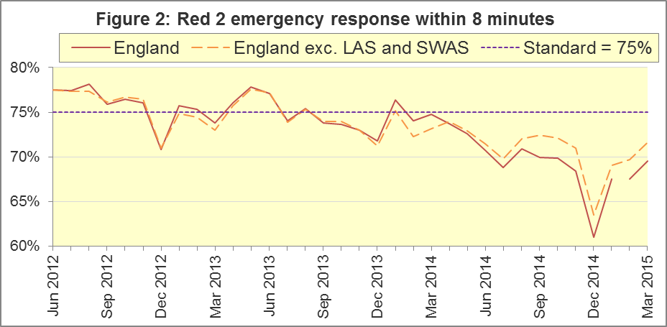
There will inevitably always be uncertainty over what the Red 2 measure for all England would have been without the DoD pilot. However, LAS and SWAS between them take about a quarter of Category A calls in England each month. Therefore, they would have had to have provided an emergency response within 8 minutes to 85% of Red 2 calls, in order for the 75% standard to be met in March 2015. This would have been unprecedented, and a very large increase upon their 2014-15 averages for Red 2 of 60% (LAS) and 72% (SWAS).
In March 2015, London had 59.1% of Red 2 responses within 8 minutes. North West and East of England also had fewer than 70%. North East, West Midlands, South Central, and Isle of Wight achieved the Red 2 standard.
The vast majority of Category A calls are Red 2 calls, so the pilot affected not only the 8 minute Red 2 measure, but also the 19 minute Category A measure.

A4 Category A Ambulance response in 19 minutes
The other standard for Ambulance Services in the Handbook to the NHS Constitution is for Trusts to send, within 19 minutes, a fully-equipped ambulance vehicle, able to transport the patient in a clinically safe manner, to 95% of Category A calls.
North West (91.2%), East Midlands (93.1%), East of England (93.9%), London (92.2%) and South Western (93.8%) did not achieve this standard in March 2015. The largest proportion was 97.3% in West Midlands.
Figure 3 shows that for all England, the 19 minute proportion increased from 93.5% in February 2015 to 94.1% in March. Excluding LAS and SWAS, there was a similar increase, from 94.1% to 94.6%.
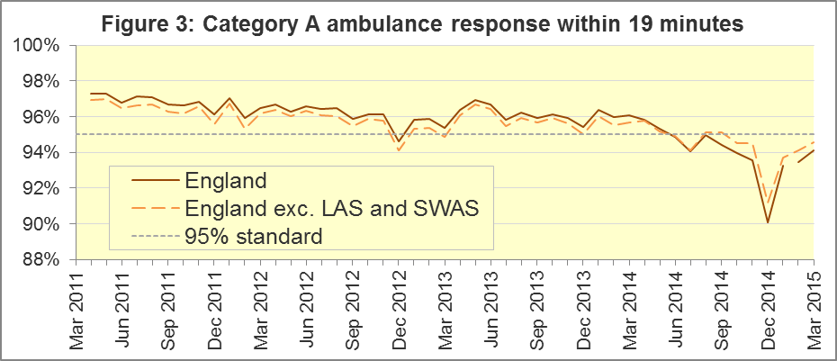
Without the DoD pilot, for the 95% standard to have been met for all England in March 2015, LAS and SWAS together would have had to have provided an ambulance response within 19 minutes to more than 96.3% of category A calls, which would have been unprecedented for them in 2014-15.
Other Systems Indicators are still measured consistently. The extra triage time in the pilot may have increased the proportion of calls closed with telephone advice. For SWAS, this was 12.2% in March 2015, its largest proportion since monthly data collection began in April 2011; it was always less than 8% before November 2014.

A5 Systems Indicators: Ambulance volumes (Figure 4)
The number of emergency telephone calls presented to switchboard in March 2015 was 694,188, an average of 22 thousand per day. However, that excludes East of England (normally about 10% of calls in England) which did not provide data, so the average would probably have been close to the 2014 average of 24 thousand per day.
There were 398,438 incidents requiring emergency patient journeys to Type 1 or Type 2 A&E in March 2015, an average of 13 thousand per day, the same as in all other months of 2014-15.
There were 266,371 Category A calls that resulted in a fully-equipped ambulance vehicle arriving at the scene of the incident in March 2015. With the exception of temporary increases each December, this measure has increased steadily over the last four years. The average for March 2015 was 8,593 per day, fewer than in each of the previous four months, but more than in each of the 43 months before those.
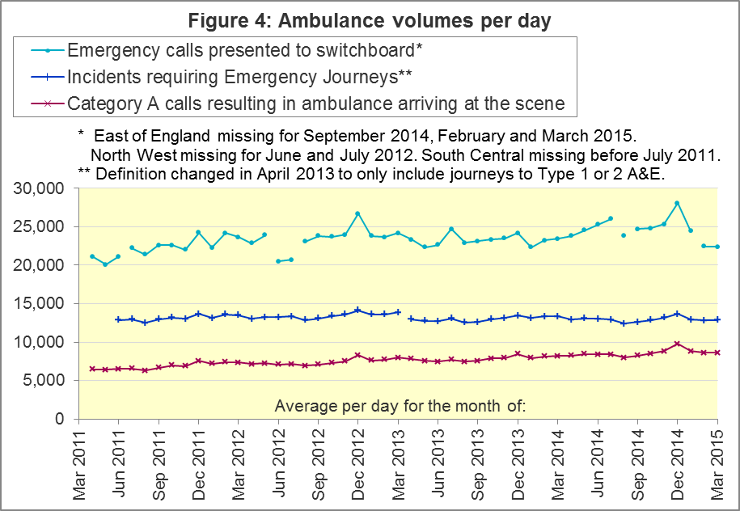

A6 Latest monthly data for other Systems Indicators
Indicator | England | Lowest Trust |  | Highest Trust
Calls abandoned before being answered | 0.7% | East Midlands | 0.1% | North West, Yorkshire | 1.5%
Calls resolved through telephone assessment | 8.9% | North West | 3.2% | London | 14.7%
Calls resolved without transport to Type 1 or Type 2 A&E | 36.3% | North West | 25.7% | South Western | 51.8%
Recontact rate following discharge by telephone advice | 7.9% | London | 3.0% | North East | 14.4%
Recontact rate following face-to-face treatment at scene | 5.6% | Yorkshire | 3.5% | London | 7.7%
Number of emergency journeys | 398,438 | North  East ⁸ | 21,061 | London | 64,154

A7 Trust-level annual analysis: resolved without transport
Figure 5 shows, of all calls that receive a telephone or face-to-face response from the ambulance service, the proportion resolved by telephone advice. This is sometimes referred to as “hear and treat”. For all England, this has increased from 5% in 2011-12 to 8% in 2014-15.
In 2014-15, London had the largest proportion, 13%. South East Coast had the second largest in 2014-15, 11%, and the largest proportions in 2012-13 and 2013-14. In all four years shown, North West was lowest, and never more than 4%.

Figure 5: Calls resolved by telephone advice
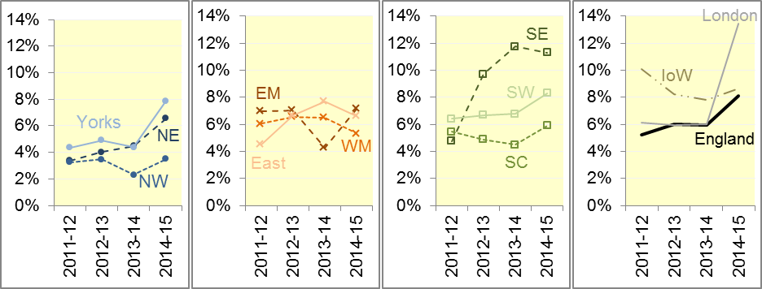

Figure 6: Calls where no patients taken to Type 1 or Type 2 A&E
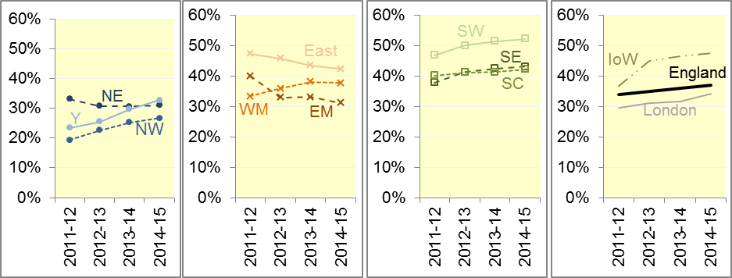
Figure 6 shows, of all calls that receive a face-to-face response from the ambulance service, the proportion where no patients were taken to a Type 1 or Type 2 A&E. This is sometimes referred to as “see and treat”.
Such patients are taken elsewhere (such as a minor injuries unit), or referred to an alternative care pathway, or discharged after treatment at the scene. Across the whole of England, the proportion not taken to Type 1 or Type 2 A&E increased slowly from 34% in 2011-12 to 37% in 2014-15.
In all four years the highest proportion was in South Western, with 52% in the last two years. The lowest proportion in each year was in North West, despite this measure increasing there from 19% in 2011-12 to 27% in 2014-15.

A8 Trust-level annual analysis: re-contacts
Figure 7 shows, of all emergency calls that are closed with telephone advice, the proportion with at least one re-contact from the same address within 24 hours. For all England, this has reduced from 13% in 2011-12 and 2012-13 to 10% in 2013-14 and 8% in 2014-15.
This measure was highest in North West in 2011-12 and 2012-13, which had more than 30% in those years, but 13% in 2013-14 and 11% in 2014-15. Yorkshire also had proportions of 20% or more in 2011-12 and 2012-13, but its proportions in 2013-14 and 2014-15 were both 6%. This measure was lowest in London in 2013-14 and 2014-15, with 2% each year.

Figure 7: Re-contacts following calls closed with telephone advice
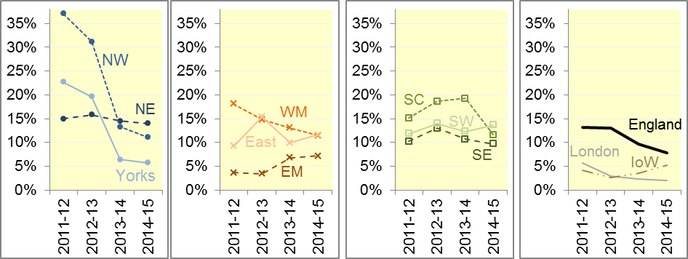

Figure 8: Re-contacts following discharge on scene
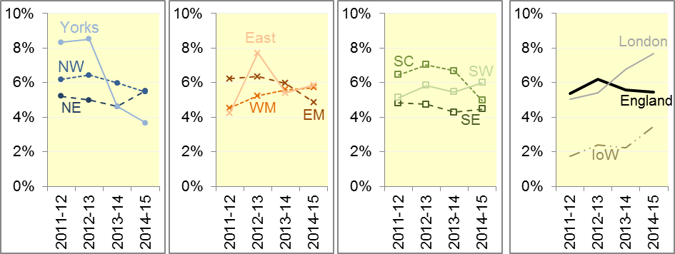
Figure 8 shows, of all patients treated and discharged on the scene, the proportion that re-contact on the telephone within 24 hours of the initial call. This is stable at 5% or 6% across England for each year 2011-12 to 2014-15.
Yorkshire had the highest proportion in 2011-12 and 2012-13 with more than 8%, but less than 5% in 2013-14 and 2014-15, so London was highest in 2014-15 with 8%. Isle of Wight was lowest in all four years, always less than 4%.

A9 Trust-level annual analysis: Volumes of Category A arrivals on scene
Figure 9 shows the average numbers of calls per day which led to a Category A ambulance arriving at the scene. This increased for all Ambulance Services between 2011-12 and 2012-13, and all except Isle of Wight had a further increase between 2012-13 and 2014-15.
London averaged 1,334 such calls per day in 2014-15 and had the largest average in each year. North West and West Midlands also averaged more than 1,000 per day in 2013-14 and 2014-15. Excluding the Isle of Wight, South Central had the fewest, but after it had an increase of more than 50% between 2011-12 and 2014-15, all Ambulance Services averaged more than 450 per day in 2014-15.
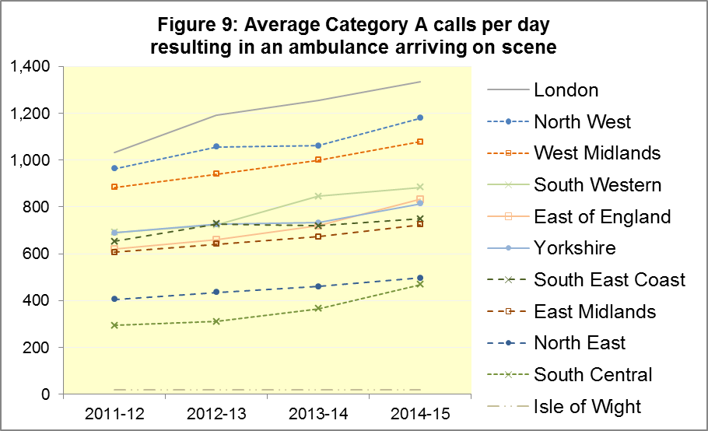

A10 Revisions to Systems Indicators
Every six months, Trusts can revise their Systems Indicators. The full set of revised data is in the Systems Indicators Time Series spreadsheet on the AQI landing page. The landing page also has a link to the 2014-15 page, which contains spreadsheets with the latest data for all of the months of 2014-15.
There are no revisions in today’s publication for the North East, South Central or Isle of Wight, and the only item revised for Yorkshire is abandoned calls for January 2015. However, the other seven Trusts have revisions for many items and for many months.
The only trust-level percentages revised by more than 1 percentage point are:
Trust | Item | Month | From | To
South Western | 8 minute Red 1 response | Jan 2015 | 73.4% | 74.9%
 | 8 minute Red 2 response | Feb 2015 | 61.6% | 65.7%
South East | 8 minute Red 2 response | Dec 2014 | 71.4% | 69.4%
 |  | Jan 2015 | 75.3% | 69.9%
 |  | Feb 2015 | 74.1% | 69.5%
 | 19 minute Category A response | Jan 2015 | 96.2% | 95.0%
 |  | Feb 2015 | 95.3% | 94.3%
East of England | Re-contact  after resolution  on the telephone | Apr 2014 | 10.0% | 11.2%
 |  | Jun 2014 | 10.0% | 11.8%
 |  | Jul 2014 | 9.9% | 11.4%
 |  | Aug 2014 | 9.8% | 11.5%
 |  | Sep 2014 | 10.0% | 11.6%
West Midlands | Re-contact after discharge on scene | Apr 2014 | 1.9% | 5.6%

The only national percentages revised by more than 0.1 percentage points are:
 | Item | Month | From | To
All England | 8 minute Red 1 response | Jan 2015 | 71.4% | 71.5%
 | 8 minute Red 2 response | Dec 2014 | 61.1% | 61.0%
 |  | Jan 2015 | 68.0% | 67.5%
 | 19 minute Category A response | Jan 2015 | 93.3% | 93.2%
 | Abandoned calls | Jan 2015 | 1.0% | 0.8%
 | Re-contact after resolution on the telephone | Jun 2014 | 7.9% | 8.0%
 |  | Jul 2014 | 8.4% | 8.5%
 |  | Aug 2014 | 7.3% | 7.4%
 | Re-contact after  discharge on the scene | Apr 2014 | 4.6% | 5.2%
 |  | Jul 2014 | 5.2% | 5.3%

At the national level, most revisions are imperceptible compared against the variation from month to month. The largest two revisions for all England are for Red 2 response (Figure 10) and re-contacts after discharge on the scene (Figure 11).
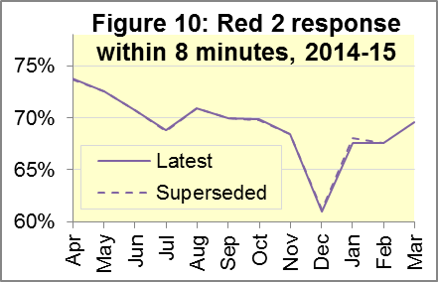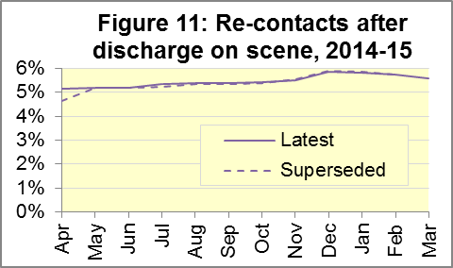

B. Clinical Outcomes
No thresholds to denote “poor” care are set for Clinical Outcomes. Commissioners are expected to examine trends in these data, and work in collaboration with Ambulance Trusts to achieve sustained improvements over time improvement in patient outcomes over time; but commissioners are not expected to use Clinical Outcomes to performance manage Trusts, because there will be significant variations in the populations served.
The DoD pilot described in section A2 will not affect these measures.

B1 Cardiac arrest: return of spontaneous circulation (ROSC) (Figure 12)
In December 2014, there were 3,376 patients with resuscitation commenced or continued by ambulance staff following an out-of-hospital cardiac arrest in England. Of these, 893 (26%) had ROSC on arrival at hospital, which was similar to the average for the year ending September 2014 of 27%. The largest proportion in December 2014 was 31% for London, and the smallest was 19% for North East.
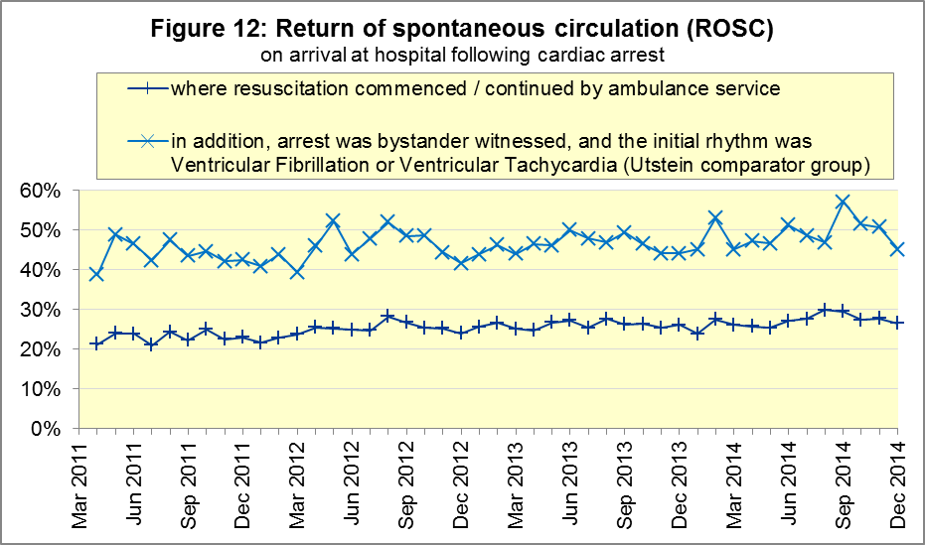
The Utstein group comprises patients who had resuscitation commenced or continued by the Ambulance Services, following an out-of-hospital cardiac arrest of presumed cardiac origin, where the arrest was bystander witnessed, and the initial rhythm was Ventricular Fibrillation or Ventricular Tachycardia. The Utstein group therefore have a better chance of survival.
There are generally fewer than 50 patients in the Utstein group in each trust each month, so percentages calculated for them can vary considerably, and changes are often not statistically significant.
Of the 341 such patients in England in December 2014, 45% had ROSC on arrival at hospital, not significantly different to the average for the year ending September 2014 of 48%. The largest proportion in the month of December 2014 was 55% for London and South East Coast, and the smallest was 30% for South Central.

B2 Cardiac arrest: survival to discharge (Figure 13)
The proportion of cardiac arrest patients in England discharged from hospital alive was 7% in December 2014, similar to the average of 9% for the year ending September 2014. The largest proportion for survival to discharge in the month of December 2014 was 13% for South Central, and the smallest was 4% for North East.
For the Utstein group in December 2014, survival to discharge was 24% in England, not significantly different to the average of 26% for the year ending September 2014. The largest¹¹ proportion in the month of December 2014 was 41% for Yorkshire, and the smallest was 14% for North West.
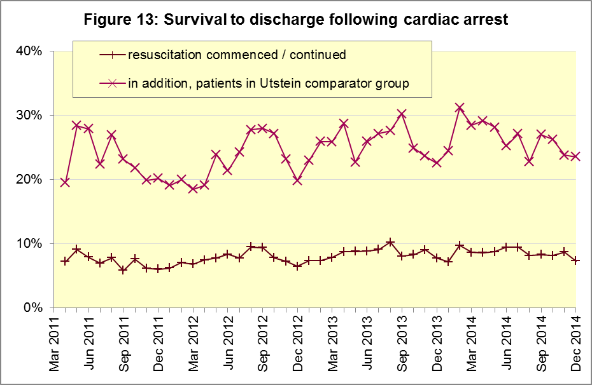

B3 ST-Elevation myocardial infarction (Figure 14)
ST-segment elevation myocardial infarction (STEMI) is a type of heart attack, determined by an electrocardiogram (ECG) test. Early access to reperfusion, where blocked arteries are opened to re-establish blood flow, and other assessment and care interventions, are associated with reductions in STEMI mortality and morbidity.
In December 2014, of 1,421 patients with an acute STEMI in England, 1,092 (77%) received the appropriate care bundle, significantly less than the proportion for the year ending September 2014 of 80%. The largest proportion for the month of December 2014 was 92% for North West, and the smallest was 54% for South Central.
Of 1,005 STEMI patients receiving primary angioplasty in December 2014 in England, 845 (84%) of them received it within 150 minutes of the call being connected to the ambulance service, not significantly different to the average for the year ending September 2014 of 87%. East Midlands had the largest¹³ proportion for the month of December 2014, with 93%, and the smallest was 72% for South Central.
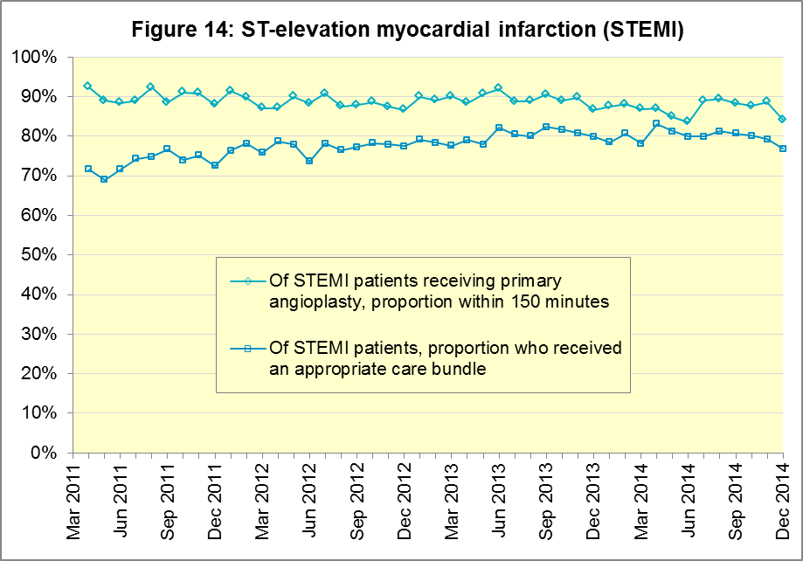

B4 Stroke (Figure 15)
The FAST procedure helps assess whether someone has suffered a stroke:
- Facial weakness: can the person smile? Has their mouth or eye drooped?
- Arm weakness: can the person raise both arms?
- Speech problems: can the person speak clearly and understand what you say?
- Time to call 999 for an ambulance if you spot any one of these signs.
In December 2014, of 3,364 FAST positive patients in England, assessed face to face, and potentially eligible for stroke thrombolysis within agreed local guidelines, 1,784 (53%) arrived at hospitals with a hyperacute stroke unit within 60 minutes of an emergency call connecting to the ambulance service.
This was the lowest proportion since the time series began, and significantly less than the average for the year ending September 2014 of 62%.
The largest proportion in the month of December 2014 was 63% for South East Coast, and the smallest was 43% for West Midlands.
There were 8,178 stroke patients assessed face to face in December 2014 in England, and 7,917 (97%) received the appropriate care bundle, the same proportion as the average for the year ending September 2014. The largest proportion in the month of December 2014 was 99.7% for North West, and the smallest was 92% for South East Coast.
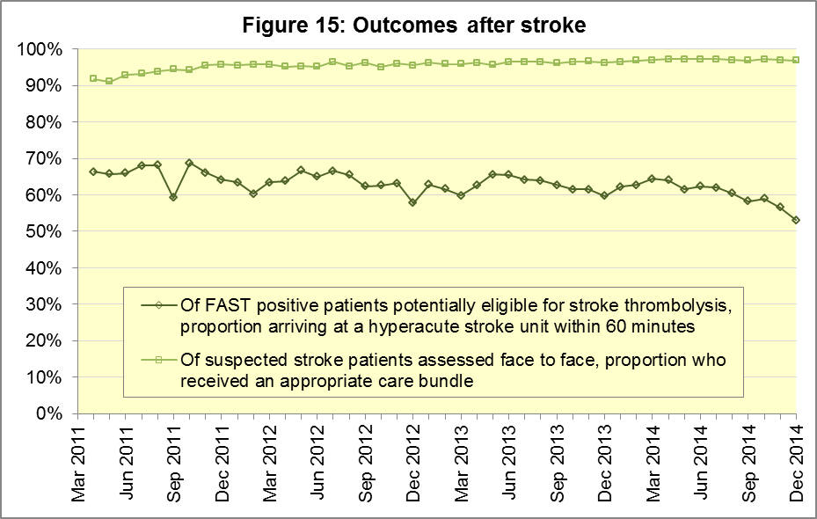

C. Further information on AQI

C1 The AQI landing page and Quality Statement
www.england.nhs.uk/statistics/statistical-work-areas/ambulance-quality-indicators, or http://bit.ly/NHSAQI, is the AQI landing page, and it holds:
- a Quality Statement for these statistics, which includes information on relevance, accuracy, timeliness, coherence, and user engagement;
- the specification guidance for those who supply the data;
- timetables for data collection and publication;
- text files and time series spreadsheets containing all data from April 2011 up to the latest month;
- links to individual web pages for each financial year.
The web pages for each financial year hold:
- separate spreadsheets of each month’s data;
- this Statistical Note, and equivalent versions from previous months;
- the list of people with pre-release access to the data.

C2 Revisions
Revisions usually follow a six-monthly cycle. The dates for past and future AQI revisions are below. The AQI Quality Statement above contains a more detailed revisions policy.
Publication date |  | Series revised |  | Months affected
5 November 2015 |  | Systems Indicators |  | April 2015 to August 2015
3 September 2015 |  | Clinical Outcomes |  | April 2014 to March 2015
30 April 2015 |  | Systems Indicators |  | April 2014 to February 2015
5 March 2015 |  | Clinical Outcomes |  | April 2014 to September 2014
6 November 2014 |  | Systems Indicators |  | April 2013 to August 2014
5 September 2014 |  | Clinical Outcomes |  | April 2013 to March 2014
2 May 2014 |  | Systems Indicators |  | April 2013 to February 2014
7 March 2014 |  | Clinical Outcomes |  | April 2013 to September 2013
1 November 2013 |  | Systems Indicators |  | April 2013 to August 2013
2 August 2013 |  | Clinical Outcomes |  | April 2012 to March 2013
3 May 2013 |  | Systems Indicators |  | April 2012 to March 2013
1 February 2013 |  | Clinical Outcomes |  | April 2012 to August 2012
11 January 2013 |  | Systems Indicators |  | April 2011 to October 2012
31 August 2012 |  | Clinical Outcomes |  | April 2011 to March 2012

C3 AQI Scope
The Ambulance Quality Indicators (AQI) include calls made by dialling either the usual UK-wide number 999 or its EU equivalent 112.
As described in the specification guidance document mentioned above, calls made to NHS 111 are not included in AQI telephony data items. These comprise the measures for calls abandoned (SQU03_1_1), re-contacts (SQU03_2_1 and SQU03_2_2), frequent callers (SQU03_2_3), time to answer calls (SQU03_8_1_1) and calls resolved by telephone advice (SQU03_10_1).
All other Systems Indicators involve the dispatch of an ambulance, and they include ambulances dispatched as a result of a call to NHS 111, as well as 999 or 112.

C4 Related statistics in England
The AQI appear in a Clinical Dashboard, available from the AQI landing page, the websites of the Ambulance Trusts (listed in the AQI Quality Statement), and http://aace.org.uk/national-performance/national-clinical-dashboards. One of the aims of these Dashboards is to use statistical process control, to indicate whether variation in proportions reflects underlying change, or merely natural variance, unavoidable even when a health system is performing well.
The AQI are also used in the latest annual Ambulance Services publication www.hscic.gov.uk/article/2021/Website-Search?productid=15165 by the Health and Social Care Information Centre (HSCIC), which includes additional annual analysis and commentary. Originally, this publication used the KA34 data collection, which was similar to the AQI Systems Indicators, but annual, and ceased collection in March 2013. The HSCIC publication therefore uses AQI data thereafter.
The AQI Quality Statement described in section C1 contains more information on the HSCIC publication. It also contains details of weekly ambulance situation reports that NHS England collected for six months from November 2010.

C5 Rest of United Kingdom
Ambulance statistics for other countries of the UK can be found at the following websites. The AQI Quality Statement described in section C1 contains more information about the comparability of these statistics.
Wales: | http://wales.gov.uk/statistics-and-research/ambulance-services/?lang=en
Scotland: | See Quality Improvement Indicators (QII) documents at www.scottishambulance.com/TheService/BoardPapers.aspx
Northern Ireland: | www.dhsspsni.gov.uk/index/statistics/hospital/emergency-care/ambulance-statistics.htm

C6 Contact information
For press enquiries, please contact the NHS England press office on 0113 825 0958 or nhsengland.media@nhs.net.
The Government Statistical Service (GSS) statistician responsible for producing these data is:
Ian Kay, Analytical Services (Operations), NHS England, Room 5E24, Quarry House, Leeds, LS2 7UE; 0113 824 9411; i.kay@nhs.net

Page 30 of the Handbook to the NHS Constitution has Ambulance response time standards, www.nhs.uk/choiceintheNHS/Rightsandpledges/NHSConstitution/Pages/Overview.aspx.
On 1 June 2012, Category A (immediately life-threatening) calls were split into Red 1 and Red 2. Red 1 calls are the most time critical, and cover cardiac arrest patients who are not breathing and do not have a pulse, and other severe conditions such as airway obstruction. Red 2 calls are serious, but less immediately time critical, and cover conditions such as stroke and fits. www.gov.uk/government/news/changes-to-ambulance-response-time-categories
Due to the differences in clock start definitions for Red 1 and Red 2 it is not possible to aggregate them into a single proportion for Category A against the 8 minute standard.
DoD pilot announcement in January 2015: www.parliament.uk/business/publications/written-questions-answers-statements/written-statement/Commons/2015-01-16/HCWS201
The number of emergency calls presented to switchboard does not usually include calls made to NHS 111 requiring an ambulance. 111 calls requiring an ambulance are usually transferred electronically direct to ambulance dispatch, and not routed via 999 call handlers. Occasionally, manual requests for ambulance are made between 111 and 999 call handlers, and such calls are included in the number of emergency calls presented to switchboard.
Type 1 are consultant-led 24 hour emergency departments with full resuscitation facilities. Type 2 offer a consultant-led speciality A&E service such as ophthalmology or dental. Type 3 is A&E / minor injury activity that may be doctor-led or nurse-led. Type 4 are NHS walk-in centres. (www.datadictionary.nhs.uk/data_dictionary/attributes/a/acc/ accident_and_emergency_department_type_de.asp)
No data for calls to switchboard, or calls abandoned, supplied for March 2015 by East of England.
Due to its small size, performance on Isle of Wight tends to vary more than other Trusts. If it has the largest or smallest value, the Table in A6 has a footnote marker to show that it is the extreme, and shows the second largest or smallest value. The Clinical Outcomes in section B also use this system.
Excluding Isle of Wight. See footnote 8 on page 5.
This definition was proposed at Utstein Abbey in Norway by an international group of cardiologists and other health professionals in 1990. http://circ.ahajournals.org/content/84/2/960.citation
Excluding Isle of Wight. See footnote 8 on page 5.
Pages 21 to 25 of the specification guidance for data suppliers on the AQI landing page at www.england.nhs.uk/statistics/statistical-work-areas/ambulance-quality-indicators describe the care bundles, and certain exclusions, for the STEMI and stroke indicators.
Excluding Isle of Wight. See footnote 8 on page 5.
Excluding Isle of Wight. See footnote 8 on page 5.

