# 

# NHS 111 Minimum Data Set (MDS) – England, August 2015

#### Summary

There were 1,061,499 calls offered to the NHS 111 service in England in August 2015. This was an average of 34.2 thousand per day, more than in June or July, but fewer than in the earlier months of 2015.

Of calls offered to NHS 111 in August 2015, the proportion abandoned after waiting longer than 30 seconds was 1.7%, the joint highest proportion in 2015.

Of calls answered by NHS 111, 93.6% were answered within 60 seconds, similar to the average for 2015 so far.

Of calls answered, 12% were offered a call back in August 2015, the same as in the previous three months.

Of call backs, 45% were within 10 minutes, similar to the average for 2015 so far.

Of calls answered, 22% were transferred to a clinical advisor in August 2015, also similar to the average for 2015 so far.

The mean average episode length of a call was 14 minutes 34 seconds in August 2015, a little less than 15 minutes 18 seconds in July 2015.

Of calls answered, 86% received triage in August 2015, the fifteenth consecutive month that this proportion has been 85%, 86% or 87%. Calls triaged are those where the NHS 111 call handler opens and uses the clinical assessment tool (NHS Pathways).Calls not triaged include, follow-ups of previous calls, or calls where the caller is unable or unwilling to give specific details about the patient’s condition, such as enquiries about contact details for pharmacists or other local care services.

Of calls triaged in August 2015, 11% had ambulances dispatched, 9% were recommended to A&E, 61% were recommended to primary care, 4% were recommended to another service, and 15% were not recommended to any service. In July 2015, these proportions were all the same, except for 60% for calls recommended to primary care and 16% were not recommended to any service.

Of calls offered to NHS 111 in August 2015, the proportion where 111 was dialled directly was 97%, similar to the level in every other month in 2015.





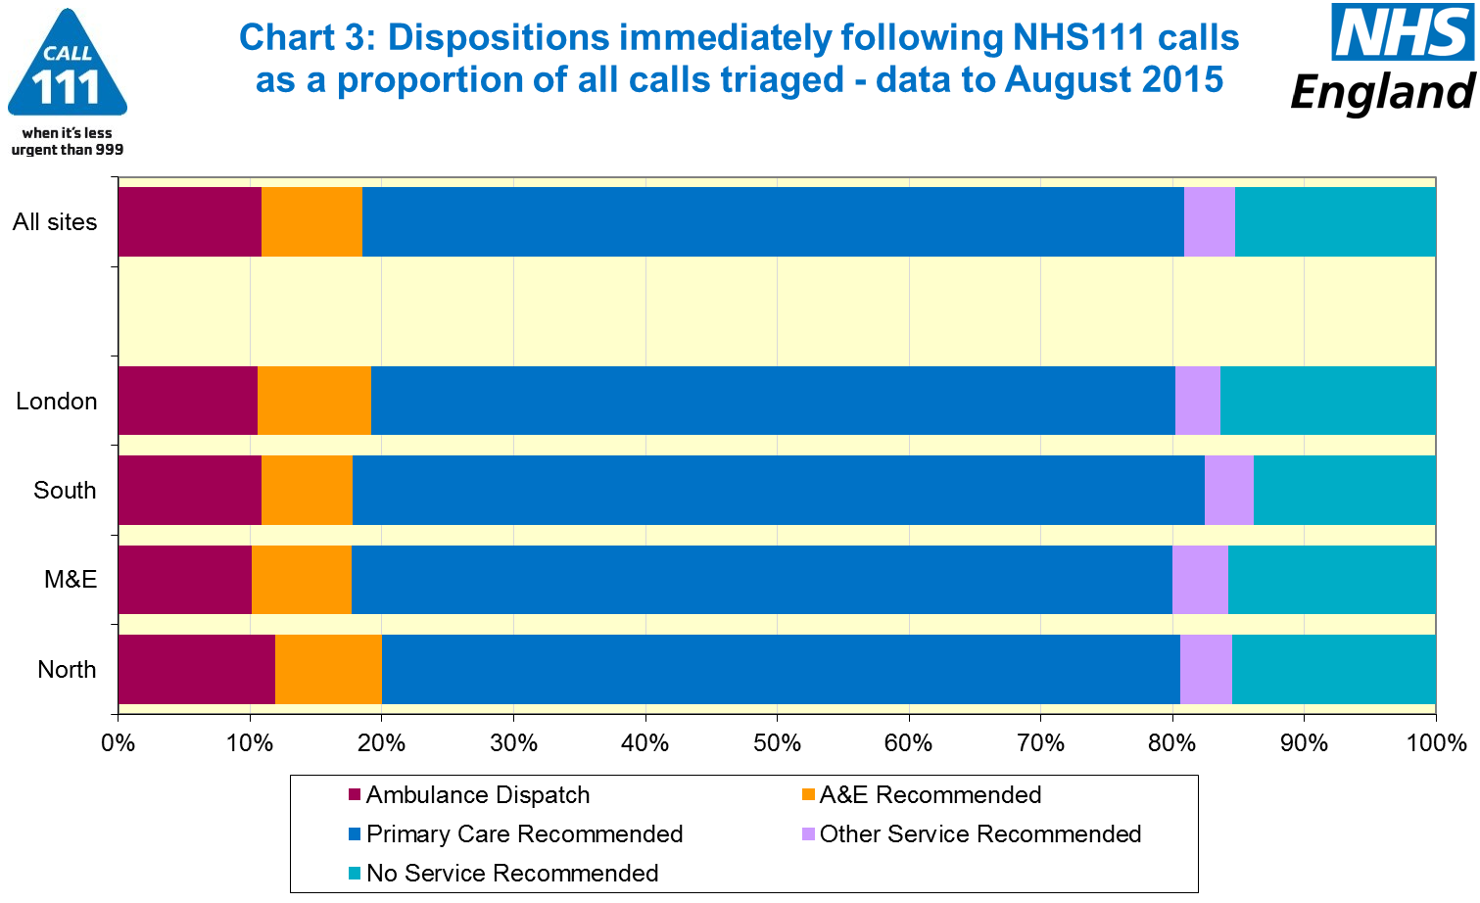





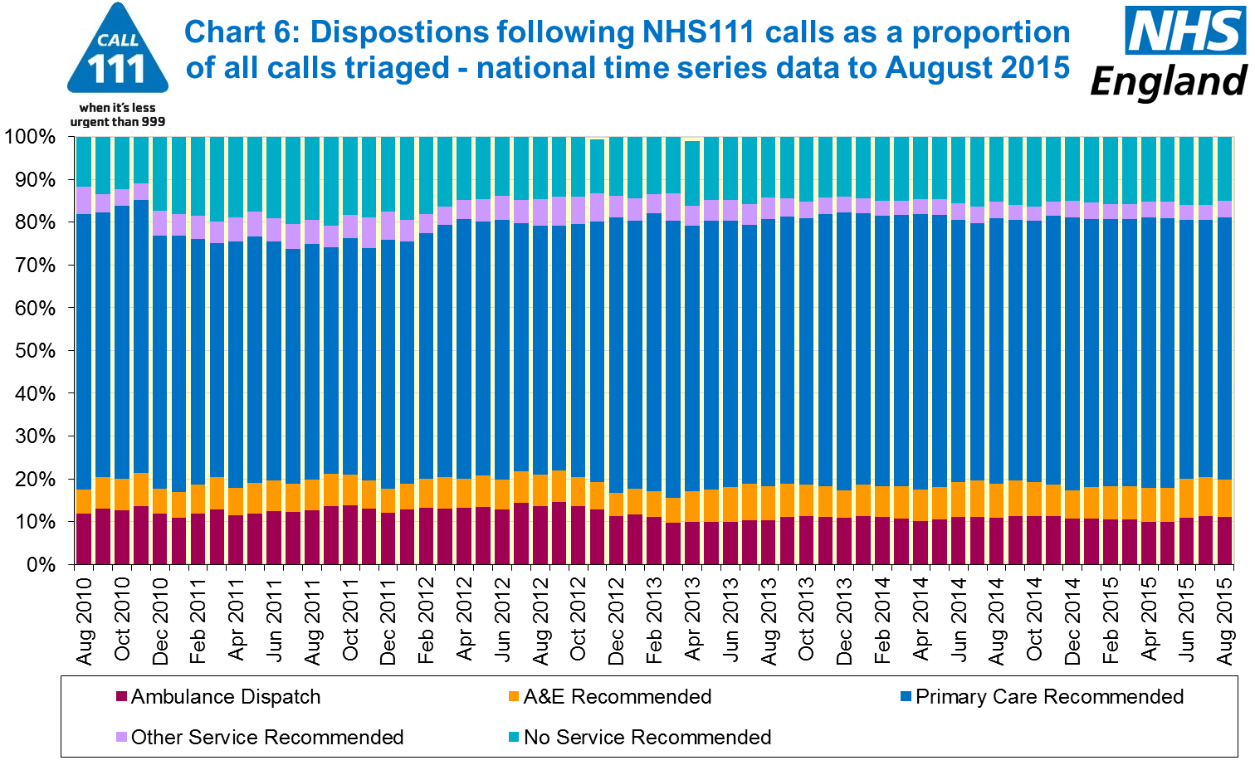

#### 

#### Additional Information:

All monthly data in the 111 minimum dataset (MDS) are available in spreadsheets at [www.england.nhs.uk/statistics/statistical-work-areas/nhs-111-minimum-data-set](http://www.england.nhs.uk/statistics/statistical-work-areas/nhs-111-minimum-data-set), along with all the previous accompanying statistical notes, the specification guidance document for those who produce the data, and the timetables for data collection and publication. Publication dates are also available from [www.gov.uk/government/statistics](http://www.gov.uk/government/statistics).

Material changes to the data or presentation of the NHS 111 Minimum Data Set (MDS) are listed in the 10 September 2015 Statistical Note and in earlier versions. Any further material changes will be described here in future Statistical Notes.

#### Contacts

For press enquiries, please contact the NHS England press office on 0113 825 0958 or [nhsengland.media@nhs.net](mailto:nhsengland.media@nhs.net).

The Government Statistical Service (GSS) statistician responsible for these data is:

Ian Kay, Operational Information for Commissioning (National),

NHS England, Room 5E24, Quarry House, Leeds, LS2 7UE.

0113 825 4606

[i.kay@nhs.net](mailto:i.kay@nhs.net)

Published on Thursday 8 October 2015.