

# NHS 111 Minimum Data Set, England, December 2015

#### Summary

There were 1,362,161 calls offered to the NHS 111 service in England in December 2015, a 2.6% decrease on the 1,398,166 in the December 2014. This was an average of 43,941 per day, the highest daily average in 2015.

Of calls offered to NHS 111 in December 2015, the proportion abandoned after waiting longer than 30 seconds was 4.4%, higher that the average for 2015 but less than the 6.1% in December 2014.

Of calls answered by NHS 111, 86.1% were answered within 60 seconds, the lowest in 2015, however higher than the 79.4% in December 2014.

Of calls answered, 12.4% were offered a call back in December 2015 higher than the 11.4% in December 2014, also slightly higher than the average of 12.1% for 2015.

Of call backs offered, 42% were within 10 minutes in December 2015, lower than 45% in December 2014.

Of calls answered, 21.5% were transferred to a clinical advisor in December 2015 was slightly lower than the average 22.3% for 2015 so far.

The average episode length of a call was 15 minutes 44 seconds in December 2015, slightly shorter than 15 minutes 57 seconds in December 2014.

Of calls answered, 87% were triaged in December 2015. This proportion has ranged between 85% and 87% for the last fifteen months. Calls triaged are those where the NHS 111 call handler opens and uses the clinical assessment tool (NHS Pathways).

Calls not triaged include, for example, follow-ups of previous calls, calls where the caller is unable or unwilling to give specific details about the patient’s condition or enquiries about contact details for pharmacists or other local care services.

Of calls triaged in December 2015, 12% had ambulances dispatched, 8% were recommended to A&E, 63% were recommended to primary care, 4% were recommended to another service, and 14% were not recommended to any service.

Of calls offered to NHS 111 in November 2015, the proportion where 111 was dialled directly was 98.5%, similar to the average of 98.2% for 2015.

December 2015 recorded the highest number of calls abandoned before waiting 30 seconds, with 82,157 calls abandoned. This also gives the highest daily average with 2,650 calls abandoned.

Of calls not triaged, the number of calls where the caller terminated the call was the highest recorded at 52,424 in December 2015, however the daily average was higher in November 2015 at 1,701.

The highest number of calls transferred to a clinical adviser was recorded in December 2015 at 262,330, this also gave the highest daily average number of 8,173.

The number of callers offered a call back was also the highest recorded in December 2015 at 150,802 giving the highest daily average of 4,865.

The total call handling time for calls received to NHS 111 in December 2015 was the highest recorded at 5,716,139 minutes or 95,268 hours of calls taken in December 2015. It should be noted that call handling time is only supplied by 21 of the 44 data sites.





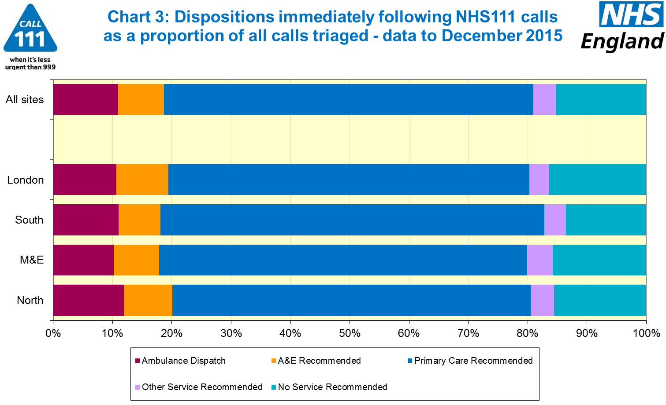





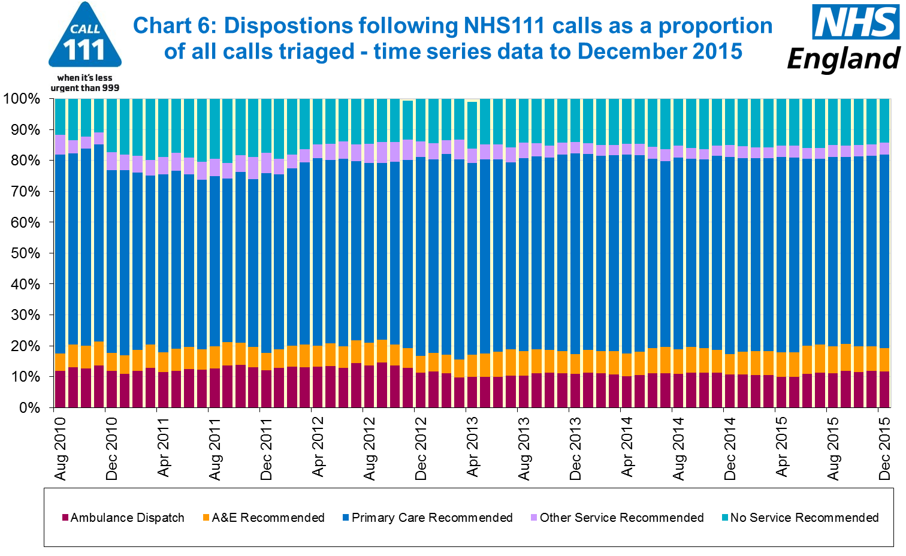

#### Additional Information:

All monthly data in the 111 Minimum Data Set (MDS) are available in spreadsheets at [www.england.nhs.uk/statistics/statistical-work-areas/nhs-111-minimum-data-set](http://www.england.nhs.uk/statistics/statistical-work-areas/nhs-111-minimum-data-set), along with all the previous accompanying statistical notes, the specification guidance document for those who produce the data, and the timetables for data collection and publication. Publication dates are also available from [www.gov.uk/government/statistics](http://www.gov.uk/government/statistics).

Material changes to the data or presentation of the NHS 111 MDS are listed in the 14 January 2016 Statistical Note and in earlier versions. Any further material changes will be described here in future Statistical Notes.

#### Contacts

For press enquiries, please contact the NHS England press office on 0113 825 0958 or [nhsengland.media@nhs.net](mailto:nhsengland.media@nhs.net).

The Government Statistical Service (GSS) statistician responsible for these data is:

Ian Kay, Operational Information for Commissioning (National),

NHS England, Room 5E24, Quarry House, Leeds, LS2 7UE.

0113 825 4606

[i.kay@nhs.net](mailto:i.kay@nhs.net)

Published on Thursday 11 February 2016.