

# NHS 111 Minimum Data Set, England, February 2016

#### Summary

There were 1,218,365 calls offered to the NHS 111 service in England in February 2016, a 18.6% increase on the 1,027,000 in February 2015. As 2016 was a leap year, February 2016 contains more days than February 2015. Comparing the average daily calls offered the increase was 14.5%.

Of calls offered to NHS 111 in February 2016, the proportion abandoned after waiting longer than 30 seconds was 5.03%, higher than in previous months and above the national quality requirement that no more than 5% of calls should be abandoned after waiting 30 seconds.

Of calls answered by NHS 111, 79.7% were answered within 60 seconds, considerably lower than the 93.2% recorded in February 2015.

Of calls answered, 13.9% were offered a call back in February 2016. This is the highest proportion of callers being offered a call back since this reporting began in August 2010. This also gave the highest daily average of 5,244.

Of call backs offered, 34.7% were within 10 minutes in February 2016, a large drop on the 45.7% in the previous February and the lowest proportion since the service achieved full national coverage in February 2014.

Of calls answered, 21.6% were transferred to a clinical advisor in February 2016 similar to the 21.7% in January 2016.

The average episode length of a call was 17 minutes 42 seconds in February 2016. An increase on the 16 minutes 20 seconds reported in January 2016.

Of calls answered, 87% were triaged in February 2016. This proportion has ranged between 85% and 87% for the last seventeen months. Calls triaged are those where the NHS 111 call handler opens and uses the clinical assessment tool (NHS Pathways).

Calls not triaged include, for example, follow-ups of previous calls, calls where the caller is unable or unwilling to give specific details about the patient’s condition or enquiries about contact details for pharmacists or other local care services.

Of calls triaged in February 2016, 12% had ambulances dispatched, 8% were recommended to A&E, 62% were recommended to primary care, 4% were recommended to another service, and 14% were not recommended to any service.

The number of calls resolved by the 111 service giving health advice was the highest ever recorded in February 2016. This was for both calls that were triaged and subsequently given health advice (13,634) and calls that were resolved without triage and given health advice (6,248).

Of calls transferred, the proportion live transferred was 35.4% in February 2016. This is considerably down on January 2016 and the lowest proportion reported since the service started in August 2010.

Of calls which were not recommended to any service, the proportion recommended home care was 5.5% in February, the lowest proportion since the service started in August 2010.





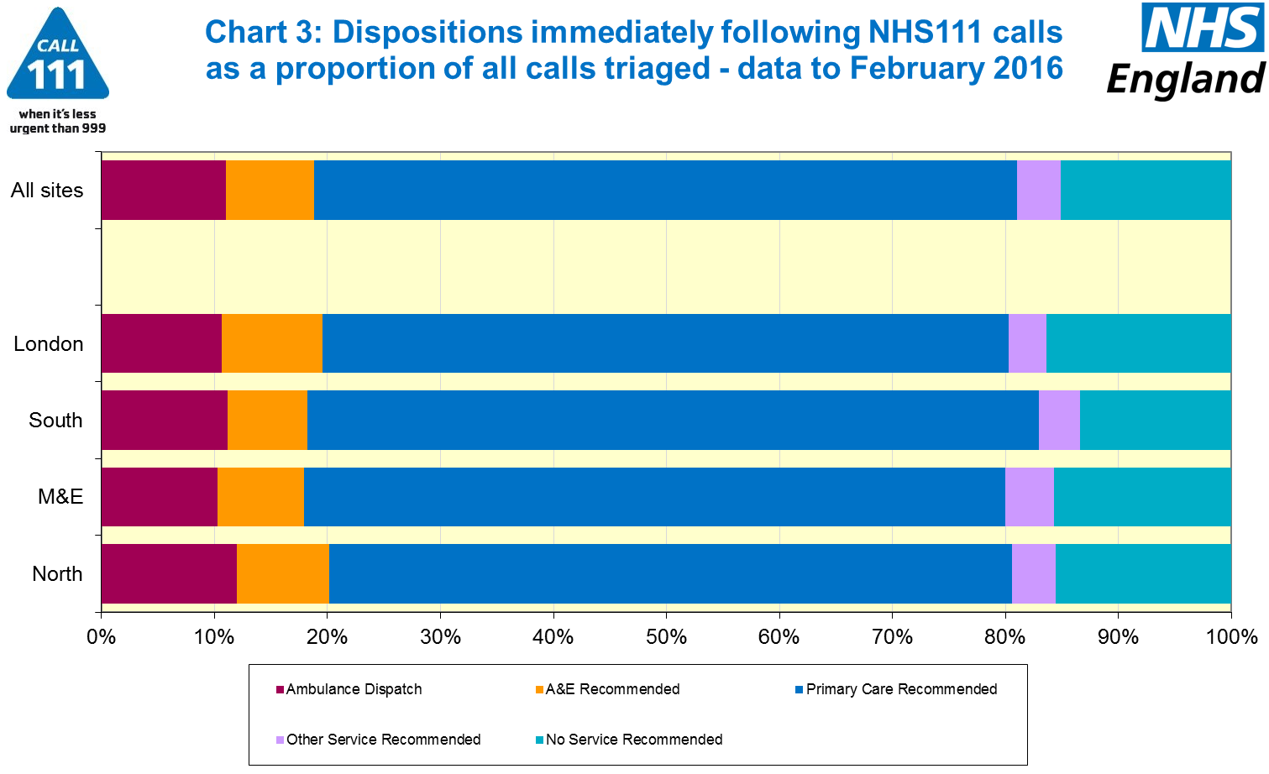





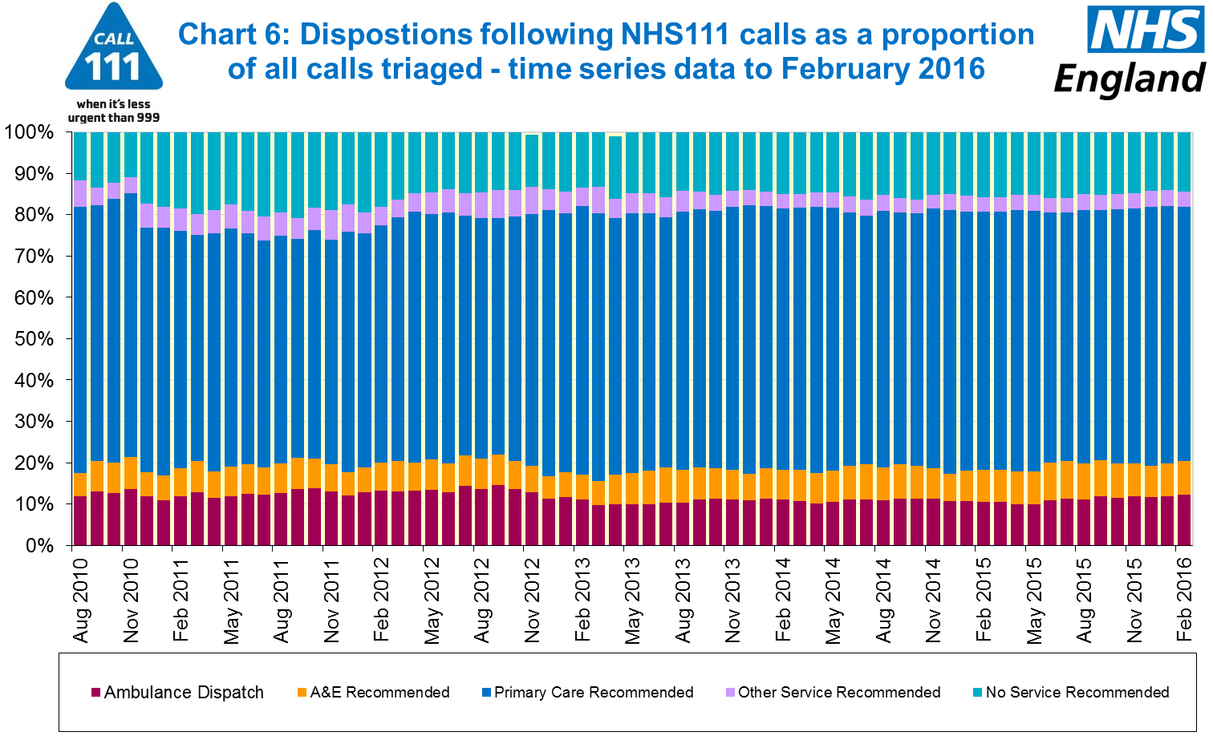

#### Additional Information:

All monthly data in the 111 Minimum Data Set (MDS) are available in spreadsheets at [www.england.nhs.uk/statistics/statistical-work-areas/nhs-111-minimum-data-set](http://www.england.nhs.uk/statistics/statistical-work-areas/nhs-111-minimum-data-set), along with all the previous accompanying statistical notes, the specification guidance document for those who produce the data, and the timetables for data collection and publication. Publication dates are also available from [www.gov.uk/government/statistics](http://www.gov.uk/government/statistics).

Material changes to the data or presentation of the NHS 111 MDS are listed in the 10 March 2016 Statistical Note and in earlier versions. Any further material changes will be described here in future Statistical Notes.

#### Contacts

For press enquiries, please contact the NHS England press office on 0113 825 0958 or [nhsengland.media@nhs.net](mailto:nhsengland.media@nhs.net).

The Government Statistical Service (GSS) statistician responsible for these data is:

James Thomas

NHS England, Operational Information for Commissioning (National)

Room 5E24, Quarry House, Leeds LS2 7UE

james.thomas5@nhs.net

0113 8250717

Published on Thursday 14 April 2016.