

# NHS 111 Minimum Data Set, England, January 2016

#### Summary

There were 1,366,094 calls offered to the NHS 111 service in England in January 2016, a 17.1% increase on the 1,166,768 in January 2015 and a slight increase on the December 2015 calls offered.

Of calls offered to NHS 111 in January 2016, the proportion abandoned after waiting longer than 30 seconds was 4.5%, similar to the proportion in the previous month.

Of calls answered by NHS 111, 82.2% were answered within 60 seconds, considerably lower than the 92.3% recorded in January 2015.

Of calls answered, 13.2% were offered a call back in January 2016. This is the highest proportion of callers being offered a call back since this reporting began in August 2010. The number of callers offered a call back was the highest recorded in January 2016 at 161,544 giving the highest daily average of 5,211.

Of call backs offered, 38.9% were within 10 minutes in January 2016, a large drop on the 47.6% in the previous January.

Of calls answered, 21.7% were transferred to a clinical advisor in January 2016 was slightly lower than the average 22.3% for 2015.

The average episode length of a call was 16 minutes 20 seconds in January 2016.

Of calls answered, 87% were triaged in January 2016. This proportion has ranged between 85% and 87% for the last sixteen months. Calls triaged are those where the NHS 111 call handler opens and uses the clinical assessment tool (NHS Pathways).

Calls not triaged include, for example, follow-ups of previous calls, calls where the caller is unable or unwilling to give specific details about the patient’s condition or enquiries about contact details for pharmacists or other local care services.

Of calls triaged in January 2016, 12% had ambulances dispatched, 8% were recommended to A&E, 62% were recommended to primary care, 4% were recommended to another service, and 14% were not recommended to any service.

The total number of callers that were transferred for ambulance dispatch was the highest ever recorded in January 2016 at 127,601.In addition to this the total number of callers recommended to attend A&E was also the highest ever recorded at 84,382 and the number recommended to attend another service was also the highest ever recorded at 41,770.

Of calls offered to NHS 111 in January 2016, the proportion where 111 was dialled directly was 98.3%, the highest proportion recorded since the service started.

Of calls not triaged, the number of calls where the caller terminated the call was the highest recorded at 54,754 in January 2016; this also gave the highest daily average of caller terminated calls at 1,766.

The highest number of calls transferred to a clinical adviser was recorded in January 2016 at 266,164; this also gave the highest daily average number of 8,586.

The total call handling time for calls received to NHS 111 in January 2016 was the highest recorded at 5,723,044 minutes or 95,384 hours of calls taken. It should be noted that call handling time is only supplied by 21 of the 44 data sites.

Of calls transferred, the proportion live transferred was 39.3% in January 2016. This is the lowest proportion reported since the service started in August 2010.

3 separate charts; first chart shows a time series with total calls offered, those answered in 60 seconds and those abandoned after waiting more than 60 seconds. Second chart shows proportion of calls answered in 60 seconds over the whole time period, shown at both a national and regional level. Third chart shows the proportion of calls abandoned after waiting more than 30 seconds, again reported for whole time period and presented at both national and regional level.

4 separate charts showing the following indicator performance over the total available time period, presented at both national and regional level.
1. Of calls answered, proportion triaged.
2. Of calls answered, proportion leading to call backs from the 111 service.
3. Of calls answered, proportion transferred to clinical advisor.
4. Average episode length in minutes and seconds.


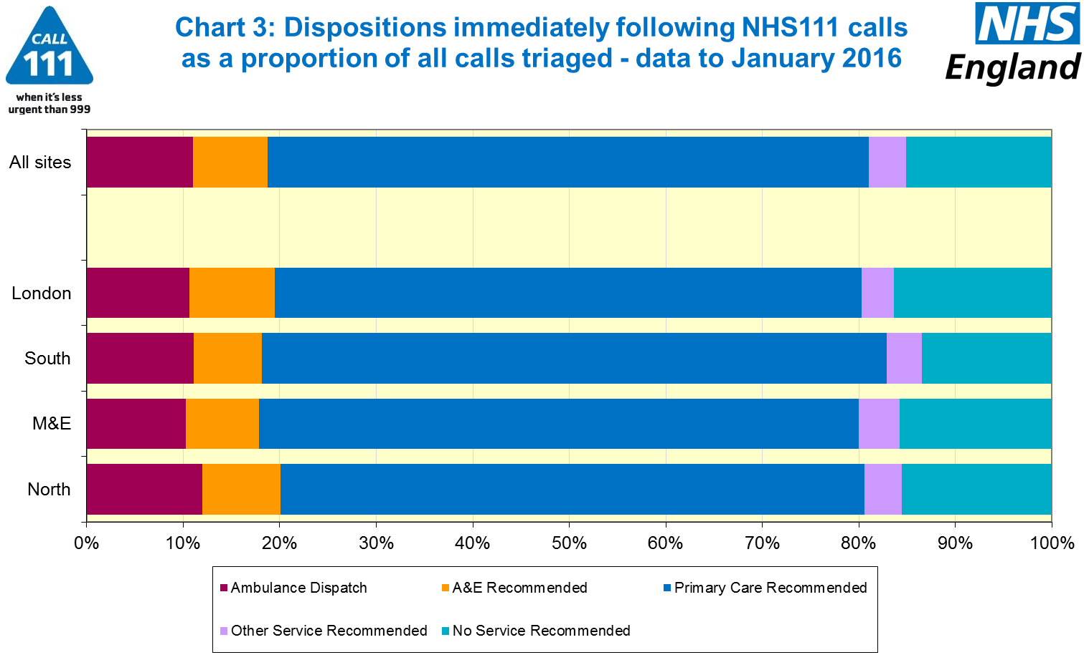

4 separate charts showing the following indicator performance presented as a national monthly time series
1. Calls per month per 1,000 people.
2. Of calls offered, proportion abandoned after at least 30 seconds.
3.Calls via 111 per month per1,000 people
4. Of calls answered, percentage in 60 seconds




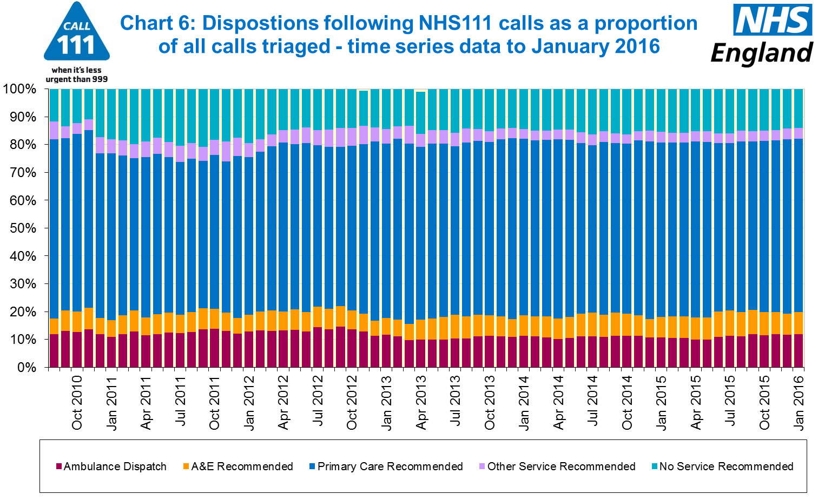

#### Additional Information:

All monthly data in the 111 Minimum Data Set (MDS) are available in spreadsheets at [www.england.nhs.uk/statistics/statistical-work-areas/nhs-111-minimum-data-set](http://www.england.nhs.uk/statistics/statistical-work-areas/nhs-111-minimum-data-set), along with all the previous accompanying statistical notes, the specification guidance document for those who produce the data, and the timetables for data collection and publication. Publication dates are also available from [www.gov.uk/government/statistics](http://www.gov.uk/government/statistics).

Material changes to the data or presentation of the NHS 111 MDS are listed in the 11 February 2016 Statistical Note and in earlier versions. Any further material changes will be described here in future Statistical Notes.

#### Contacts

For press enquiries, please contact the NHS England press office on 0113 825 0958 or [nhsengland.media@nhs.net](mailto:nhsengland.media@nhs.net).

The individual responsible for these data is:

James Thomas

NHS England, Operational Information for Commissioning (National)

Room 5E24, Quarry House, Leeds LS2 7UE

james.thomas5@nhs.net

0113 8250717

Published on Thursday 10 March 2016.