# NHS 111 Minimum Data Set (MDS) – England, July 2015

#### Summary

There were 1,016,249 calls offered to the NHS 111 service in England in July 2015. This was an average of 32,782 per day, the lowest average since October 2014.

Of calls offered to NHS 111 in July 2015, the proportion abandoned after waiting longer than 30 seconds was 1.3%, which was as the same as in June 2015.

Of calls answered by NHS 111 in July 2015, 94.1% were answered within 60 seconds, also the same as in June 2015 (revised from 94.4%).

Of calls answered, 12% were offered a call back in July 2015, the same as in the previous two months.

Of those offered a call back, 42% were called back within 10 minutes in July 2015, more than 41% in June 2015, but less than in every month of 2014.

Of calls answered, 23% were transferred to a clinical advisor in July 2015, as the same as in June 2015.

The mean average episode length of a call in July 2015 was 15 minutes 18 seconds, similar to 15 minutes 12 seconds in June 2015.

Of calls answered, 86% received triage in July 2015. This proportion has been 85%, 86% or 87% in each of the latest fourteen months. Calls triaged are those where the NHS 111 call handler opens and uses the clinical assessment tool (NHS Pathways).Calls not triaged include, for example, follow-ups of previous calls, or calls where the caller is unable or unwilling to give specific details about the patient’s condition, such as enquiries about contact details for pharmacists or other local care services.

Of calls triaged in July 2015, 11% had ambulances dispatched, 9% were recommended to A&E, 60% were recommended to primary care, 4% were recommended to another service, and 16% were not recommended to any service. In June 2015, these proportions were all the same, except for 61% for calls recommended to primary care.

Of calls offered to NHS 111 in July 2015, the proportion where 111 was dialled directly was 97%, the same as in every other month in 2015.

Some revisions have been included in this month’s publication:

Outer North East London: Item 5.10, calls answered in 60 seconds, corrected for June 2015.

Inner North West London: Items 5.18 and 5.21, average transfer time and average episode length, previously missing in August 2014, now included.

Norfolk: items 5.8 and 5.9, calls answered through 111 and through other numbers, corrected for November 2014.





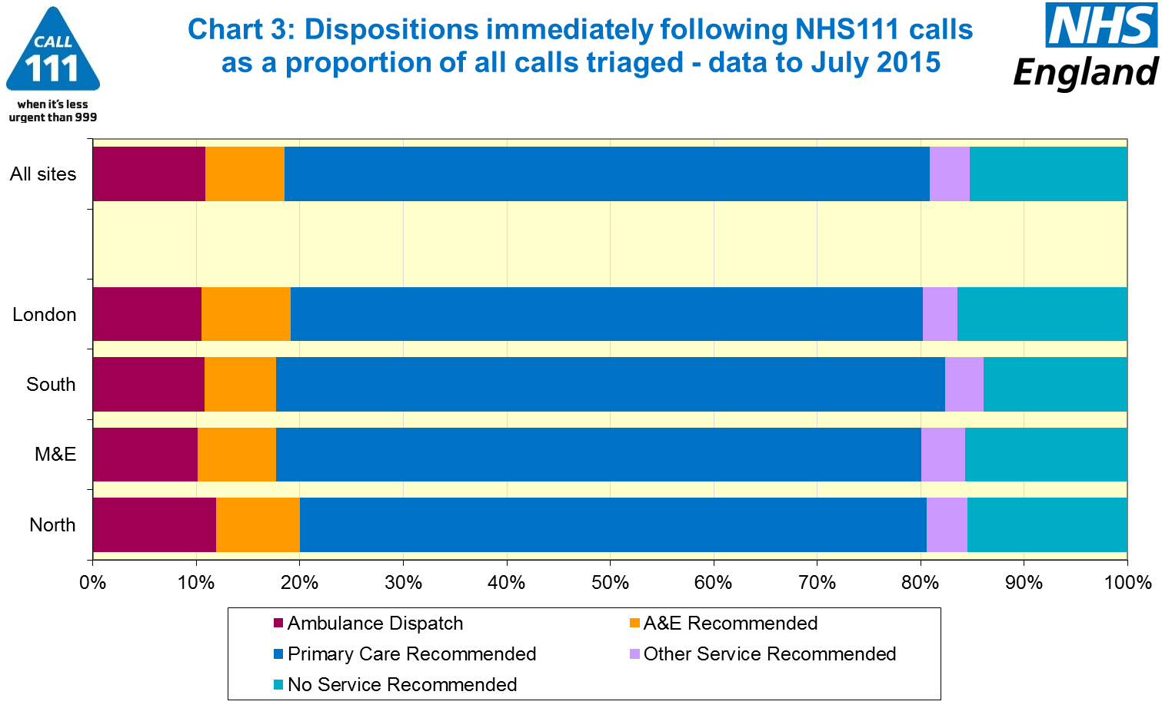





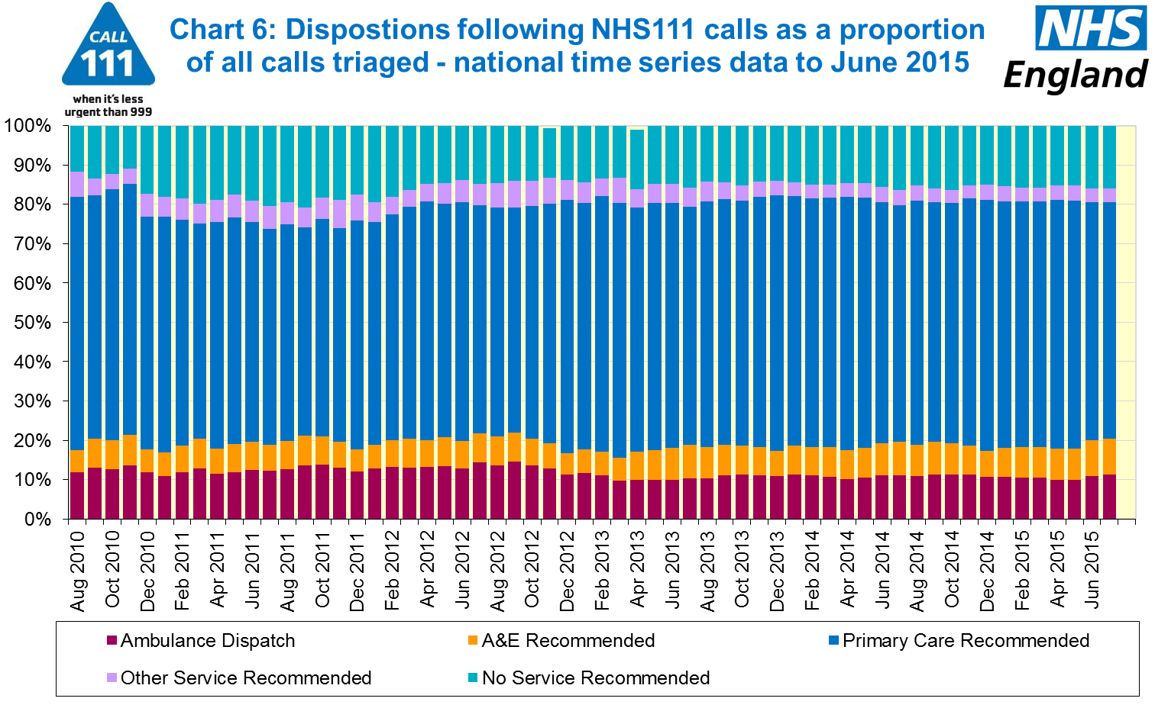

#### 

#### Additional Information:

All monthly data in the 111 minimum dataset (MDS) are available in spreadsheets at [www.england.nhs.uk/statistics/statistical-work-areas/nhs-111-minimum-data-set](http://www.england.nhs.uk/statistics/statistical-work-areas/nhs-111-minimum-data-set), along with all the previous accompanying statistical notes, the specification guidance document for those who produce the data, and the timetables for data collection and publication. Publication dates are also available from [www.gov.uk/government/statistics](http://www.gov.uk/government/statistics).

Material changes to the data or presentation of the NHS 111 Minimum Data Set (MDS) are listed in the 3 July 2015 Statistical Note and in earlier versions. Any further material changes will be described here in future Statistical Notes.

#### Contacts

For press enquiries, please contact the NHS England press office on 0113 825 0958 or [nhsengland.media@nhs.net](mailto:nhsengland.media@nhs.net).

The Government Statistical Service (GSS) statistician responsible for these data is:

Ian Kay, Operational Information for Commissioning (National),

NHS England, Room 5E24, Quarry House, Leeds, LS2 7UE.

0113 825 4606

[i.kay@nhs.net](mailto:i.kay@nhs.net)

Published on Thursday 10 September 2015.