# NHS 111 Minimum Data Set (MDS) – England, June 2015

#### Summary

There were 987,107 calls offered to the NHS 111 service in England in June 2015. This was an average of 32,904 per day; the lowest average since October 2014, although it was very similar to 32,793 per day in June 2014.

Of calls offered to NHS 111 in June 2015, the proportion abandoned after waiting longer than 30 seconds was 1.3%, also the lowest since October 2014.

Of calls answered by NHS 111 in June 2015, 94.4% were answered within 60 seconds, the highest proportion since October 2014.

Of calls answered, 12% were offered a call back in June 2015. Before February 2015, this proportion was always less than 12%.

Of those offered a call back, 41% were called back within 10 minutes, the lowest proportion since September 2013.

Of calls answered, 23% were transferred to a clinical advisor, the highest proportion since September 2013.

The mean average episode length of a call in June 2015 was 15 minutes 12 seconds, similar to 15 minutes 8 seconds in May 2015.

Of calls answered, 87% received triage in June 2015. This proportion was also 85%, 86% or 87% in the previous twelve months. Calls triaged are those where the NHS 111 call handler opens and uses the clinical assessment tool (NHS Pathways).

Calls not triaged include, for example, follow-ups of previous calls, or calls where the caller is unable or unwilling to give specific details about the patient’s condition, such as enquiries about contact details for pharmacists or other local care services.

Of calls triaged in June 2015, 11% had ambulances dispatched, 9% were recommended to A&E, 61% were recommended to primary care, 4% were recommended to another service, and 16% were not recommended to any service. These proportions were all the same as, or one percentage point different to, the respective averages for the previous twelve months.

Of calls offered to NHS 111, the proportion where 111 was dialled directly was 97% in every month from January to June 2015.







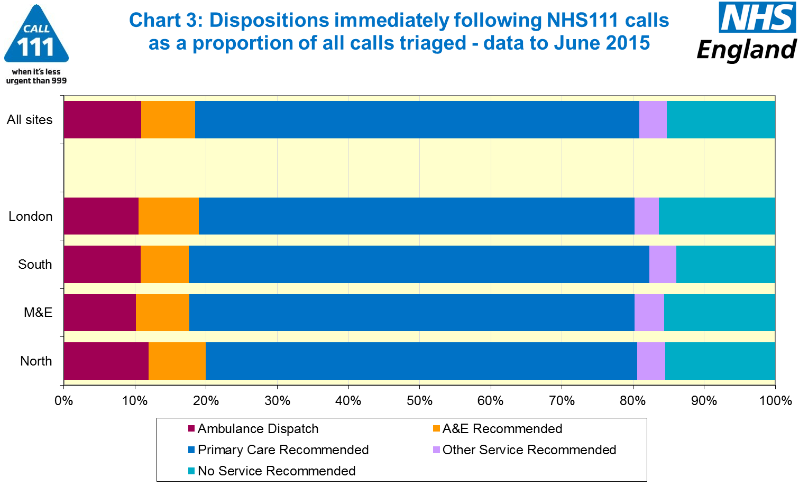





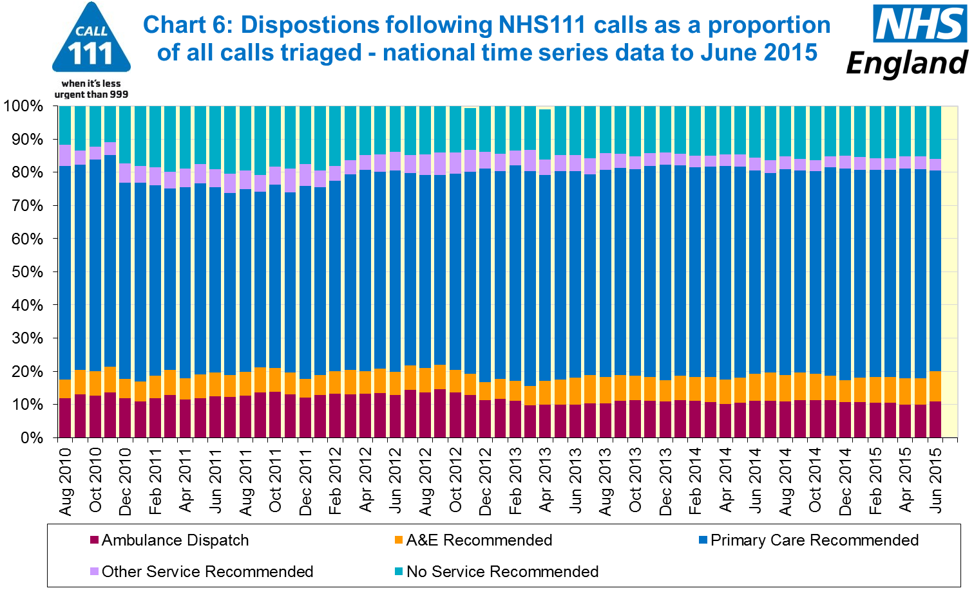

#### Additional Information:

All monthly data in the 111 minimum dataset (MDS) are available in spreadsheets at [www.england.nhs.uk/statistics/statistical-work-areas/nhs-111-minimum-data-set](http://www.england.nhs.uk/statistics/statistical-work-areas/nhs-111-minimum-data-set), along with all the previous accompanying statistical notes, the specification guidance document for those who produce the data, and the timetables for data collection and publication. Publication dates are also available from [www.gov.uk/government/statistics](http://www.gov.uk/government/statistics).

Material changes to the data or presentation of the NHS 111 Minimum Data Set (MDS) are listed in the 13 August 2015 Statistical Note and in earlier versions. Any further material changes will be described here in future Statistical Notes.

#### Contacts

For press enquiries, please contact the NHS England press office on 0113 825 0958 or [nhsengland.media@nhs.net](mailto:nhsengland.media@nhs.net).

The Government Statistical Service (GSS) statistician responsible for these data is:

Ian Kay, Operational Information for Commissioning (National),

NHS England, Room 5E24, Quarry House, Leeds, LS2 7UE.

0113 825 4606

[i.kay@nhs.net](mailto:i.kay@nhs.net)

Published on Thursday 13 August 2015.