

# NHS 111 Minimum Data Set, England, March 2016

#### Summary

There were 1,515,031 calls offered to the NHS 111 service in England in March 2016, a 33.1% increase on the 1,137,856 in March 2015. This is the highest monthly figure since the service began in August 2010. The number of calls answered by the service was 1,298,102 in March 2016; again this is the highest value ever recorded and a 20% increase on March 2015 where 1,081,571 calls were answered.

Of calls offered to NHS 111 in March 2016, the proportion abandoned after waiting longer than 30 seconds was 8.4%, the highest since recording began and above the national quality requirement that no more than 5% of calls should be abandoned after waiting 30 seconds. The total number of calls abandoned after waiting 30 seconds in March 2016 was the highest recorded. Also the total number of callers abandoning the call before waiting 30 seconds was the highest recorded at 89,599.

Of calls answered by NHS 111, 70.7% were answered within 60 seconds, considerably lower than the 92.1% recorded in March 2015 and the lowest recorded performance.

Of calls answered, 13.9% were offered a call back in March 2016. The total number of callers offered a call back was the highest monthly figure recorded at 180,855

Of call backs offered, 35.6% were within 10 minutes in March 2016, a large drop on the 42.3% in the previous March. However the 64,454 callers receiving a call back within 10 minutes was the highest number recorded in any month since the service began.

Of calls answered, 21.0% were transferred to a clinical advisor in March 2016 slightly down on the 21.6% in February 2016. The number of calls transferred to a clinical advisor was 272,753 the highest number since recording began in August 2010

The average length of calls was 17 minutes 41 seconds in March 2016 an increase on the 15 minutes 37 seconds reported in March 2015.

Of calls answered, 87% were triaged in March 2016. This proportion has ranged between 85% and 87% for the last eighteen months. Calls triaged are those where the NHS 111 call handler opens and uses the clinical assessment tool (NHS Pathways).

Calls not triaged include, for example, follow-ups of previous calls, calls where the caller is unable or unwilling to give specific details about the patient’s condition or enquiries about contact details for pharmacists or other local care services.

Of calls triaged in March 2016, 11% had ambulances dispatched, 8% were recommended to A&E, 63% were recommended to primary care, 4% were recommended to another service, and 14% were not recommended to any service.

The number of calls resolved by the 111 service giving health advice was the highest ever recorded in March 2016. This was for both calls that were triaged and subsequently given health advice (16,027) and calls that were resolved without triage and given health advice (8,459).

Of calls transferred, the proportion live transferred was 32.9% in March 2016. This has dropped in each of the last 5 months and is the lowest proportion reported since the service started in August 2010.

The number of calls where the caller terminated the call was the highest ever recorded in March 2016 at 55,361; this also gave a highest daily average of 1,786.

Of calls which were not recommended to any service, the proportion recommended home care was 5.4% in March, the lowest proportion since the service started in August 2010.





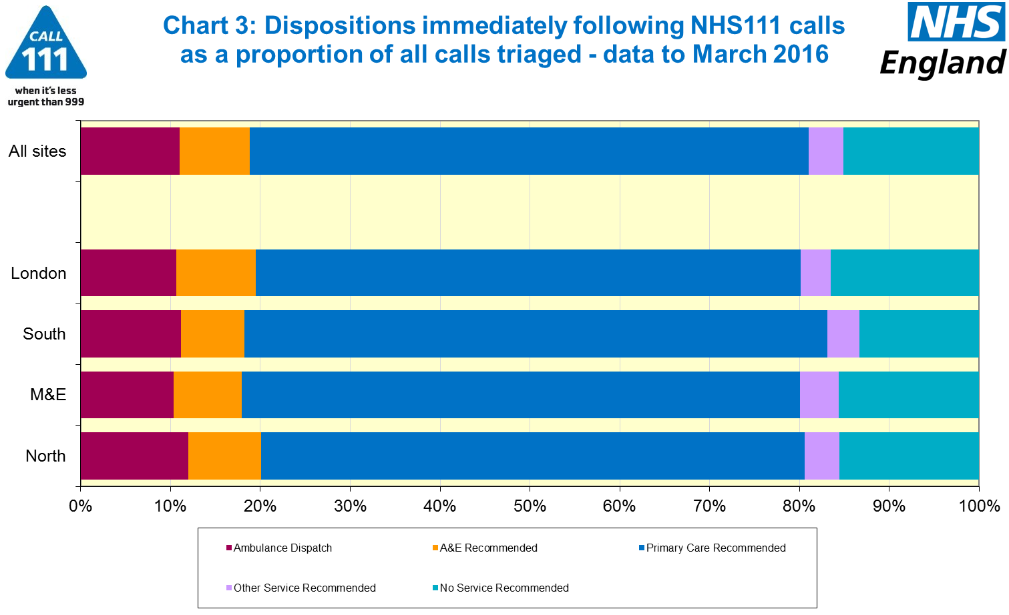





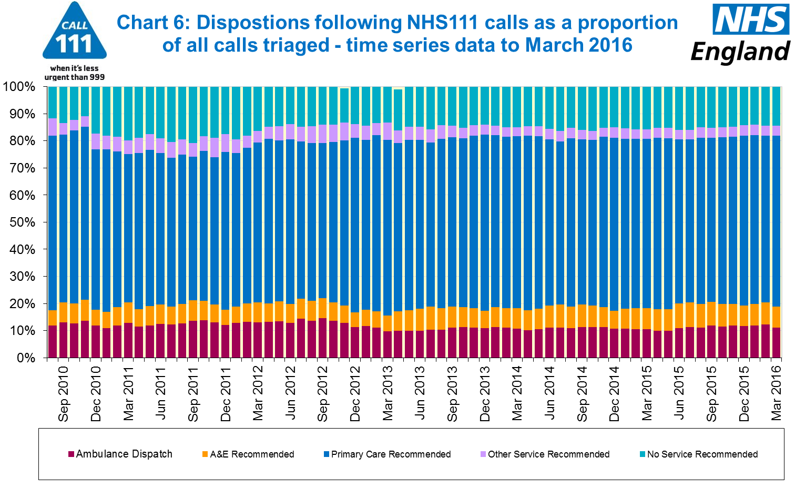

#### Additional Information:

All monthly data in the 111 Minimum Data Set (MDS) are available in spreadsheets at [www.england.nhs.uk/statistics/statistical-work-areas/nhs-111-minimum-data-set](http://www.england.nhs.uk/statistics/statistical-work-areas/nhs-111-minimum-data-set), along with all the previous accompanying statistical notes, the specification guidance document for those who produce the data, and the timetables for data collection and publication. Publication dates are also available from [www.gov.uk/government/statistics](http://www.gov.uk/government/statistics).

Material changes to the data or presentation of the NHS 111 MDS are listed in the 14 April 2016 Statistical Note and in earlier versions. Any further material changes will be described here in future Statistical Notes.

#### Contacts

For press enquiries, please contact the NHS England press office on 0113 825 0958 or [nhsengland.media@nhs.net](mailto:nhsengland.media@nhs.net).

The Government Statistical Service (GSS) statistician responsible for these data is:

James Thomas

NHS England, Operational Information for Commissioning (National)

Room 5E24, Quarry House, Leeds LS2 7UE

james.thomas5@nhs.net

0113 8250717

Published on Thursday 12 May 2016.