

# NHS 111 Minimum Data Set, England, November 2015

#### Summary

There were 1,160,300 calls offered to the NHS 111 service in England in November 2015. This was an average of 38,677 per day, the highest daily average in 2015. This is an increase of around 7% on the 36,141 per day in November 2014 last year.

Of calls offered to NHS 111 in November 2015, the proportion abandoned after waiting longer than 30 seconds was 1.8%, higher that the average for 2015 but less than the 2.2% in November 2014.

Of calls answered by NHS 111, 89.6% were answered within 60 seconds, the lowest in 2015 so far, which is lower than the 90.6% in November 2014.

Of calls answered, 13% were offered a call back in November 2015, higher than the 10% in November 2014, also slightly higher than the average for 2015.

Of call backs, 40% were within 10 minutes in November 2015, the lowest figure since September 2013.

Of calls answered, 22% were transferred to a clinical advisor in November 2015, similar to the average for 2015 so far.

The average episode length of a call was 16 minutes 40 seconds in November 2015, the longest monthly average reported since March 2013.

Of calls answered, 87% were triaged in November 2015. This proportion has ranged between 85% and 87% for the last sixteen months. Calls triaged are those where the NHS 111 call handler opens and uses the clinical assessment tool (NHS Pathways).

Calls not triaged include, for example, follow-ups of previous calls, calls where the caller is unable or unwilling to give specific details about the patient’s condition or enquiries about contact details for pharmacists or other local care services.

Of calls triaged in November 2015, 12% had ambulances dispatched, 8% were recommended to A&E, 62% were recommended to primary care, 4% were recommended to another service, and 15% were not recommended to any service. These November proportions are the similar to the average figures for 2015.

Of calls offered to NHS 111 in November 2015, the proportion where 111 was dialled directly was 98.3%, the highest figure since the service began.

#### Survey data for April 2015 to September 2015

NHS 111 providers are expected to supply their patient survey data to NHS England every six months for each area they provide services for. The sample size for each of the areas is expected to be a minimum of 200. Data was submitted for 44[1] of the 45 NHS 111 areas for the period April 2015 to September 2015. The number of respondents by NHS 111 area ranged from 48 to 1327. 16 areas had greater than 200 survey responses.

The total number of survey responses supplied for England1 was 12,185 for the period.

Of survey respondents between April and September 2015 inclusive that expressed a view, 90.4% were either very or fairly satisfied, slightly up on that reported in the two previous six-month periods.

If 111 had not been available, 19.2% of April 2015 to September 2015 respondents would have contacted the 999 ambulance service, increased from 17.4% on the previous six month survey. The proportion who would have contacted A&E also slightly increased to 28.0% from the 26.5% reported in the previous six months. The proportion of respondents that would have not used any service, decreased to 6.0% from 9.5%.

Considering the data supplied for the full year period (October 2014 to March 2015 and April to September 2015 surveys), 18.2% of patients reported they would have called for an ambulance and 27.2% would have attended A&E. However, for 10.8% of triaged calls an ambulance was dispatched by the NHS 111 service and in 8.0% of calls the caller was advised to attend A&E.

In the year period October 2014 to September 2015, 10.7 million calls were triaged. From this we can estimate the impact of the 111 service. The differences mean that due to availability of the NHS 111 service, about 2.1 million people that year were directed away from A&E, and about 800,000 were directed away from calling an ambulance.

3 separate charts; first chart shows a time series with total calls offered, those answered in 60 seconds and those abandoned after waiting more than 60 seconds. Second chart shows proportion of calls answered in 60 seconds over the whole time period, shown at both a national and regional level. Third chart shows the proportion of calls abandoned after waiting more than 30 seconds, again reported for whole time period and presented at both national and regional level.

4 separate charts showing the following indicator performance over the total available time period, presented at both national and regional level.
1. Of calls answered, proportion triaged.
2. Of calls answered, proportion leading to call backs from the 111 service.
3. Of calls answered, proportion transferred to clinical advisor.
4. Average episode length in minutes and seconds.


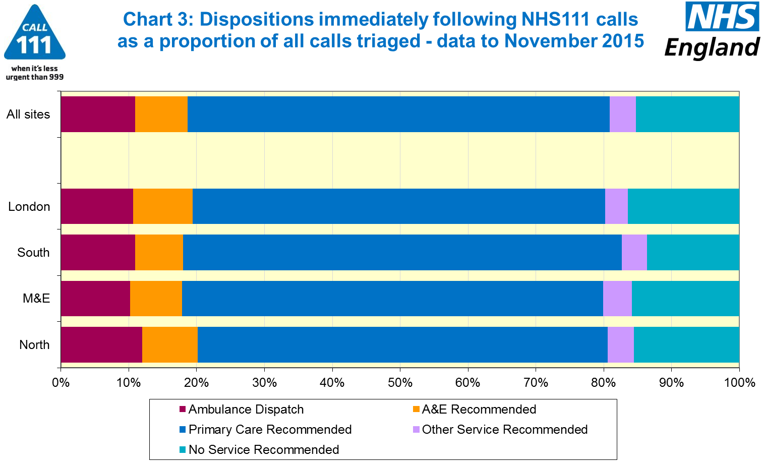

4 separate charts showing the following indicator performance presented as a national monthly time series
1. Calls per month per 1,000 people.
2. Of calls offered, proportion abandoned after at least 30 seconds.
3.Calls via 111 per month per1,000 people
4. Of calls answered, percentage in 60 seconds


4 separate charts showing the following indicator performance presented as a national monthly time series
1. Of calls answered, proportion triaged.
2. Of calls answered, proportion leading to a call back.
3. Of calls answered, proportion transferred to a clinical advisor.
4. Average episode length, in minutes and seconds.


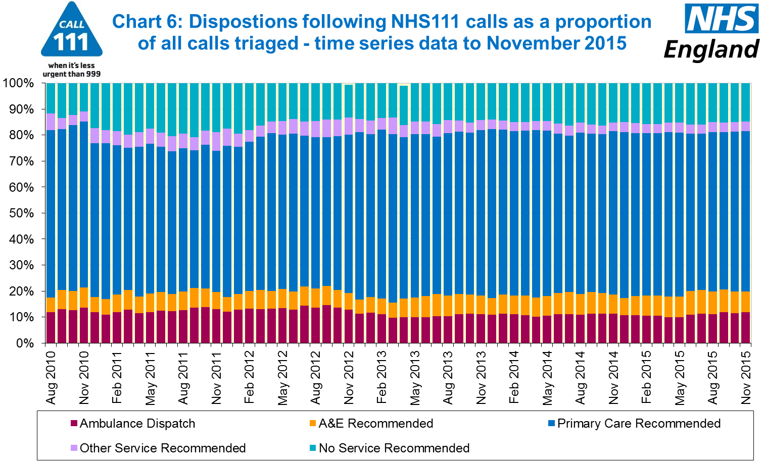

#### Additional Information:

All monthly data in the 111 Minimum Data Set (MDS) are available in spreadsheets at [www.england.nhs.uk/statistics/statistical-work-areas/nhs-111-minimum-data-set](http://www.england.nhs.uk/statistics/statistical-work-areas/nhs-111-minimum-data-set), along with all the previous accompanying statistical notes, the specification guidance document for those who produce the data, and the timetables for data collection and publication. Publication dates are also available from [www.gov.uk/government/statistics](http://www.gov.uk/government/statistics).

Material changes to the data or presentation of the NHS 111 MDS are listed in the 10 December 2015 Statistical Note and in earlier versions. Any further material changes will be described here in future Statistical Notes.

#### Contacts

For press enquiries, please contact the NHS England press office on 0113 825 0958 or [nhsengland.media@nhs.net](mailto:nhsengland.media@nhs.net).

The Government Statistical Service (GSS) statistician responsible for these data is:

Ian Kay, Operational Information for Commissioning (National),

NHS England, Room 5E24, Quarry House, Leeds, LS2 7UE.

0113 825 4606

[i.kay@nhs.net](mailto:i.kay@nhs.net)

Published on Thursday 14 January 2016.

1. Yorkshire Ambulance Service were unable to provide survey data for the period April 2015 to September 2015.