

# NHS 111 Minimum Data Set, England, October 2015

#### Summary

There were 1,083,628 calls offered to the NHS 111 service in England in October 2015. This was an average of 35.0 thousand per day, higher than the previous 4 months. It has gone up by around 7% compared with 32.7 thousand per day in October 2014 last year.

Of calls offered to NHS 111 in October 2015, the proportion abandoned after waiting longer than 30 seconds was 1.5%, the same as the average for 2015 so far.

Of calls answered by NHS 111, 91.4% were answered within 60 seconds, similar to the figure for September 2015, and the joint lowest in 2015 so far.

Of calls answered, 23% were transferred to a clinical advisor in October 2015, similar to the average for 2015 so far.

Of calls answered, 12% were offered a call back in October 2015, as the same as the average for 2015 so far.

Of call backs, 43% were within 10 minutes, the same as in September 2015.

The average episode length of a call was 16 minutes 24 seconds in October 2015, the longest monthly average reported since April 2013.

Of calls answered, 87% received triage in October 2015. This proportion has only ranged between 85% and 87% in the last twelve months. Calls triaged are those where the NHS 111 call handler opens and uses the clinical assessment tool (NHS Pathways).

Calls not triaged include, for example, follow-ups of previous calls, calls where the caller is unable or unwilling to give specific details about the patient’s condition, or enquiries about contact details for pharmacists or other local care services.

Of calls triaged in October 2015, 11% had ambulances dispatched, 8% were recommended to A&E, 62% were recommended to primary care, 4% were recommended to another service, and 15% were not recommended to any service. These October proportions are the same as the average figures for 2015 so far.

Of calls offered to NHS 111 in October 2015, the proportion where 111 was dialled directly was 98%, similar to the level in every other month in 2015.

From 1 October 2015, the North West Ambulance Service provides the NHS 111 service for the whole of the North West of England. There is no longer a separate service for the Blackpool area, and the data in this publication reflect this.





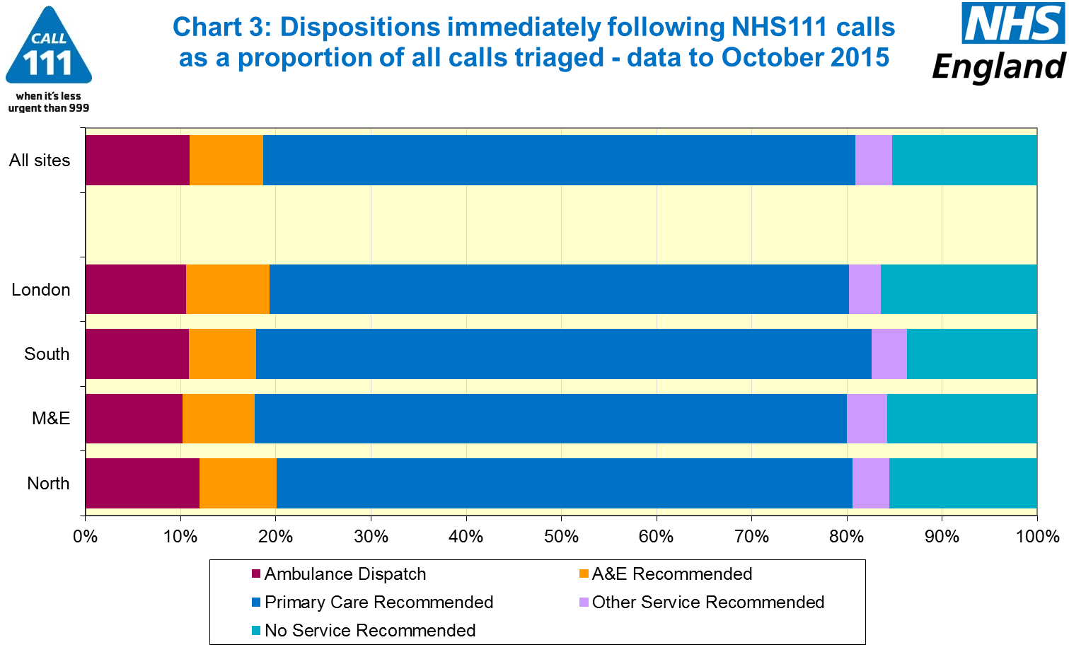





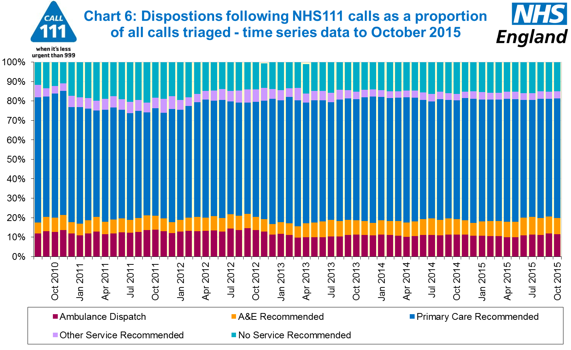

#### Additional Information:

All monthly data in the 111 Minimum Data Set (MDS) are available in spreadsheets at [www.england.nhs.uk/statistics/statistical-work-areas/nhs-111-minimum-data-set](http://www.england.nhs.uk/statistics/statistical-work-areas/nhs-111-minimum-data-set), along with all the previous accompanying statistical notes, the specification guidance document for those who produce the data, and the timetables for data collection and publication. Publication dates are also available from [www.gov.uk/government/statistics](http://www.gov.uk/government/statistics).

Material changes to the data or presentation of the NHS 111 MDS are listed in the 10 October 2015 Statistical Note and in earlier versions. Any further material changes will be described here in future Statistical Notes.

#### Contacts

For press enquiries, please contact the NHS England press office on 0113 825 0958 or [nhsengland.media@nhs.net](mailto:nhsengland.media@nhs.net).

The Government Statistical Service (GSS) statistician responsible for these data is:

Ian Kay, Operational Information for Commissioning (National),

NHS England, Room 5E24, Quarry House, Leeds, LS2 7UE.

0113 825 4606

[i.kay@nhs.net](mailto:i.kay@nhs.net)

Published on Thursday 10 December 2015.