

# NHS 111 Minimum Data Set, England, September 2015

#### Summary

There were 954,074 calls offered to the NHS 111 service in England in September 2015. This was an average of 31,802 per day, the lowest figure since September 2014.

Of calls offered to NHS 111 in September 2015, the proportion abandoned after waiting longer than 30 seconds was 1.4%, similar to the average for 2015.

Of calls answered by NHS 111, 91.4% were answered within 60 seconds, the lowest proportion in 2015.

Of calls answered, 13% were offered a call back in September 2015, higher than the average for 2015 (12%).

Of call backs, 43% were within 10 minutes, lower than in August but similar to June and July.

Of calls answered, 23% were transferred to a clinical advisor in September 2015, similar to the average for 2015 so far.

The mean average episode length of a call was 15 minutes 52 seconds in September 2015, the longest monthly average reported in 2015.

Of calls answered, 86% received triage in September 2015. This proportion has ranged between 85% and 87% for the last fifteen months. Calls triaged are those where the NHS 111 call handler opens and uses the clinical assessment tool (NHS Pathways).Calls not triaged include, follow-ups of previous calls, or calls where the caller is unable or unwilling to give specific details about the patient’s condition, such as enquiries about contact details for pharmacists or other local care services.

Of calls triaged in September 2015, 12% had ambulances dispatched, 9% were recommended to A&E, 61% were recommended to primary care, 4% were recommended to another service, and 15% were not recommended to any service. Compared with August 2015 data, these September proportions were similar, with the only percentage point change being in ambulances dispatched up from 11%.

Of calls offered to NHS 111 in September 2015, the proportion where 111 was dialled directly was 98%, similar to the level in every other month in 2015.

From 1 September 2015 the Norfolk NHS 111 Service was taken over by IC24, replacing the East of England Ambulance Service.

From 8 September 2015 the West Midlands NHS 111 Service was taken over by West Midlands Doctors Urgent Care, replacing the West Midlands Ambulance Service. Data for 1 to 7 September from West Midlands Ambulance Service were combined with data for 8 to 30 September from West Midlands Doctors Urgent Care, to produce the data for the West Midlands NHS 111 Service for September 2015.

The number of calls answered where 111 was dialled directly, and the number of calls answered through other numbers, have been revised for August 2015, for Leicestershire and Rutland, and therefore for England too. The total number of calls answered and all other data in the 8 October 2015 Statistical Note are unaffected.





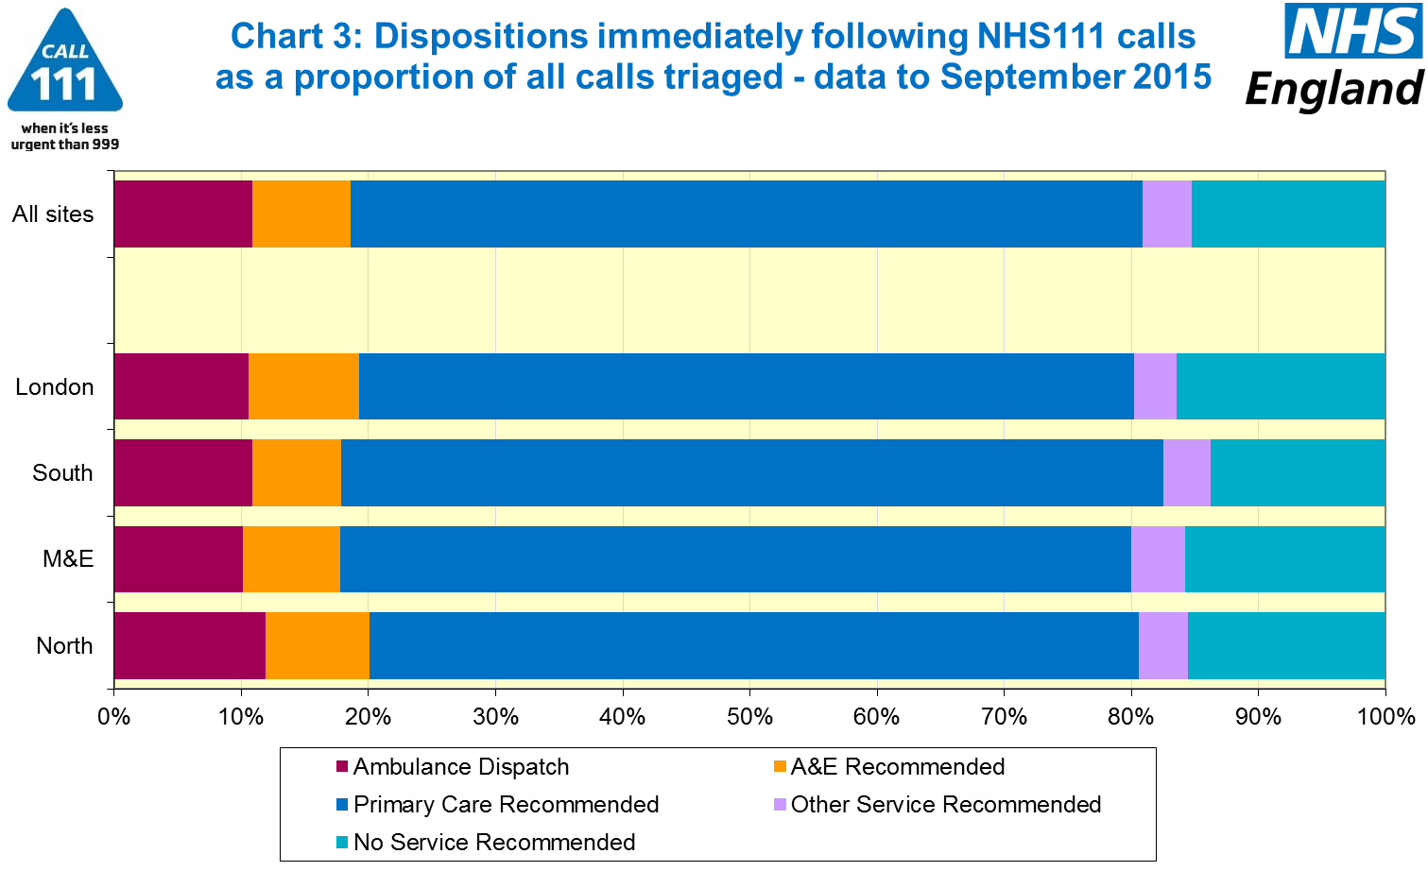





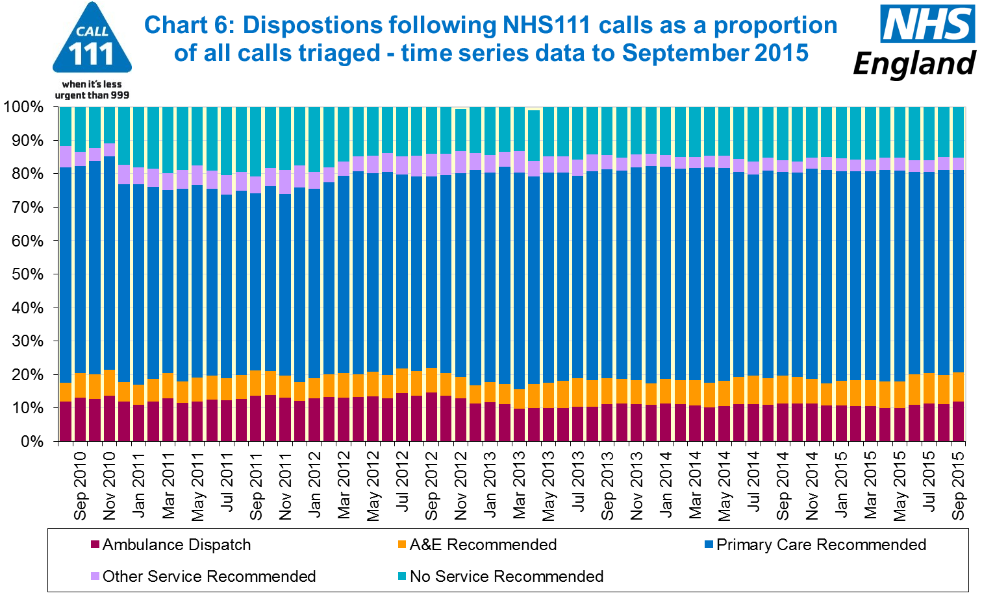

#### Additional Information:

All monthly data in the 111 Minimum Data Set (MDS) are available in spreadsheets at [www.england.nhs.uk/statistics/statistical-work-areas/nhs-111-minimum-data-set](http://www.england.nhs.uk/statistics/statistical-work-areas/nhs-111-minimum-data-set), along with all the previous accompanying statistical notes, the specification guidance document for those who produce the data, and the timetables for data collection and publication. Publication dates are also available from [www.gov.uk/government/statistics](http://www.gov.uk/government/statistics).

Material changes to the data or presentation of the NHS 111 MDS are listed in the 10 September 2015 Statistical Note and in earlier versions. Any further material changes will be described here in future Statistical Notes.

#### Contacts

For press enquiries, please contact the NHS England press office on 0113 825 0958 or [nhsengland.media@nhs.net](mailto:nhsengland.media@nhs.net).

The Government Statistical Service (GSS) statistician responsible for these data is:

Ian Kay, Operational Information for Commissioning (National),

NHS England, Room 5E24, Quarry House, Leeds, LS2 7UE.

0113 825 4606

[i.kay@nhs.net](mailto:i.kay@nhs.net)

Published on Thursday 12 November 2015.