## Statistical Note: Ambulance Quality Indicators (AQI)

* The latest Systems Indicators for March 2016 for Ambulance Services in England showed the standards in the Handbook[1] to the NHS constitution were not met.

## A. Systems Indicators

### A1 Emergency response in 8 minutes (Figure 1)

In March 2016, of Category[2] A Red 1 calls in England resulting in an emergency response, the proportion arriving within 8 minutes was 66.5%.

In March 2016, of Category2 A Red 2 calls in England resulting in an emergency response, the proportion arriving within 8 minutes was 58.0%. This is the lowest proportion recorded since the data collection began in June 2012.

Red 2 data from February 2015 onwards are not completely comparable across England; see section A2 on Dispatch on Disposition.

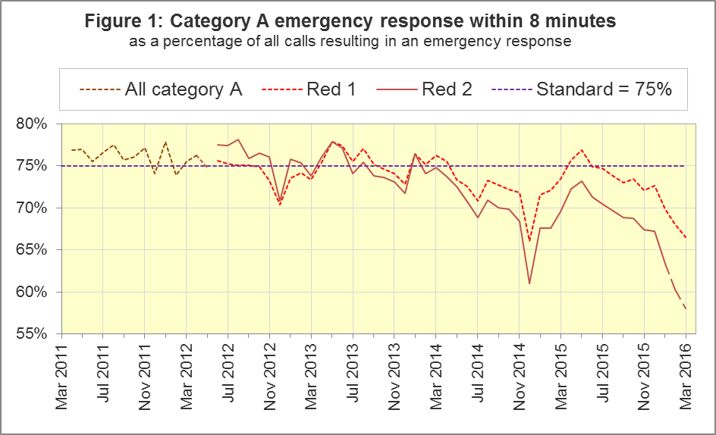

The standard for Ambulance Services is to send an emergency response, with a defibrillator, within 8 minutes to 75% of Category A calls. Figure 1 shows that for England, Red 1 performance significantly[3] decreased to 66.5% in March 2016, it has been below 75% for the past ten months.

For Red 1, one trust had a proportion exceeding 75%: West Midlands (76.1%). Ten trusts had proportions of less than 70%: North East (61.5%), North West (67.3%), Yorkshire (68.5%), East Midlands (64.1%), East of England (55.1%), South Central (69.1%), South Western (67.9%), London (65.6%), South East Coast (62.2%) and Isle of Wight (58.6%).

### A2 Dispatch on Disposition (DoD)

In January 2015, the Secretary of State for Health announced[4] the introduction of Dispatch on Disposition (DoD), allowing up to two additional minutes for triage (to identify the clinical situation and take appropriate action). This was based upon clinical advice that it would be likely to improve the overall outcomes for ambulance patients.

For Red 1 calls, the clock start time is still the instant that the telephone call connects. However, from 10 February 2015, all other calls received by London Ambulance Service (LAS) and South Western Ambulance Service (SWAS) use DoD.

During October 2015, DoD was introduced in the Ambulance Services of North East (NEAS), Yorkshire (YAS), West Midlands (WMAS) and South Central (SCAS), and the potential extra time was increased further for SWAS. Details of the clock start time for the various cohorts are shown in the table below.

|  |  |
| --- | --- |
| Cohort | Clock start time, excluding Red 1 |
| LAS and SWAS up to 10 February 2015;  NEAS, YAS, WMAS and SCAS up to October 2015;  continually used for the rest of England: | Earliest of:   * chief complaint or NHS Pathways initial disposition (Dx) code obtained; * first vehicle assigned; * 60 seconds after call connect. |
| LAS from 10 February 2015;  NEAS from 8 October 2015;  YAS from 21 October 2015;  WMAS and SCAS from 19 October 2015;  SWAS, 10 February to 5 October 2015: | Earliest of:   * chief complaint or NHS Pathways initial Dx code obtained; * first vehicle assigned; * 180 seconds after call connect. |

|  |  |
| --- | --- |
| SWAS from 5 October 2015: | As above for 5October 2015 except;   * 240 seconds after call connect. |
| SWAS from 14 December 2015 | As above for 5October 2015 except;   * 300 seconds after call connect. |
| SWAS from 1 March 2016 | As above for 14 December 2015 except;   * 240 seconds after call connect. |
| YAS from 16 March 2016 | As above for 21 October 2015 except;   * 240 seconds after call connect. |

The differing clock start times mean that data for the different cohorts are not comparable with each other. Red 2 calls comprise the vast majority of Category A calls, so 19 minute Category A data are also not comparable for the different cohorts.

Figure 2 shows the Red 2 measure for each cohort.

The numerators and denominators for the above proportions are displayed in the Systems Indicators Time Series spreadsheet at <http://bit.ly/NHSAQI>, on the “DoD R2” tab, and the “DoD A19” tab shows equivalent figures for the 19 minute measure below.

### A3 Category A Ambulance response in 19 minutes (Figure 3)

The other ambulance standard in the Handbook to the NHS Constitution is for trusts to send, within 19 minutes, a fully-equipped ambulance vehicle, able to transport the patient in a clinically safe manner, to 95% of Category A calls. This measure is also affected by DoD. For England as a whole, this measure decreased to 88.0% in March 2016 from 89.8% in February 2016. The performance for providers (North West, East Midlands, Eastern, South East Coast and Isle of Wight) not undertaking DoD was 84.3%.

DoD does not affect how other indicators are measured, but it may lead to changes in the levels for other indicators. For example, a longer triage time may mean fewer ambulances dispatched, leading to better ambulance availability, and more timely responses to Red 1 calls. A longer triage time may also mean more calls are closed on the telephone. However, any such effects will be difficult to detect within the habitual variation of the many Ambulance Quality Indicators.

### A4 Systems Indicators: Ambulance volumes (Figure 4)

The number[5] of emergency telephone calls presented to switchboard in March 2016 was 861,853, an average of 27.8 thousand per day. Figure 4 shows that there is a fair amount variation in call volume.

There were 594,863 emergency calls that received a face-to-face response from the ambulance service in March 2016, an average of 19.2 thousand per day. This is the highest number recorded since this data collection began.

There were 420,339 incidents with a patient transported to Type 1 or Type 2 A&E[6] in March 2016, an average of 13.6 thousand per day.

There were 319,990 Category A calls that resulted in a fully-equipped ambulance vehicle arriving at the scene of the incident in March 2016, this equates to 10.3 thousand per day, the highest figure since records began. Figure 4 shows how this has increased steadily between 2011 and 2015.

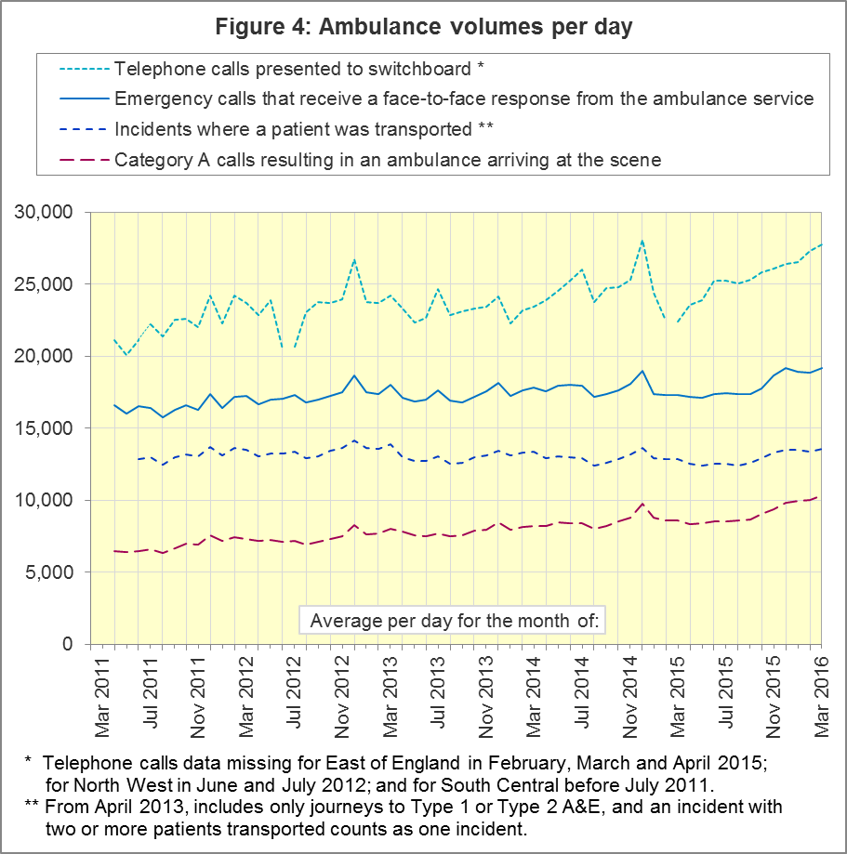

### A5 Latest monthly data for other Systems Indicators, March 2016

| Indicator | England | Lowest Trust | | Highest Trust | |
| --- | --- | --- | --- | --- | --- |
| Calls abandoned before being answered | 1.3% | London | 0.3% | South Western | 3.5 % |
| Calls resolved through telephone assessment | 10.2% | West Midlands | 5.7% | East Midlands | 15.8% |
| Calls resolved without transport to Type 1 or Type 2 A&E | 38.7% | Yorkshire | 29.4% | South East Coast[7] | 50.7% |
| Recontact rate following discharge by telephone advice | 6.5% | East Midlands | 1.8% | West Midlands | 14.3% |
| Recontact rate following face-to-face treatment at scene | 5.5% | Yorkshire7 | 3.2% | London | 8.8% |
| Incidents where a patient was transported | 420,343 | North  East7 | 21,093 | London | 68,315 |

In March 2016, the proportion of calls resolved through telephone assessment was 10.2%, higher than the 8.9% recorded in March 2015.

Of emergency calls resolved with telephone advice, the proportion where the patient subsequently re-contacts 999 within 24 hours was 6.5% in March 2016.

### A6 Trust-level annual analysis: resolved without transport

Figure 5 shows, of all calls that receive a telephone or face-to-face response from the ambulance service, the proportion resolved by telephone advice. This is sometimes referred to as “hear and treat”. For all England, this has increased from 5% in 2011-12 to 10% in 2015-16.

In 2015-16, East Midlands had the largest proportion with 15%. West Midlands had the lowest proportion in 2015-16 with 5% of calls being resolved with telephone advice. Both North West and East Midlands greater than doubled their ‘hear and treat’ rates in 2015-16 compared to their 2014-15 rates.

##### Figure 5: Calls resolved by telephone advice

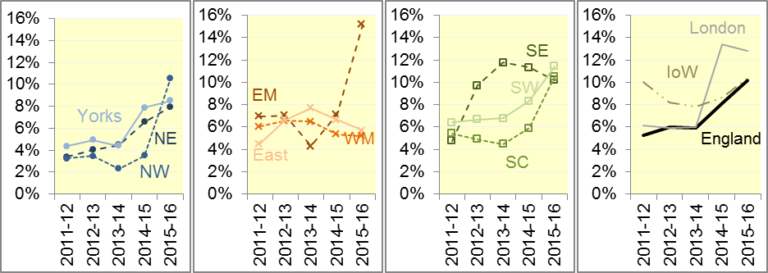

##### Figure 6: Calls where no patients taken to Type 1 or Type 2 A&E

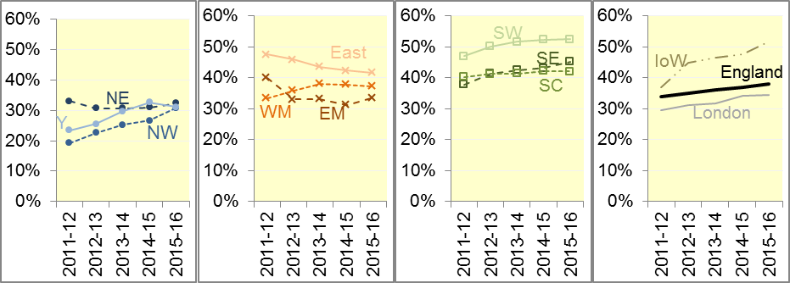

Figure 6 shows, of all calls that receive a face-to-face response from the ambulance service, the proportion where no patients were taken to a Type 1 or Type 2 A&E. This is sometimes referred to as “see and treat”.

Such patients are taken elsewhere (such as a minor injuries unit), or referred to an alternative care pathway, or discharged after treatment at the scene. Across the whole of England, the proportion not taken to Type 1 or Type 2 A&E increased slowly from 34% in 2011-12 to 38% in 2015-16.

In all five years the highest proportion was in South Western, with 52% in the last three years. The lowest proportion in each year was in North West, despite this measure increasing there from 19% in 2011-12 to 31% in 2015-16.

### A8 Trust-level annual analysis: re-contacts

Figure 7 shows, of all emergency calls that are closed with telephone advice, the proportion with at least one re-contact from the same address within 24 hours. For all England, this has reduced from 13% in 2011-12 and 2012-13 to 10% in 2013-14, 8% in 2014-15 and is now at 6% in 2015-16.

This measure was highest in North West in 2011-12 and 2012-13, which had more than 30% in those years, but 13% in 2013-14 and 11% in 2014-15. Yorkshire also had proportions of 20% or more in 2011-12 and 2012-13, but its proportions in 2013-14 and 2014-15 were both 6%. This measure was lowest in London in 2013-14 and 2014-15, with 2% each year.

##### Figure 7: Re-contacts following calls closed with telephone advice

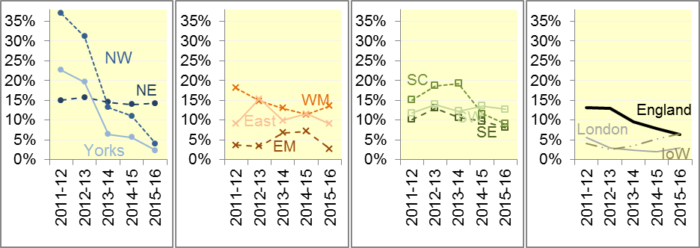

##### Figure 8: Re-contacts following discharge on scene

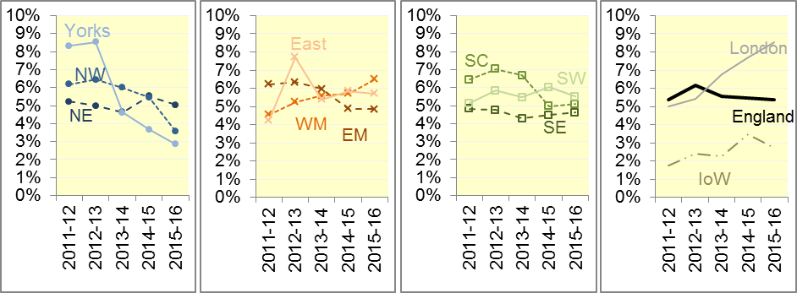

Figure 8 shows, of all patients treated and discharged on the scene, the proportion that re-contact on the telephone within 24 hours of the initial call. This is stable at 5% or 6% across England for each year 2011-12 to 2015-16.

London has reported the highest proportion of re-contacts for the past 2 years, rising to 9% in 2015-16. Isle of Wight was lowest in all five years, always less than 4%.

### A9 Trust-level annual analysis: Volumes of Category A arrivals on scene

Figure 9 shows the average numbers of calls per day which led to a Category A ambulance arriving at the scene. This has increased 33% between 2011-12 and 2015-16.

London averaged 1,369 such calls per day in 2015-16 and had the largest average in each year. North West and West Midlands also averaged more than 1,000 per day each year since 2012-13. Excluding the Isle of Wight, North East had the fewest daily calls recorded at 519. This is followed by South Central with 525, this represents an increase of nearly 80% between 2011-12 and 2015-16.

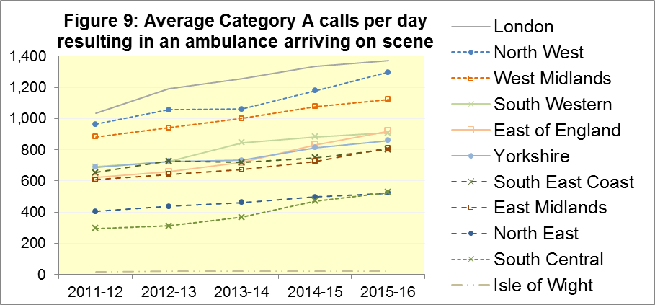

### A6 Revisions

Nine Trusts (North East, North West, East Midlands, West Midlands, East of England, South Central, South Western, London and South East Coast) have supplied us with revisions to data for April 2015 to March 2016, which are included in the data in Section A above. The largest revisions are for rates of ‘See and Treat’, ‘Hear and Treat’ and telephone re-contact rates (Figures 14, 15 and 17 respectively below)

#### Figure 10: Revisions to Category A Red 1 calls in England resulting in an emergency response, the proportion arriving within 8 minutes

#### Figure 11: Revisions to Category A Red 2 calls in England resulting in an emergency response, the proportion arriving within 8 minutes



#### Figure 12: Revisions to Category A calls in England resulting in an emergency response, the proportion arriving within 19 minutes

#### Figure 13: Revisions to proportion of calls abandoned before being answered, England

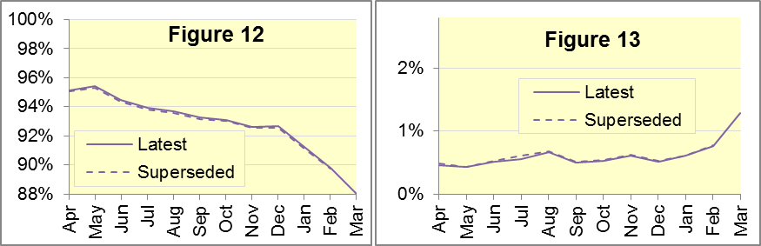

#### Figure 14: Revisions to proportion of calls resolved by telephone advice, England

#### Figure 15: Revisions to proportion of incidents managed without need for transport to Accident and Emergency department, England

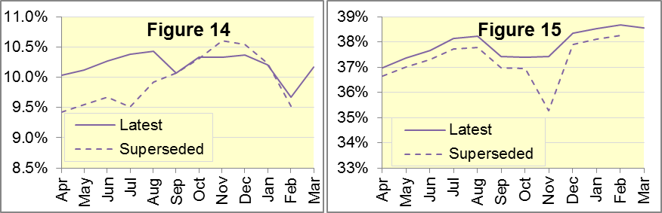

#### Figure 16: Revisions to re-contacts after discharge on scene, England

#### Figure 17: Revisions to proportion of incidents managed without need for transport to Accident and Emergency department, England

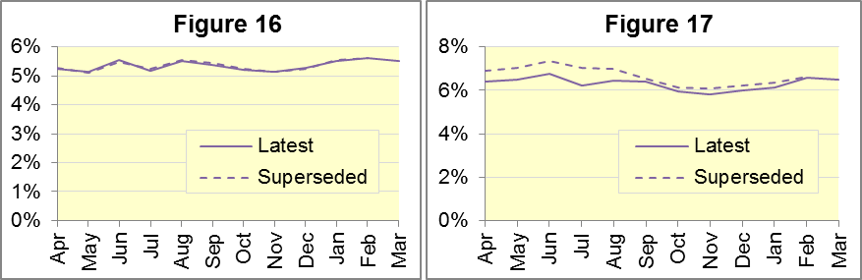

#### Figure 18: Revisions of more than 2% points to Trust-level monthly data

|  |  |  |  |  |  |  |  |  |
| --- | --- | --- | --- | --- | --- | --- | --- | --- |
| Trust | Indicator | | Month | | From | | To | |
| East Midlands | Emergency calls closed with telephone advice | | Apr | | 7.7% | | 13.6% | |
|  |  | | May | | 8.2% | | 14.0% | |
|  |  | | Jun | | 8.6% | | 14.0% | |
|  |  | | Jul | | 9.1% | | 15.4% | |
|  |  | | Aug | | 8.7% | | 15.8% | |
|  | Patients discharged, after treatment at the scene or onward referral | | Apr | | 30.6% | | 33.8% | |
|  |  | | May | | 30.3% | | 33.6% | |
|  |  | | Jun | | 29.9% | | 33.4% | |
|  |  | | Jul | | 30.7% | | 34.3% | |
|  |  | | Aug | | 30.6% | | 34.4% | |
|  |  | | Sep | | 29.7% | | 33.5% | |
|  |  | | Oct | | 29.6% | | 33.4% | |
|  |  | | Nov | | 29.2% | | 32.6% | |
|  |  | | Dec | | 29.9% | | 33.8% | |
|  |  | | Jan | | 29.9% | | 32.9% | |
|  |  | | Feb | | 30.0% | | 33.4% | |
|  | Emergency calls closed with telephone advice where re-contact occurs via 999 within 24 hours | | Apr | | 7.5% | | 4.0% | |
|  |  | | May | | 7.0% | | 3.8% | |
|  |  | | Jun | | 7.0% | | 3.9% | |
|  |  | | Jul | | 6.2% | | 3.4% | |
|  |  | | Aug | | 6.0% | | 3.1% | |
| East of England | Emergency calls closed with telephone advice where re-contact occurs via 999 within 24 hours | | May | | 11.8% | | 9.7% | |
|  |  | | Jun | | 11.6% | | 9.0% | |
|  |  | | Jul | | 10.9% | | 8.7% | |
|  |  | | Aug | | 11.5% | | 9.5% | |
|  |  | | Sep | | 12.1% | | 9.3% | |
|  |  | | Oct | | 10.5% | | 8.2% | |
| South Central | | Emergency calls closed with telephone advice | | Jul | | 6.6% | | 9.4% | |
|  | Emergency calls closed with telephone advice where re-contact occurs via 999 within 24 hours | | Jul | | 11.9% | | 8.2% | |
| South Western | Emergency calls closed with telephone advice | | Nov | | 13.1% | | 10.1% | |
|  |  | | Dec | | 12.6% | | 10.5% | |
| South East Coast | Red 2 calls arriving within 8 minutes | | Apr | | 77.3% | | 74.7% | |
|  |  | | May | | 76.0% | | 74.0% | |
|  |  | | Jun | | 74.2% | | 72.0% | |
|  |  | | Jul | | 73.3% | | 70.7% | |
|  |  | | Aug | | 72.0% | | 69.6% | |
|  |  | | Sep | | 73.2% | | 70.3% | |
|  |  | | Oct | | 73.4% | | 70.8% | |

#### Figure 19: Revisions of more than 0.5% points to England monthly data

|  |  |  |  |
| --- | --- | --- | --- |
| Indicator | Month | From | To |
| Patients discharged, after treatment at the scene or onward referral | May | 35.3% | 37.4% |
| Emergency calls closed with telephone advice | Apr | 9.4% | 10.0% |
| May | 9.5% | 10.1% |
| Jun | 9.7% | 10.3% |
| Jul | 9.5% | 10.4% |
| Aug | 9.9% | 10.4% |
| Emergency calls closed with telephone advice where re-contact occurs via 999 within 24 hours | Apr | 6.9% | 6.4% |
| May | 7.1% | 6.5% |
| Jun | 7.4% | 6.7% |
| Jul | 7.0% | 6.2% |
| Aug | 7.0% | 6.5% |

## B. Clinical Outcomes

No thresholds to denote “poor” care are set for Clinical Outcomes. Commissioners are expected to examine trends in these data, and work in collaboration with ambulance trusts to achieve sustained improvement in patient outcomes over time; but commissioners are not expected to use Clinical Outcomes to performance manage trusts, because there will be significant variations in the populations served.

### B1 Cardiac arrest: return of spontaneous circulation (ROSC)

Patients in cardiac arrest will typically have no pulse and will not be breathing. In December 2015 in England, resuscitation was commenced or continued by ambulance staff out-of-hospital for 2,646 such patients. Of these, 713 (26.9%) had ROSC, with a pulse, on arrival at hospital (Figure 20), similar to the average for 2014-15 of 27.3%. The largest proportion in December 2015 was 32.2% for North West. The smallest proportion reported was 20.7% for Yorkshire.

The Utstein group[8] comprises patients who had resuscitation commenced or continued by the Ambulance Services, following an out-of-hospital cardiac arrest of presumed cardiac origin, where the arrest was bystander witnessed, and the initial rhythm was Ventricular Fibrillation or Ventricular Tachycardia. The Utstein group therefore have a better chance of survival.

There were 336 such patients in England in December 2015, of which 156 (46.4%) had ROSC on arrival at hospital (Figure 20). Below the England average for 2014-15 of 49.1%. The largest proportion in the December 2015 was reported in East Midlands9 with 66.7%, and the smallest was 30.0% for North East.

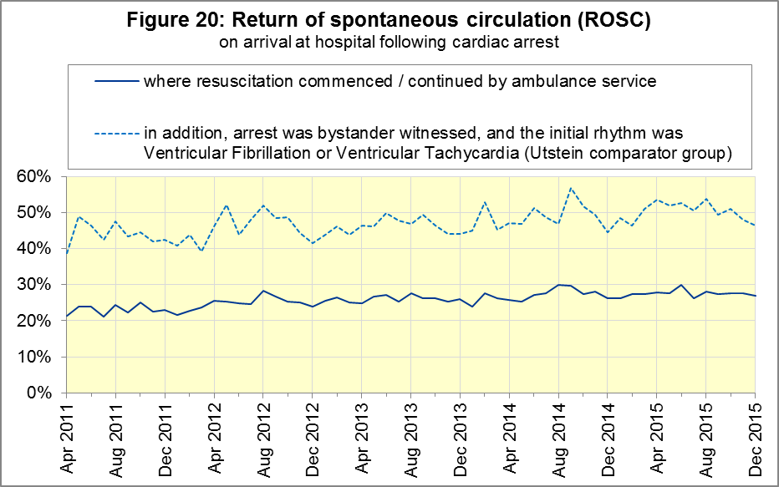

### B2 Cardiac arrest: survival to discharge

The proportion of cardiac arrest patients in England discharged from hospital alive was 7.2% in December 2015 (Figure 21), slightly below the average for 2014-15 of 8.6%. The largest proportion in December 2015 was 15.0% for South Central[9], the smallest was 2.8% for North East.

For the Utstein group, survival to discharge in December 2015 was 24.4%, lower than the average for 2014-15 of 26.3%. The largest proportion was 55.6% for Yorkshire, the smallest was 9.1% for East of England.

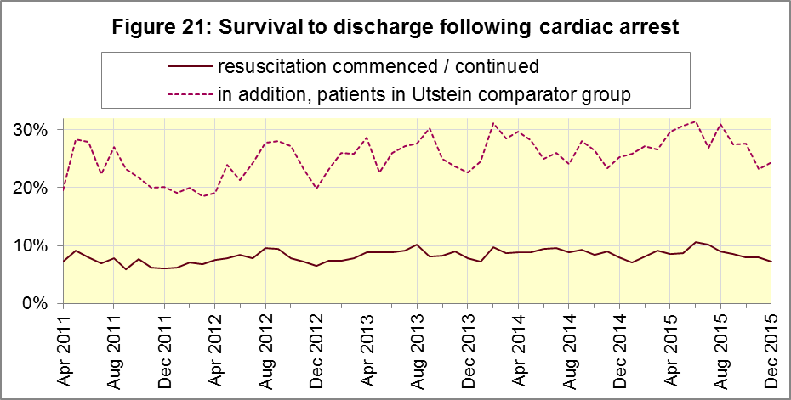

### B3 ST-Elevation myocardial infarction

ST-segment elevation myocardial infarction (STEMI) is a type of heart attack, determined by an electrocardiogram (ECG) test. Early access to reperfusion, where blocked arteries are opened to re-establish blood flow, and other assessment and care interventions, are associated with reductions in STEMI mortality and morbidity.

910 STEMI patients received primary angioplasty in December 2015 in England. Of these 910 patients, 810 (89.0%) of them received it within 150 minutes of the call being connected to the ambulance service (Figure 22), significantly above the average for 2014-15. The largest proportion for December 2015 was 94.5% for North East[10], and the smallest was 77.9% for South Western.

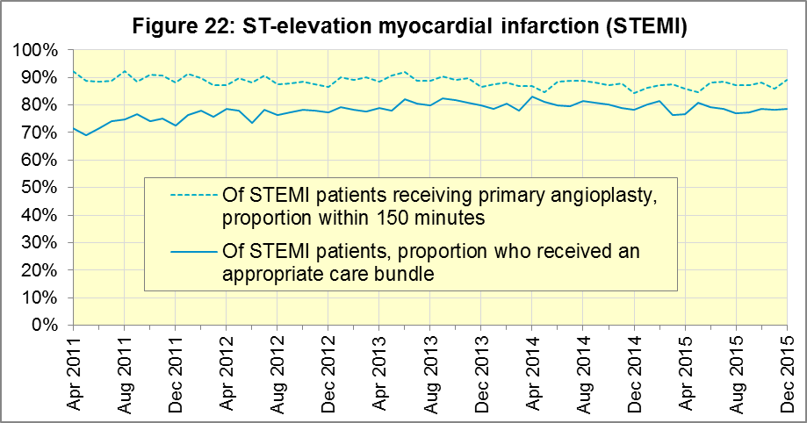

In December 2015, of 1,423 patients with an acute STEMI in England, 1,120 (78.7%) received the appropriate care bundle[11]. This was similar to the average for 2014-15 of 80.0%. North West had the largest proportion with 86.6%, and the smallest was South East Coast[12] with 68.1%.

### B4 Stroke

The FAST procedure helps assess whether someone has suffered a stroke:

* **F**acial weakness: can the person smile? Has their mouth or eye drooped?
* **A**rm weakness: can the person raise both arms?
* **S**peech problems: can the person speak clearly and understand what you say?
* **T**ime to call 999 for an ambulance if you spot any one of these signs.

In December 2015, of 3,093 FAST positive patients in England, assessed face to face, and potentially eligible for stroke thrombolysis within agreed local guidelines, 1,699 (54.9%) arrived at hospitals with a hyperacute stroke unit within 60 minutes of an emergency call connecting to the ambulance service, below the average for 2014-15 of 59.0%.

The largest proportion for December 2015 was 67.7% for South East Coast12, and the smallest was 33.3% for South Central.

There were 6,867 stroke patients assessed face to face in December 2015 in England, and 6,667 (97.1%) received the appropriate care bundle, the same as the average for 2014-15 of 97.1%.

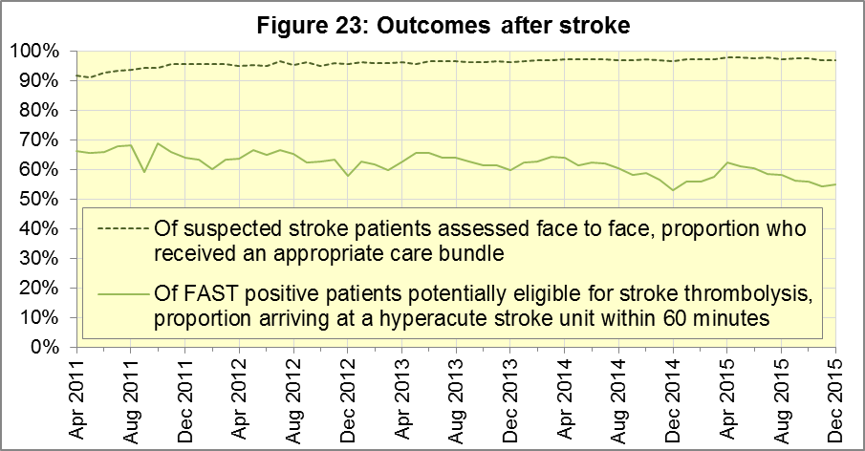

## C. Further information on AQI

### C1 The AQI landing page and Quality Statement

[www.england.nhs.uk/statistics/statistical-work-areas/ambulance-quality-indicators](http://www.england.nhs.uk/statistics/statistical-work-areas/ambulance-quality-indicators), or <http://bit.ly/NHSAQI>, is the AQI landing page, and it holds:

* a Quality Statement for these statistics, which includes information on relevance, accuracy, timeliness, coherence, and user engagement;
* the specification guidance document for those who supply the data;
* timetables for data collection and publication;
* text files and time series spreadsheets containing all data from April 2011 up to the latest month;
* links to individual web pages for each financial year.

The web pages for each financial year hold:

* separate spreadsheets of each month’s data;
* this Statistical Note, and equivalent versions from previous months;
* the list of people with pre-release access to the data.

Publication dates are also at [www.gov.uk/government/statistics/announcements](http://www.gov.uk/government/statistics/announcements).

### C2 Revisions Timetable

Revisions usually follow a six-monthly cycle. The dates for past and future AQI scheduled revisions are below. The AQI Quality Statement above contains a more detailed revisions policy.

| Publication date |  | Series revised |  | Months affected |
| --- | --- | --- | --- | --- |
| 12 May 2016 |  | Systems Indicators |  | April 2015 to February 2016 |
| 10 March 2016 |  | Clinical Outcomes |  | April 2015 to September 2015 |
| 10 September 2015 |  | Clinical Outcomes |  | April 2014 to March 2015 |
| 4 June 2015 |  | Systems Indicators |  | April 2014 to February 2015 |
| 30 April 2015 |  | Systems Indicators |  | April 2014 to February 2015 |
| 5 March 2015 |  | Clinical Outcomes |  | April 2014 to September 2014 |
| 6 November 2014 |  | Systems Indicators |  | April 2013 to August 2014 |
| 5 September 2014 |  | Clinical Outcomes |  | April 2013 to March 2014 |
| 2 May 2014 |  | Systems Indicators |  | April 2013 to February 2014 |
| 7 March 2014 |  | Clinical Outcomes |  | April 2013 to September 2013 |
| 1 November 2013 |  | Systems Indicators |  | April 2013 to August 2013 |
| 2 August 2013 |  | Clinical Outcomes |  | April 2012 to March 2013 |
| 3 May 2013 |  | Systems Indicators |  | April 2012 to March 2013 |
| 1 February 2013 |  | Clinical Outcomes |  | April 2012 to August 2012 |
| 11 January 2013 |  | Systems Indicators |  | April 2011 to October 2012 |
| 31 August 2012 |  | Clinical Outcomes |  | April 2011 to March 2012 |

### C3 AQI Scope

The AQI include calls made by dialling either the usual UK-wide number 999 or its international equivalent 112.

As described in the specification guidance in section C1, calls made to NHS 111 are not included in the AQI measures for calls abandoned, re-contacts, frequent callers, time to answer calls and calls resolved by telephone advice.

All other Systems Indicators involve the dispatch of an ambulance, and include ambulances dispatched as a result of a call to NHS 111, as well as 999 or 112.

### C4 Related statistics in England

The AQI appear in a Clinical Dashboard, available from the AQI landing page, the websites of the Ambulance Trusts (listed in the AQI Quality Statement), and <http://aace.org.uk/national-performance/national-clinical-dashboards>. One of the aims of these Dashboards is to use statistical process control, to indicate whether variation in proportions reflects underlying change, or merely natural variance, unavoidable even when a health system is performing well.

The AQI are also used in the “Ambulance Services” publication by the Health and Social Care Information Centre (HSCIC), which includes additional annual analysis and commentary. Until March 2013, the HSCIC publication used the KA34 data collection, which was similar to the AQI Systems Indicators, but annual rather than monthly. After that date, the HSCIC publication used AQI data. [www.hscic.gov.uk/article/2021/Website-Search?q=ambulance+-accident&sort=Title](http://www.hscic.gov.uk/article/2021/Website-Search?q=ambulance+-accident&sort=Title)

Ambulance handover delays of over 30 minutes at each Emergency Department were collected and published by NHS England each winter until 2014-15: [www.england.nhs.uk/statistics/statistical-work-areas/winter-daily-sitreps](http://www.england.nhs.uk/statistics/statistical-work-areas/winter-daily-sitreps)

The AQI Quality Statement described in section C1 contains more information on the HSCIC publication. It also contains details of weekly ambulance situation reports that NHS England collected for six months from November 2010.

### C5 Rest of United Kingdom

Ambulance statistics for other countries of the UK can be found at the following websites. The AQI Quality Statement described in section C1 contains more information about the comparability of these statistics.

|  |  |
| --- | --- |
| Wales: | <http://wales.gov.uk/statistics-and-research/ambulance-services/?lang=en> |
| Scotland: | See Quality Improvement Indicators (QII) documents at [www.scottishambulance.com/TheService/BoardPapers.aspx](http://www.scottishambulance.com/TheService/BoardPapers.aspx) |
| Northern Ireland: | [www.dhsspsni.gov.uk/index/statistics/hospital/emergency-care/ambulance-statistics.htm](http://www.dhsspsni.gov.uk/index/statistics/hospital/emergency-care/ambulance-statistics.htm) |

### C6 Contact information

For press enquiries, please contact the NHS England press office on 0113 825 0958 or [nhsengland.media@nhs.net](mailto:nhsengland.media@nhs.net).

The statistician responsible for producing this publication is:

Ian Kay, Operational Information for Commissioning (National), NHS England

Room 5E24, Quarry House, Leeds, LS2 7UE; 0113 825 4606; [i.kay@nhs.net](mailto:i.kay@nhs.net)

### C7 National Statistics

The UK Statistics Authority has designated these statistics as National Statistics, in accordance with the Statistics and Registration Service Act 2007 and signifying compliance with the Code of Practice for Official Statistics.

Designation can be broadly interpreted to mean that the statistics:

* meet identified user needs;
* are well explained and readily accessible;
* are produced according to sound methods; and
* are managed impartially and objectively in the public interest.

Once statistics have been designated as National Statistics it is a statutory requirement that the Code of Practice shall continue to be observed.

1. Page 34 of the July 2015 Handbook to the NHS Constitution has Ambulance response time standards, [www.gov.uk/government/publications/the-nhs-constitution-for-england](http://www.gov.uk/government/publications/the-nhs-constitution-for-england).
2. On 1 June 2012, Category A (immediately life-threatening) calls was split into Red 1 and Red 2. Red 1 calls are the most time critical, and cover cardiac arrest patients who are not breathing and do not have a pulse, and other severe conditions such as airway obstruction. Red 2 calls are serious, but less immediately time critical, and cover conditions such as stroke and fits. [www.gov.uk/government/news/changes-to-ambulance-response-time-categories](http://www.gov.uk/government/news/changes-to-ambulance-response-time-categories)

   Due to the differences in clock start definitions for Red 1 and Red 2 it is not possible to aggregate them into a single proportion for Category A against the 8 minute standard.
3. Significance test used is t-test
4. Dispatch on Disposition announcement: [www.parliament.uk/business/publications/written-questions-answers-statements/written-statement/Commons/2015-01-16/HCWS201](http://www.parliament.uk/business/publications/written-questions-answers-statements/written-statement/Commons/2015-01-16/HCWS201)
5. The number of emergency calls presented to switchboard does not usually include calls made to NHS 111 requiring an ambulance. 111 calls requiring an ambulance are usually transferred electronically direct to ambulance dispatch, and not routed via 999 call handlers. Occasionally, manual requests for ambulance are made between 111 and 999 call handlers, and such calls are included in the number of emergency calls presented to switchboard.
6. Type 1 are consultant-led 24 hour emergency departments with full resuscitation facilities / Type 2 offer a consultant-led speciality A&E service such as ophthalmology or dental /Type 3 is A&E / minor injury activity that may be doctor-led or nurse-led /Type 4 are NHS walk-in centres.
7. Due to its small size, performance on Isle of Wight tends to vary more than other trusts. If it has the largest or smallest value, the Table in A5 shows the second largest or smallest value, but has a footnote marker to show that Isle of Wight is more extreme. The Clinical Outcomes in section B also uses this system.
8. This definition was proposed at Utstein Abbey in Norway by an international group of cardiologists and other health professionals in 1990. <http://circ.ahajournals.org/content/84/2/960.citation>
9. Excluding Isle of Wight. See footnote 7 on page 6
10. Excluding Isle of Wight. See footnote 7 on page 6.
11. Pages 27 to 30 of the specification guidance for data suppliers on the AQI landing page at [www.england.nhs.uk/statistics/statistical-work-areas/ambulance-quality-indicators](http://www.england.nhs.uk/statistics/statistical-work-areas/ambulance-quality-indicators) describe the care bundles, and certain exclusions, for the STEMI and stroke indicators.
12. Excluding Isle of Wight. See footnote 7 on page 6.