Statistical Note: Ambulance Quality Indicators (AQI)
- The latest Systems Indicators for July 2015 for Ambulance Services in England showed responses against the standards in the Handbook to the NHS constitution declined, and therefore were not met.
- The latest Clinical Outcomes data for patients transported by Ambulance Services for April 2015 showed a decrease in myocardial infarction patients receiving the appropriate care bundle, adding to the decrease from March 2015.

A. Systems Indicators

A1 Emergency response in 8 minutes (Figure 1)
In July 2015, of Category A Red 1 calls in England resulting in an emergency response, the proportion arriving within 8 minutes was 74.5%.
In July 2015, of Category A Red 2 calls in England resulting in an emergency response, the proportion arriving within 8 minutes was 70.6%.
Red 2 data from February 2015 onwards are not completely comparable across England; see section A2 on the Dispatch on Disposition pilot.
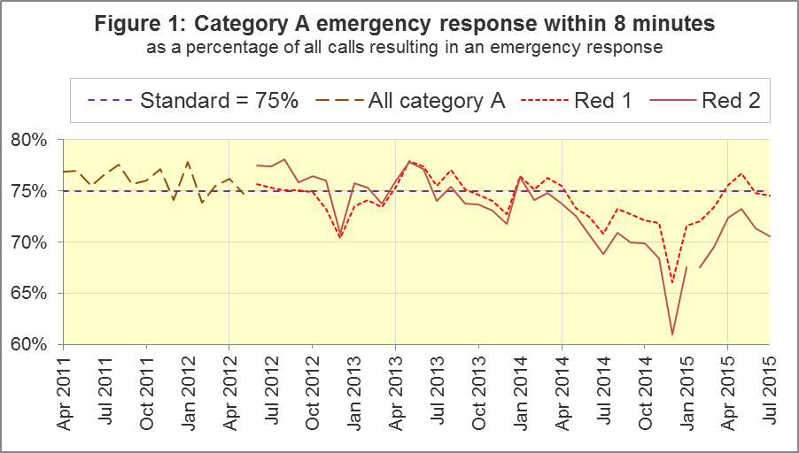
The standard for Ambulance Services is to send an emergency response, with a defibrillator, within 8 minutes to 75% of Category A calls. Figure 1 shows that for England, Red 1 performance was only above 75% in two of the previous twelve months.
The largest proportions were 79.4% for West Midlands and 79.3% for North West. North East, East Midlands and South Western also had proportions above 75%. The smallest proportions were 67.2% for London and 67.8% for South Central.

A2 Dispatch on Disposition (DoD) pilot (Figure 2)
Because of the DoD pilot, from 10 February 2015 onwards, London Ambulance Service (LAS) and South Western Ambulance Service (SWAS) data for the 8 minute Red 2 measure are not comparable with other services.
Figure 2 shows the Red 2 measure including and excluding the affected trusts. For all England, it decreased from 71.4% in June 2015 to 70.6% in July 2015. With LAS and SWAS excluded, the measure decreased by a little more, from 73.4% in June to 72.0% in July.
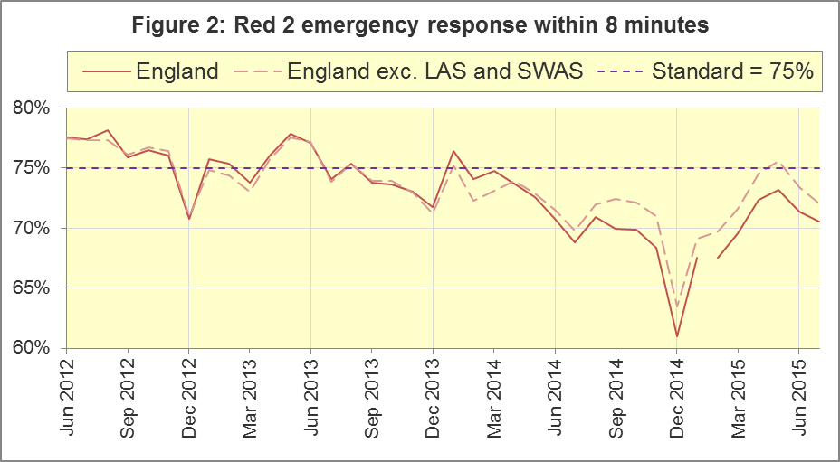
In July 2015, four trusts had more than 75% of Red 2 responses within 8 minutes: North East (75.2%), North West and West Midlands (joint highest, 76.0%) and Isle of Wight (75.3%). Three had fewer than 70%: East of England (62.5%), London (66.2%) and South Western (66.6%).
Red 2 calls comprise the vast majority of Category A calls, so the DoD pilot affects not only the 8 minute Red 2 measure, but also the 19 minute Category A measure.

A3 Category A Ambulance response in 19 minutes (Figure 3)
The other ambulance standard in the Handbook to the NHS Constitution is for trusts to send, within 19 minutes, a fully-equipped ambulance vehicle, able to transport the patient in a clinically safe manner, to 95% of Category A calls. Figure 3 shows for England as a whole, this measure decreased from 94.4% in June 2015 to 93.8% in July. Excluding LAS and SWAS, the decrease was similar, from 95.0% to 94.3%.
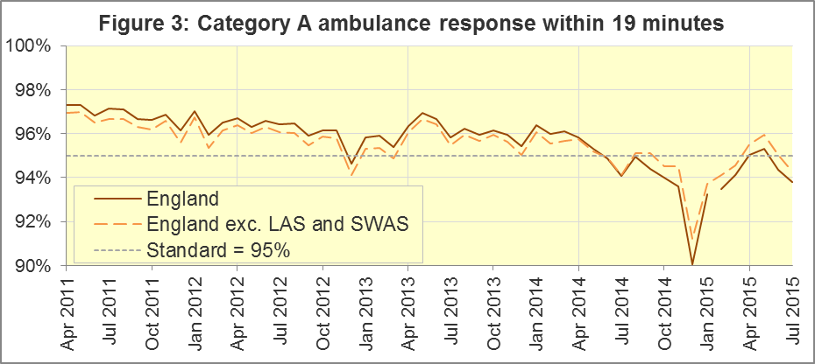
West Midlands had the largest proportion (97.4%) for this measure. North East and Yorkshire also met the 95% standard. The lowest were East of England (90.8%) and South Western (90.5%).
The measurement of the other Systems Indicators is unaffected by the pilot.

A4 Systems Indicators: Ambulance volumes (Figure 4)
The number of emergency telephone calls presented to switchboard in July 2015 was 782,469, an average of 25 thousand per day, fewer than 26 thousand per day in July 2014.
There were 544,380 emergency calls that received a face-to-face response from the ambulance service in July 2015. This was an average of 18 thousand per day, the highest number since December 2014.
There were 390,626 incidents with a patient transported to Type 1 or Type 2 A&E in July 2015, an average of 13 thousand per day, the same as the 2014-15 average.
There were 265,562 Category A calls that resulted in a fully-equipped ambulance vehicle arriving at the scene of the incident in July 2015, or 8.6 thousand per day. Figure 4 shows that this rate increased steadily from 6.9 thousand per day in 2011-12 to 8.6 thousand per day in 2014-15, but has changed little in 2015.
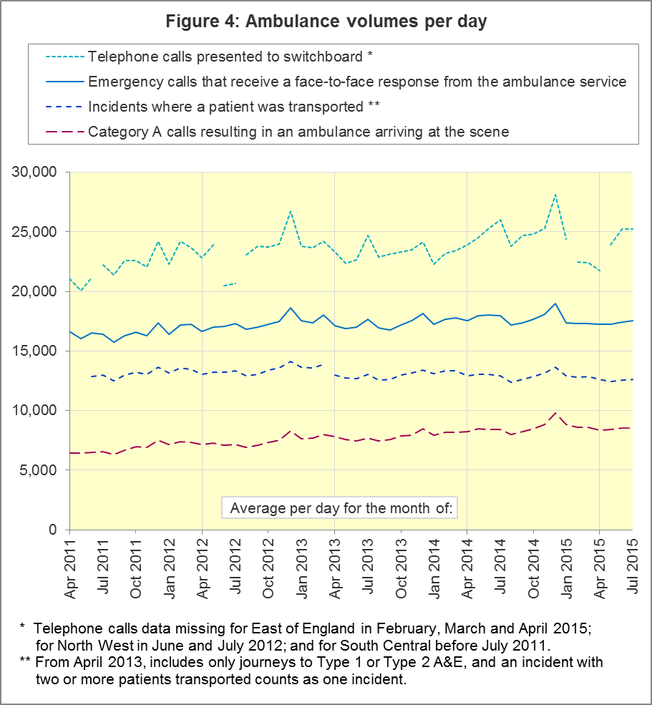

A5 Latest monthly data for other Systems Indicators, July 2015
Indicator | England | Lowest Trust |  | Highest Trust
Calls abandoned before being answered | 0.6% | East Midlands | 0.1% | South Central | 1.3%
Calls resolved through telephone assessment | 9.5% | West Midlands | 4.9% | London | 13.6%
Calls resolved without transport to Type 1 or Type 2 A&E | 37.7% | East Midlands | 30.7% | South Western | 53.0%
Recontact rate following discharge by telephone advice | 7.0% | Yorkshire | 1.5% | North East | 14.2%
Recontact rate following face-to-face treatment at scene | 5.2% | Yorkshire | 3.0% | London | 8.5%
Incidents where a patient was transported | 390,626 | North  East⁶ | 20,570 | London | 64,390

B. Clinical Outcomes
Our previous publication on 13 August 2015 contained Clinical Outcomes data for March 2015, which completed the financial year 2014-15. However, we have waited until now to include trust-level analysis of annual Clinical Outcomes, because today’s publication contains the scheduled revisions to Clinical Outcomes for 2014-15, described in Section B5 below.
No thresholds to denote “poor” care are set for Clinical Outcomes. Commissioners are expected to examine trends in these data, and work in collaboration with ambulance trusts to achieve sustained improvements over time improvement in patient outcomes over time; but commissioners are not expected to use Clinical Outcomes to performance manage trusts, because there will be significant variations in the populations served.

B1 Cardiac arrest: return of spontaneous circulation (ROSC)
Patients in cardiac arrest will typically have no pulse and will not be breathing. In April 2015 in England, resuscitation was commenced or continued by ambulance staff out-of-hospital for 2,375 such patients. Of these, 662 (28%) had ROSC, with a pulse, on arrival at hospital (Figure 5), similar to the average for 2014-15 of 27%.
The Utstein group comprises patients who had resuscitation commenced or continued by the Ambulance Services, following an out-of-hospital cardiac arrest of presumed cardiac origin, where the arrest was bystander witnessed, and the initial rhythm was Ventricular Fibrillation or Ventricular Tachycardia. The Utstein group therefore have a better chance of survival.
There are usually fewer than 50 patients in the Utstein group in most trusts each month, so percentages calculated for them can vary considerably, and changes are often not statistically significant. There were 323 such patients in England in April 2015, of which 173 (54%) had ROSC on arrival at hospital (Figure 5). This was not significantly different to the England average for 2014-15 of 49%.
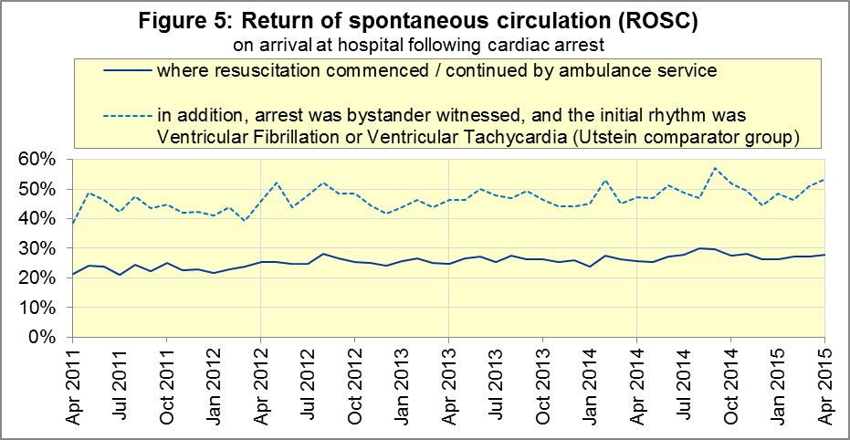
For all patients, the England average has increased from 23% in 2011-12 to 27% in 2014-15 (Figure 6). Part of this increase is due to South Central, which had 22% in 2011-12 but had the highest proportion in each of the last three financial years, including 38% in 2014-15, although the highest proportion in the month of April 2015 was 36% for North West.
East Midlands had the lowest average in each of the last three financial years, including 19% for 2014-15%, although for the month of April 2015, North East had the lowest proportion, 21%.

Figure 6: ROSC following cardiac arrest: annual trust-level data, all patients
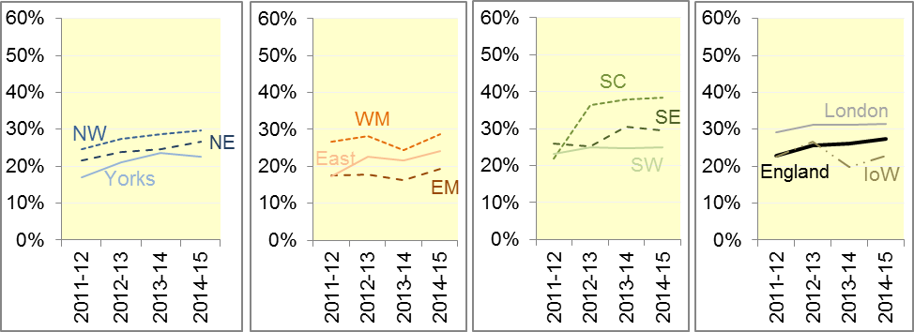
For the Utstein group (Figure 7), the England proportion also increased between 2011-12 and 2014-15, from 43% to 49%.
North East had the highest proportions in 2013-14 and 2014-15, both 60%, although Yorkshire had the highest proportion in April 2015, 69%. East Midlands was lowest for each of the last three financial years, including 36% for 2014-15, although East of England and South East Coast were lowest in April 2015 with 39%.

Figure 7: ROSC following cardiac arrest: annual trust-level data, Utstein group
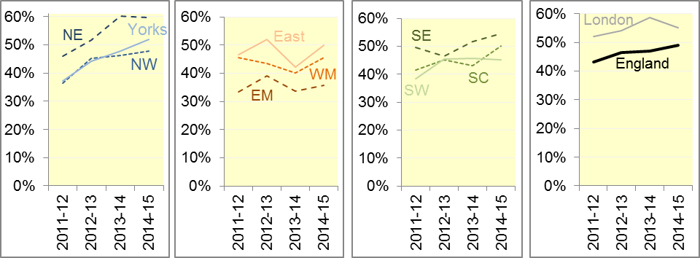

B2 Cardiac arrest: survival to discharge
The proportion of cardiac arrest patients in England discharged from hospital alive was 8% in April 2015 (Figure 8), similar to the average for 2014-15 of 9%. For the Utstein group, survival to discharge in April 2015 was 29%, which was also not significantly different to the average for 2014-15 (26%).
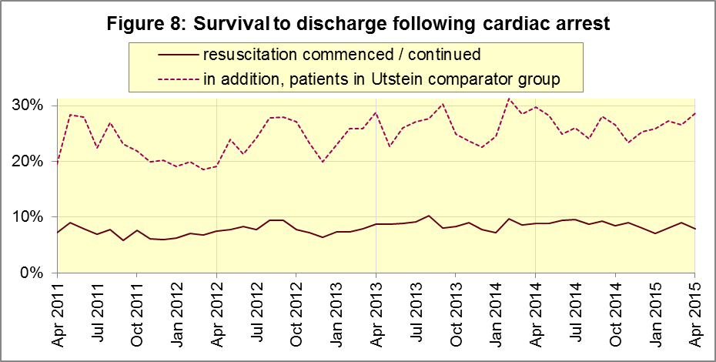
For annual data, the proportion across England increased slowly from 7% in 2011-12 to 9% in 2014-15 (Figure 9).
South Central had the highest proportions the last three years, including 17% in 2014-15, and was highest again in the month of April 2015 with 11%. North East and East Midlands were lowest across 2014-15 with 5% each, and East Midlands had the lowest proportion (4%) in April 2015.

Figure 9: survival following cardiac arrest: annual trust-level data, all patients
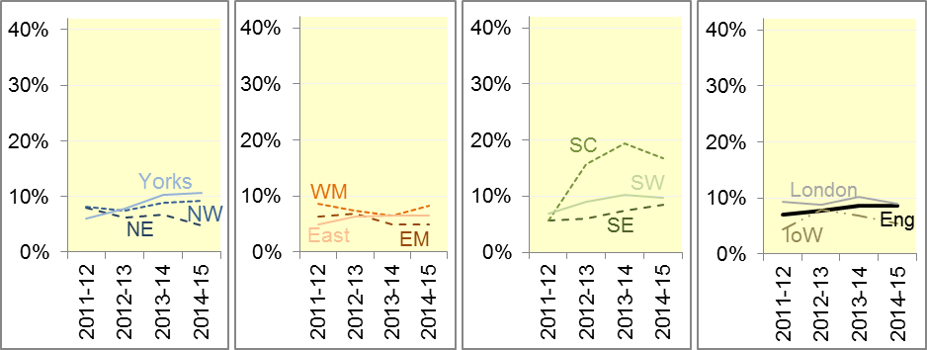
For the Utstein group, the England proportion also increased slowly, from 22% in 2011-12 to 26% in 2014-15 (Figure 10). Yorkshire was highest in 2014-15 with 41%, and also in April 2015, with 45%. East Midlands was lowest in 2014-15 with 16%, and South East Coast was lowest in April 2015 with 17%.

Figure 10: survival following cardiac arrest: trust-level data, Utstein group
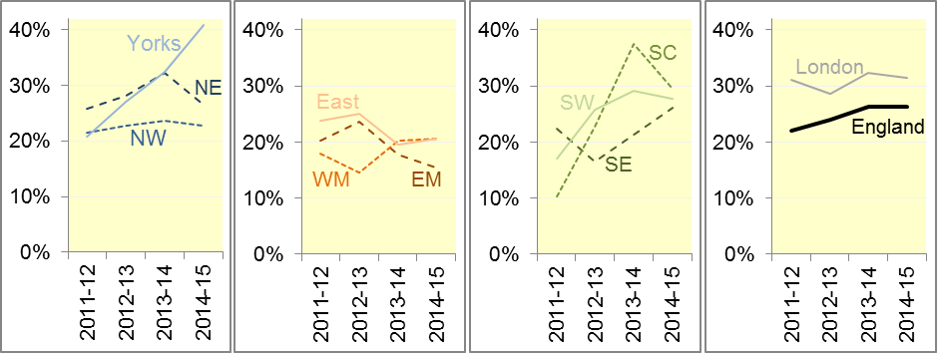

B3 ST-Elevation myocardial infarction
ST-segment elevation myocardial infarction (STEMI) is a type of heart attack, determined by an electrocardiogram (ECG) test. Early access to reperfusion, where blocked arteries are opened to re-establish blood flow, and other assessment and care interventions, are associated with reductions in STEMI mortality and morbidity.

Of 963 STEMI patients that received primary angioplasty in April 2015 in England, 817 (85%) of them received it within 150 minutes of the call being connected to the ambulance service (Figure 11). This is not quite significantly less than the average for 2014-15 of 87%.
In April 2015, of 1,582 patients with an acute STEMI in England, 1,187 (75%) received the appropriate care bundle. This was significant less than the average for 2014-15 of 80%.
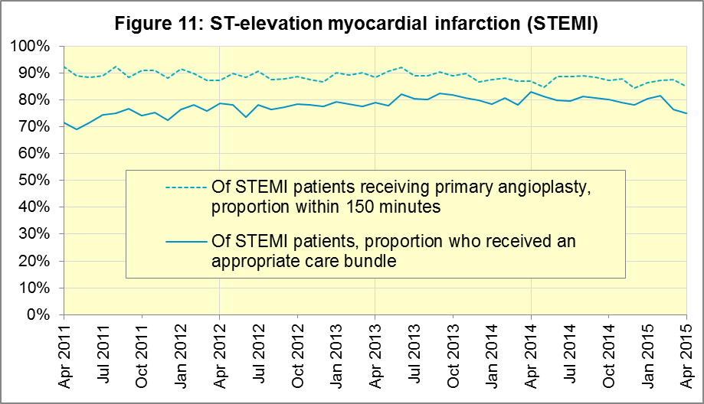
Financial year data for all England (Figure 12) show, for patients receiving angioplasty, the proportion receiving it within 150 minutes has decreased from 90% in 2011-12 to 87% in 2014-15.

Figure 12: angioplasty within 150 minutes of STEMI: annual trust-level data
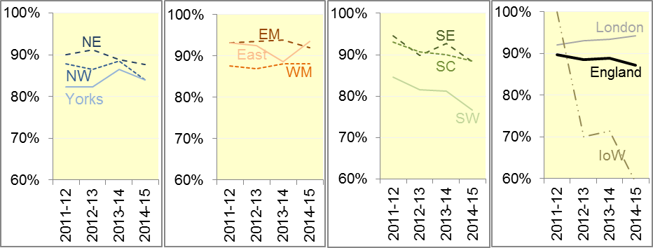
For the last three years this proportion was lowest for South Western, where it decreased to 77% in 2014-15, and where it was lowest again in April 2015 at 76%. In 2014-15 this proportion was highest for London, at 94%, although in April 2015 the highest proportion was 93% for East Midlands.
The proportion of STEMI patients across England receiving the appropriate care bundle increased from 74% in 2011-12 to 80% in 2013-14 and 2014-15 (Figure 13). North East had the highest proportion in 2014-15 and again in April 2015 (both 90%). However, it decreased in some Trusts, and South Central had the lowest proportion in 2014-15 (66%) and in April 2015 (48%).

Figure 13: Care bundle after STEMI: annual trust-level data
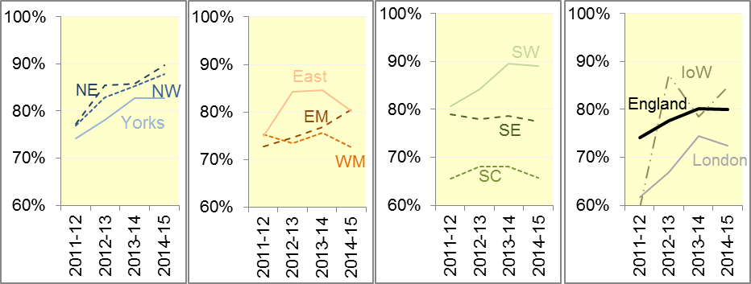

B4 Stroke
The FAST procedure helps assess whether someone has suffered a stroke:
- Facial weakness: can the person smile? Has their mouth or eye drooped?
- Arm weakness: can the person raise both arms?
- Speech problems: can the person speak clearly and understand what you say?
- Time to call 999 for an ambulance if you spot any one of these signs.
In April 2015, of 2,586 FAST positive patients in England, assessed face to face, and potentially eligible for stroke thrombolysis within agreed local guidelines, 1,500 (58%) arrived at hospitals with a hyperacute stroke unit within 60 minutes of an emergency call connecting to the ambulance service (Figure 14). This was similar to the average for 2014-15 of 59%.
We have received no data from North West for April 2015, which has also informed us that its supplied numerators and denominators from January 2015 onwards are likely to need revising upwards. We aim to include any such revisions with the next scheduled Clinical Outcome revisions in March 2016.
Excluding those, there were 6,270 stroke patients assessed face to face in April 2015 in England, and 6,114 (98%) received the appropriate care bundle, similar to the average for 2014-15 of 97%.
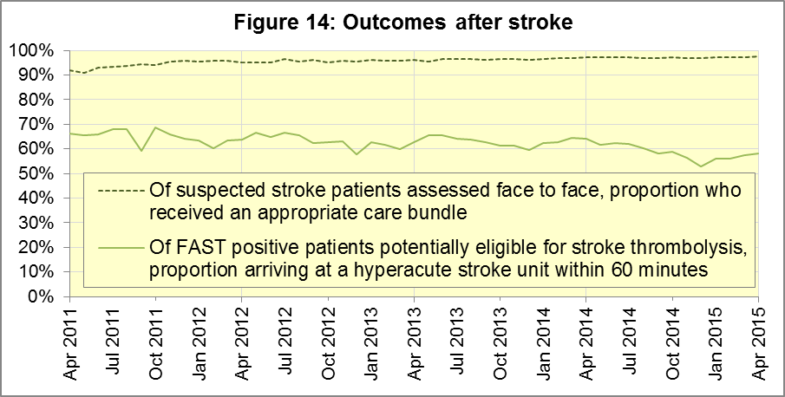
Financial year data across England show that the thrombolysis proportion decreased from 65% to 59% in 2014-15 (Figure 15). The lowest proportion was for West Midlands in 2014-15 (47%), and again in April 2015 (32%). The highest proportion was for North East in 2014-15 (68%), and again in April 2015 (70%).

Figure 15: thrombolysis within 60 minutes of stroke: annual trust-level data
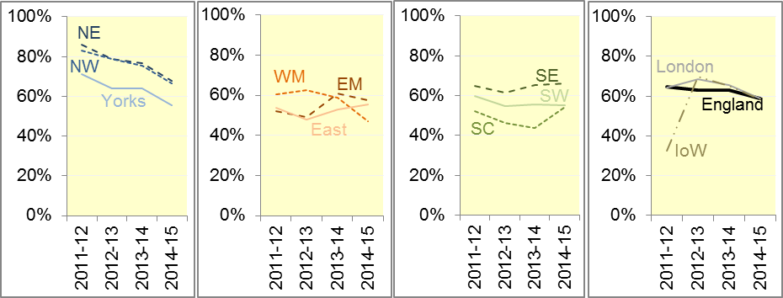

Figure 16: Care bundle after stroke: annual trust-level data
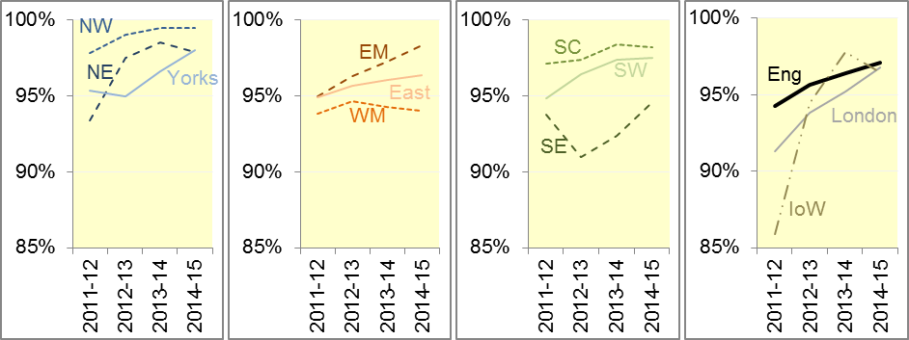
The proportion of stroke patients receiving the appropriate care bundle exceeded 90% in each Trust in each year since 2012-13 (Figure 16), and was at least 94% in each Trust in 2014-15, and again at least 94% in the month of April 2015.

B5 Revisions
Five Trusts (North West, East Midlands, West Midlands, London and South East Coast) have supplied us with revisions to 2014-15 data, which are included in the data in Section B above. The largest revisions are for the survival indicators (Figures 19 and 20) and the angioplasty indicator (Figure 21).

Figure 17: Revisions to ROSC after cardiac arrest (all patients), England

Figure 18: Revisions to ROSC after cardiac arrest (Utstein group), England
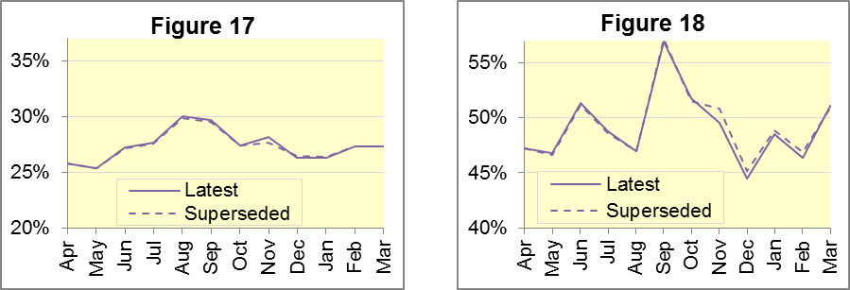

Figure 19: Revisions to Survival after cardiac arrest (all patients), England

Figure 20: Revisions to Survival after cardiac arrest (Utstein group), England
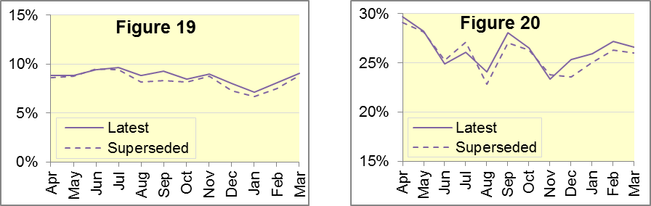

Figure 21: Revisions to angioplasty within 150 minutes of STEMI, England

Figure 22: Revisions to STEMI patients given care bundle, England
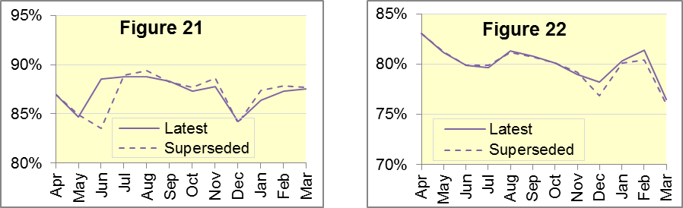

Figure 23: Revisions to Thrombolysis within 60 minutes of stroke, England

Figure 24: Revisions to stroke patients given care bundle, England
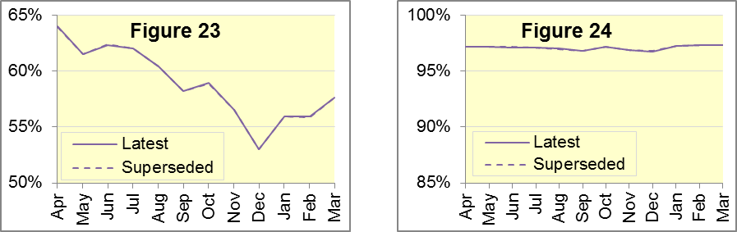

Figure 25: Revisions of more than 10% points to Trust-level monthly data
Trust | Indicator | Month | From | To
North West | STEMI Angioplasty within 150 minutes | Jun | 53.8% | 83.1%
London | Survival after cardiac arrest (Utstein) | Dec | 21.6% | 35.6%
South East Coast | Survival after cardiac arrest (Utstein) | Jul | 41.9% | 31.3%
 |  | Sep | 25.9% | 38.7%
 |  | Nov | 31.3% | 15.6%
 | STEMI patients receiving care bundle | Dec | 69.1% | 80.2%
 |  | Feb | 68.9% | 79.8%
 | ROSC following cardiac arrest (Utstein) | Feb | 46.7% | 36.4%

Figure 26: Revisions of more than 1 percentage point to England monthly data
Indicator | Month | From | To
STEMI Angioplasty within 150 minutes | Jun | 83.5% | 88.5%
Survival following cardiac arrest (Utstein) | Jul | 27.1% | 26.0%
 | Aug | 22.8% | 24.1%
 | Sep | 27.0% | 28.1%
 | Dec | 23.5% | 25.3%
STEMI patients receiving the appropriate care bundle | Dec | 76.8% | 78.2%
ROSC following cardiac arrest (Utstein) | Nov | 50.8% | 49.5%

C. Further information on AQI

C1 The AQI landing page and Quality Statement
www.england.nhs.uk/statistics/statistical-work-areas/ambulance-quality-indicators, or http://bit.ly/NHSAQI, is the AQI landing page, and it holds:
- a Quality Statement for these statistics, which includes information on relevance, accuracy, timeliness, coherence, and user engagement;
- the specification guidance document for those who supply the data;
- timetables for data collection and publication;
- text files and time series spreadsheets containing all data from April 2011 up to the latest month;
- links to individual web pages for each financial year.
The web pages for each financial year hold:
- separate spreadsheets of each month’s data;
- this Statistical Note, and equivalent versions from previous months;
- the list of people with pre-release access to the data.
Publication dates are also at www.gov.uk/government/statistics/announcements.

C2 Revisions
Revisions usually follow a six-monthly cycle. The dates for past and future AQI scheduled revisions are below. The AQI Quality Statement above contains a more detailed revisions policy.
Publication date |  | Series revised |  | Months affected
12 May 2016 |  | Systems Indicators |  | April 2015 to February 2016
10 March 2016 |  | Clinical Outcomes |  | April 2015 to September 2015
12 November 2015 |  | Systems Indicators |  | April 2015 to August 2015
10 September 2015 |  | Clinical Outcomes |  | April 2014 to March 2015
4 June 2015 |  | Systems Indicators |  | April 2014 to February 2015
30 April 2015 |  | Systems Indicators |  | April 2014 to February 2015
5 March 2015 |  | Clinical Outcomes |  | April 2014 to September 2014
6 November 2014 |  | Systems Indicators |  | April 2013 to August 2014
5 September 2014 |  | Clinical Outcomes |  | April 2013 to March 2014
2 May 2014 |  | Systems Indicators |  | April 2013 to February 2014
7 March 2014 |  | Clinical Outcomes |  | April 2013 to September 2013
1 November 2013 |  | Systems Indicators |  | April 2013 to August 2013
2 August 2013 |  | Clinical Outcomes |  | April 2012 to March 2013
3 May 2013 |  | Systems Indicators |  | April 2012 to March 2013
1 February 2013 |  | Clinical Outcomes |  | April 2012 to August 2012
11 January 2013 |  | Systems Indicators |  | April 2011 to October 2012
31 August 2012 |  | Clinical Outcomes |  | April 2011 to March 2012

C3 AQI Scope
The AQI include calls made by dialling either the usual UK-wide number 999 or its international equivalent 112.
As described in the specification guidance in section C1, calls made to NHS 111 are not included in the AQI measures for calls abandoned, re-contacts, frequent callers, time to answer calls and calls resolved by telephone advice.
All other Systems Indicators involve the dispatch of an ambulance, and include ambulances dispatched as a result of a call to NHS 111, as well as 999 or 112.

C4 Related statistics in England
The AQI appear in a Clinical Dashboard, available from the AQI landing page, the websites of the Ambulance Trusts (listed in the AQI Quality Statement), and http://aace.org.uk/national-performance/national-clinical-dashboards. One of the aims of these Dashboards is to use statistical process control, to indicate whether variation in proportions reflects underlying change, or merely natural variance, unavoidable even when a health system is performing well.
The AQI are also used in the “Ambulance Services” publication by the Health and Social Care Information Centre (HSCIC), which includes additional annual analysis and commentary. Until March 2013, the HSCIC publication used the KA34 data collection, which was similar to the AQI Systems Indicators, but annual rather than monthly. After that date, the HSCIC publication used AQI data. www.hscic.gov.uk/article/2021/Website-Search?q=ambulance+-accident&sort=Title
Ambulance handover delays of over 30 minutes at each Emergency Department were collected and published by NHS England each winter: www.england.nhs.uk/statistics/statistical-work-areas/winter-daily-sitreps
The AQI Quality Statement described in section C1 contains more information on the HSCIC publication. It also contains details of weekly ambulance situation reports that NHS England collected for six months from November 2010.

C5 Rest of United Kingdom
Ambulance statistics for other countries of the UK can be found at the following websites. The AQI Quality Statement described in section C1 contains more information about the comparability of these statistics.
Wales: | http://wales.gov.uk/statistics-and-research/ambulance-services/?lang=en
Scotland: | See Quality Improvement Indicators (QII) documents at www.scottishambulance.com/TheService/BoardPapers.aspx
Northern Ireland: | www.dhsspsni.gov.uk/index/statistics/hospital/emergency-care/ambulance-statistics.htm

C6 Contact information
For press enquiries, please contact the NHS England press office on 0113 825 0958 or nhsengland.media@nhs.net.
The statistician responsible for producing this publication is:
Ian Kay, Operational Information for Commissioning (National), NHS England
Room 5E24, Quarry House, Leeds, LS2 7UE; 0113 825 4606; i.kay@nhs.net

C7 National Statistics
The UK Statistics Authority has designated these statistics as National Statistics, in accordance with the Statistics and Registration Service Act 2007 and signifying compliance with the Code of Practice for Official Statistics.
Designation can be broadly interpreted to mean that the statistics:
- meet identified user needs;
- are well explained and readily accessible;
- are produced according to sound methods; and
- are managed impartially and objectively in the public interest.
Once statistics have been designated as National Statistics it is a statutory requirement that the Code of Practice shall continue to be observed.

Page 34 of the July 2015 Handbook to the NHS Constitution has Ambulance response time standards, www.gov.uk/government/publications/the-nhs-constitution-for-england.
On 1 June 2012, Category A (immediately life-threatening) calls were split into Red 1 and Red 2. Red 1 calls are the most time critical, and cover cardiac arrest patients who are not breathing and do not have a pulse, and other severe conditions such as airway obstruction. Red 2 calls are serious, but less immediately time critical, and cover conditions such as stroke and fits. www.gov.uk/government/news/changes-to-ambulance-response-time-categories Due to the differences in clock start definitions for Red 1 and Red 2 it is not possible to aggregate them into a single proportion for Category A against the 8 minute standard.
Dispatch on Disposition pilot announcement: www.parliament.uk/business/publications/written-questions-answers-statements/written-statement/Commons/2015-01-16/HCWS201 (January 2015). For more information, see the 9 April, 30 April or 4 June 2015 AQI Statistical Notes.
The number of emergency calls presented to switchboard does not usually include calls made to NHS 111 requiring an ambulance. 111 calls requiring an ambulance are usually transferred electronically direct to ambulance dispatch, and not routed via 999 call handlers. Occasionally, manual requests for ambulance are made between 111 and 999 call handlers, and such calls are included in the number of emergency calls presented to switchboard.
Type 1 are consultant-led 24 hour emergency departments with full resuscitation facilities. Type 2 offer a consultant-led speciality A&E service such as ophthalmology or dental. Type 3 is A&E / minor injury activity that may be doctor-led or nurse-led. Type 4 are NHS walk-in centres. (www.datadictionary.nhs.uk/data_dictionary/attributes/a/acc/ accident_and_emergency_department_type_de.asp)
Due to its small size, performance on Isle of Wight tends to vary more than other trusts. If it has the largest or smallest value, the Table in A5 shows the second largest or smallest value, but has a footnote marker to show that Isle of Wight is more extreme. The Clinical Outcomes in section B also use this system.
This definition was proposed at Utstein Abbey in Norway by an international group of cardiologists and other health professionals in 1990. http://circ.ahajournals.org/content/84/2/960.citation
Significance calculations throughout this document use t-tests with 95% confidence.
Excluding Isle of Wight. See footnote 6 on page 5.
Excluding Isle of Wight. See footnote 6 on page 5. For the Utstein group, Isle of Wight has fewer than 50 patients each year, and is therefore omitted from Figures 7 and 10.
Pages 27 to 30 of the specification guidance for data suppliers on the AQI landing page at www.england.nhs.uk/statistics/statistical-work-areas/ambulance-quality-indicators describe the care bundles, and certain exclusions, for the STEMI and stroke indicators.
Excluding Isle of Wight. See footnote 6 on page 5.

