Statistical Note: Ambulance Quality Indicators (AQI)
- The latest Systems Indicators for September 2015 for Ambulance Services in England showed the standards in the Handbook to the NHS constitution were not met, although there was an increase in calls resolved by telephone advice.
- The latest Clinical Outcomes data for patients transported by Ambulance Services for June 2015 showed, for patients who had resuscitation by ambulance service following a cardiac arrest, a significant increase in the proportion, who were discharged from hospital alive.

A. Systems Indicators

A1 Emergency response in 8 minutes (Figure 1)
In September 2015, of Category A Red 1 calls in England resulting in an emergency response, the proportion arriving within 8 minutes was 72.9%.
In September 2015, of Category A Red 2 calls in England resulting in an emergency response, the proportion arriving within 8 minutes was 68.9%.
Red 2 data from February 2015 onwards are not completely comparable across England; see section A2 on the Dispatch on Disposition pilot.
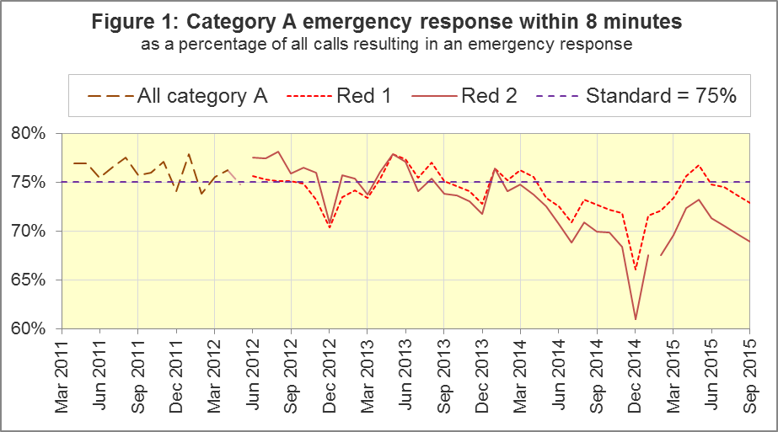
The standard for Ambulance Services is to send an emergency response, with a defibrillator, within 8 minutes to 75% of Category A calls. Figure 1 shows that for England, Red 1 performance was below 75% in the last four months in a row, and decreased to 72.9% in September 2015.
For Red 1, four trusts had proportions exceeding 75%: North West (78.4%), West Midlands (78.6%), South Western (75.0%) and Isle of Wight (78.6%). Two trusts had proportions of less than 70%: London (62.2%) and South Central (68.7%).

A2 Dispatch on Disposition (DoD) pilot (Figure 2)
Because of the DoD pilot, from 10 February 2015 onwards, London Ambulance Service (LAS) and South Western Ambulance Service (SWAS) data for the 8 minute Red 2 measure are not comparable with other services.
Figure 2 shows the Red 2 measure including and excluding the affected trusts. For all England, it decreased from 69.7% in August 2015 to 68.9% in September 2015. With LAS and SWAS excluded, the September 2015 performance was 70.5%, down from 70.8% in August.
In September 2015, two trusts had greater than 75% of Red 2 responses within 8 minutes: West Midlands (75.1%) and Isle of Wight (75.8%). Four had fewer than 70%: East Midlands (66.2%), East of England (58.7%), London (62.1%) and South Western (68.1%).
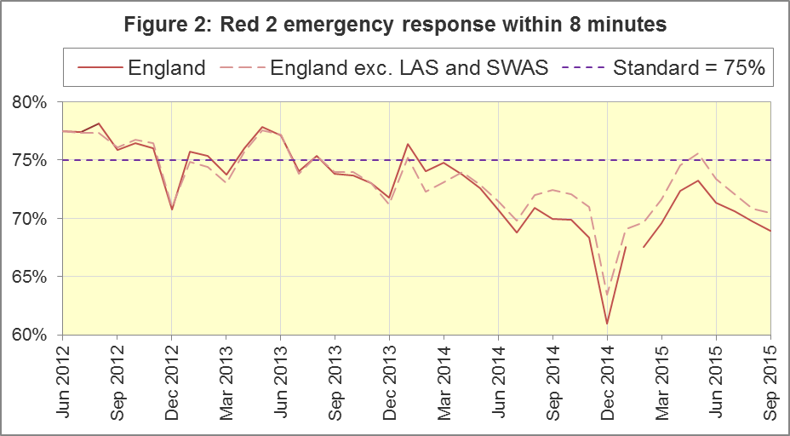
Red 2 calls comprise the vast majority of Category A calls, so the DoD pilot affects not only the 8 minute Red 2 measure, but also the 19 minute Category A measure.

A3 Category A Ambulance response in 19 minutes (Figure 3)
The other ambulance standard in the Handbook to the NHS Constitution is for trusts to send, within 19 minutes, a fully-equipped ambulance vehicle, able to transport the patient in a clinically safe manner, to 95% of Category A calls. Figure 3 shows for England as a whole, this measure decreased from 93.5% in August 2015 to 93.2% in September 2015. Excluding LAS and SWAS, the decrease was similar, from 93.9% to 93.6%.
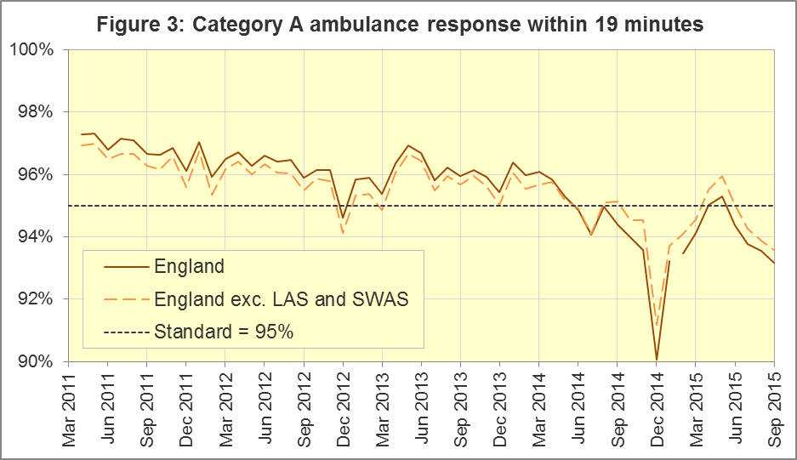
West Midlands had the largest proportion (96.9%) for this measure. Yorkshire (95.3%) and Isle of Wight (95.2%) also met the 95% standard. Two trusts reported less than 90%: East Midlands (89.6%) and East of England (88.9%).
The measurement of the other Systems Indicators is unaffected by the pilot.

A4 Systems Indicators: Ambulance volumes (Figure 4)
The number of emergency telephone calls presented to switchboard in September 2015 was 759,166, an average of 25.3 thousand per day, up from the 24.7 thousand per day for September 2014. Figure 4 shows that this measure often changes a lot from month to month.
There were 523,939 emergency calls that received a face-to-face response from the ambulance service in September 2015. This was an average of 17.5 thousand per day, similar to 17.4 thousand per day in September 2014.
There were 379,676 incidents with a patient transported to Type 1 or Type 2 A&E in September 2015, an average of 12.7 thousand per day, similar to 12.6 thousand per day in September 2014.
There were 260,181 Category A calls that resulted in a fully-equipped ambulance vehicle arriving at the scene of the incident in September 2015, this equates to 8.7 thousand per day. This was higher than the 8.2 thousand per day in September 2014. Figure 4 shows how this has increased steadily between 2011 and 2014, but has changed little in 2015.
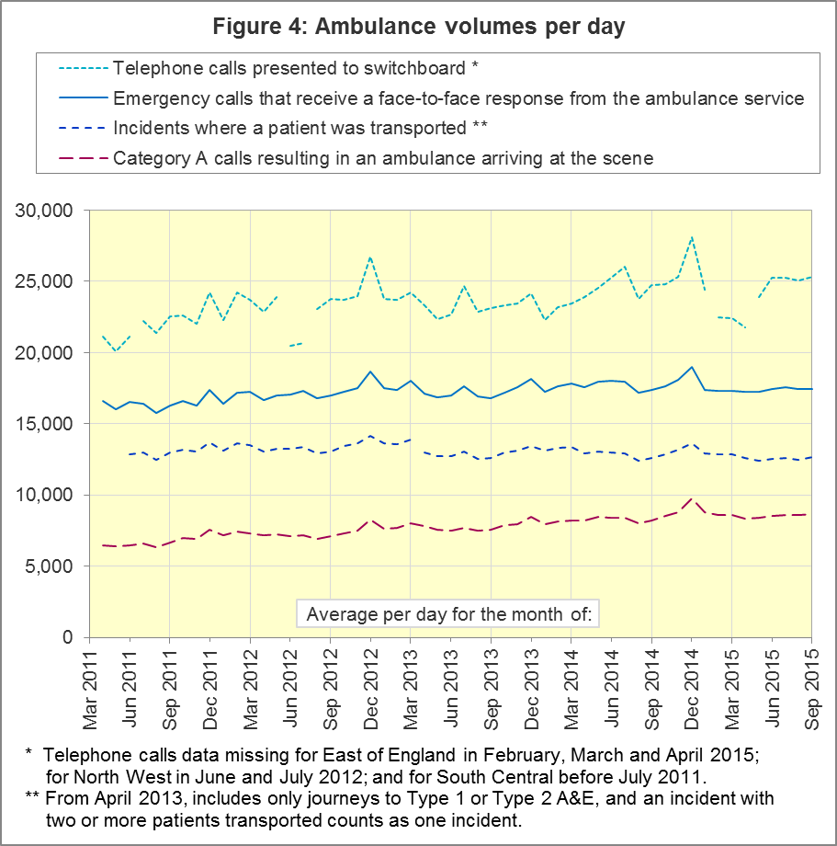

A5 Latest monthly data for other Systems Indicators, September 2015
Indicator | England | Lowest Trust |  | Highest Trust
Calls abandoned before being answered | 0.5% | London | 0.1% | South East | 1.1%
Calls resolved through telephone assessment | 10.1% | West Midlands | 5.1% | East Midlands | 15.4%
Calls resolved without transport to Type 1 or Type 2 A&E | 37.0% | East Midlands | 29.7% | South Western | 52.3%
Recontact rate following discharge by telephone advice | 6.6% | Yorkshire | 1.9% | West Midlands | 15.0%
Recontact rate following face-to-face treatment at scene | 5.4% | Yorkshire⁶ | 3.2% | London | 8.5%
Incidents where a patient was transported | 379,676 | North  East | 19,749 | London | 62,397

In September 2015, the proportion of calls resolved through telephone assessment was 10.1%, a significant increase on last year, and the highest proportion since monthly data collection began in April 2011.
Of emergency calls resolved with telephone advice, the proportion where the patient subsequently re-contacts 999 within 24 hours was 6.6% in September 2015, the lowest since monthly data collection began.

A6 Revisions
Every six months, Trusts can revise their Systems Indicators. September 2015 was the month in the revision timetable (Section C2) for Trusts to submit any revisions for the previous six months. No revisions were submitted by any of the trusts for any of the months.

B. Clinical Outcomes
No thresholds to denote “poor” care are set for Clinical Outcomes. Commissioners are expected to examine trends in these data, and work in collaboration with ambulance trusts to achieve sustained improvement in patient outcomes over time; but commissioners are not expected to use Clinical Outcomes to performance manage trusts, because there will be significant variations in the populations served.

B1 Cardiac arrest: return of spontaneous circulation (ROSC)
Patients in cardiac arrest will typically have no pulse and will not be breathing. In June 2015 in England, resuscitation was commenced or continued by ambulance staff out-of-hospital for 2,454 such patients. Of these, 733 (30%) had ROSC, with a pulse, on arrival at hospital (Figure 5), higher than the average for 2014-15 of 27%.
The largest proportion in June 2015 was 36% for North West. The smallest proportion was 25% for South Western.
The Utstein group comprises patients who had resuscitation commenced or continued by the Ambulance Services, following an out-of-hospital cardiac arrest of presumed cardiac origin, where the arrest was bystander witnessed, and the initial rhythm was Ventricular Fibrillation or Ventricular Tachycardia. The Utstein group therefore have a better chance of survival.
There were 342 such patients in England in June 2015, of which 180 (53%) had ROSC on arrival at hospital (Figure 5). This was not significantly different to the England average for 2014-15 of 49%. The largest⁸ proportion in the month of June 2015 was North East with 70%, and the smallest was 33% for East Midlands.

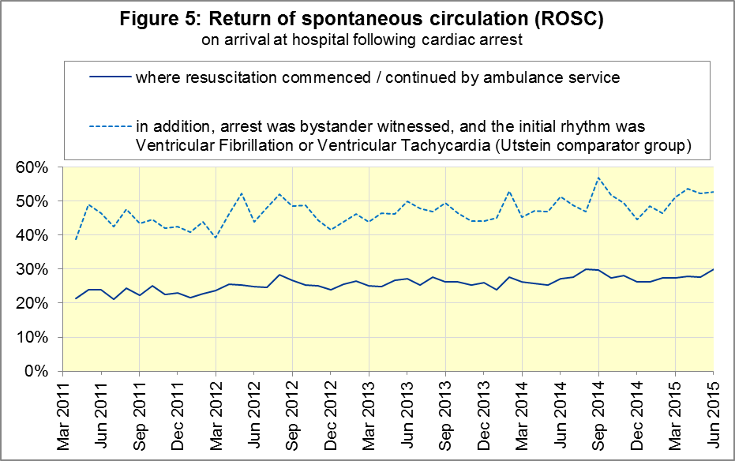

B2 Cardiac arrest: survival to discharge
The proportion of cardiac arrest patients in England discharged from hospital alive was 10% in June 2015 (Figure 6), just about a significant increase on the average for 2014-15 of 9%. The largest proportion in June 2015 was 16% for South Central, and the smallest was 6% for East Midlands.
For the Utstein group, survival to discharge in June 2015 was 30%, which was improved but not significantly different to the average for 2014-15 (26%). The largest proportion was 50% for Yorkshire, and the smallest was 10% for East Midlands.
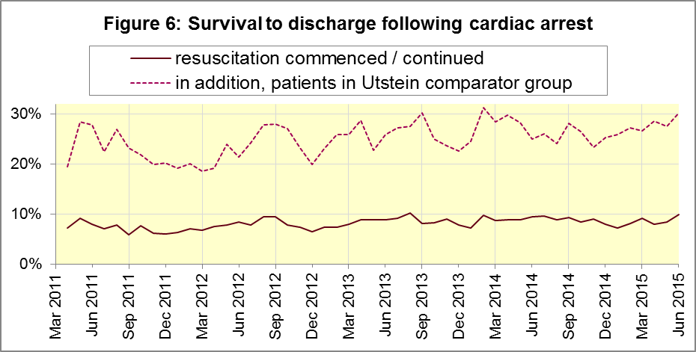

B3 ST-Elevation myocardial infarction
ST-segment elevation myocardial infarction (STEMI) is a type of heart attack, determined by an electrocardiogram (ECG) test. Early access to reperfusion, where blocked arteries are opened to re-establish blood flow, and other assessment and care interventions, are associated with reductions in STEMI mortality and morbidity.
Of 938 STEMI patients that received primary angioplasty in June 2015 in England, 827 (88%) of them received it within 150 minutes of the call being connected to the ambulance service (Figure 7), similar to the average for 2014-15 of 87%. The largest proportion for June 2015 was 94% for South East Coast, and the smallest¹⁰ was 77% for South Western.
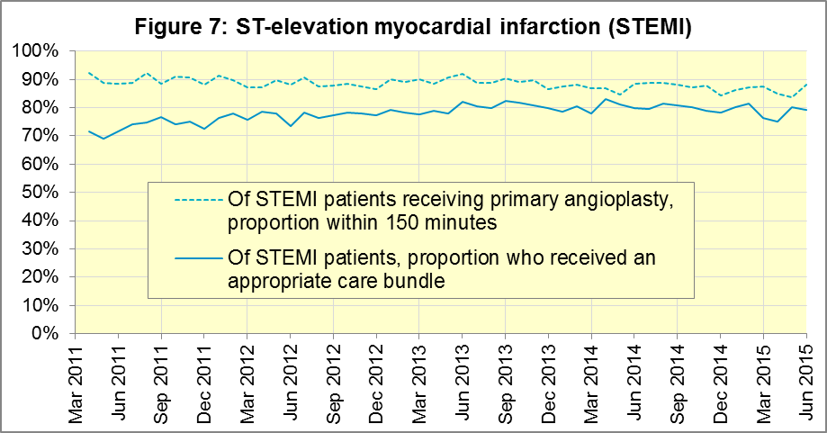
In June 2015, of 1,476 patients with an acute STEMI in England, 1,168 (79%) received the appropriate care bundle. This was similar to the average for 2014-15 of 80%. North West had the largest proportion with 90%, and the smallest was South Central with 62%.

B4 Stroke
The FAST procedure helps assess whether someone has suffered a stroke:
- Facial weakness: can the person smile? Has their mouth or eye drooped?
- Arm weakness: can the person raise both arms?
- Speech problems: can the person speak clearly and understand what you say?
- Time to call 999 for an ambulance if you spot any one of these signs.
In June 2015, of 3,486 FAST positive patients in England, assessed face to face, and potentially eligible for stroke thrombolysis within agreed local guidelines, 2,103 (60%) arrived at hospitals with a hyperacute stroke unit within 60 minutes of an emergency call connecting to the ambulance service, similar to the average for 2014-15 of 59%.
The largest proportion in the month of June 2015 was 72% for North West, and the smallest was 49% for South Central.
There were 8,242 stroke patients assessed face to face in June 2015 in England, and 8,055 (98%) received the appropriate care bundle, similar to the average for 2014-15 of 97%. All trusts had 95% or larger for this in June 2015.
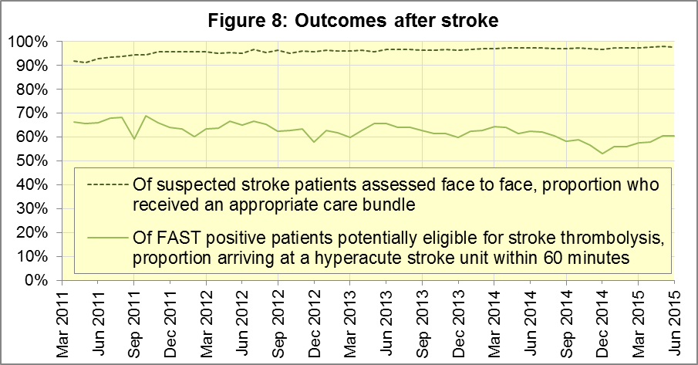

C. Further information on AQI

C1 The AQI landing page and Quality Statement
www.england.nhs.uk/statistics/statistical-work-areas/ambulance-quality-indicators, or http://bit.ly/NHSAQI, is the AQI landing page, and it holds:
- a Quality Statement for these statistics, which includes information on relevance, accuracy, timeliness, coherence, and user engagement;
- the specification guidance document for those who supply the data;
- timetables for data collection and publication;
- text files and time series spreadsheets containing all data from April 2011 up to the latest month;
- links to individual web pages for each financial year.
The web pages for each financial year hold:
- separate spreadsheets of each month’s data;
- this Statistical Note, and equivalent versions from previous months;
- the list of people with pre-release access to the data.
Publication dates are also at www.gov.uk/government/statistics/announcements.

C2 Revisions
Revisions usually follow a six-monthly cycle. The dates for past and future AQI scheduled revisions are below. The AQI Quality Statement above contains a more detailed revisions policy.
Publication date |  | Series revised |  | Months affected
12 May 2016 |  | Systems Indicators |  | April 2015 to February 2016
10 March 2016 |  | Clinical Outcomes |  | April 2015 to September 2015
10 September 2015 |  | Clinical Outcomes |  | April 2014 to March 2015
4 June 2015 |  | Systems Indicators |  | April 2014 to February 2015
30 April 2015 |  | Systems Indicators |  | April 2014 to February 2015
5 March 2015 |  | Clinical Outcomes |  | April 2014 to September 2014
6 November 2014 |  | Systems Indicators |  | April 2013 to August 2014
5 September 2014 |  | Clinical Outcomes |  | April 2013 to March 2014
2 May 2014 |  | Systems Indicators |  | April 2013 to February 2014
7 March 2014 |  | Clinical Outcomes |  | April 2013 to September 2013
1 November 2013 |  | Systems Indicators |  | April 2013 to August 2013
2 August 2013 |  | Clinical Outcomes |  | April 2012 to March 2013
3 May 2013 |  | Systems Indicators |  | April 2012 to March 2013
1 February 2013 |  | Clinical Outcomes |  | April 2012 to August 2012
11 January 2013 |  | Systems Indicators |  | April 2011 to October 2012
31 August 2012 |  | Clinical Outcomes |  | April 2011 to March 2012

C3 AQI Scope
The AQI include calls made by dialling either the usual UK-wide number 999 or its international equivalent 112.
As described in the specification guidance in section C1, calls made to NHS 111 are not included in the AQI measures for calls abandoned, re-contacts, frequent callers, time to answer calls and calls resolved by telephone advice.
All other Systems Indicators involve the dispatch of an ambulance, and include ambulances dispatched as a result of a call to NHS 111, as well as 999 or 112.

C4 Related statistics in England
The AQI appear in a Clinical Dashboard, available from the AQI landing page, the websites of the Ambulance Trusts (listed in the AQI Quality Statement), and http://aace.org.uk/national-performance/national-clinical-dashboards. One of the aims of these Dashboards is to use statistical process control, to indicate whether variation in proportions reflects underlying change, or merely natural variance, unavoidable even when a health system is performing well.
The AQI are also used in the “Ambulance Services” publication by the Health and Social Care Information Centre (HSCIC), which includes additional annual analysis and commentary. Until March 2013, the HSCIC publication used the KA34 data collection, which was similar to the AQI Systems Indicators, but annual rather than monthly. After that date, the HSCIC publication used AQI data. www.hscic.gov.uk/article/2021/Website-Search?q=ambulance+-accident&sort=Title
Ambulance handover delays of over 30 minutes at each Emergency Department were collected and published by NHS England each winter until 2014-15: www.england.nhs.uk/statistics/statistical-work-areas/winter-daily-sitreps
The AQI Quality Statement described in section C1 contains more information on the HSCIC publication. It also contains details of weekly ambulance situation reports that NHS England collected for six months from November 2010.

C5 Rest of United Kingdom
Ambulance statistics for other countries of the UK can be found at the following websites. The AQI Quality Statement described in section C1 contains more information about the comparability of these statistics.
Wales: | http://wales.gov.uk/statistics-and-research/ambulance-services/?lang=en
Scotland: | See Quality Improvement Indicators (QII) documents at www.scottishambulance.com/TheService/BoardPapers.aspx
Northern Ireland: | www.dhsspsni.gov.uk/index/statistics/hospital/emergency-care/ambulance-statistics.htm

C6 Contact information
For press enquiries, please contact the NHS England press office on 0113 825 0958 or nhsengland.media@nhs.net.
The statistician responsible for producing this publication is:
Ian Kay, Operational Information for Commissioning (National), NHS England
Room 5E24, Quarry House, Leeds, LS2 7UE; 0113 825 4606; i.kay@nhs.net

C7 National Statistics
The UK Statistics Authority has designated these statistics as National Statistics, in accordance with the Statistics and Registration Service Act 2007 and signifying compliance with the Code of Practice for Official Statistics.
Designation can be broadly interpreted to mean that the statistics:
- meet identified user needs;
- are well explained and readily accessible;
- are produced according to sound methods; and
- are managed impartially and objectively in the public interest.
Once statistics have been designated as National Statistics it is a statutory requirement that the Code of Practice shall continue to be observed.

Page 34 of the July 2015 Handbook to the NHS Constitution has Ambulance response time standards, www.gov.uk/government/publications/the-nhs-constitution-for-england.
On 1 June 2012, Category A (immediately life-threatening) calls were split into Red 1 and Red 2. Red 1 calls are the most time critical, and cover cardiac arrest patients who are not breathing and do not have a pulse, and other severe conditions such as airway obstruction. Red 2 calls are serious, but less immediately time critical, and cover conditions such as stroke and fits. www.gov.uk/government/news/changes-to-ambulance-response-time-categories Due to the differences in clock start definitions for Red 1 and Red 2 it is not possible to aggregate them into a single proportion for Category A against the 8 minute standard.
Dispatch on Disposition pilot announcement: www.parliament.uk/business/publications/written-questions-answers-statements/written-statement/Commons/2015-01-16/HCWS201 (January 2015). For more information, see the 30 April 2015 AQI Statistical Note.
The number of emergency calls presented to switchboard does not usually include calls made to NHS 111 requiring an ambulance. 111 calls requiring an ambulance are usually transferred electronically direct to ambulance dispatch, and not routed via 999 call handlers. Occasionally, manual requests for ambulance are made between 111 and 999 call handlers, and such calls are included in the number of emergency calls presented to switchboard.
Type 1 are consultant-led 24 hour emergency departments with full resuscitation facilities. Type 2 offer a consultant-led speciality A&E service such as ophthalmology or dental. Type 3 is A&E / minor injury activity that may be doctor-led or nurse-led. Type 4 are NHS walk-in centres. (www.datadictionary.nhs.uk/data_dictionary/attributes/a/acc/ accident_and_emergency_department_type_de.asp)
Due to its small size, performance on Isle of Wight tends to vary more than other trusts. If it has the largest or smallest value, the Table in A5 shows the second largest or smallest value, but has a footnote marker to show that Isle of Wight is more extreme. The Clinical Outcomes in section B also use this system.
Significance calculations throughout this document use t-tests with 95% confidence.
Excluding Isle of Wight. See footnote 6 on page 5.
This definition was proposed at Utstein Abbey in Norway by an international group of cardiologists and other health professionals in 1990. http://circ.ahajournals.org/content/84/2/960.citation
Excluding Isle of Wight. See footnote 6 on page 5.
Pages 27 to 30 of the specification guidance for data suppliers on the AQI landing page at www.england.nhs.uk/statistics/statistical-work-areas/ambulance-quality-indicators describe the care bundles, and certain exclusions, for the STEMI and stroke indicators.
Excluding Isle of Wight. See footnote 6 on page 5.

