Statistical Note: Ambulance Quality Indicators (AQI)
- The latest Systems Indicators for October 2015 for Ambulance Services in England showed the standards in the Handbook to the NHS constitution were not met, although there was an increase in calls resolved by telephone advice.
- The latest Clinical Outcomes data for patients transported by Ambulance Services for July 2015 showed, for patients who were assessed face to face for suspected stroke, a significant increase in the proportion, who received an appropriate care bundle.

A. Systems Indicators

A1 Emergency response in 8 minutes (Figure 1)
In October 2015, of Category A Red 1 calls in England resulting in an emergency response, the proportion arriving within 8 minutes was 73.3%.
In October 2015, of Category A Red 2 calls in England resulting in an emergency response, the proportion arriving within 8 minutes was 68.8%.
Red 2 data from February 2015 onwards are not completely comparable across England; see section A2 on Dispatch on Disposition.
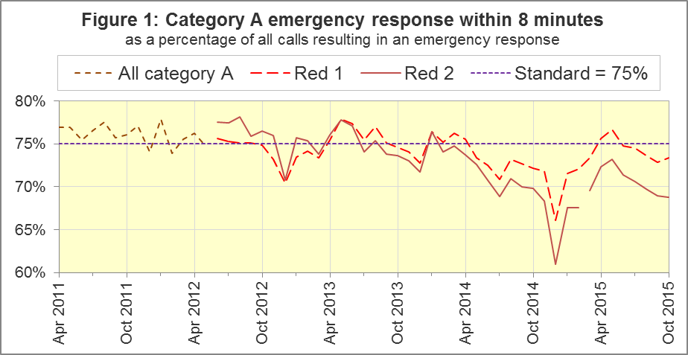
The standard for Ambulance Services is to send an emergency response, with a defibrillator, within 8 minutes to 75% of Category A calls. Figure 1 shows that for England, Red 1 performance was below 75% in the last five months in a row, although it increased to 73.3% in October 2015.
For Red 1, four trusts had proportions exceeding 75%: North West (75.9%), West Midlands (79.3%), South Western (76.7%) and Isle of Wight (79.5%). Two trusts had proportions of less than 70%: North East (63.6%) and East Midlands (66.7%).

A2 Dispatch on Disposition (DoD)
In January 2015, the Secretary of State for Health announced the introduction of Dispatch on Disposition (DoD), allowing up to two additional minutes for triage (to identify the clinical situation and take appropriate action). This was based upon clinical advice that it would be likely to improve the overall outcomes for ambulance patients.
For Red 1 calls, the clock start time is still the instant that the telephone call connects. However, from 10 February 2015, all other calls received by London Ambulance Service (LAS) and South Western Ambulance Service (SWAS) use DoD.
During October 2015, DoD was introduced in the Ambulance Services of North East (NEAS), Yorkshire (YAS), West Midlands (WMAS) and South Central (SCAS), and the potential extra time was increased further for SWAS.
Cohort | Clock start time, excluding Red 1
LAS and SWAS up to 10 February 2015;  NEAS, YAS, WMAS and SCAS up to October 2015;  continually used for the rest of England: | Earliest of:  - chief complaint or NHS Pathways initial disposition (Dx) code obtained;  - first vehicle assigned;  - 60 seconds after call connect.
LAS from 10 February 2015;  NEAS from 8 October 2015;  YAS from 21 October 2015;  WMAS and SCAS from 19 October 2015;  SWAS, 10 February to 5 October 2015: | Earliest of:  - chief complaint or NHS Pathways initial Dx code obtained;  - first vehicle assigned;  - 180 seconds after call connect.
SWAS from 5 October 2015: | Earliest of:  - chief complaint or NHS Pathways initial Dx code obtained;  - first vehicle assigned;  - 240 seconds after call connect.

The differing clock start times mean that data for the different cohorts are not comparable with each other. Red 2 calls comprise the vast majority of Category A calls, so 19 minute Category A data are also not comparable for different cohorts.
Figure 2 shows the Red 2 measure for each cohort.
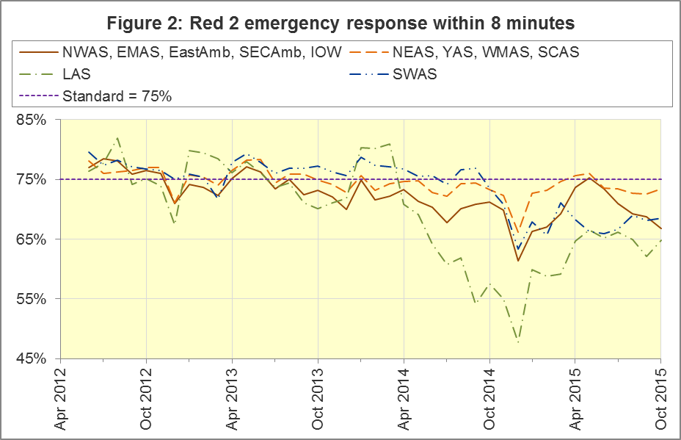
The numerators and denominators for the above proportions are displayed in the Systems Indicators Time Series spreadsheet at http://bit.ly/NHSAQI, on the “DoD R2” tab, and the “DoD A19” tab shows equivalent figures for the 19 minute measure below.
During the period 20th December 2014 to the 24th February 2014 South East Coast Ambulance Service NHS Foundation Trust (SECAmb) undertook a project to re-triage calls transferred into their 999 service from the NHS 111 service. NHS England investigation reports into this project are available at www.england.nhs.uk/south/our-work/ind-invest-reports.
In summary, Red 2 calls passed from NHS 111 to the 999 service were relabelled to a Red 3 category and were given an additional 10 minutes clinical triage before an ambulance was dispatched. Data initially submitted for this time period by SECAmb was subsequently revised. The clock start for the revised data is consistent with all other trusts: the instant that the ambulance request was received from the 111 service by the Ambulance Service. Given the additional time for triage of these passed calls it was less likely that the Category A Red 2 target of 8 minutes would be met for these calls.
The details of SECAmb performance and the revisions made by this provider are outlined in Section A10 of the March 2015 AmbSYS and December 2014 AmbCO Statistical Note published on the Ambulance Quality Indicators Data 2014-15 Web page, www.england.nhs.uk/statistics/statistical-work-areas/ambulance-quality-indicators/ambulance-quality-indicators-data-2014-15.

A3 Category A Ambulance response in 19 minutes (Figure 3)
The other ambulance standard in the Handbook to the NHS Constitution is for trusts to send, within 19 minutes, a fully-equipped ambulance vehicle, able to transport the patient in a clinically safe manner, to 95% of Category A calls. This measure is also affected by DoD. For England as a whole, this measure decreased to 93.0% in October 2015 from 93.2% in September 2015. The performance for providers not undertaking DoD was 91.6%.
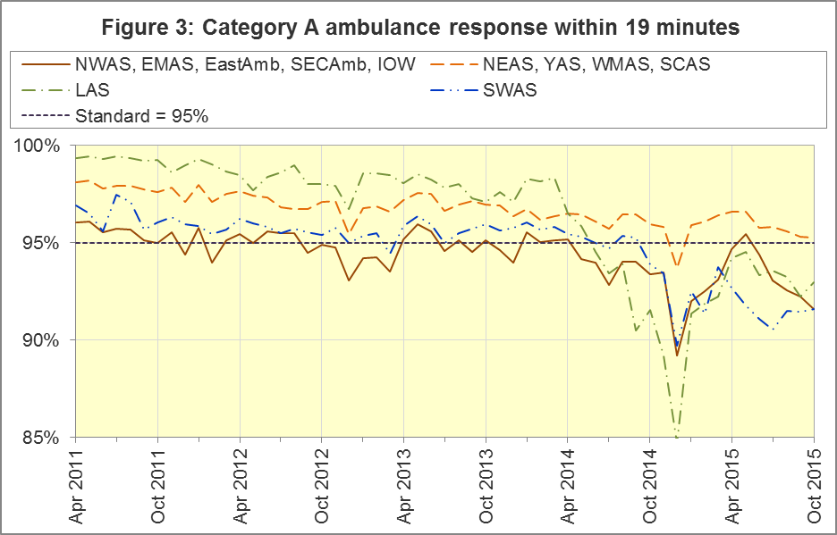
DoD does not affect how other indicators are measured, but it may lead to changes in the levels for other indicators. For example, a longer triage time may mean fewer ambulances dispatched, leading to better ambulance availability, and more timely responses to Red 1 calls. A longer triage time may also mean more calls are closed on the telephone. However, any such effects will be difficult to detect within the habitual variation of the many Ambulance Quality Indicators.

A4 Systems Indicators: Ambulance volumes (Figure 4)
The number of emergency telephone calls presented to switchboard in October 2015 was 801,122, an average of 25.8 thousand per day, up from the 24.8 thousand per day for October 2014 and the highest figure reported in 2015. Figure 4 shows that there is a fair amount variation in call volume.
There were 554,578 emergency calls that received a face-to-face response from the ambulance service in October 2015. This was an average of 17.9 thousand per day, this compares with 17.7 thousand per day in October 2014.
There were 401,682 incidents with a patient transported to Type 1 or Type 2 A&E in October 2015, an average of 13.0 thousand per day, similar to 12.9 thousand per day in October 2014.
There were 281,094 Category A calls that resulted in a fully-equipped ambulance vehicle arriving at the scene of the incident in October 2015, this equates to 9.1 thousand per day. This is higher than the 8.5 thousand per day in October 2014. Figure 4 shows how this has increased steadily between 2011 and 2014, but has changed little in 2015.
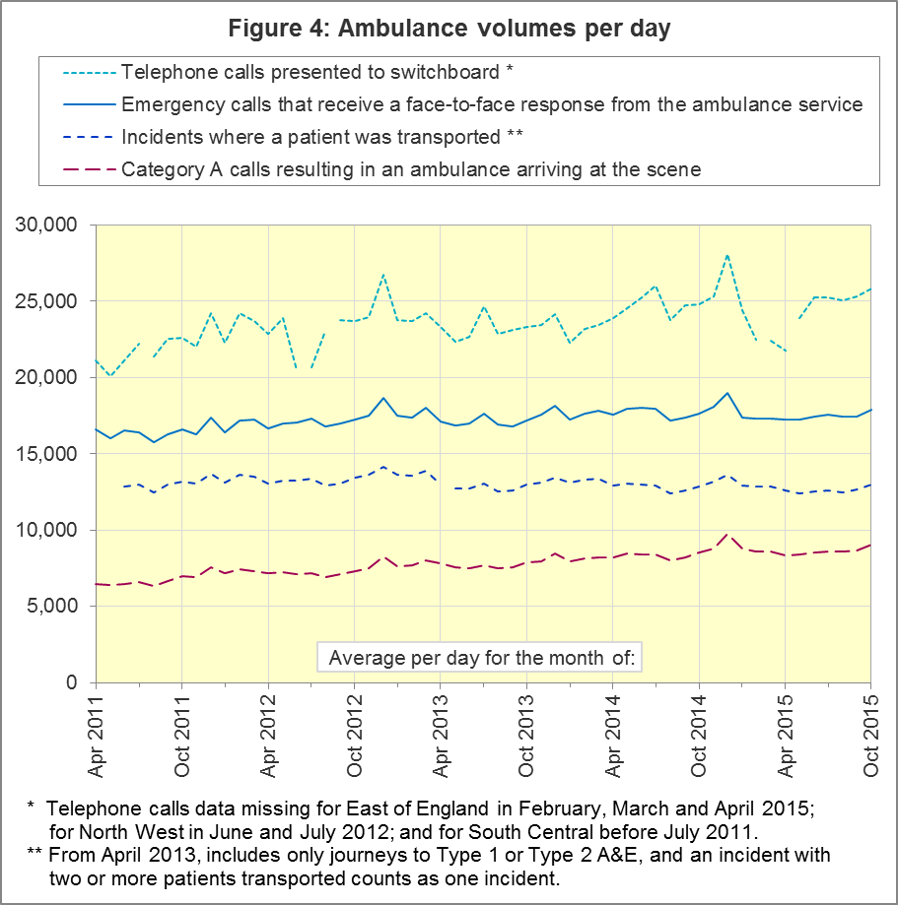

A5 Latest monthly data for other Systems Indicators, October 2015
Indicator | England | Lowest Trust |  | Highest Trust
Calls abandoned before being answered | 0.5% | London | 0.2% | Yorkshire | 1.0%
Calls resolved through telephone assessment | 10.3% | West Midlands | 5.3% | East Midlands | 15.7%
Calls resolved without transport to Type 1 or Type 2 A&E | 37.0% | East Midlands | 29.6% | South Western | 51.9%
Recontact rate following discharge by telephone advice | 6.1% | Yorkshire | 1.1% | West Midlands | 13.8%
Recontact rate following face-to-face treatment at scene | 5.2% | North West | 2.7% | London | 8.6%
Incidents where a patient was transported | 401,682 | North  East | 20,459 | London | 66,313

In October 2015, the proportion of calls resolved through telephone assessment was 10.3%, a significant increase on last year, and the highest proportion since monthly data collection began in April 2011.
Of emergency calls resolved with telephone advice, the proportion where the patient subsequently re-contacts 999 within 24 hours was 6.1% in October 2015, the lowest since monthly data collection began.

B. Clinical Outcomes
No thresholds to denote “poor” care are set for Clinical Outcomes. Commissioners are expected to examine trends in these data, and work in collaboration with ambulance trusts to achieve sustained improvement in patient outcomes over time; but commissioners are not expected to use Clinical Outcomes to performance manage trusts, because there will be significant variations in the populations served.

B1 Cardiac arrest: return of spontaneous circulation (ROSC)
Patients in cardiac arrest will typically have no pulse and will not be breathing. In July 2015 in England, resuscitation was commenced or continued by ambulance staff out-of-hospital for 2,428 such patients. Of these, 688 (27.5%) had ROSC, with a pulse, on arrival at hospital (Figure 5), similar to the average for 2014-15 of 27%.
The largest proportion in July 2015 was 32.9% for West Midlands. The smallest proportion was 22.0% for South Central.
The Utstein group comprises patients who had resuscitation commenced or continued by the Ambulance Services, following an out-of-hospital cardiac arrest of presumed cardiac origin, where the arrest was bystander witnessed, and the initial rhythm was Ventricular Fibrillation or Ventricular Tachycardia. The Utstein group therefore have a better chance of survival.
There were 309 such patients in England in July 2015, of which 156 (50.5%) had ROSC on arrival at hospital (Figure 5). This was not significantly different to the England average for 2014-15 of 49%. The largest⁸ proportion in the month of July 2015 was Yorkshire with 66%, and the smallest was 31% for North East.
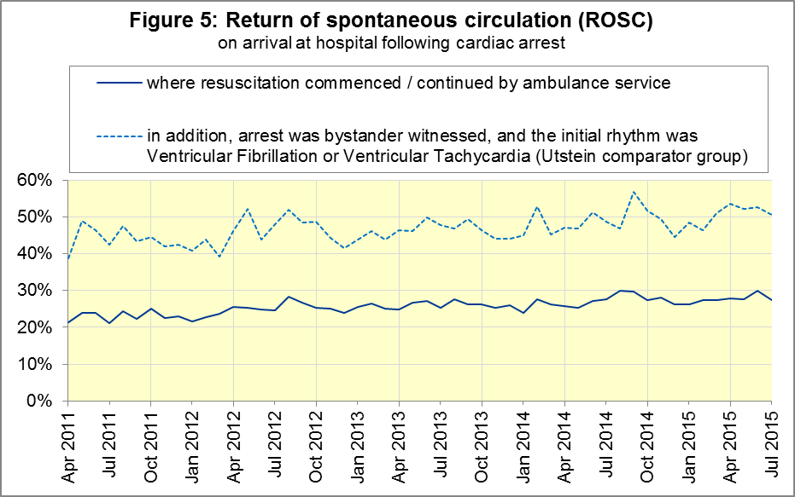

B2 Cardiac arrest: survival to discharge
The proportion of cardiac arrest patients in England discharged from hospital alive was 9% in July 2015 (Figure 6), the same as the average for 2014-15 of 9%. The largest proportion in July 2015 was 18% for South Central, and the smallest⁸ was 6% for North West.
For the Utstein group, survival to discharge in July 2015 was 26%, which was the same as the average for 2014-15 (26%). The largest proportion was 47% for South Central, and the smallest⁸ was 8% for North East.

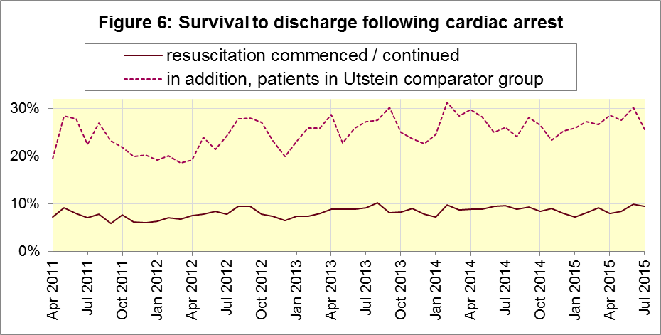

B3 ST-Elevation myocardial infarction
ST-segment elevation myocardial infarction (STEMI) is a type of heart attack, determined by an electrocardiogram (ECG) test. Early access to reperfusion, where blocked arteries are opened to re-establish blood flow, and other assessment and care interventions, are associated with reductions in STEMI mortality and morbidity.
Of 866 STEMI patients that received primary angioplasty in July 2015 in England, 756 (87%) of them received it within 150 minutes of the call being connected to the ambulance service (Figure 7), the same as the average for 2014-15 of 87%. The largest proportion for July 2015 was 98% for South Central, and the smallest was 75% for South Western.
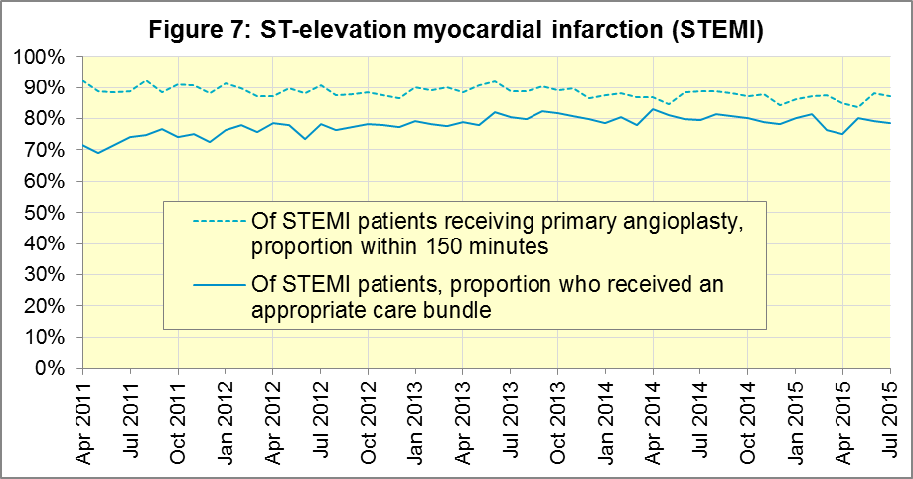
In July 2015, of 1,427 patients with an acute STEMI in England, 1,123 (79%) received the appropriate care bundle. This was similar to the average for 2014-15 of 80%. North East had the largest proportion with 93%, and the smallest was South Central with 60%.

B4 Stroke
The FAST procedure helps assess whether someone has suffered a stroke:
- Facial weakness: can the person smile? Has their mouth or eye drooped?
- Arm weakness: can the person raise both arms?
- Speech problems: can the person speak clearly and understand what you say?
- Time to call 999 for an ambulance if you spot any one of these signs.
In July 2015, of 3,255 FAST positive patients in England, assessed face to face, and potentially eligible for stroke thrombolysis within agreed local guidelines, 1,906 (59%) arrived at hospitals with a hyperacute stroke unit within 60 minutes of an emergency call connecting to the ambulance service, the same as the average for 2014-15 of 59%.
The largest proportion in the month of July 2015 was 71% for North East, and the smallest was 44% for South Western.
There were 7,504 stroke patients assessed face to face in July 2015 in England, and 7,347 (98%) received the appropriate care bundle, similar to the average for 2014-15 of 97%. This is the highest recorded proportion since monthly recording began and the proportion for all trusts was 95% or above in July 2015.
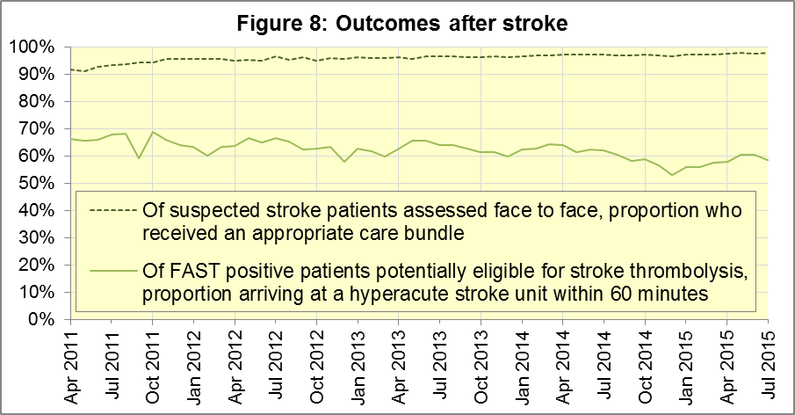

C. Further information on AQI

C1 The AQI landing page and Quality Statement
www.england.nhs.uk/statistics/statistical-work-areas/ambulance-quality-indicators, or http://bit.ly/NHSAQI, is the AQI landing page, and it holds:
- a Quality Statement for these statistics, which includes information on relevance, accuracy, timeliness, coherence, and user engagement;
- the specification guidance document for those who supply the data;
- timetables for data collection and publication;
- text files and time series spreadsheets containing all data from April 2011 up to the latest month;
- links to individual web pages for each financial year.
The web pages for each financial year hold:
- separate spreadsheets of each month’s data;
- this Statistical Note, and equivalent versions from previous months;
- the list of people with pre-release access to the data.
Publication dates are also at www.gov.uk/government/statistics/announcements.

C2 Revisions
Revisions usually follow a six-monthly cycle. The dates for past and future AQI scheduled revisions are below. The AQI Quality Statement above contains a more detailed revisions policy.
Publication date |  | Series revised |  | Months affected
12 May 2016 |  | Systems Indicators |  | April 2015 to February 2016
10 March 2016 |  | Clinical Outcomes |  | April 2015 to September 2015
10 September 2015 |  | Clinical Outcomes |  | April 2014 to March 2015
4 June 2015 |  | Systems Indicators |  | April 2014 to February 2015
30 April 2015 |  | Systems Indicators |  | April 2014 to February 2015
5 March 2015 |  | Clinical Outcomes |  | April 2014 to September 2014
6 November 2014 |  | Systems Indicators |  | April 2013 to August 2014
5 September 2014 |  | Clinical Outcomes |  | April 2013 to March 2014
2 May 2014 |  | Systems Indicators |  | April 2013 to February 2014
7 March 2014 |  | Clinical Outcomes |  | April 2013 to September 2013
1 November 2013 |  | Systems Indicators |  | April 2013 to August 2013
2 August 2013 |  | Clinical Outcomes |  | April 2012 to March 2013
3 May 2013 |  | Systems Indicators |  | April 2012 to March 2013
1 February 2013 |  | Clinical Outcomes |  | April 2012 to August 2012
11 January 2013 |  | Systems Indicators |  | April 2011 to October 2012
31 August 2012 |  | Clinical Outcomes |  | April 2011 to March 2012

C3 AQI Scope
The AQI include calls made by dialling either the usual UK-wide number 999 or its international equivalent 112.
As described in the specification guidance in section C1, calls made to NHS 111 are not included in the AQI measures for calls abandoned, re-contacts, frequent callers, time to answer calls and calls resolved by telephone advice.
All other Systems Indicators involve the dispatch of an ambulance, and include ambulances dispatched as a result of a call to NHS 111, as well as 999 or 112.

C4 Related statistics in England
The AQI appear in a Clinical Dashboard, available from the AQI landing page, the websites of the Ambulance Trusts (listed in the AQI Quality Statement), and http://aace.org.uk/national-performance/national-clinical-dashboards. One of the aims of these Dashboards is to use statistical process control, to indicate whether variation in proportions reflects underlying change, or merely natural variance, unavoidable even when a health system is performing well.
The AQI are also used in the “Ambulance Services” publication by the Health and Social Care Information Centre (HSCIC), which includes additional annual analysis and commentary. Until March 2013, the HSCIC publication used the KA34 data collection, which was similar to the AQI Systems Indicators, but annual rather than monthly. After that date, the HSCIC publication used AQI data. www.hscic.gov.uk/article/2021/Website-Search?q=ambulance+-accident&sort=Title
Ambulance handover delays of over 30 minutes at each Emergency Department were collected and published by NHS England each winter until 2014-15: www.england.nhs.uk/statistics/statistical-work-areas/winter-daily-sitreps
The AQI Quality Statement described in section C1 contains more information on the HSCIC publication. It also contains details of weekly ambulance situation reports that NHS England collected for six months from November 2010.

C5 Rest of United Kingdom
Ambulance statistics for other countries of the UK can be found at the following websites. The AQI Quality Statement described in section C1 contains more information about the comparability of these statistics.
Wales: | http://wales.gov.uk/statistics-and-research/ambulance-services/?lang=en
Scotland: | See Quality Improvement Indicators (QII) documents at www.scottishambulance.com/TheService/BoardPapers.aspx
Northern Ireland: | www.dhsspsni.gov.uk/index/statistics/hospital/emergency-care/ambulance-statistics.htm

C6 Contact information
For press enquiries, please contact the NHS England press office on 0113 825 0958 or nhsengland.media@nhs.net.
The statistician responsible for producing this publication is:
Ian Kay, Operational Information for Commissioning (National), NHS England
Room 5E24, Quarry House, Leeds, LS2 7UE; 0113 825 4606; i.kay@nhs.net

C7 National Statistics
The UK Statistics Authority has designated these statistics as National Statistics, in accordance with the Statistics and Registration Service Act 2007 and signifying compliance with the Code of Practice for Official Statistics.
Designation can be broadly interpreted to mean that the statistics:
- meet identified user needs;
- are well explained and readily accessible;
- are produced according to sound methods; and
- are managed impartially and objectively in the public interest.
Once statistics have been designated as National Statistics it is a statutory requirement that the Code of Practice shall continue to be observed.

Page 34 of the July 2015 Handbook to the NHS Constitution has Ambulance response time standards, www.gov.uk/government/publications/the-nhs-constitution-for-england.
On 1 June 2012, Category A (immediately life-threatening) calls were split into Red 1 and Red 2. Red 1 calls are the most time critical, and cover cardiac arrest patients who are not breathing and do not have a pulse, and other severe conditions such as airway obstruction. Red 2 calls are serious, but less immediately time critical, and cover conditions such as stroke and fits. www.gov.uk/government/news/changes-to-ambulance-response-time-categories Due to the differences in clock start definitions for Red 1 and Red 2 it is not possible to aggregate them into a single proportion for Category A against the 8 minute standard.
Dispatch on Disposition announcement: www.parliament.uk/business/publications/written-questions-answers-statements/written-statement/Commons/2015-01-16/HCWS201
The number of emergency calls presented to switchboard does not usually include calls made to NHS 111 requiring an ambulance. 111 calls requiring an ambulance are usually transferred electronically direct to ambulance dispatch, and not routed via 999 call handlers. Occasionally, manual requests for ambulance are made between 111 and 999 call handlers, and such calls are included in the number of emergency calls presented to switchboard.
Type 1 are consultant-led 24 hour emergency departments with full resuscitation facilities. Type 2 offer a consultant-led speciality A&E service such as ophthalmology or dental. Type 3 is A&E / minor injury activity that may be doctor-led or nurse-led. Type 4 are NHS walk-in centres. (www.datadictionary.nhs.uk/data_dictionary/attributes/a/acc/ accident_and_emergency_department_type_de.asp)
Due to its small size, performance on Isle of Wight tends to vary more than other trusts. If it has the largest or smallest value, the Table in A5 shows the second largest or smallest value, but has a footnote marker to show that Isle of Wight is more extreme. The Clinical Outcomes in section B also use this system.
Significance calculations throughout this document use t-tests with 95% confidence.
Excluding Isle of Wight. See footnote 6 on page 7.
This definition was proposed at Utstein Abbey in Norway by an international group of cardiologists and other health professionals in 1990. http://circ.ahajournals.org/content/84/2/960.citation
Excluding Isle of Wight. See footnote 6 on page 7.
Pages 27 to 30 of the specification guidance for data suppliers on the AQI landing page at www.england.nhs.uk/statistics/statistical-work-areas/ambulance-quality-indicators describe the care bundles, and certain exclusions, for the STEMI and stroke indicators.
Excluding Isle of Wight. See footnote 6 on page 7.

