Statistical Note: Ambulance Quality Indicators (AQI)
- The latest Systems Indicators for December 2015 for Ambulance Services in England showed the standards in the Handbook to the NHS constitution were not met. The proportion of incidents managed without need for transport to Accident and Emergency department was also the highest since April 2011.

A. Systems Indicators

A1 Emergency response in 8 minutes (Figure 1)
In December 2015, of Category A Red 1 calls in England resulting in an emergency response, the proportion arriving within 8 minutes was 72.6%.
In December 2015, of Category² A Red 2 calls in England resulting in an emergency response, the proportion arriving within 8 minutes was 67.2%.
Red 2 data from February 2015 onwards are not completely comparable across England; see section A2 on Dispatch on Disposition.
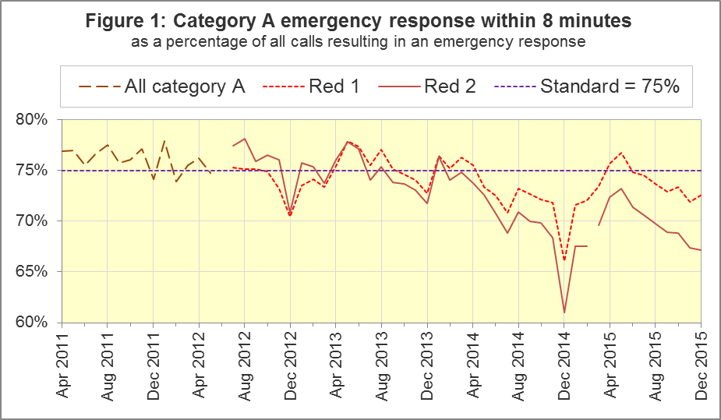
The standard for Ambulance Services is to send an emergency response, with a defibrillator, within 8 minutes to 75% of Category A calls. Figure 1 shows that for England, Red 1 performance increased to 72.6% in December 2015 although it has been below 75% for the past seven months.
For Red 1, two trusts had proportions exceeding 75%: West Midlands (79.0%) and South Western (75.3%). Four trusts had proportions of less than 70%: North East (61.5%), Yorkshire (69.0%), East Midlands (67.7%) and East of England (69.6%).

A2 Dispatch on Disposition (DoD)
In January 2015, the Secretary of State for Health announced the introduction of Dispatch on Disposition (DoD), allowing up to two additional minutes for triage (to identify the clinical situation and take appropriate action). This was based upon clinical advice that it would be likely to improve the overall outcomes for ambulance patients.
For Red 1 calls, the clock start time is still the instant that the telephone call connects. However, from 10 February 2015, all other calls received by London Ambulance Service (LAS) and South Western Ambulance Service (SWAS) use DoD.
During October 2015, DoD was introduced in the Ambulance Services of North East (NEAS), Yorkshire (YAS), West Midlands (WMAS) and South Central (SCAS), and the potential extra time was increased further for SWAS. Details of the clock start time for the various cohorts are shown in the table below.
Cohort | Clock start time, excluding Red 1
LAS and SWAS up to 10 February 2015;  NEAS, YAS, WMAS and SCAS up to October 2015;  continually used for the rest of England: | Earliest of:  - chief complaint or NHS Pathways initial disposition (Dx) code obtained;  - first vehicle assigned;  - 60 seconds after call connect.
LAS from 10 February 2015;  NEAS from 8 October 2015;  YAS from 21 October 2015;  WMAS and SCAS from 19 October 2015;  SWAS, 10 February to 5 October 2015: | Earliest of:  - chief complaint or NHS Pathways initial Dx code obtained;  - first vehicle assigned;  - 180 seconds after call connect.
SWAS from 5 October 2015: | Earliest of:  - chief complaint or NHS Pathways initial Dx code obtained;  - first vehicle assigned;  - 240 seconds after call connect.

The differing clock start times mean that data for the different cohorts are not comparable with each other. Red 2 calls comprise the vast majority of Category A calls, so 19 minute Category A data are also not comparable for different cohorts.
Figure 2 shows the Red 2 measure for each cohort.
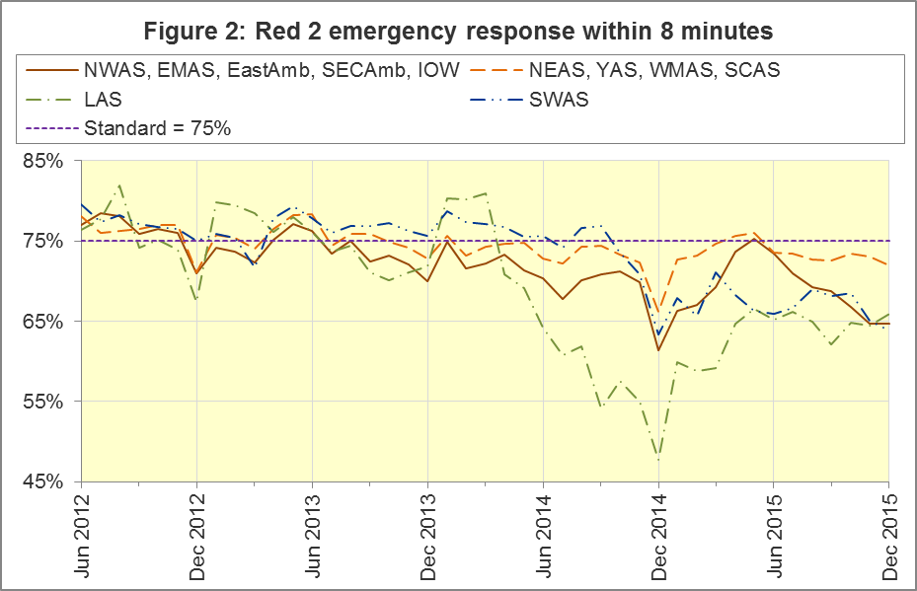
The numerators and denominators for the above proportions are displayed in the Systems Indicators Time Series spreadsheet at http://bit.ly/NHSAQI, on the “DoD R2” tab, and the “DoD A19” tab shows equivalent figures for the 19 minute measure below.
During the period 20th December 2014 to the 24th February 2014 South East Coast Ambulance Service NHS Foundation Trust (SECAmb) undertook a project to re-triage calls transferred into their 999 service from the NHS 111 service. A detailed description of this project can be found in the Ambulance Quality Indicators Statistical Note for October 2015, available at http://bit.ly/NHSAQI.

A3 Category A Ambulance response in 19 minutes (Figure 3)
The other ambulance standard in the Handbook to the NHS Constitution is for trusts to send, within 19 minutes, a fully-equipped ambulance vehicle, able to transport the patient in a clinically safe manner, to 95% of Category A calls. This measure is also affected by DoD. For England as a whole, this measure decreased to 92.5% in December 2015 from 92.6% in November 2015. The performance for providers not undertaking DoD was 91.3%.
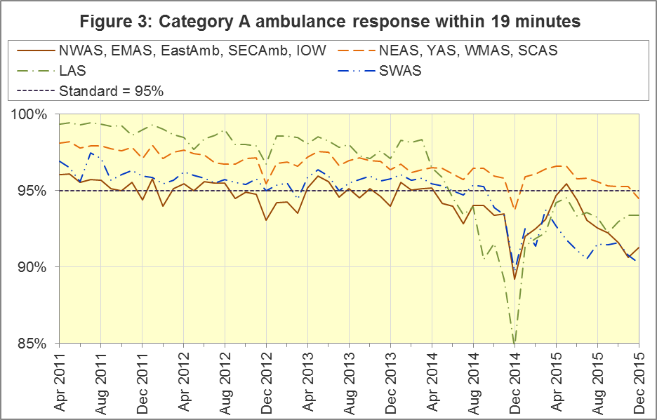
DoD does not affect how other indicators are measured, but it may lead to changes in the levels for other indicators. For example, a longer triage time may mean fewer ambulances dispatched, leading to better ambulance availability, and more timely responses to Red 1 calls. A longer triage time may also mean more calls are closed on the telephone. However, any such effects will be difficult to detect within the habitual variation of the many Ambulance Quality Indicators.

A4 Systems Indicators: Ambulance volumes (Figure 4)
The number of emergency telephone calls presented to switchboard in December 2015 was 819,183, an average of 26.4 thousand per day, lower than the 28.1 thousand per day for December 2014. December had the highest daily average reported in 2015. Figure 4 shows that there is a fair amount variation in call volume.
There were 597,322 emergency calls that received a face-to-face response from the ambulance service in December 2015. This was an average of 19.3 thousand per day, the highest figure recorded since these records began in April 2011.
There were 417,064 incidents with a patient transported to Type 1 or Type 2 A&E in December 2015, an average of 13.5 thousand per day, similar to 13.7 thousand per day in December 2014.
There were 304,756 Category A calls that resulted in a fully-equipped ambulance vehicle arriving at the scene of the incident in December 2015, this equates to 9.8 thousand per day. This is the highest figure since records began. Figure 4 shows how this has increased steadily between 2011 and 2015.
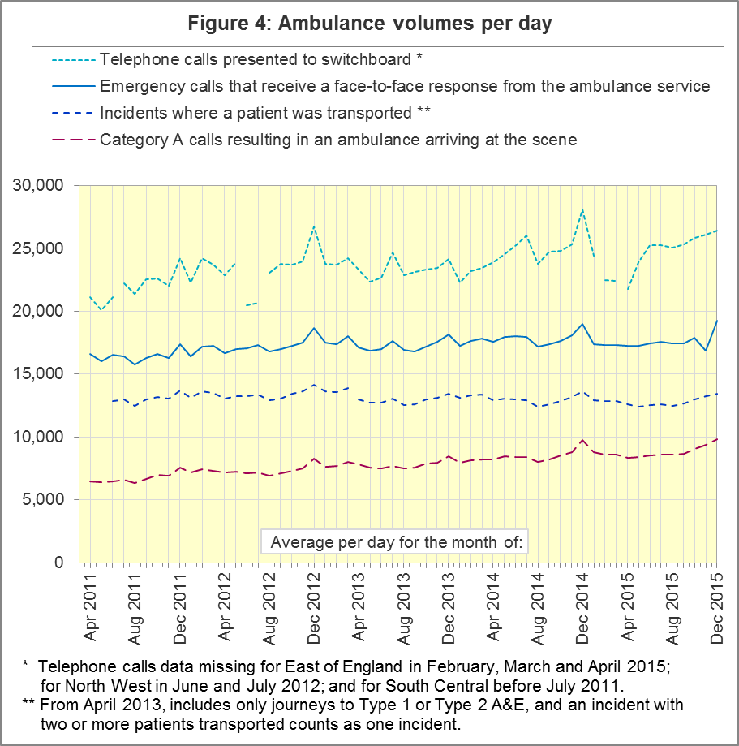

A5 Latest monthly data for other Systems Indicators, November 2015
Indicator | England | Lowest Trust |  | Highest Trust
Calls abandoned before being answered | 0.5% | London | 0.1% | South Western⁶ | 1.0%
Calls resolved through telephone assessment | 10.5% | West Midlands | 5.2% | South Western | 12.6%
Calls resolved without transport to Type 1 or Type 2 A&E | 37.9% | East Midlands | 29.9% | South Western⁶ | 53.6%
Recontact rate following discharge by telephone advice | 6.7% | Yorkshire | 1.9% | West Midlands | 14.8%
Recontact rate following face-to-face treatment at scene | 5.2% | Yorkshire | 2.2% | London | 9.0%
Incidents where a patient was transported | 417,064 | North  East | 20,797 | London | 68,419

In December 2015, the proportion of calls resolved through telephone assessment was 10.5%, similar to the 10.6% recorded in November 2015.
Of emergency calls resolved with telephone advice, the proportion where the patient subsequently re-contacts 999 within 24 hours was 6.2% in December.
The proportion of incidents managed without need for transport to Accident and Emergency department was 37.9%, the highest since April 2011.

B. Clinical Outcomes
No thresholds to denote “poor” care are set for Clinical Outcomes. Commissioners are expected to examine trends in these data, and work in collaboration with ambulance trusts to achieve sustained improvement in patient outcomes over time; but commissioners are not expected to use Clinical Outcomes to performance manage trusts, because there will be significant variations in the populations served.

B1 Cardiac arrest: return of spontaneous circulation (ROSC)
Patients in cardiac arrest will typically have no pulse and will not be breathing. In September 2015 in England, resuscitation was commenced or continued by ambulance staff out-of-hospital for 2,363 such patients. Of these, 646 (27.3%) had ROSC, with a pulse, on arrival at hospital (Figure 5), same as the average for 2014-15 of 27.3%. The largest proportion in September 2015 was 35.9% for North West. The smallest proportion was 14.0% for South Central.

The Utstein group comprises patients who had resuscitation commenced or continued by the Ambulance Services, following an out-of-hospital cardiac arrest of presumed cardiac origin, where the arrest was bystander witnessed, and the initial rhythm was Ventricular Fibrillation or Ventricular Tachycardia. The Utstein group therefore have a better chance of survival.
There were 306 such patients in England in September 2015, of which 152 (49.7%) had ROSC on arrival at hospital (Figure 5). This was similar to the England average for 2014-15 of 49%. The largest proportion in the month of September 2015 was North West with 62.2%, and the smallest was 18.9% for South Central.
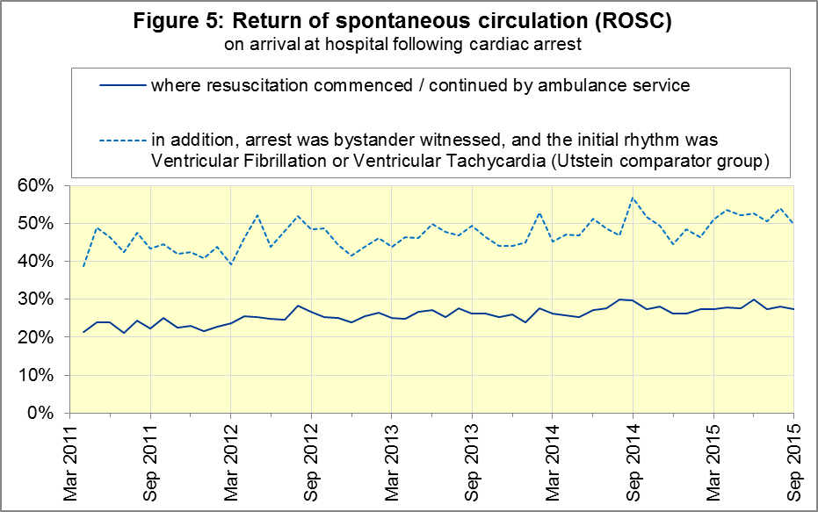

B2 Cardiac arrest: survival to discharge
The proportion of cardiac arrest patients in England discharged from hospital alive was 8.2% in September 2015 (Figure 6), similar to the average for 2014-15 of 8.6%. The largest proportion in September 2015 was 13.4% for South Central, and the smallest was 3.5% for London⁸.
For the Utstein group, survival to discharge in September 2015 was 26.3%, same as the average for 2014-15 of 26.3%. The largest proportion was 39.1% for East of England, the smallest was 12.5% for London⁸.

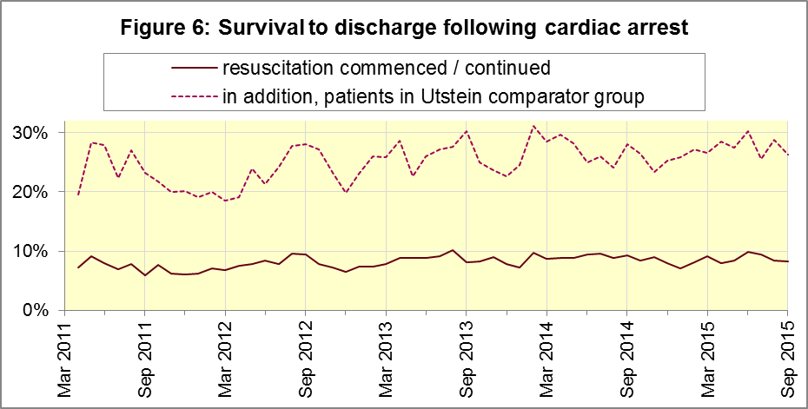

B3 ST-Elevation myocardial infarction
ST-segment elevation myocardial infarction (STEMI) is a type of heart attack, determined by an electrocardiogram (ECG) test. Early access to reperfusion, where blocked arteries are opened to re-establish blood flow, and other assessment and care interventions, are associated with reductions in STEMI mortality and morbidity.
846 STEMI patients received primary angioplasty in September 2015 in England, this is the lowest figure since data collection began in April 2011. Of these 846 patients, 736 (87.0%) of them received it within 150 minutes of the call being connected to the ambulance service (Figure 7), similar to the average for 2014-15. The largest proportion for September 2015 was 92.7% for London, and the smallest was 80% for Yorkshire.
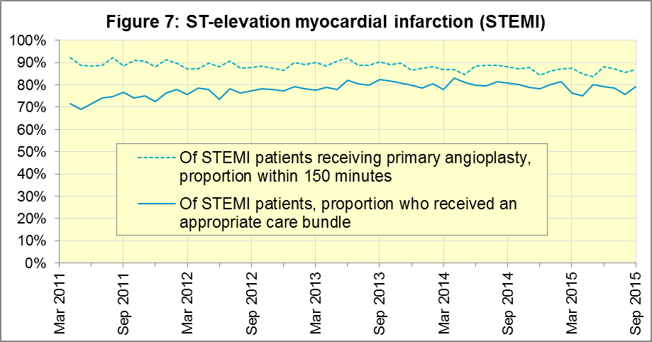
In September 2015, of 1,192 patients with an acute STEMI in England, 946 (79.4%) received the appropriate care bundle. This was similar to the average for 2014-15 of 80.0%. North West had the largest proportion with 97.3%, and the smallest was South East Coast with 66.7%. In September 2015, the total number and the daily average for patients with an acute STEMI was the lowest since this recording began in April 2011.

B4 Stroke
The FAST procedure helps assess whether someone has suffered a stroke:
- Facial weakness: can the person smile? Has their mouth or eye drooped?
- Arm weakness: can the person raise both arms?
- Speech problems: can the person speak clearly and understand what you say?
- Time to call 999 for an ambulance if you spot any one of these signs.
In September 2015, of 3,289 FAST positive patients in England, assessed face to face, and potentially eligible for stroke thrombolysis within agreed local guidelines, 1,854 (56.4%) arrived at hospitals with a hyperacute stroke unit within 60 minutes of an emergency call connecting to the ambulance service, slightly below the average for 2014-15 of 59.0%.
The largest proportion in the month of September 2015 was 64.5% for South East Coast, and the smallest was 40.2% for South Western.
There were 7,541 stroke patients assessed face to face in September 2015 in England, and 7,351 (97.5%) received the appropriate care bundle, similar to the average for 2014-15 of 97.1%.
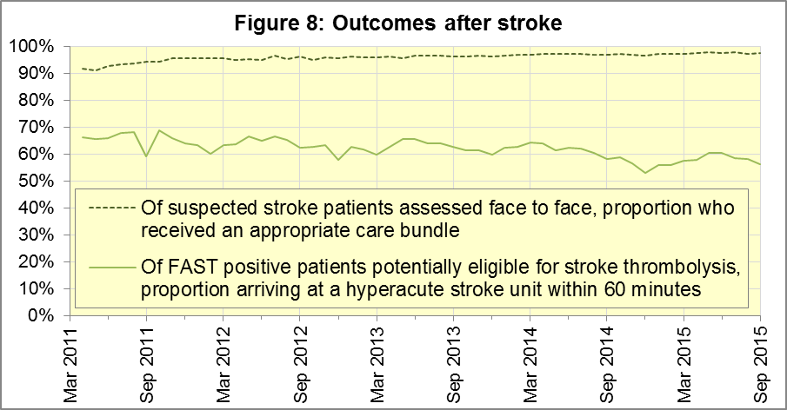

C. Further information on AQI

C1 The AQI landing page and Quality Statement
www.england.nhs.uk/statistics/statistical-work-areas/ambulance-quality-indicators, or http://bit.ly/NHSAQI, is the AQI landing page, and it holds:
- a Quality Statement for these statistics, which includes information on relevance, accuracy, timeliness, coherence, and user engagement;
- the specification guidance document for those who supply the data;
- timetables for data collection and publication;
- text files and time series spreadsheets containing all data from April 2011 up to the latest month;
- links to individual web pages for each financial year.
The web pages for each financial year hold:
- separate spreadsheets of each month’s data;
- this Statistical Note, and equivalent versions from previous months;
- the list of people with pre-release access to the data.
Publication dates are also at www.gov.uk/government/statistics/announcements.

C2 Revisions
Revisions usually follow a six-monthly cycle. The dates for past and future AQI scheduled revisions are below. The AQI Quality Statement above contains a more detailed revisions policy.
Publication date |  | Series revised |  | Months affected
12 May 2016 |  | Systems Indicators |  | April 2015 to February 2016
10 March 2016 |  | Clinical Outcomes |  | April 2015 to September 2015
10 September 2015 |  | Clinical Outcomes |  | April 2014 to March 2015
4 June 2015 |  | Systems Indicators |  | April 2014 to February 2015
30 April 2015 |  | Systems Indicators |  | April 2014 to February 2015
5 March 2015 |  | Clinical Outcomes |  | April 2014 to September 2014
6 November 2014 |  | Systems Indicators |  | April 2013 to August 2014
5 September 2014 |  | Clinical Outcomes |  | April 2013 to March 2014
2 May 2014 |  | Systems Indicators |  | April 2013 to February 2014
7 March 2014 |  | Clinical Outcomes |  | April 2013 to September 2013
1 November 2013 |  | Systems Indicators |  | April 2013 to August 2013
2 August 2013 |  | Clinical Outcomes |  | April 2012 to March 2013
3 May 2013 |  | Systems Indicators |  | April 2012 to March 2013
1 February 2013 |  | Clinical Outcomes |  | April 2012 to August 2012
11 January 2013 |  | Systems Indicators |  | April 2011 to October 2012
31 August 2012 |  | Clinical Outcomes |  | April 2011 to March 2012

C3 AQI Scope
The AQI include calls made by dialling either the usual UK-wide number 999 or its international equivalent 112.
As described in the specification guidance in section C1, calls made to NHS 111 are not included in the AQI measures for calls abandoned, re-contacts, frequent callers, time to answer calls and calls resolved by telephone advice.
All other Systems Indicators involve the dispatch of an ambulance, and include ambulances dispatched as a result of a call to NHS 111, as well as 999 or 112.

C4 Related statistics in England
The AQI appear in a Clinical Dashboard, available from the AQI landing page, the websites of the Ambulance Trusts (listed in the AQI Quality Statement), and http://aace.org.uk/national-performance/national-clinical-dashboards. One of the aims of these Dashboards is to use statistical process control, to indicate whether variation in proportions reflects underlying change, or merely natural variance, unavoidable even when a health system is performing well.
The AQI are also used in the “Ambulance Services” publication by the Health and Social Care Information Centre (HSCIC), which includes additional annual analysis and commentary. Until March 2013, the HSCIC publication used the KA34 data collection, which was similar to the AQI Systems Indicators, but annual rather than monthly. After that date, the HSCIC publication used AQI data. www.hscic.gov.uk/article/2021/Website-Search?q=ambulance+-accident&sort=Title
Ambulance handover delays of over 30 minutes at each Emergency Department were collected and published by NHS England each winter until 2014-15: www.england.nhs.uk/statistics/statistical-work-areas/winter-daily-sitreps
The AQI Quality Statement described in section C1 contains more information on the HSCIC publication. It also contains details of weekly ambulance situation reports that NHS England collected for six months from November 2010.

C5 Rest of United Kingdom
Ambulance statistics for other countries of the UK can be found at the following websites. The AQI Quality Statement described in section C1 contains more information about the comparability of these statistics.
Wales: | http://wales.gov.uk/statistics-and-research/ambulance-services/?lang=en
Scotland: | See Quality Improvement Indicators (QII) documents at www.scottishambulance.com/TheService/BoardPapers.aspx
Northern Ireland: | www.dhsspsni.gov.uk/index/statistics/hospital/emergency-care/ambulance-statistics.htm

C6 Contact information
For press enquiries, please contact the NHS England press office on 0113 825 0958 or nhsengland.media@nhs.net.
The statistician responsible for producing this publication is:
Ian Kay, Operational Information for Commissioning (National), NHS England
Room 5E24, Quarry House, Leeds, LS2 7UE; 0113 825 4606; i.kay@nhs.net

C7 National Statistics
The UK Statistics Authority has designated these statistics as National Statistics, in accordance with the Statistics and Registration Service Act 2007 and signifying compliance with the Code of Practice for Official Statistics.
Designation can be broadly interpreted to mean that the statistics:
- meet identified user needs;
- are well explained and readily accessible;
- are produced according to sound methods; and
- are managed impartially and objectively in the public interest.
Once statistics have been designated as National Statistics it is a statutory requirement that the Code of Practice shall continue to be observed.

Page 34 of the July 2015 Handbook to the NHS Constitution has Ambulance response time standards, www.gov.uk/government/publications/the-nhs-constitution-for-england.
On 1 June 2012, Category A (immediately life-threatening) calls were split into Red 1 and Red 2. Red 1 calls are the most time critical, and cover cardiac arrest patients who are not breathing and do not have a pulse, and other severe conditions such as airway obstruction. Red 2 calls are serious, but less immediately time critical, and cover conditions such as stroke and fits. www.gov.uk/government/news/changes-to-ambulance-response-time-categories Due to the differences in clock start definitions for Red 1 and Red 2 it is not possible to aggregate them into a single proportion for Category A against the 8 minute standard.
Dispatch on Disposition announcement: www.parliament.uk/business/publications/written-questions-answers-statements/written-statement/Commons/2015-01-16/HCWS201
The number of emergency calls presented to switchboard does not usually include calls made to NHS 111 requiring an ambulance. 111 calls requiring an ambulance are usually transferred electronically direct to ambulance dispatch, and not routed via 999 call handlers. Occasionally, manual requests for ambulance are made between 111 and 999 call handlers, and such calls are included in the number of emergency calls presented to switchboard.
Type 1 are consultant-led 24 hour emergency departments with full resuscitation facilities. Type 2 offer a consultant-led speciality A&E service such as ophthalmology or dental. Type 3 is A&E / minor injury activity that may be doctor-led or nurse-led. Type 4 are NHS walk-in centres. (www.datadictionary.nhs.uk/data_dictionary/attributes/a/acc/ accident_and_emergency_department_type_de.asp)
Due to its small size, performance on Isle of Wight tends to vary more than other trusts. If it has the largest or smallest value, the Table in A5 shows the second largest or smallest value, but has a footnote marker to show that Isle of Wight is more extreme. The Clinical Outcomes in section B also use this system.
This definition was proposed at Utstein Abbey in Norway by an international group of cardiologists and other health professionals in 1990. http://circ.ahajournals.org/content/84/2/960.citation
Please see footnote 6 on page 6
Excluding Isle of Wight. See footnote 6 on page 6.
Pages 27 to 30 of the specification guidance for data suppliers on the AQI landing page at www.england.nhs.uk/statistics/statistical-work-areas/ambulance-quality-indicators describe the care bundles, and certain exclusions, for the STEMI and stroke indicators.

